1. Integrating Chebyshev polynomials
   1. Finished implementing the Chebyshev approximation of functions (with symbolic features) using the expression below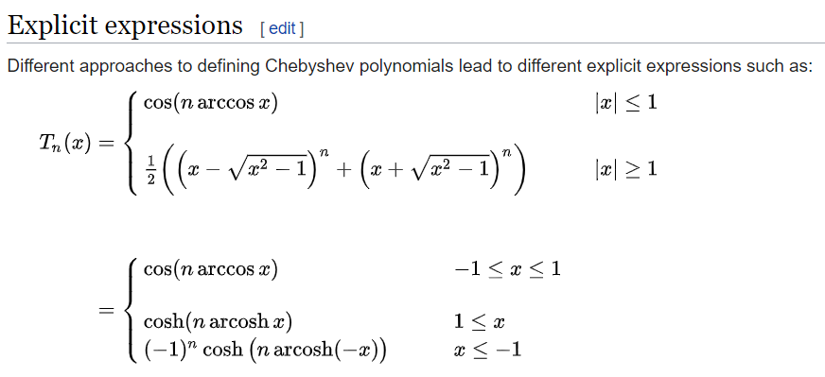
      1. we only care abt |x|<=1 since we’re integrating from 0 to 1
      2. For |x|>1, my implementation doesn’t agree with the package although I’m using the same coefficients. Perhaps I’m not fully understanding the approximation correctly: Since the Chebyshev polynomials are defined different on [-1,1] and elsewhere, how does the approximation work if I’m approximating a function on say [1/2,2]?
   2. managed to do the line integral using Julia’s native quadgk() function (which agrees with the symbolic integration)
2. Implementing the transform pair:
   1. The definition of Xlj involves the (l+1, j+1) entry of M, but l, j range from 1 to n and M is n-by-n?
   2. Given a list of zeroes, construct the contours in Figure 3 in the form of a list of points in the complex plane that form a path avoiding the zeroes