1. Finding zeroes of delta(lambda)
   1. Using contour plots of the argument of delta (zeroes are where the contour changes rapidly): Difficult with contour plots like this

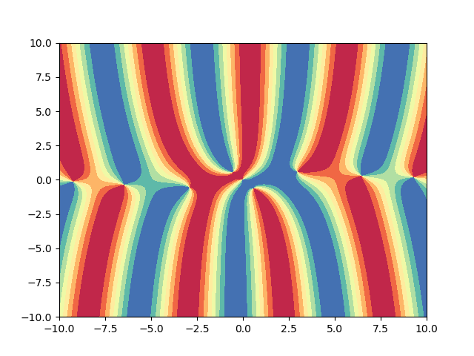

* 1. Find zeroes manually: TBD

1. The “f” in (2.15a) and (3.12) is as in (2.12b), right?
   1. (2.12b) and (2.12c) mean that the spatial q(x,0) = f and temporal q(, t) both satisfy the homogeneous boundary conditions. To test the transform pairs, do I just choose an f that satisfies the homogeneous boundary conditions Uf=0 and set it to be q(x,0)?
2. In (2.15a), to characterize “\lambda \in \Gamma”, I need to find out how to check if a given point is on the contour characterized by a list of points (it may not be one of the points), right?
3. Documentation
   1. Proposed platform & format: IJulia (explanation in markdown and examples in code)
   2. Or Github style?
   3. Content: Not just how to use but also what exactly the code is doing?