Numeric workaround:

1. Can evaluate within a minute, but cannot yet plot in reasonable time if F+, F- have relatively long formulas due to long compilation time of integrandPlus each time q(x, t) is evaluated at a new point
   1. integrandPlus is redefined using x, t each time q(x,t) is evaluated. So when plotting, integrandPlus needs to be recompiled at each point
   2. integrandPlus uses F+, so if F+ has long formula, compilation time is long
   3. Tried currying, anonymous function, as slow as recompiling
   4. Solutions:
      1. Analytic formula separating x, t, and F+/-
2. quadgk() itself is slow on certain paths (e.g., gamma0Plus)
   1. 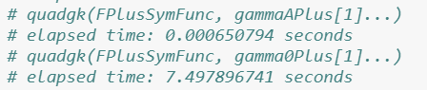

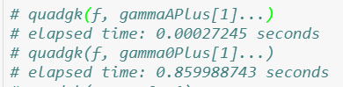



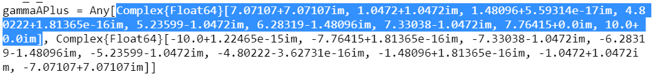

* 1. Alternatives?
     1. ApproxFun: <https://discourse.julialang.org/t/evaluate-integral-on-many-points-cubature-jl/1723/4>
     2. Other languages, python, matlab?

Report 3

1. Purpose: phrase as “provide computer aid”, including approximation of roots of delta and symbolic formula for F^+, F^-
   1. If the Fokas method depends on F+/- ->0 as lambda -> infty in D+, but isn’t that already proved in Miller Smith appendix A?
2. Epsilon = 1/5*min_distance?
3. Examples of IBVPs that can be solved by classical transform