# Sales-Performance-Dashboard-PowerBI
Interactive Power BI dashboard analyzing sales performance, profitability, regional trends, product categories, and payment methods using DAX measures and data visualization techniques.
# Sales Performance Dashboard (Power BI)

## Project Overview

This project presents an interactive Sales Performance Dashboard built in Power BI to analyze key business metrics, including sales, profit, units sold, regional performance, product category performance, and customer payment preferences.

The dashboard enables users to explore sales trends through interactive filters and visualizations, helping identify high-performing categories, profitable products, top-performing states, and preferred payment methods.

## Key Features

* KPI tracking for Total Sales, Total Profit, and Total Units Sold
* Sales analysis by product category
* Profitability analysis by category
* Regional sales performance by state
* Payment method analysis
* Interactive state filtering using slicers
* Data modeling and DAX measures

## Tools & Technologies

* Power BI
* DAX (Data Analysis Expressions)
* Power Query
* Data Modeling
* CSV Data Sources

## Business Insights

* Electronics generated the highest sales revenue.
* Clothing generated the highest profit.
* Maharashtra was the top-performing state by sales.
* Credit Card and COD represented the largest share of payment methods.

## Dashboard Preview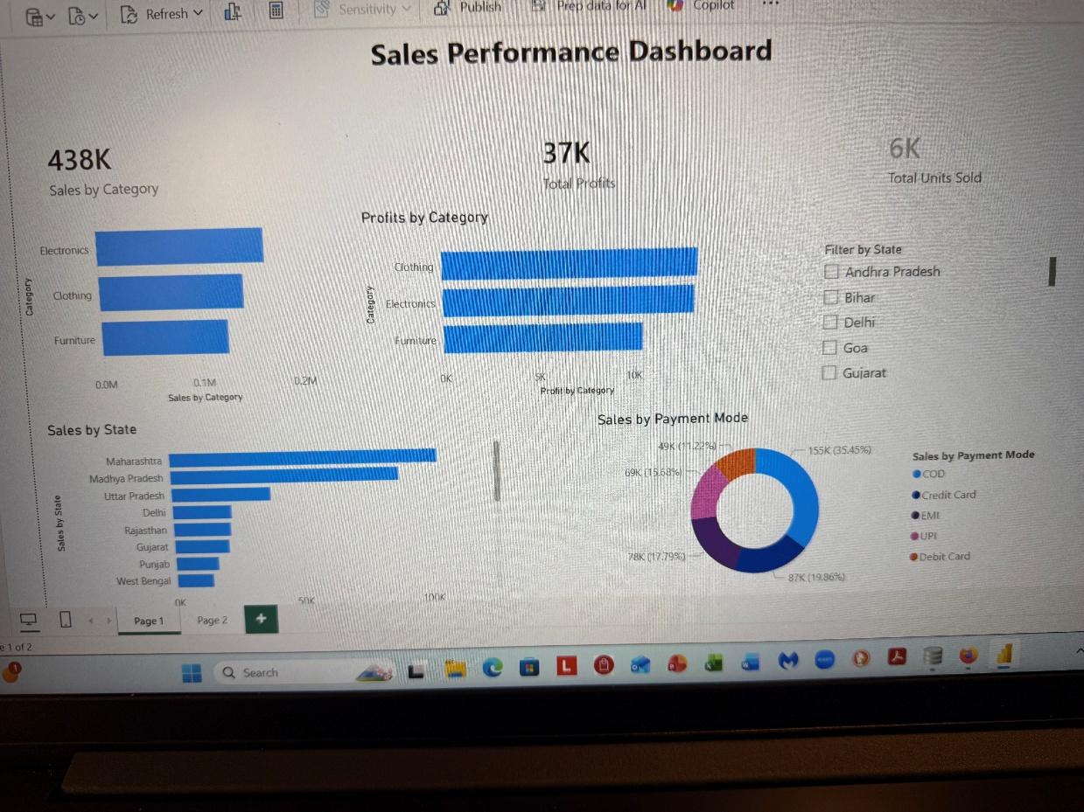
## Author

edward-walker: benifield
Aspiring Data Analyst | Power BI | Python | Data Visualization

