SUGAR Application Configuration Tutorial

1. first step

Install the MySQL database and Tomcat 7 according to the Internet related installation tutorial. When install the MYSQL, you need to set the username and password. In the current project, user name is “root” and the password is “123456”. You can also set different user name and password, just tell me change the original code.

2.second step

Create a database named sugar in MySQL which contains four tables as follows:

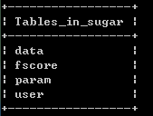

Data table stores users’ game data;

fscore table stores the highest score of each user;

param table stores parameters of the current game;

user table stores users’ registration information;

Field attributes of each table are as follows:

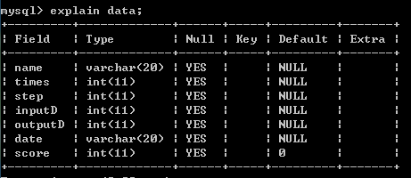

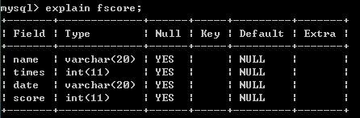

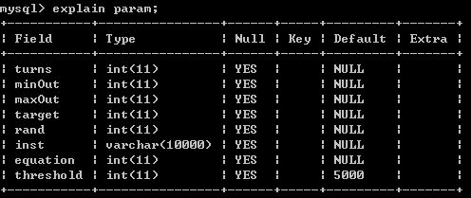

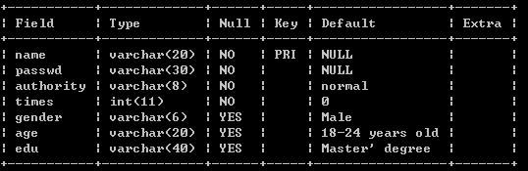

Because our project does not provide the administrator registration now, you should insert directly one or more administrator record into user table.

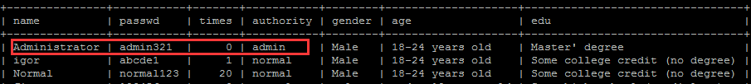

3.third step

Find the Tomcat 7 installation directory. Copy the SimpleServlet and SugerGameServer folder to the webapps directory. These two folders are in the appendix. Restart the Tomcat service.

Now you can test whether the application is installed successfully. Open your browser and enter the following address:

http://+ server ip+:8080/SimpleServlet/Login.jsp

