Ensure the IntelliJ IDEA version is : 

1. Create a new Java Enterprise project:

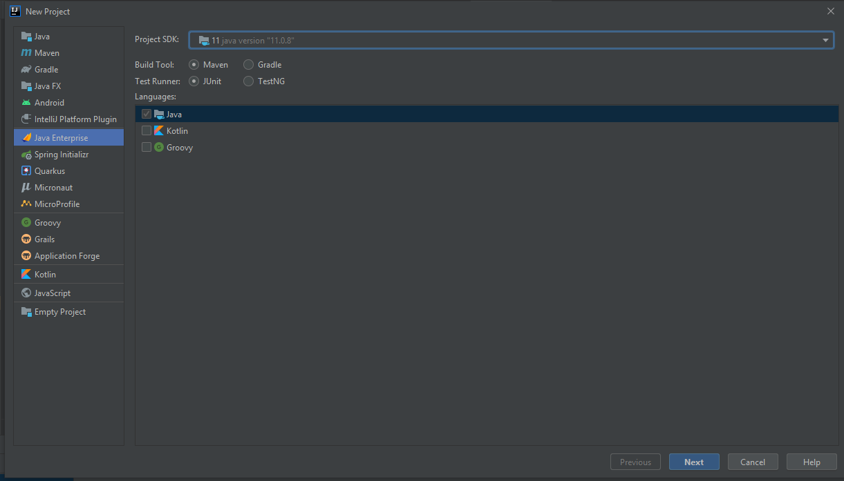

1. Choose the Web Profile (includes Servlets)

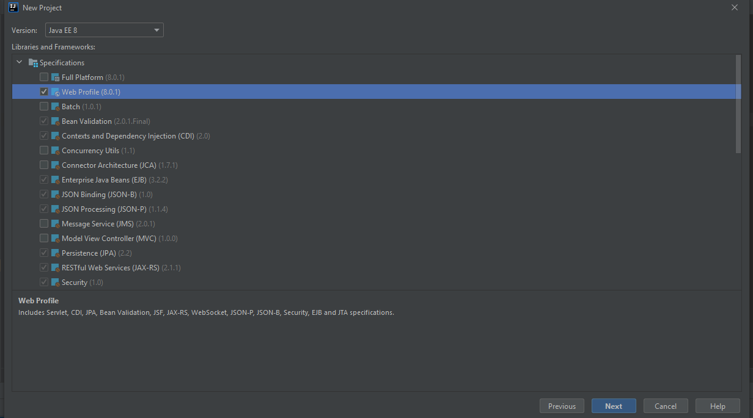

1. Create a JSP file.

A JSP file is a server-generated web page. It is similar to an .ASP or .PHP file, but contains Java code instead of ActiveX or PHP. The code is parsed by the web server, which generates HTML that is sent to the user's computer.

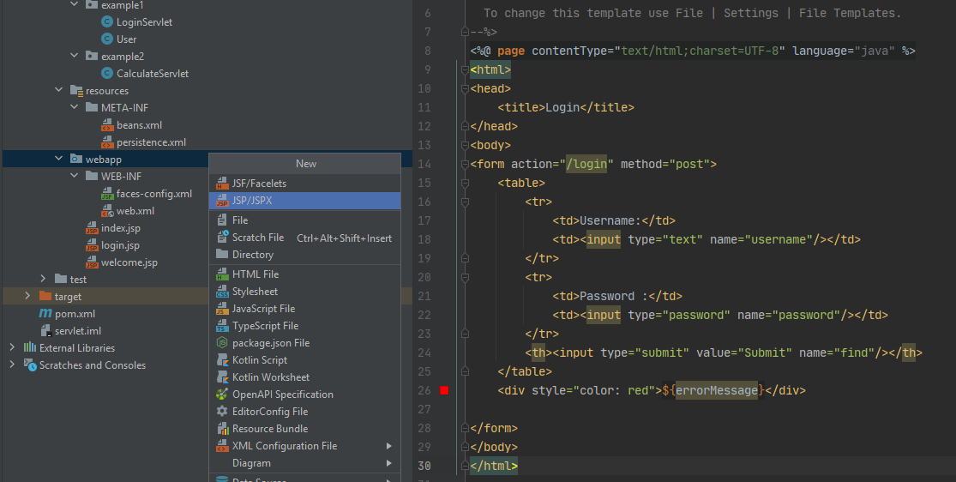

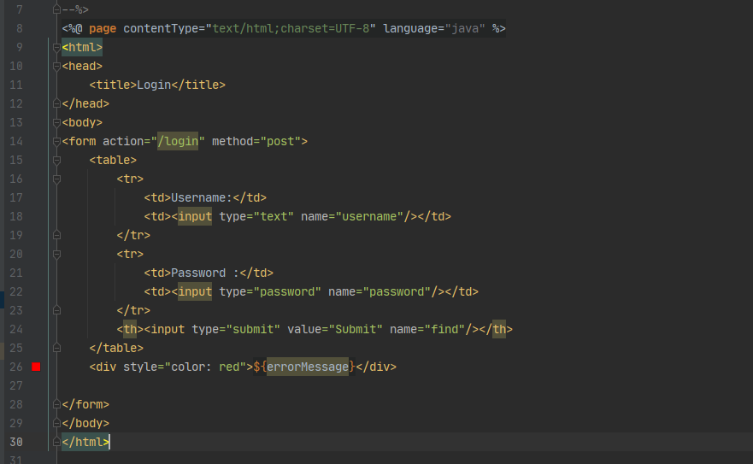

1. Create a Java Servlet

 All servlets must implement the Servlet interface, which defines life-cycle methods. When it comes to HTTP Servlets, the java class must extend the abstract HttpServlet class which provides methods, such as doGet and doPost, for handling HTTP-specific services.

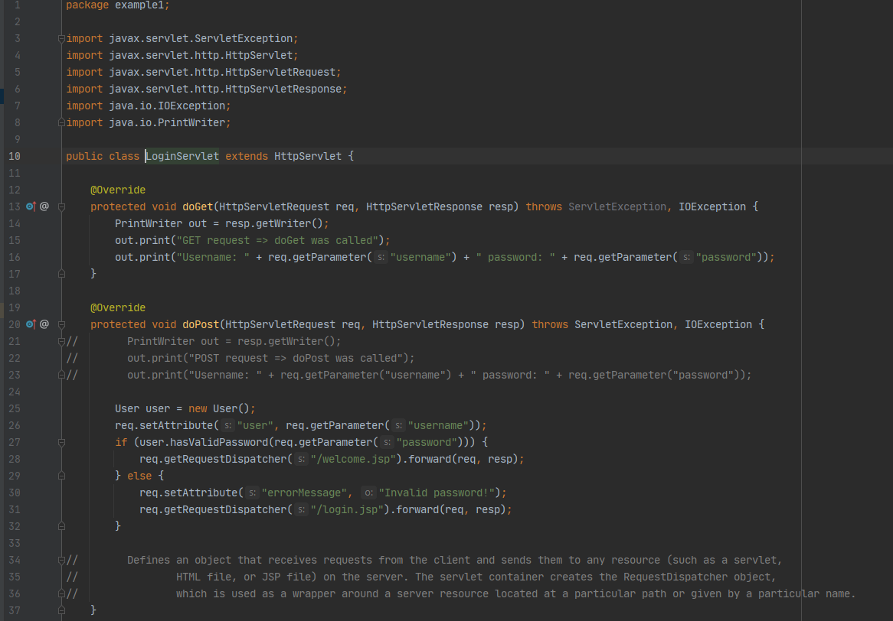

1. Map the servlet using XML deployment descriptor named web.xml

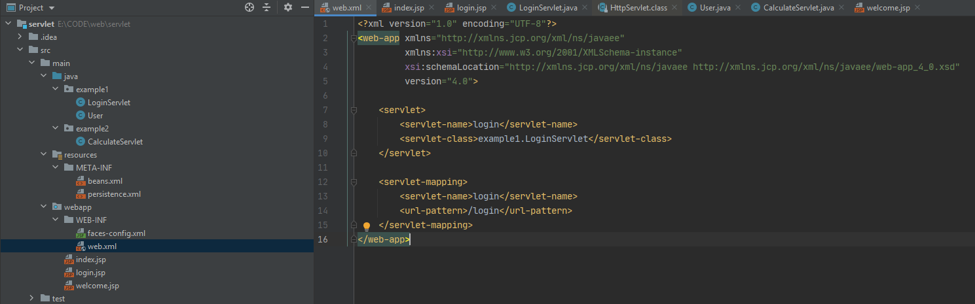

We can avoid using XML deployment descriptor named web.xml for our Servlet mapping by using the [*@WebServlet*](https://docs.oracle.com/javaee/6/api/javax/servlet/annotation/WebServlet.html) annotation which is processed by the container at deployment time, and the corresponding servlet made available at the specified URL patterns:

