SYSTEM IDENTIFICATION
- PROJECT -

- Part1-
Fitting an unknown function

Teacher: Students:
Lucian Bușoniu Mihuț Larisa- Diana
Nenu Maria

Year of study: 3
Group: 30331

CONTENTS

- Introduction
- Regression
- Fitting of an unknown function
  - The set of data
  - Polynomial function
  - Output approximation function
  - Mean square error function
  - The main function
  - Results
- Conclusions
- Appendices
  - A1: Main function
  - A2: Function for calculating the regressors matrix
  - A3: Function for calculating the approximated matrix
  - A4: Function for calculating the mean square error

- Introduction

This report represents the first part of the assignament for the System Identification course. We are disscussing our solution for the problem of fitting an unknown function using MATLAB.
Main topics of the report:
- Theoretical background: aspects about the technologies used
- Fitting an unknown function : computation of a configurable polynomial generator and of the model fitting of the function
- Conclusions : disscusion on overfitting and model choice
- Appendix: source code written in MATLAB

- Reggresion

Regression models are static models that make correlations between two or more random variables for predicting one of them based on the others.
Linear regression is one of the main parts of statistics when it comes to predictions. Prediction represents the process of estimating an unknown value based on a given one and it consists of two parts:
- determination of the regression equation
- usage of the equation in a prediction

Non-linear regression appears when the link between the two static variables is not linear, but it exists. The dependent variable is a nonlinear combination of the independent variables.
The polynomial regression is going to have the following form:
Y = b₀+ b₁X+ b₂X²+...+b_{n}X^{n} , b_{0...n}- constants
Y- resultant variable
X- predictor variable
Y= X* b, where
Y₁
Y = Y₂ , a vector p-dimensional (2.1)
....
Y_{p}

1 X₁ ... (X₁)^{n}
X= ... ... ... ... , marix of the regressors (basis functions) (2.2)
1 X_{p} ... (X_{p})^{n}

b- (n+1) vector, its components are the constant/unknown values of the model
b= (X’ * X)⁻¹ * X’ * Y . (2.3)

- Fitting of an unknown function

In this part we create in MATLAB a model for a configurable polynomial function that is nonlinear and static, with the help of regression.

  - The set of data

We are given 2 sets of date, one for identification (id) and one for validation (val). Each one has a set of grid coordinates:
- X for the inputs, a cell array of 2 vectors: X{1}(i), X{2};
- Y for the ouputs(corrupted by noise, additive, zero-mean Gaussian), a matrix (n x n), where Y(i,j) = f(X{1}(i) , X{2}(j)), (see 2.1)
where f- unknown, linear, static function;

  - Polynomial function

On this function depends the accuracy of our model. It returns the matrix of the regressors depending on the degree (see 2.2), after the computation of the polynomials. (See full code in Appendix A2)

3 function [fi] = fi(m,x1,x2,y)

  - Output approximation function

In order to obtain our approximated matrix, we had to convert our given matrix y into a column vector (see 2.1):

4 y= y(:);

This function calculates the matrix with the unknown constants of the polynomial (see 2.3). In MATLAB, we used the following formula:

5 theta = fi\y; %matrix for the constants of the polynomial

Therefore, having the matrix of the constants, the function returns the approximated matrix, the output of the model.

6 yhat = fi * theta; %matrix for approximation

(See full code in Appendix A3)

  - Mean square error function

In order to find the error of our algorithm, we created the following function:

7 function [M] = mse(y,yhat)

It only takes the initial output value and the output of the model and returns the mean square error of the algorithm after the calculus is done. (for full code see Appendix A3).

  - The main function

Firstly, the identification data is being saved in 3 new variables for working easier with them.

1 x1=id.X{1, 1};
x2=id.X{2, 1};
y=id.Y;

Secondly, the identificaton data is being plotted. (figure 1)

2 mesh(x1,x2,y);

(full code in Appendix A1)

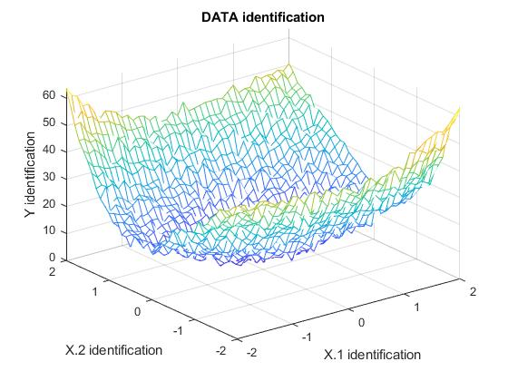
Figure 1 Plot of the identification data

Next, we have computed the regressors matrix, the approximated function and the mean square error for both the identification and validation data, using the functions mentioned above. (See Appendix A1 for the code).

  - Results

In order to obtain best results, we have computed polynomials for different degrees for the identification data set. Then, we have chosen the degree that has the smallest MSE(mean square error), the one that is most accurate.
The following table contains the values obtained for the MSE for the indentificaton and validation datasets:

Degree of the polynomial | MSE for identification | MSE for validation
1 |  | 15.8663
2 |  | 2.0100
3 |  | 1.6101
4 |  | 1.4995
5 |  | 1.3421
6 |  | 1.1927
7 |  | 1.0820
8 |  | 0.9903
9 |  | 0.8752
10 |  | 0.7227
11 |  | 0.6038
12 |  | 0.4674
13 |  | 0.3328
14 |  | 0.2292
15 |  | 0.1837

The MSE for degree 21 has the smallest value, so for degree 21 our model fits the best the validation plot. Figure 2 shows the plot of validation data and the plot of our model for degree 21. We have used color red for the validation data and green for the model, the parts that fit the best turned into blue.

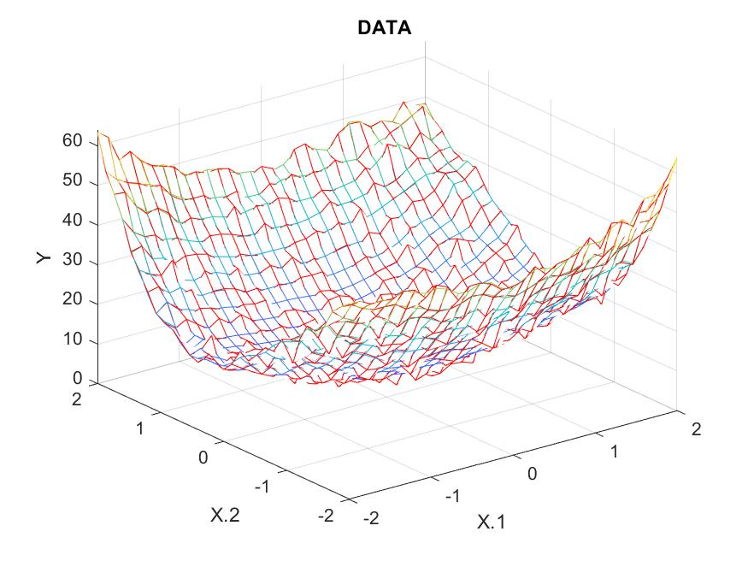
Figure 2. Plot for validation and for the model

- Disscussion

We can see that the MSE becomes smaller as the degree increases. The more degrees we have, the fitting of the polynomial on the set is better. But this does not mean more degrees, more accuracy.
A common problem when giving too much information is represented by overfitting. Algorithms can predict unreal situations because of the experience on the test set. As a result, complexity makes the prediction poor.
Also, in our case, the sampled data lies between [-2,2], so the values are extreamly close one to each other. When we try to compute polynomials, we encounter rank deficency problems that affects the condition of the model.

- Appendices

  - A1: Main function
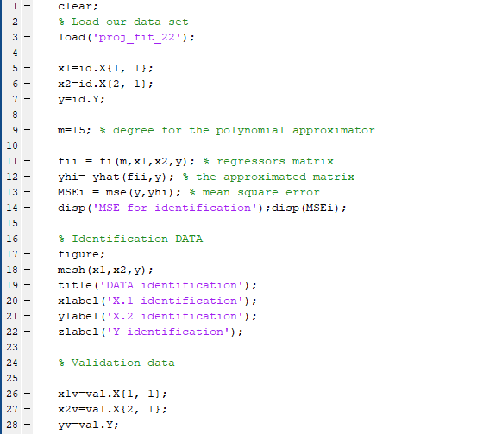
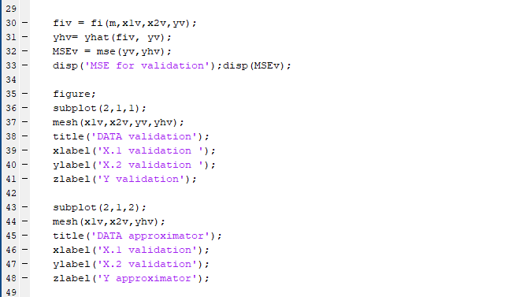

  - A2: Function for calculating the regressors matrix

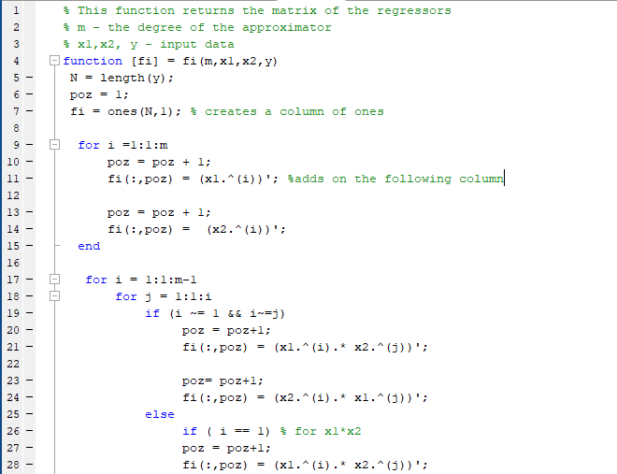
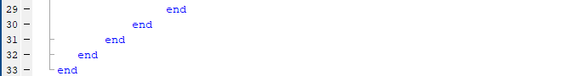

  - A3: Function for calculating the approximated matrix

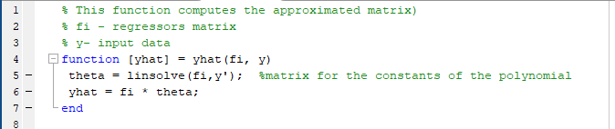

  - A4: Function for calculating the mean square error
