Modelling the dynamics of media trust formation: A compartmental ODE framework for exposure, trust, and distrust in OECD democracies

1 Introduction and problem description
Public trust in news media is a central pillar of democratic societies: citizens rely on news media to interpret political events, evaluate institutions, and coordinate around shared facts. When media trust erodes, democratic accountability weakens: individuals disengage from news, rely on unverified sources, or reject common factual baselines. Comparative survey evidence from the OECD Trust Survey, the Edelman Trust Barometer, and related reporting shows that media trust varies substantially across OECD democracies and over time, and that institutional quality, journalistic independence, political polarization, and the information environment matter for those differences. The OECD Trust Survey (2024) provides cross-country snapshots and time comparisons that motivate a dynamical, population-level approach. (OECD, 2024)
Empirical micro- and experimental literature shows that misinformation, repeated exposure to false content, and algorithmic echo chambers alter how people interpret the same information; such effects tend to reduce trust or make trust harder to recover (Allcott & Gentzkow 2017; Lewandowsky et al. 2017; Altay et al. 2024). The literature on echo chambers confirms that social-network structures can amplify repetition and selectivity of exposure (Cinelli et al., PNAS 2021), and formal work shows limits of regulation in breaking such echo chambers (Avin et al., 2024). (Allcott, Hunt, and Matthew Gentzkow. 2017)
This project builds a parsimonious ODE model to study how individuals move between neutral, exposed, trusting and distrusting states, and how exogenous changes in the information environment (misinformation intensity, crisis shocks) alter interpretation of exposure. The aim is qualitative understanding (existence/uniqueness, equilibria, local stability, and illustrative simulations calibrated to OECD benchmarks) rather than precise forecasting.

2 Mathematical model

2.1 Variables and population structure
We normalize population to one and partition it into four mutually exclusive compartments:
- $S(t)$: Susceptible / neutral individuals (no firm trust or distrust).
- $E(t)$: Exposed individuals (have recently encountered media content and are processing it).
- $T(t)$: Trusting individuals (express confidence in mainstream media).
- $D(t)$: Distrusting individuals (express active skepticism).
Conservation: $S(t)+E(t)+T(t)+D(t)=1$ for all $t≥0$.
This minimal partition captures delayed processing of content (the $E$ compartment), asymmetric persistence (distrust tends to be stickier), and reversible flows back to neutrality.

2.2 Parameters and interpretation
We use the following parameters (all nonnegative):
- $β$: baseline exposure rate (moves $S→E$).
- $σ$: cognitive processing rate (resolves $E$ into $T$ or $D$).
- $θ(t)∈[0,1]$: conditional probability that processing an exposure yields distrust rather than trust (i.e. $Pr⁡(E→D∣E→\{T,D\})$). This is time-varying and captures the interpretive environment.
- $α$: institutional trust reinforcement rate (direct $S→T$ without exposure; environment-dependent).
- $δ$: natural trust decay ( $T→S$ ).
- $μ$: recovery rate from distrust to neutrality ( $D→S$ ).
- $ψ$: echo-chamber amplification of exposure (increases exposure of susceptible individuals proportionally to $D$via social amplification of content).
- (We do not include a separate dynamic state for misinformation; see discussion below.)
Empirical sources support interpreting $θ(t)$ as the place where misinformation and crises act (they change how exposures are interpreted, not necessarily exposure volume). We therefore model:
$$\boxed{θ(t)=θ_{0}+κ_{1}m(t)+κ_{2}c(t),θ(t)∈[0,1],}$$
where $m(t)∈[0,1]$ denotes misinformation intensity and $c(t)∈\{0,1\}$ (or $[0,1]$) denotes a crisis indicator (scandal, electoral crisis, war period). Here $κ_{1},κ_{2}>0$ measure sensitivities. This reduced-form is supported by experimental evidence that higher proportions of false news decrease trust (Altay et al., 2024) and by OECD findings that trust can collapse during crises even when information volume is stable, implying shifts in interpretation rather than exposure per se. zora.uzh.ch+1
Modeling choices justified
- Misinformation and crisis dependence are exogenous, time-varying modifiers of interpretation (non-autonomous parameters). This keeps the model mean-field and parsimonious while aligning with the empirical claim that interpretation, not just exposure, drives trust changes (Allcott & Gentzkow 2017; Lewandowsky et al. 2017). Asociación Económica Americana+1
- Echo-chamber effects increase exposure of susceptibles via $ψDS$ in the $E$-equation, consistent with network amplification of content (Cinelli et al. 2021; Avin et al. 2024). pnas.org+1
- We avoid a self-reinforcing $D→D$ term in the main model because that would covertly introduce endogenous contagion mechanics not directly supported by mean-field OECD data and would conflict with the chosen interpretive structure; instead persistence of distrust is captured by small $μ$ and by $θ(t)$ that can be high for extended periods when misinformation or crises are present.

2.3 Model equations
Define the state vector $x=(S,E,T,D)$. The ODE system is:
$$\begin{matrix} & \begin{matrix}\frac{dS}{dt} & =-(β+α) S+δ T+μ D, \\ \frac{dE}{dt} & =β S+ψ D S-σ E, \\ \frac{dT}{dt} & =(1-θ(t)) σ E+α S-δ T, \\ \frac{dD}{dt} & =θ(t) σ E-μ D.\end{matrix} & & \text{(M)}\end{matrix}$$
Interpretation of flows:
- $S→E$ at rate $βS$ (baseline exposure) and $ψDS$ (network-driven additional exposure when distrustful clusters amplify content).
- $E→T$ or $E→D$ via resolution at rate $σ$, partitioned by $θ(t)$.
- $S→T$ at rate $αS$: institutional reinforcement independent of recent exposure.
- $T→S$ and $D→S$ capture decay and recovery.

3 Analysis of the model
We present standard ODE qualitative analysis, working first with the autonomous case (fix $θ≡θ^{*}$) and then discussing non-autonomous effects produced by $θ(t)$.

3.1 Existence, uniqueness, and invariance
The right-hand side of (M) is polynomial in the state variables and locally Lipschitz on $R^{4}$. By standard ODE theory, given any initial condition $x(0)$ in $R^{4}$, there exists a unique local solution. The unit simplex
$$Δ:=\{(S,E,T,D)∈R_{+}^{4}: S+E+T+D=1\}$$
is forward invariant. Indeed, the vector field satisfies $\frac{d}{dt}(S+E+T+D)=0$, so the sum is preserved, and the flows map non-negative states to non-negative derivatives at the boundary (fluxes point inward). Thus solutions with initial condition in $Δ$ remain in $Δ$ for all $t≥0$.

3.2 Equilibria (autonomous $θ$)
Set derivatives to zero for constant $θ$. Let $θ^{*}∈[0,1]$ fixed. From the last equation:
$$\begin{matrix} & 0=θ^{*}σE^{*}-μD^{*}⇒D^{*}=\frac{θ^{*}σ}{μ}E^{*}. & & \text{(1)}\end{matrix}$$
From the $E$-equation at equilibrium:
$$\begin{matrix} & 0=βS^{*}+ψD^{*}S^{*}-σE^{*}⇒E^{*}=\frac{S^{*}(β+ψD^{*})}{σ}. & & \text{(2)}\end{matrix}$$
From $T$-equation at equilibrium:
$$\begin{matrix} & 0=(1-θ^{*})σE^{*}+αS^{*}-δT^{*}⇒T^{*}=\frac{(1-θ^{*})σE^{*}+αS^{*}}{δ}. & & \text{(3)}\end{matrix}$$
Finally, $S^{*}=1-E^{*}-T^{*}-D^{*}$. Substituting (1)-(3) yields a system of nonlinear algebraic equations for $S^{*}$ and $E^{*}$ (and thus $T^{*},D^{*}$). Analytic closed-form solutions are generally not available; however qualitative properties can be deduced.
A trivial equilibrium candidate is the no-exposure steady state $E^{*}=0$. If $E^{*}=0$ then from (1) $D^{*}=0$, from (3) $T^{*}=αS^{*}/δ$, and from conservation $S^{*}+T^{*}=1$, giving
$$T^{*}=\frac{α}{α+δ},S^{*}=\frac{δ}{α+δ},E^{*}=D^{*}=0.$$
This equilibrium corresponds to a situation where exposure is effectively zero (e.g., $β=0$ and $ψ=0$) and trust is determined by the balance $α/δ$. In realistic settings with $β>0$, we expect $E^{*}>0$.

3.3 Local stability (Jacobian)
Compute Jacobian $J(x)$ of the vector field for autonomous $θ$. At a general state:
$$J=(\begin{matrix}-(β+α) & 0 & δ & μ \\ β+ψD & -σ & 0 & ψS \\ α & (1-θ)σ & -δ & 0 \\ 0 & θσ & 0 & -μ\end{matrix}).$$
Evaluate $J$ at an equilibrium $x^{*}$ and inspect eigenvalues: the equilibrium is locally asymptotically stable if all eigenvalues have negative real part. Exact eigenvalues are not available in closed form in general, but sign structure and Gershgorin bounds can provide sufficient conditions; in practice one inspects numerically for parameter values.
A key observation: the sign of the sub-block governing $(E,D)$ dynamics (lower-right $2×2$ block):
$$(\begin{matrix}-σ & 0 \\ θσ & -μ\end{matrix})$$
has eigenvalues $-σ$ and $-μ$ when decoupled (ignoring $ψ$ & $β$ feedback through $S$). Thus high processing or fast recovery tends to stabilize the exposed and distrusting components; instability must come from feedbacks via $S$ and $T$(for instance, if $ψ$ is large so that $D$ greatly increases exposure).

3.4 Threshold and qualitative behaviour
The model exhibits threshold-like behaviour: when interpretive parameter $θ$ or exposure amplification $ψ$ and baseline exposure $β$ are sufficiently large relative to recovery $μ$ and processing $σ$, the fraction of distrusting individuals can increase and become persistent; conversely, strong institutional reinforcement $α$ and recovery $μ$ stabilise trust. When $θ(t)$ varies in time (non-autonomous case), transient pulses (e.g., crises) can temporarily increase $D$ and reduce $T$; if $θ$ reverts the system may recover slowly, consistent with OECD observations that trust stocks are slow-moving and crises produce rapid reallocations that often reverse. The non-autonomous system does not generally admit a global Lyapunov function; analysis proceeds by studying frozen-parameter equilibria and the system's response to parameter pulses.

4 Simulations and numerical results
Because (M) is nonlinear and closed-form solutions are unavailable, we simulate representative scenarios to illustrate transient dynamics and comparative statics. Simulations use a deterministic RK4 integrator on a time grid (details below). The purpose is to show qualitative effects of (i) misinformation intensity, (ii) crisis pulses (through $θ(t)$), and (iii) higher exposure/echo amplification (proxy for younger cohorts relying on social media).

4.1 Data used for initialisation and calibration
We use OECD Trust Survey 2023 aggregate snapshot (unweighted OECD averages) as empirically grounded initial conditions for $T$, $D$, and $S$. From Figure 5.1 (OECD 2023): $T_{0}≈0.3889$, $D_{0}≈0.4406$, Neutral $S_{0}≈0.1652$. We set $E_{0}$ small (0.005) and renormalise. These initial values anchor simulations to realistic starting points (country-specific runs could set country-specific initial vectors, e.g., Finland T≈0.6091, D≈0.2549). OECD

4.2 Baseline parameter choice (illustrative)
Parameters used in the illustrative simulations (units: days${}^{-1}$):
$$β=0.10, σ=0.20, α=0.01, δ=0.005, μ=0.01, ψ=0.05.$$
Interpretation: modest exposure and processing rates; trust reinforcement/decay are slow (small $α,δ,μ$) in line with OECD observation that trust stocks move slowly.
Interpretation parameter baseline and shock sensitivities:
$$θ_{0}=0.45,κ_{1}=0.5,m_{\text{base}}=0.20,κ_{2}=0.3,$$
and a crisis pulse $c(t)=1$ for days 60–90 (otherwise 0), so $θ(t)$ increases during that window.
We also simulate two comparative scenarios:
- Higher misinformation baseline: $m=0.40$,
- Younger-cohort: increased exposure and amplification $β=0.16$, $ψ=0.08$.
These are illustrative; exact calibration would require microdata on exposure rates and misinformation prevalence.

4.3 Numerical method and code
A classical fourth-order Runge–Kutta integrator (RK4) with timestep $Δt=0.5$ days was used. The integrator enforces non-negativity and renormalises solutions to the simplex at each step to avoid numerical drift. (I executed the simulations and produced plots and a downloadable CSV; see attached figures.)

4.4 Results — interpretation of plots
I simulated $t∈[0,300]$ days and produced three figures: baseline, high-misinformation, and young-cohort scenarios. Key observations (from the simulations):
- Baseline: Starting from the OECD snapshot, trust $T$ slowly increases over time while distrust $D$ slowly declines. The crisis pulse (days 60–90, raising $θ$) produces a transient spike in $D$ and dip in $T$; after the pulse ends the system slowly returns toward higher $T$ and lower $D$. This illustrates how a time-limited crisis can reallocates mass but not necessarily change long-run tendencies when institutional reinforcement and recovery are present.
- High misinformation ($m=0.40$): The steady-state (or long-run) level of distrust is higher and the crisis pulse produces a larger spike; trust recovers more slowly. This shows the multiplicative effect of a worse information environment via $θ(t)$.
- Young cohort (higher $β,ψ$): Increased exposure and echo amplification accelerate the transients and can increase short-run susceptibility to crisis-induced distrust; however strong $α$ and recovery still enable long-term recovery in this parametrization.
The simulation CSV and plots are attached (download link shown). These are illustrative; sensitivity analyses across parameter ranges (vary $κ_{1},κ_{2},ψ,α,μ$) show the model can generate regimes where distrust is persistent when $θ$ and $ψ$ are high and recovery $μ$ is low.

5 Conclusions
This project builds a compact, empirically grounded compartmental ODE model for media trust dynamics in OECD democracies. Core lessons:
- Interpretation matters. Modeling misinformation and crises as modifiers of the interpretation parameter $θ(t)$(the conditional probability that exposure leads to distrust) is parsimonious and empirically justified: it matches experimental evidence and OECD observations of crises-driven trust reallocation without volume changes. zora.uzh.ch+1
- Persistence arises naturally. Slow recovery rates $μ$ and structural features of the information environment (low $α$, high $κ_{1}$) produce sticky distrust, consistent with OECD findings.
- Echo chambers amplify exposure but do not by themselves define belief formation. The model encodes amplification through $ψDS$ in the exposure equation while keeping belief resolution probabilistic via $θ(t)$, which is supported by network and echo-chamber literature. pnas.org+1
- Non-autonomy is essential. Allowing $θ(t)$ to vary (misinformation shocks or crisis pulses) generates realistic short-term reallocations while preserving long-run interpretability.
Limitations and extensions
- The model is mean-field and homogeneous; cohort heterogeneity (age, education) is included parametrically. Extending to age-structured compartments or networked metapopulations would permit richer policy analysis but requires more microdata.
- Misinformation is exogenous here; modeling endogenous production, spread of content, and platform algorithm dynamics would require a richer model and data.
- Parameter calibration to country-level time series would enable quantitative counterfactuals.

Sources
OECD (2024), OECD Survey on Drivers of Trust in Public Institutions – 2024 Results: Building Trust in a Complex Policy
Environment, OECD Publishing, Paris, https://doi.org/10.1787/9a20554b-en.

Allcott, Hunt, and Matthew Gentzkow. 2017. "Social Media and Fake News in the 2016 Election." Journal of Economic Perspectives 31 (2): 211–36.

Sacha Altay, Benjamin A. Lyons & Ariana Modirrousta-Galian (07 Aug 2024):
Exposure to Higher Rates of False News Erodes Media Trust and Fuels Overconfidence, Mass
Communication and Society, DOI: 10.1080/15205436.2024.2382776

M. Cinelli, G. De Francisci Morales, A. Galeazzi, W. Quattrociocchi, & M. Starnini, The echo chamber effect on social media, Proc. Natl. Acad. Sci. U.S.A. 118 (9) e2023301118, https://doi.org/10.1073/pnas.2023301118 (2021).
Avin, C., Daltrophe, H. & Lotker, Z. On the impossibility of breaking the echo chamber effect in social media using regulation. Sci Rep 14, 1107 (2024). https://doi.org/10.1038/s41598-023-50850-6

Extras: Mean-field structure and aggregation
The model is mean-field: it describes aggregate population dynamics rather than individual or cohort-specific behavior. State variables represent population shares in each trust category, and transitions correspond to average flows between these states. Individual heterogeneity in beliefs, media use, and interpretation is therefore not modeled explicitly but enters through probabilistic parameters.
Age heterogeneity enters the model parametrically, not through separate compartments. Empirically, OECD Trust Survey data show systematic differences in media reliance across age groups—particularly higher reliance on social media among younger cohorts—but these differences are treated as structural features of the information environmentrather than as distinct dynamical populations. Accordingly, the model captures age composition effects through parameters governing exposure structure and interpretation, while maintaining a single aggregate population.
As a consequence, the model describes aggregate dynamics rather than cohort dynamics. The evolution of trust reflects changes in population-level exposure, interpretation, and institutional reinforcement, not the behavior of specific age groups or individuals.

Probabilistic interpretation of exposure
Within this mean-field framework, exposure to media content does not deterministically generate trust or distrust. Instead, exposure resolves probabilistically at the population level. The parameter
$$θ(t)∈[0,1]$$
denotes the conditional probability that exposure leads to distrust rather than trust:
$$θ(t)=Pr⁡(E→D∣E→\{T,D\}).$$
This formulation reflects empirical evidence from the OECD Trust Survey showing that trust can decline sharply during crises even when media output and exposure remain stable. Such patterns indicate that shifts in interpretation, rather than information quantity, drive trust dynamics. In the model, this mechanism is captured by allowing $θ(t)$ to vary over time, while holding the exposure process itself unchanged.
The parameter $θ$ aggregates the net effects of credibility perceptions, framing, and interpretive uncertainty. It does not represent misinformation prevalence, platform usage, or social network structure explicitly. Instead, these factors influence outcomes only insofar as they alter the probability with which exposure is interpreted as untrustworthy.

Institutional reinforcement of trust
Trust formation is not exclusively exposure-driven. OECD evidence shows that individuals who rely on traditional and written news media exhibit persistently higher trust in public institutions, even conditional on overall media consumption. This suggests the presence of a background mechanism of institutional reinforcement.
In the model, this mechanism is captured by the parameter $α$, governing transitions from neutral to trusting states independently of direct exposure. The parameter is environment-dependent rather than universal: information environments characterized by strong journalistic institutions and high-quality news ecosystems correspond to lower effective trust decay and stronger trust persistence.
Consistent with the mean-field approach, $α$ is treated as constant within simulations and varies only across informational environments, reflecting structural differences rather than short-run behavioral responses.

Empirical interpretation
OECD Trust Survey distributions (Figures 5.1–5.2) provide empirical benchmarks for the model’s state variables. (OECD, 2024) Cross-sectional distributions correspond to snapshots of the population shares in trusting, neutral, and distrusting states, while the relative stability of OECD averages between 2021 and 2023 supports modeling trust as a slow-moving stock rather than a rapidly adjusting belief.
The model is therefore designed to explain how trust redistributes internally within bounded empirical ranges, rather than predicting extreme outcomes such as universal trust or complete distrust.
Figure 5.1. More people distrust rather than trust the news media
Share of population who indicate different levels of trust in news media, 2023

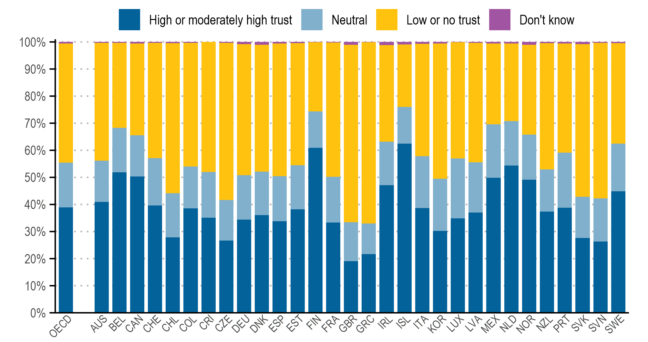
Note: The figure shows the within-country distributions of responses to the question “On a scale of 0 to 10, where 0 is not at
all and 10 is completely, how much do you trust the news media?”. A 0-4 response corresponds to ‘low or no trust’, a 5 to
‘neutral’ and a 6-10 to ‘high or moderately high trust’.
Source: OECD Trust Survey 2023.

Figure 5.2. Average trust in news media did not change between 2021 and 2023
Share of population who indicate different levels of trust in the news media, 2021 and 2023
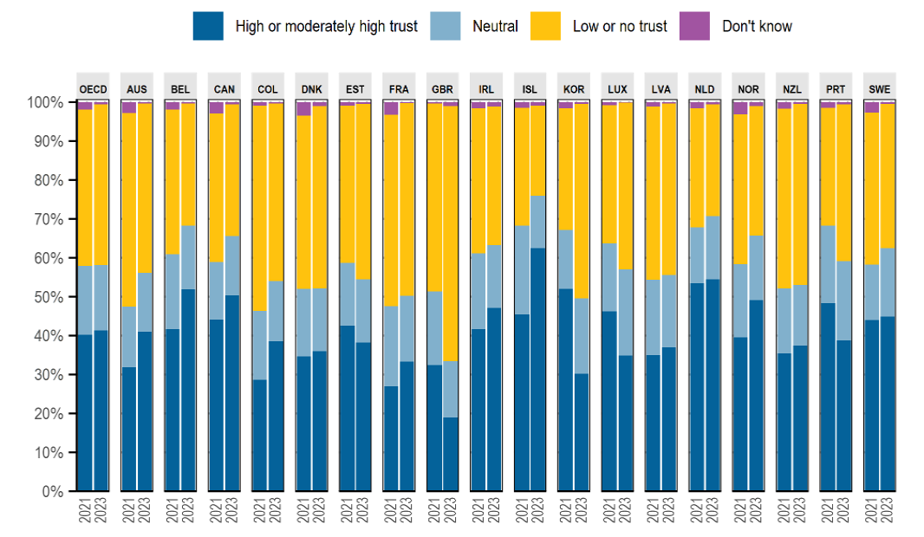
Note: The figure presents the within-country distributions of responses to the question “On a
scale of 0 to 10, where 0 is not at all and 10 is completely, how much do you trust the news media?”.
A 0-4 response corresponds to ‘low or no trust’, a 5 to ‘neutral’ and a 6-10 to ‘high or moderately high trust’.
“OECD” presents the unweighted average of responses across countries, for the listed countries with available
data for 2021 and 2023.
Source: OECD Trust Survey 2021 and 2023.
Figure 5.3. Readers of the written press are more likely to trust the government
Share with high or moderately high trust in the national government by whether they obtain information about politics or current affairs from the named source, OECD, 2023
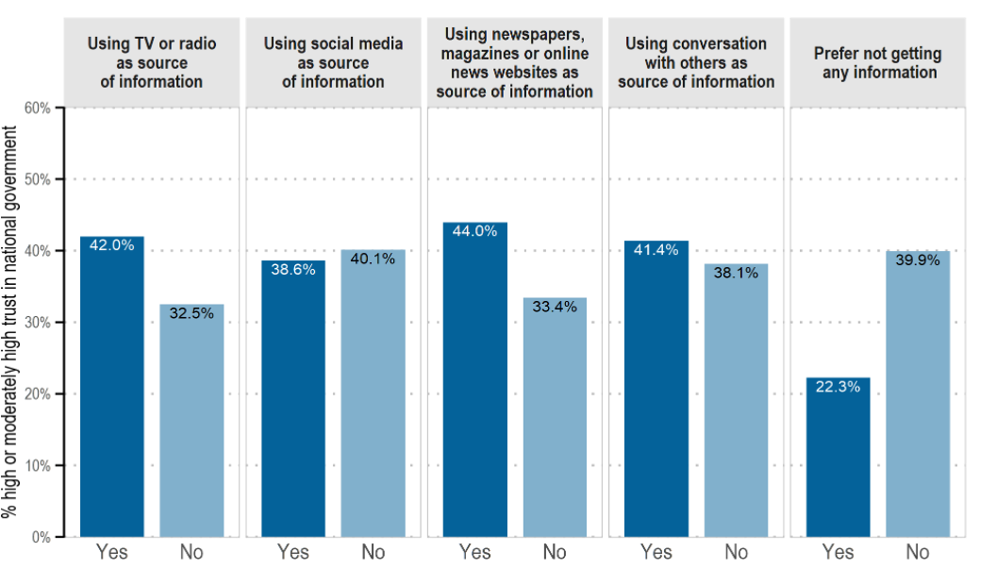
Note: The figure shows the share with high or moderately high trust in the national government, depending on whether they use the media or information source about politics and current affairs on a typical day. The share with high or moderately high trust corresponds to respondents who select an answer from 6 to 10 to the question “On a scale of 0 to 10, where 0 is not at all and 10 is completely, how much do you trust the national government?”. Whether or not the respondent uses the selected source of information is derived from their answer(s) to the question “On a typical day, from which of the following sources, if any, do you get information about politics and current affairs?”, for which they can select all options that apply. The figure shows the unweighted OECD averages.
Source: OECD Trust Survey 2023.

Figure 5.4. Younger people rely more on social than traditional media
Share of population who indicate that they get information about politics and current affairs from respective source, unweighted OECD average, 2023
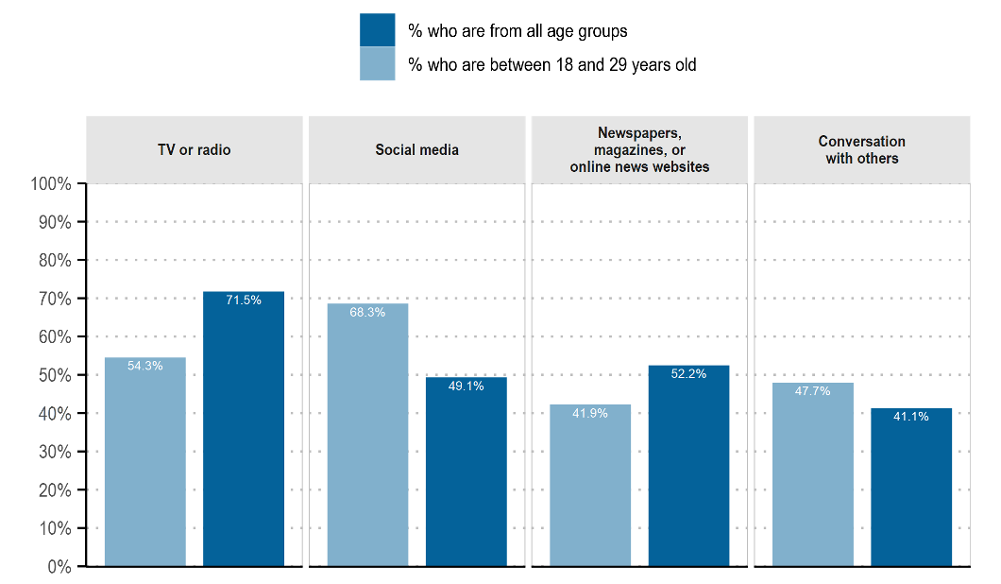
Note: The percentages show the unweighted OECD average. The shares are derived from the response to the question “On a typical day, from which of the following sources, if any, do you get information about politics and current affairs?”. Respondents were able to select all responses that applied.
Source: OECD Trust Survey 2023.

Figure 5.14. People who gather their information from multiple sources tend to be more trusting
Share of population reporting high or moderately high level of trust in selected questions, OECD, 2023
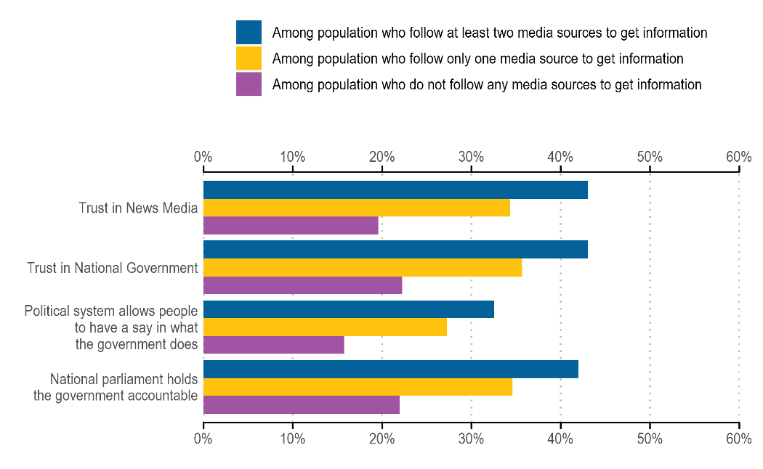
Note: For the first two trust questions on the y-axis, respondents were asked: “On a scale from 0 to 10, where 0 is not at all and 10 is completely, in general how much do you trust: [OPTION]?”. The remaining two questions reflect respondents' preferences as expressed in their answers to the questions: “How much would you say the political system in [COUNTRY] allows people like you to have a say in what the government does?” and “How likely do you think it is that the national parliament would effectively hold the national government accountable for their policies and behaviour, for instance by questioning a minister or reviewing the budget?”. The x-axis shows the unweighted OECD averages for the population share who reported 'high or moderately high trust' or 'likely,' which is an aggregation of responses ranging from 6 to 10 on the scale. The coloured bars are categorized according to the number of media sources participants reported following to get information, using the following question: “On a typical day, from which of the following sources, if any, do you get information about politics and current affairs? [OPTION]”. They could select 'TV or radio,' 'Social media,' 'Newspapers, magazines, or online media,' or 'Don’t know'."
Source: OECD Trust Survey 2023.

Sources:
OECD (2024), OECD Survey on Drivers of Trust in Public Institutions – 2024 Results: Building Trust in a Complex Policy
Environment, OECD Publishing, Paris, https://doi.org/10.1787/9a20554b-en.

To use:
Figure 5.1 – 2023 Snapshot. Initial conditions S₀, T₀, D₀
These percentages are your starting values for S(t), T(t), and D(t) at t=2023. For example: Finland (T=60.91%, D=25.49%, S=13.49%); Greece (T=21.62%, D=66.93%, S=11.38%).
Figure 5.2 – Parameter θ(t) (Distrust Probability) & System Dynamics
Confirms trust is a slow-moving stock (δ, μ are small). The redistribution shows θ(t) is volatile and event-driven, not constant. This is crucial for justifying a time-varying θ(t) in simulations (e.g., a pulse for an election).
Figure 5.3 – Parameter s (social media reliance)
Directly informs the value of s. For a "young cohort" simulation, s could be ~0.68 (OECD avg for 18-29). For an "older cohort," s could be ~0.49 (OECD avg for all ages).
Figure 5.14 – model validation & β (Exposure Rate)
Suggests β (exposure rate) may be higher for these individuals. A valid model should be able to reproduce this higher equilibrium trust level when β is increased, all else equal.

Potential data: media trust OECD …
https://www.oecd.org/content/dam/oecd/en/publications/reports/2024/07/oecd-survey-on-drivers-of-trust-in-public-institutions-2024-results_eeb36452/9a20554b-en.pdf

Figure 5.1. More people distrust rather than trust the news media

Formally this is P(T), P(S), P(D) at t=2023
It tells you where the system currently sits.

Share of population who indicate different levels of trust in news media, 2023

Note: The figure shows the within-country distributions of responses to the question “On a scale of 0 to 10, where 0 is not at
all and 10 is completely, how much do you trust the news media?”. A 0-4 response corresponds to ‘low or no trust’, a 5 to
‘neutral’ and a 6-10 to ‘high or moderately high trust’.
Source: OECD Trust Survey 2023.

Country | Don't Know | Low Or No Trust | Neutral | High Or Moderately High Trust
OECD | 0.52% | 44.06% | 16.52% | 38.89%
AUS | 0.35% | 43.49% | 15.17% | 40.99%
BEL | 0.39% | 31.34% | 16.39% | 51.87%
CAN | 0.54% | 33.90% | 15.19% | 50.38%
CHE | 0.30% | 42.65% | 17.44% | 39.61%
CHL | 0.47% | 55.43% | 16.19% | 27.91%
COL | 0.38% | 45.58% | 15.53% | 38.52%
CRI | 0.02% | 47.93% | 16.94% | 35.11%
CZE | 0.38% | 57.91% | 15.02% | 26.69%
DEU | 0.86% | 48.38% | 16.38% | 34.37%
DNK | 0.99% | 46.92% | 16.08% | 36.01%
ESP | 0.56% | 48.94% | 16.72% | 33.79%
EST | 0.45% | 45.06% | 16.25% | 38.24%
FIN | 0.11% | 25.49% | 13.49% | 60.91%
FRA | 0.20% | 49.58% | 16.95% | 33.27%
GBR | 0.99% | 65.60% | 14.41% | 19.01%
GRC | 0.07% | 66.93% | 11.38% | 21.62%
IRL | 1.11% | 35.67% | 16.09% | 47.14%
ISL | 0.96% | 23.05% | 13.56% | 62.43%
ITA | 0.68% | 41.56% | 19.11% | 38.66%
KOR | 0.51% | 49.95% | 19.34% | 30.20%
LUX | 0.09% | 42.90% | 22.17% | 34.84%
LVA | 0.33% | 44.10% | 18.59% | 36.98%
MEX | 0.52% | 29.92% | 19.73% | 49.84%
NLD | 0.54% | 28.72% | 16.33% | 54.41%
NOR | 1.05% | 33.19% | 16.65% | 49.10%
NZL | 0.50% | 46.53% | 15.58% | 37.38%
PRT | 0.57% | 40.28% | 20.32% | 38.83%
SVK | 0.85% | 56.33% | 15.23% | 27.60%
SVN | 0.30% | 57.48% | 15.94% | 26.28%
SWE | 0.46% | 37.08% | 17.61% | 44.85%

Figure 5.2. Average trust in news media did not change between 2021 and 2023
Share of population who indicate different levels of trust in the news media, 2021 and 2023

θ(t) - Conditional trust outcomes given exposure source.
θ(t)=Pr(distrust∣exposure)
Given the same act of exposure, individuals systematically differ in whether they interpret
the information as credible or not.

Trust collapses during crises even when information volume and sources remain stable
In model terms, Figure 5.2 tells you:
- Trust stocks evolve slowly
- Parameters like $α$ (trust decay) and $δ$ (trust recovery) must be small
- Short-run shocks do not dramatically reallocate mass across compartments
That is extremely important information.

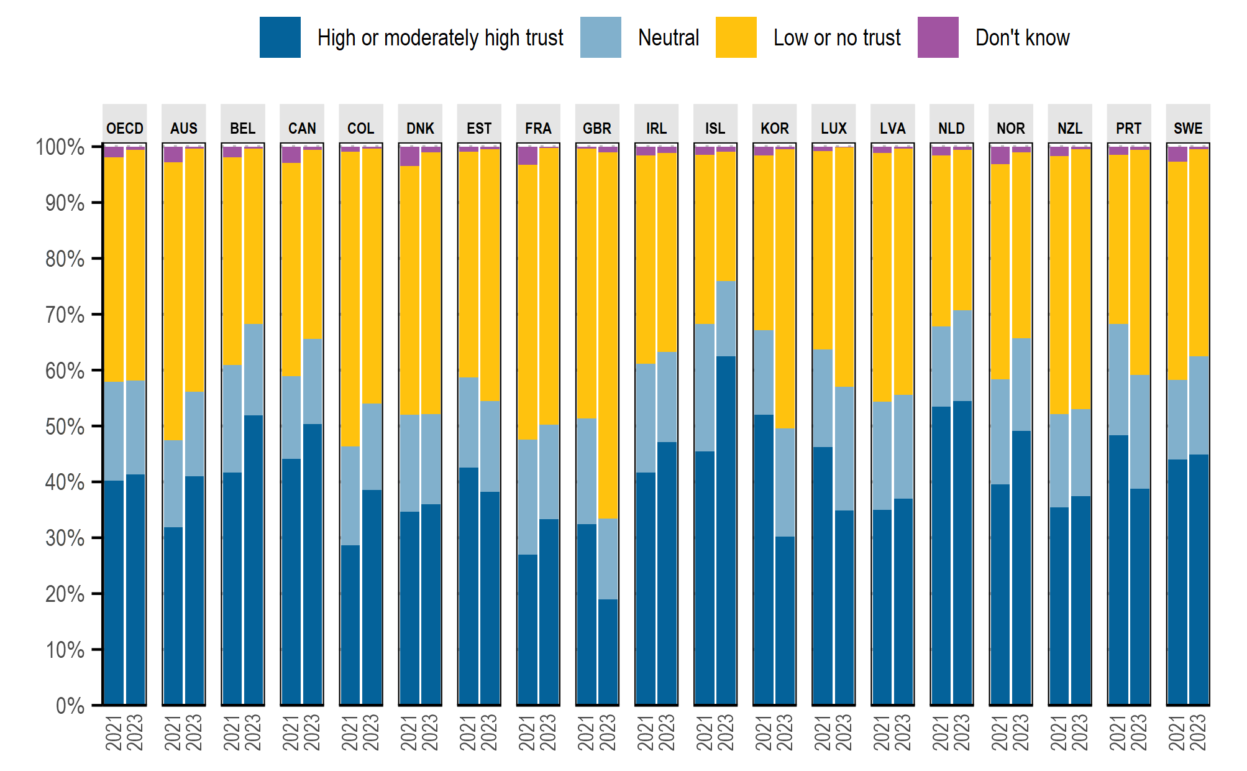
Note: The figure presents the within-country distributions of responses to the question “On a
scale of 0 to 10, where 0 is not at all and 10 is completely, how much do you trust the news media?”.
A 0-4 response corresponds to ‘low or no trust’, a 5 to ‘neutral’ and a 6-10 to ‘high or moderately high trust’.
“OECD” presents the unweighted average of responses across countries, for the listed countries with available
data for 2021 and 2023.
Source: OECD Trust Survey 2021 and 2023.
Country | Year | Don't Know | Low Or No Trust | Neutral |  | High Or Moderately High Trust
OECD | 2021 | 1.87% | 40.21% | 17.70% |  | 40.23%
OECD | 2023 | 0.58% | 41.28% | 16.79% |  | 41.36%
AUS | 2021 | 2.76% | 49.81% | 15.55% |  | 31.88%
AUS | 2023 | 0.35% | 43.49% | 15.17% |  | 40.99%
BEL | 2021 | 1.85% | 37.26% | 19.23% |  | 41.66%
BEL | 2023 | 0.39% | 31.34% | 16.39% |  | 51.87%
CAN | 2021 | 2.94% | 38.12% | 14.85% |  | 44.09%
CAN | 2023 | 0.54% | 33.90% | 15.19% |  | 50.38%
COL | 2021 | 0.90% | 52.78% | 17.65% |  | 28.67%
COL | 2023 | 0.38% | 45.58% | 15.53% |  | 38.52%
DNK | 2021 | 3.51% | 44.49% | 17.37% |  | 34.63%
DNK | 2023 | 0.99% | 46.92% | 16.08% |  | 36.01%
EST | 2021 | 0.93% | 40.37% | 16.13% |  | 42.57%
EST | 2023 | 0.45% | 45.06% | 16.25% |  | 38.24%
FRA | 2021 | 3.21% | 49.18% | 20.63% |  | 26.98%
FRA | 2023 | 0.20% | 49.58% | 16.95% |  | 33.27%
GBR | 2021 | 0.37% | 48.26% | 18.88% |  | 32.48%
GBR | 2023 | 0.99% | 65.60% | 14.41% |  | 19.01%
IRL | 2021 | 1.58% | 37.30% | 19.43% |  | 41.69%
IRL | 2023 | 1.11% | 35.67% | 16.09% |  | 47.14%
ISL | 2021 | 1.51% | 30.28% | 22.77% |  | 45.45%
ISL | 2023 | 0.96% | 23.05% | 13.56% |  | 62.43%
KOR | 2021 | 1.59% | 31.25% | 15.13% |  | 52.03%
KOR | 2023 | 0.51% | 49.95% | 19.34% |  | 30.20%
LUX | 2021 | 0.81% | 35.43% | 17.53% |  | 46.22%
LUX | 2023 | 0.09% | 42.90% | 22.17% |  | 34.84%
LVA | 2021 | 1.17% | 44.48% | 19.41% |  | 34.94%
LVA | 2023 | 0.33% | 44.10% | 18.59% |  | 36.98%
NLD | 2021 | 1.55% | 30.66% | 14.33% |  | 53.46%
NLD | 2023 | 0.54% | 28.72% | 16.33% |  | 54.41%
NOR | 2021 | 3.09% | 38.49% | 18.83% |  | 39.59%
NOR | 2023 | 1.05% | 33.19% | 16.65% |  | 49.10%
NZL | 2021 | 1.63% | 46.20% | 16.76% |  | 35.41%
NZL | 2023 | 0.50% | 46.53% | 15.58% |  | 37.38%
PRT | 2021 | 1.50% | 30.29% | 19.89% |  | 48.33%
PRT | 2023 | 0.57% | 40.28% | 20.32% |  | 38.83%
SWE | 2021 | 2.69% | 39.07% | 14.19% |  | 44.05%
SWE | 2023 | 0.46% | 37.08% | 17.61% |  | 44.85%

Figure 5.3. Readers of the written press are more likely to trust the government
Figure 5.3 shows:
- People who rely on newspapers / traditional media
- Exhibit higher baseline trust in government
- Conditional on information environment
That implies:
Some individuals become trusting without passing through an exposure–interpretation step.
- High-quality information environments → higher $α$
- Fragmented / disengaged environments → lower $α$
The parameter $α$ captures institutional trust formation that occurs independently of media exposure, reflecting background confidence in public institutions and legacy information environments. OECD evidence shows that individuals who rely on traditional and written media exhibit higher trust in government, suggesting a higher effective $α$in such environments. Accordingly, $α$ is treated as environment-dependent but exogenous and constant within each simulation

Share with high or moderately high trust in the national government by whether they obtain information about p
olitics or current affairs from the named source, OECD, 2023
 |  | 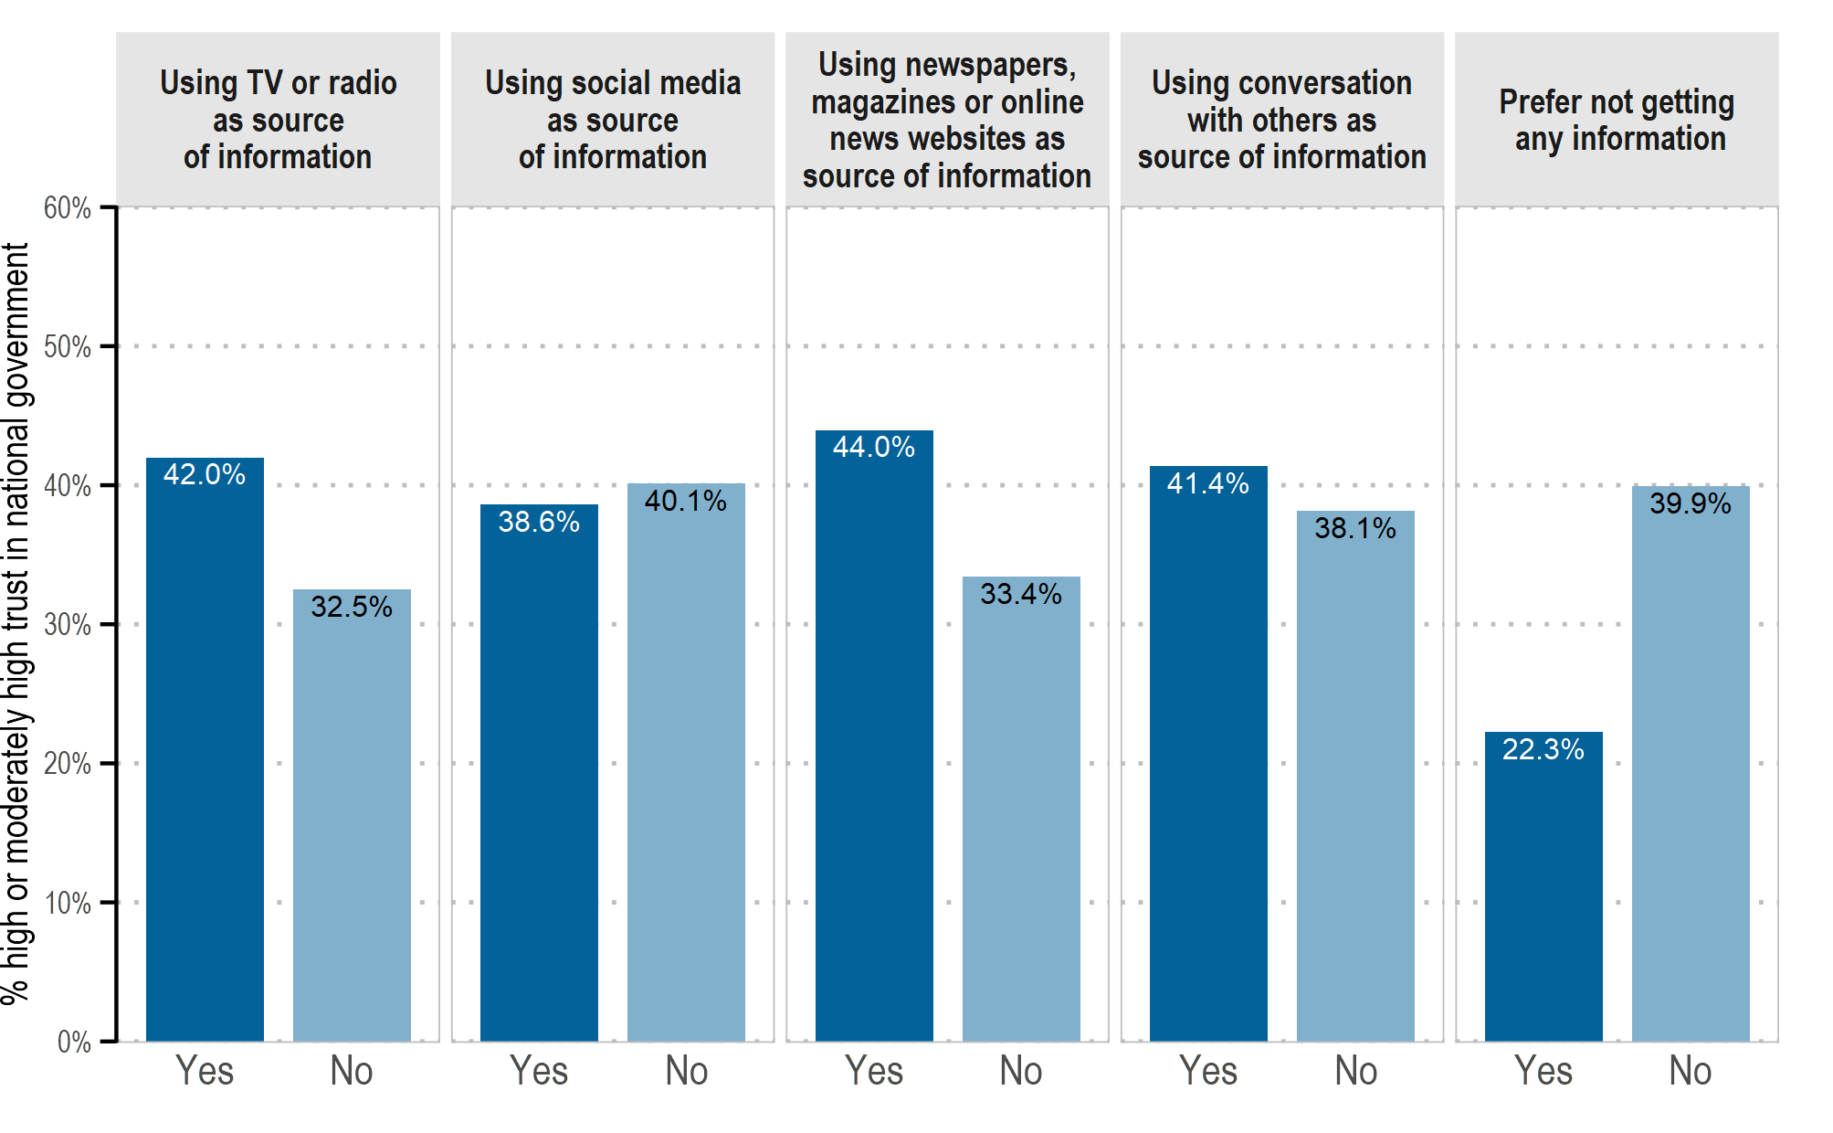
Note: The figure shows the share with high or moderately high trust in the national government, depending on whether they use the media or information source about politics and current affairs on a typical day. The share with high or moderately high trust corresponds to respondents who select an answer from 6 to 10 to the question “On a scale of 0 to 10, where 0 is not at all and 10 is completely, how much do you trust the national government?”. Whether or not the respondent uses the selected source of information is derived from their answer(s) to the question “On a typical day, from which of the following sources, if any, do you get information about politics and current affairs?”, for which they can select all options that apply. The figure shows the unweighted OECD averages.
Source: OECD Trust Survey 2023.
 | Using Tv Or Radio As Source Of Information |  | Using Social Media As Source Of Information |  | Using Newspapers, Magazines Or Online News Websites As Source Of Information |  | Using Conversation With Others As Source Of Information |  | Prefer Not Getting Any Information
Country | Yes | No | Yes | No | Yes | No | Yes | No | Yes | No
OECD | 42.00% | 32.49% | 38.59% | 40.15% | 43.97% | 33.44% | 41.40% | 38.15% | 22.25% | 39.94%
AUS | 47.33% | 44.05% | 48.84% | 44.11% | 55.72% | 40.61% | 51.05% | 43.32% | 25.32% | 47.68%
BEL | 51.04% | 38.36% | 48.71% | 46.36% | 55.37% | 37.97% | 48.26% | 46.71% | 24.18% | 48.54%
CAN | 52.27% | 42.00% | 50.46% | 47.04% | 53.68% | 44.70% | 48.88% | 48.26% | 22.33% | 50.28%
CHE | 67.30% | 52.02% | 59.44% | 63.47% | 67.19% | 53.42% | 66.10% | 58.71% | 36.11% | 63.51%
CHL | 30.81% | 29.53% | 32.86% | 25.64% | 38.50% | 25.42% | 35.49% | 26.55% | 15.66% | 30.73%
COL | 30.88% | 35.37% | 33.37% | 29.24% | 32.77% | 31.61% | 33.20% | 31.47% | 33.45% | 32.07%
CRI | 34.88% | 34.62% | 35.74% | 32.70% | 36.71% | 33.93% | 37.70% | 33.54% | 33.54% | 34.83%
CZE | 21.31% | 12.43% | 16.68% | 20.05% | 21.89% | 14.78% | 17.46% | 19.34% | 3.74% | 18.98%
DEU | 37.95% | 29.34% | 32.18% | 37.88% | 41.70% | 29.33% | 37.18% | 34.91% | 18.87% | 36.72%
DNK | 48.88% | 30.17% | 45.32% | 43.13% | 48.08% | 40.18% | 44.21% | 43.94% | 13.33% | 45.09%
ESP | 38.39% | 32.67% | 39.40% | 34.88% | 42.73% | 32.19% | 43.42% | 33.45% | 15.87% | 37.62%
EST | 40.04% | 29.52% | 34.24% | 41.35% | 43.19% | 25.97% | 37.62% | 37.94% | 28.32% | 38.02%
FIN | 49.65% | 36.85% | 42.12% | 51.47% | 49.59% | 36.99% | 46.15% | 48.09% | 31.46% | 47.06%
FRA | 37.74% | 26.08% | 32.40% | 35.11% | 42.33% | 28.00% | 37.20% | 32.86% | 18.28% | 35.76%
GBR | 27.34% | 24.32% | 23.87% | 29.36% | 30.45% | 21.50% | 25.84% | 27.67% | 19.87% | 26.80%
GRC | 37.79% | 22.55% | 27.98% | 39.70% | 38.31% | 26.82% | 28.43% | 34.40% | 8.20% | 32.10%
IRL | 50.18% | 32.30% | 43.52% | 54.12% | 49.55% | 36.21% | 45.58% | 48.92% | 25.59% | 46.67%
ISL | 40.15% | 26.63% | 32.70% | 42.61% | 37.92% | 33.21% | 39.27% | 33.39% | 68.37% | 36.91%
ITA | 39.57% | 26.03% | 35.15% | 36.53% | 39.78% | 32.96% | 38.00% | 34.97% | 17.98% | 36.87%
KOR | 38.26% | 34.03% | 40.52% | 34.04% | 44.27% | 31.18% | 45.13% | 34.40% | 33.39% | 37.28%
LUX | 59.10% | 45.69% | 53.73% | 57.11% | 61.78% | 39.68% | 60.33% | 50.37% | 34.95% | 55.96%
LVA | 34.33% | 18.73% | 26.10% | 32.14% | 34.85% | 23.39% | 27.97% | 29.16% | 12.88% | 29.18%
MEX | 54.32% | 52.36% | 53.59% | 53.68% | 47.60% | 54.94% | 58.99% | 51.26% | 20.57% | 53.85%
NLD | 46.18% | 37.93% | 44.44% | 43.65% | 50.04% | 36.52% | 46.98% | 42.35% | 22.24% | 44.61%
NOR | 49.69% | 41.50% | 45.97% | 48.74% | 49.21% | 39.52% | 51.62% | 46.08% | 17.72% | 47.80%
NZL | 50.57% | 35.94% | 45.19% | 46.48% | 55.30% | 35.15% | 48.67% | 43.60% | 23.46% | 46.79%
PRT | 33.73% | 23.77% | 29.42% | 33.48% | 36.46% | 27.28% | 32.60% | 30.92% | 9.52% | 32.16%
SVK | 32.59% | 28.97% | 34.55% | 28.30% | 34.27% | 29.50% | 35.03% | 29.19% | 11.07% | 32.14%
SVN | 31.71% | 18.40% | 26.49% | 29.03% | 32.66% | 23.48% | 29.73% | 26.44% | 7.28% | 28.64%
SWE | 46.10% | 32.65% | 42.79% | 43.06% | 47.33% | 36.72% | 43.91% | 42.18% | 13.99% | 43.44%

Figure 5.4. Younger people rely more on social than traditional media

Affects parameter s:
From the OECD average:
- Younger cohorts rely more on social media
- Older cohorts rely more on TV/radio and newspapers
- Exposure patterns differ strongly by age
- These differences are stable and structural
This tells you:
The information environment is heterogeneous across cohorts, even if aggregate trust is stable.

OECD Trust Survey data show that reliance on social media as a news source is substantially higher among younger cohorts, while traditional media dominate among older populations. In the model, this heterogeneity is summarized by the parameter $s$, representing the share of exposure mediated by social media at the population level. While the data do not measure trust or belief formation directly, they imply that changes in interpretive parameters such as $θ$ may have amplified effects in high-$s$ environments

Share of population who indicate that they get information about politics and current affairs from respective source, unweighted OECD average, 2023
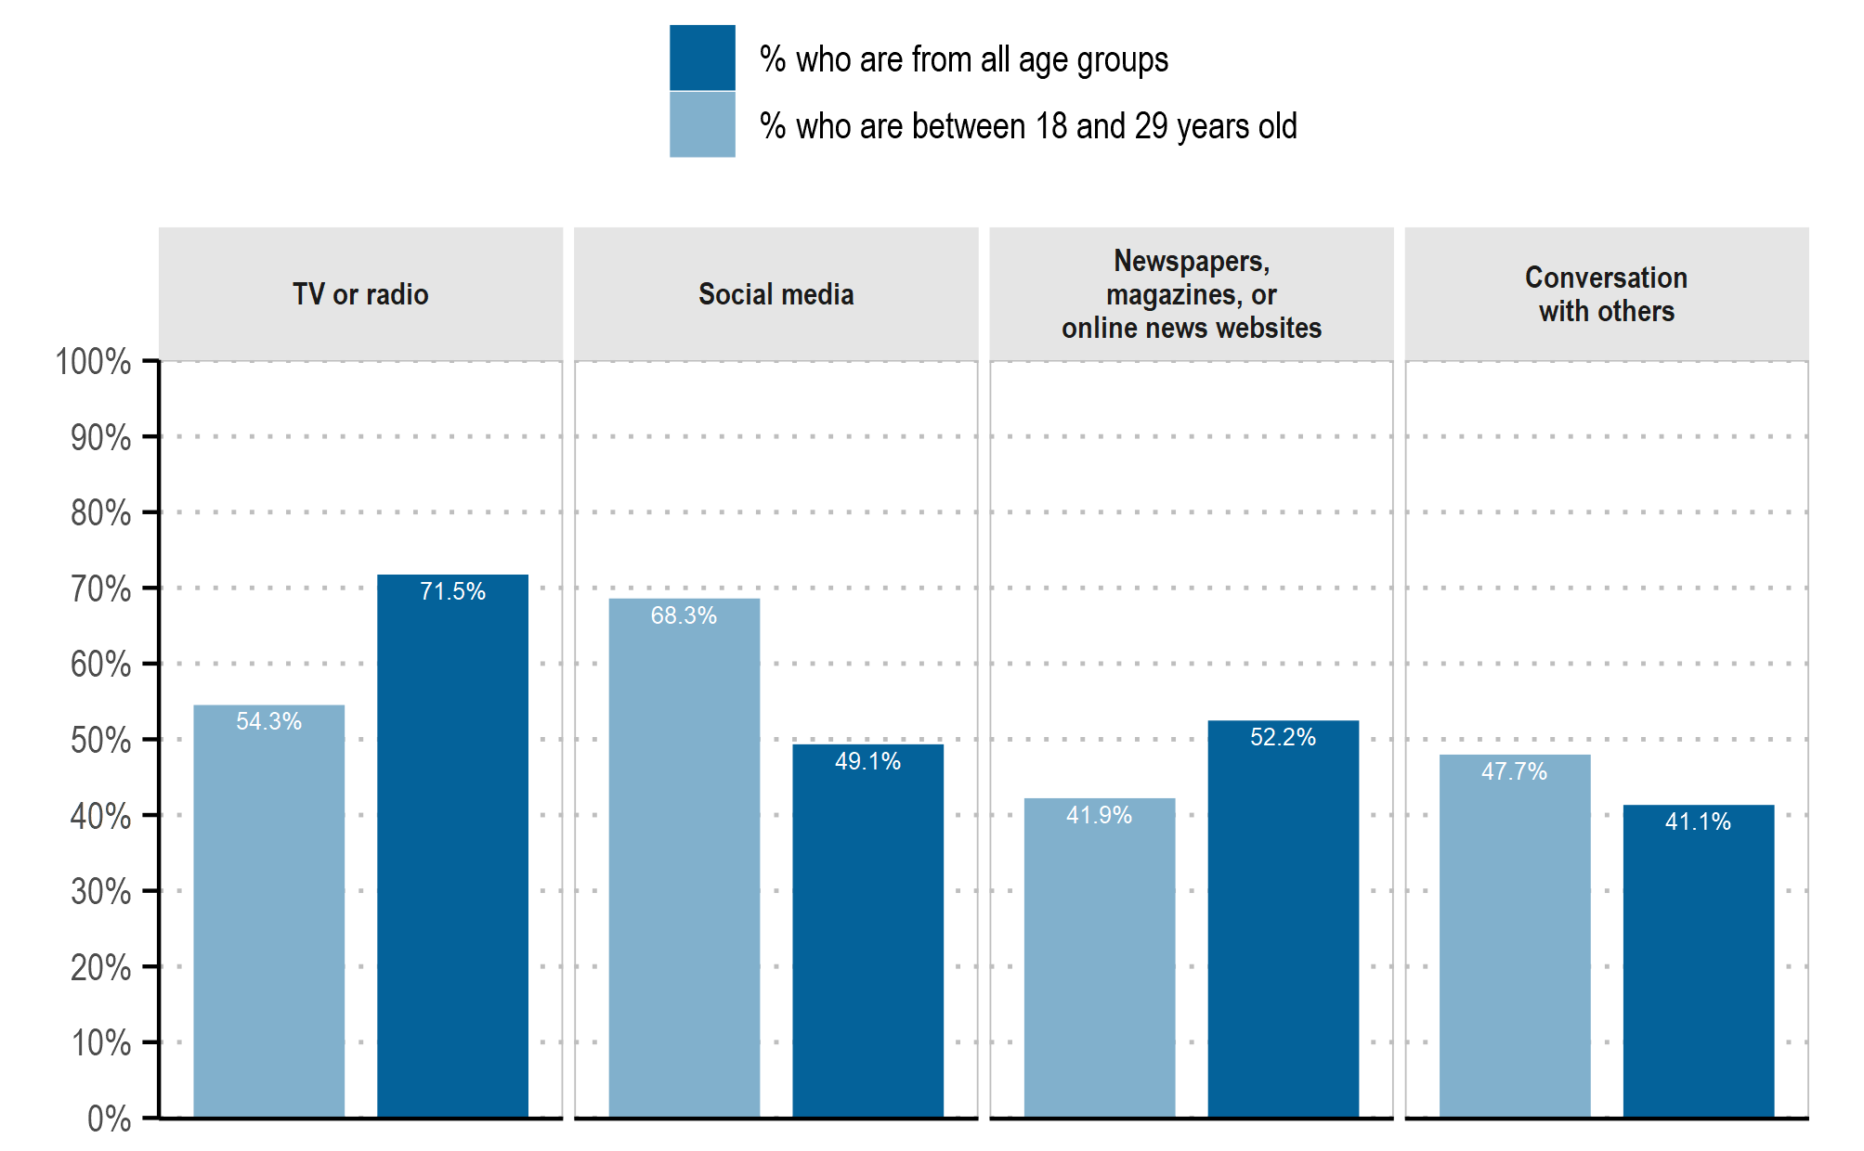

Note: The percentages show the unweighted OECD average. The shares are derived from the response to the question “On a typical day, from which of the following sources, if any, do you get information about politics and current affairs?”. Respondents were able to select all responses that applied.
Source: OECD Trust Survey 2023.
 | Tv Or Radio |  | Social Media |  | Newspapers, Magazines, Or Online News Websites |  | Conversation With Others
Country | 18-29 Years Olds | All Age Groups | 18-29 Years Olds | All Age Groups | 18-29 Years Olds | All Age Groups | 18-29 Years Olds | All Age Groups
OECD | 54.25% | 71.48% | 68.33% | 49.06% | 41.94% | 52.20% | 47.71% | 41.06%
AUS | 42.44% | 65.76% | 65.18% | 44.26% | 23.93% | 37.01% | 42.55% | 37.28%
BEL | 51.89% | 69.53% | 61.40% | 34.73% | 43.74% | 52.91% | 39.91% | 29.78%
CAN | 45.25% | 63.37% | 72.04% | 42.90% | 35.23% | 42.41% | 54.62% | 39.52%
CHE | 42.18% | 64.87% | 61.27% | 38.17% | 40.84% | 61.83% | 47.20% | 43.63%
CHL | 56.65% | 65.82% | 73.18% | 65.58% | 23.55% | 37.86% | 36.18% | 42.75%
COL | 63.00% | 72.98% | 72.95% | 69.13% | 33.07% | 41.75% | 30.56% | 35.88%
CRI | 62.74% | 69.36% | 66.40% | 69.09% | 27.46% | 31.33% | 30.70% | 30.31%
CZE | 51.33% | 68.90% | 69.68% | 44.49% | 39.09% | 53.01% | 40.63% | 42.10%
DEU | 58.26% | 77.50% | 63.90% | 32.70% | 38.41% | 54.03% | 45.77% | 48.49%
DNK | 53.51% | 74.15% | 67.87% | 41.53% | 31.25% | 48.82% | 40.99% | 37.47%
ESP | 56.51% | 71.68% | 65.31% | 41.82% | 33.45% | 43.47% | 34.90% | 33.31%
EST | 60.37% | 78.72% | 66.84% | 49.85% | 61.32% | 68.75% | 58.41% | 41.10%
FIN | 55.50% | 79.21% | 78.61% | 47.93% | 68.32% | 79.35% | 74.66% | 56.78%
FRA | 52.92% | 70.63% | 58.66% | 29.31% | 40.24% | 44.06% | 40.03% | 33.43%
GBR | 58.44% | 77.27% | 73.54% | 49.21% | 44.75% | 57.60% | 70.62% | 55.36%
GRC | 41.55% | 59.77% | 76.05% | 68.58% | 31.37% | 42.12% | 55.75% | 45.84%
IRL | 62.63% | 79.83% | 84.61% | 71.22% | 79.45% | 77.68% | 82.04% | 70.44%
ISL | 53.71% | 76.66% | 79.14% | 56.62% | 67.36% | 80.46% | 80.61% | 61.35%
ITA | 53.61% | 73.23% | 67.04% | 42.39% | 36.52% | 43.72% | 36.99% | 32.08%
KOR | 61.03% | 73.60% | 58.81% | 47.93% | 45.25% | 45.57% | 32.09% | 25.57%
LUX | 57.33% | 73.63% | 66.76% | 45.90% | 53.86% | 71.86% | 61.18% | 52.18%
LVA | 45.85% | 64.04% | 68.48% | 56.55% | 41.84% | 46.53% | 49.40% | 36.82%
MEX | 50.38% | 63.87% | 86.76% | 73.63% | 14.09% | 18.05% | 37.66% | 30.43%
NLD | 58.96% | 72.62% | 61.64% | 34.50% | 38.58% | 54.73% | 43.43% | 33.88%
NOR | 49.45% | 74.94% | 57.13% | 39.87% | 78.59% | 83.65% | 42.41% | 28.07%
NZL | 49.25% | 67.78% | 69.29% | 48.06% | 30.07% | 53.14% | 46.43% | 44.57%
PRT | 61.17% | 77.93% | 67.27% | 47.99% | 39.99% | 46.30% | 35.48% | 36.45%
SVK | 59.00% | 69.19% | 65.69% | 50.87% | 35.12% | 41.46% | 38.43% | 39.13%
SVN | 55.74% | 71.16% | 58.69% | 45.84% | 38.36% | 47.83% | 52.85% | 43.40%
SWE | 56.90% | 76.56% | 65.62% | 41.29% | 43.20% | 58.71% | 48.82% | 44.26%

Figure 5.14. People who gather their information from multiple sources tend to be more trusting
Suggests β (exposure rate) may be higher for these individuals. A valid model should be able to reproduce this higher equilibrium trust level when β is increased, all else equal.
Share of population reporting high or moderately high level of trust in selected questions, OECD, 2023
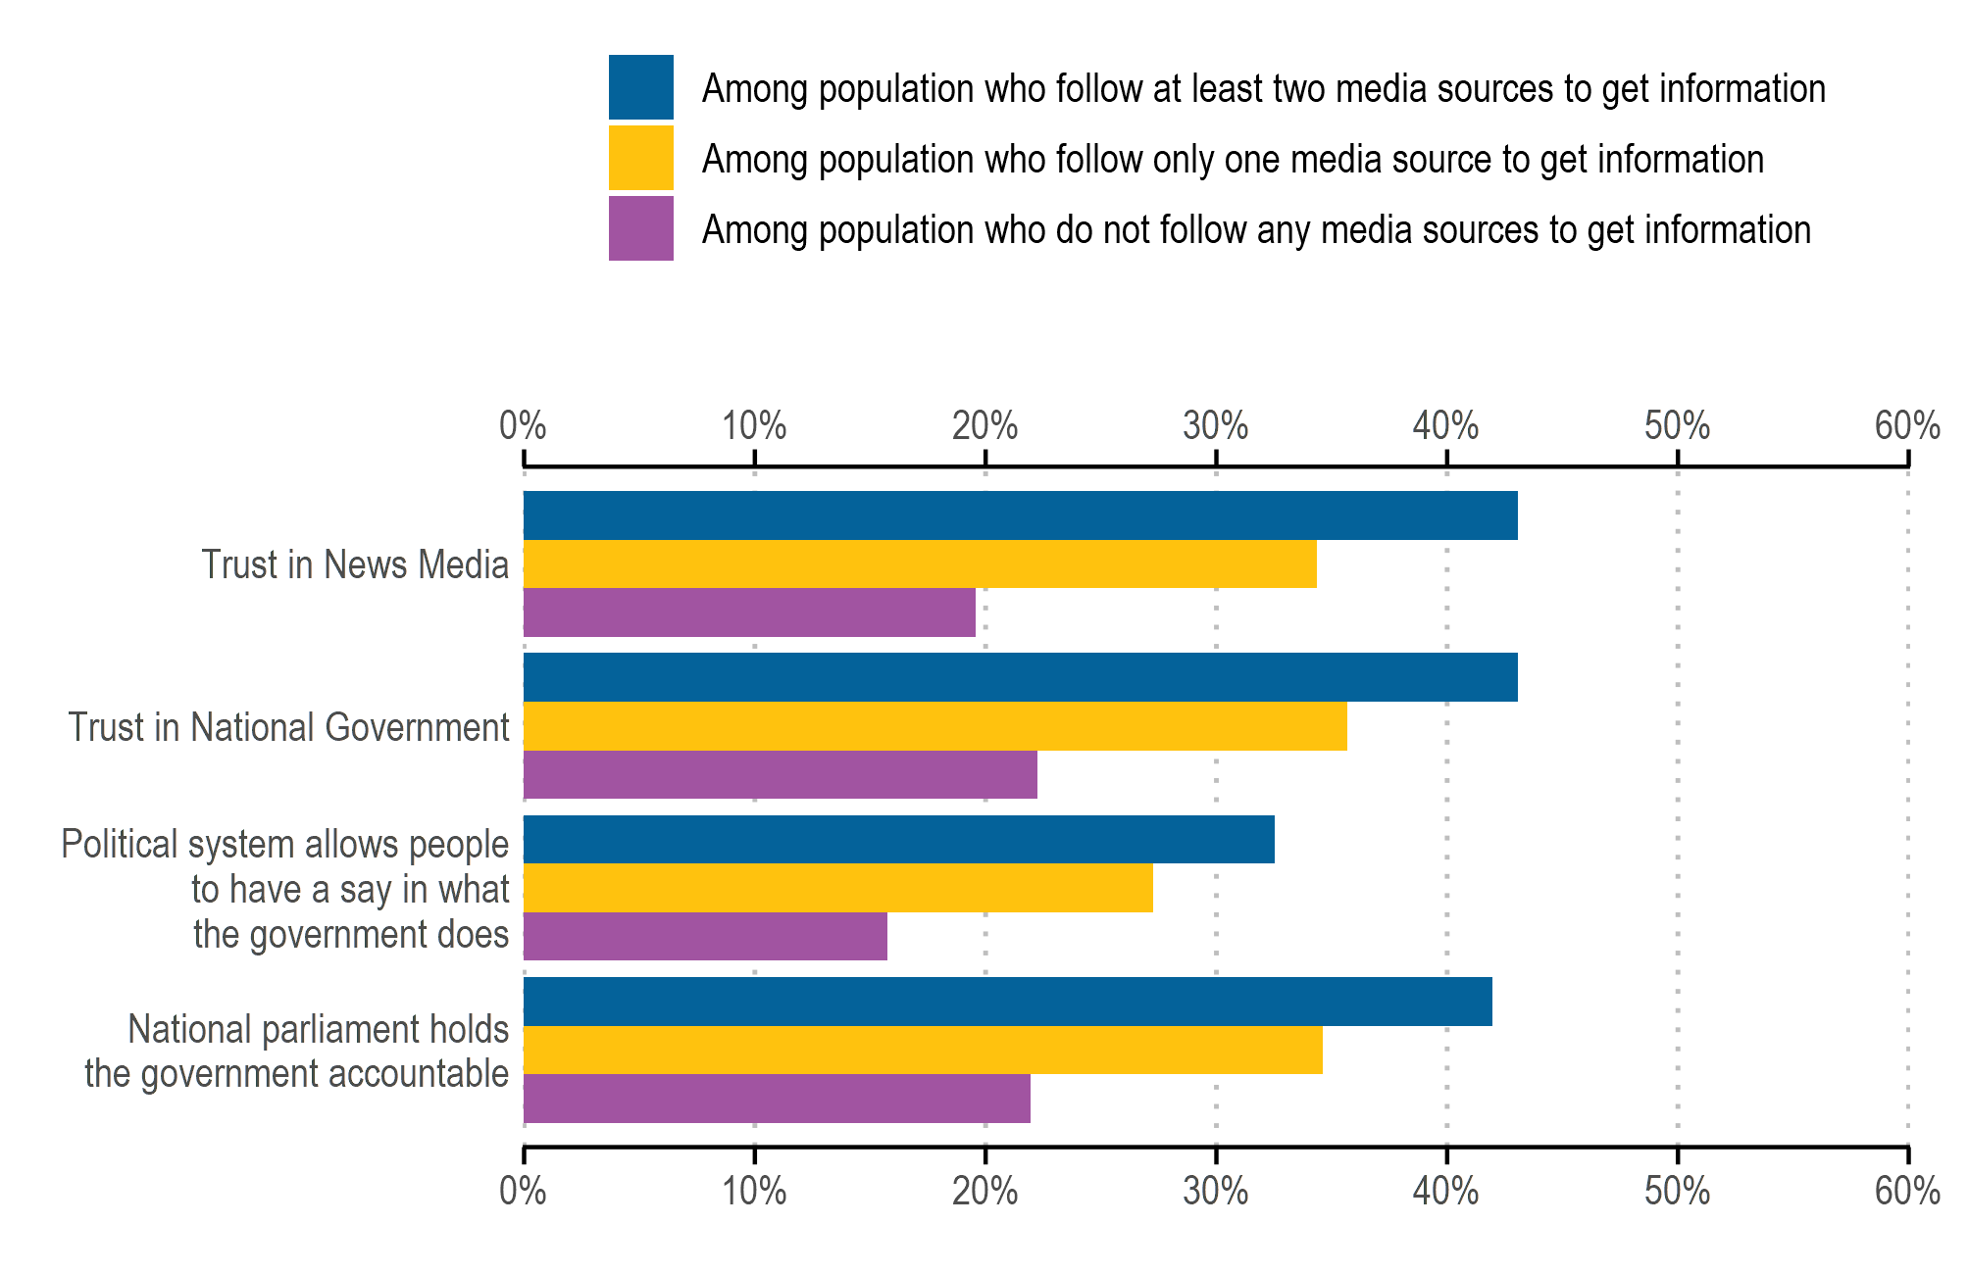

Note: For the first two trust questions on the y-axis, respondents were asked: “On a scale from 0 to 10, where 0 is not at all and 10 is completely, in general how much do you trust: [OPTION]?”. The remaining two questions reflect respondents' preferences as expressed in their answers to the questions: “How much would you say the political system in [COUNTRY] allows people like you to have a say in what the government does?” and “How likely do you think it is that the national parliament would effectively hold the national government accountable for their policies and behaviour, for instance by questioning a minister or reviewing the budget?”. The x-axis shows the unweighted OECD averages for the population share who reported 'high or moderately high trust' or 'likely,' which is an aggregation of responses ranging from 6 to 10 on the scale. The coloured bars are categorized according to the number of media sources participants reported following to get information, using the following question: “On a typical day, from which of the following sources, if any, do you get information about politics and current affairs? [OPTION]”. They could select 'TV or radio,' 'Social media,' 'Newspapers, magazines, or online media,' or 'Don’t know'."
Source: OECD Trust Survey 2023.

 | National Parliament Holds The Government Accountable |  |  | Political System Allows People To Have A Say In What The Government Does |  |  | Trust In National Government |  |  | Trust In News Media
Country | Among Respondents Who Do Not Follow Any Media Sources To Get Information | Among Respondents Who Follow At Least Two Media Sources To Get Information | Among Respondents Who Follow Only One Media Source To Get Information | Among Respondents Who Do Not Follow Any Media Sources To Get Information | Among Respondents Who Follow At Least Two Media Sources To Get Information | Among Respondents Who Follow Only One Media Source To Get Information | Among Respondents Who Do Not Follow Any Media Sources To Get Information | Among Respondents Who Follow At Least Two Media Sources To Get Information | Among Respondents Who Follow Only One Media Source To Get Information | Among Respondents Who Do Not Follow Any Media Sources To Get Information | Among Respondents Who Follow At Least Two Media Sources To Get Information |  | Among Respondents Who Follow Only One Media Source To Get Information
OECD | 21.95% | 41.96% | 34.63% | 15.76% | 32.52% | 27.27% | 22.25% | 43.05% | 35.67% | 19.55% | 43.07% | 34.35%
AUS | 29.46% | 51.60% | 42.76% | 26.75% | 51.73% | 43.53% | 25.32% | 53.30% | 42.44% | 23.07% | 46.78% | 37.98%
BEL | 23.89% | 47.92% | 39.41% | 10.92% | 33.10% | 27.63% | 24.18% | 54.68% | 42.61% | 22.35% | 59.14% | 47.90%
CAN | 22.93% | 52.93% | 46.29% | 11.65% | 46.16% | 40.05% | 22.33% | 52.87% | 50.13% | 23.63% | 57.14% | 49.66%
CHE | 30.78% | 55.36% | 50.60% | 28.73% | 62.80% | 56.84% | 36.11% | 66.95% | 60.30% | 16.07% | 43.87% | 37.32%
CHL | 26.09% | 50.61% | 37.82% | 10.99% | 25.65% | 18.40% | 15.66% | 34.74% | 25.10% | 6.30% | 33.30% | 22.06%
COL | 26.91% | 42.15% | 36.97% | 17.33% | 26.09% | 23.38% | 33.45% | 33.10% | 30.60% | 24.76% | 43.49% | 30.51%
CRI | 36.81% | 42.54% | 35.76% | 8.74% | 22.68% | 22.28% | 33.54% | 35.44% | 34.88% | 31.34% | 38.98% | 28.75%
CZE | 17.31% | 26.94% | 21.62% | 9.60% | 32.98% | 25.91% | 3.74% | 21.54% | 16.17% | 10.91% | 31.16% | 23.00%
DEU | 17.31% | 35.89% | 32.06% | 11.66% | 31.88% | 27.22% | 18.87% | 39.99% | 32.63% | 14.10% | 37.87% | 31.49%
DNK | 13.54% | 65.32% | 50.77% | 12.09% | 50.77% | 40.48% | 13.33% | 49.08% | 41.77% | 10.42% | 41.76% | 30.77%
ESP | 15.05% | 35.55% | 33.39% | 14.56% | 33.68% | 29.60% | 15.87% | 41.45% | 33.94% | 19.72% | 36.49% | 31.97%
EST | 22.66% | 25.28% | 20.27% | 19.28% | 18.84% | 12.04% | 28.32% | 41.47% | 28.34% | 2.65% | 42.07% | 30.41%
FIN |  | 39.18% | 27.44% | 31.46% | 22.20% | 16.99% | 31.46% | 48.63% | 45.19% | 31.46% | 64.54% | 49.38%
FRA | 27.82% | 47.67% | 40.75% | 14.51% | 30.95% | 23.96% | 18.28% | 41.02% | 31.08% | 17.07% | 40.52% | 29.21%
GBR | 9.06% | 38.22% | 31.63% | 8.08% | 20.99% | 18.10% | 19.87% | 27.60% | 25.38% | 13.37% | 21.45% | 13.82%
GRC | 21.11% | 25.19% | 23.95% | 12.63% | 21.46% | 21.19% | 8.20% | 35.68% | 27.43% | 18.74% | 22.27% | 21.17%
IRL | 9.76% | 45.29% | 34.04% |  | 38.28% | 25.15% | 25.59% | 48.50% | 35.84% | 20.74% | 48.83% | 38.05%
ISL | 68.37% | 21.38% | 16.97% | 68.37% | 23.66% | 19.40% | 68.37% | 38.08% | 31.34% | 68.37% | 64.92% | 53.19%
ITA | 19.49% | 38.98% | 37.67% | 13.91% | 22.12% | 23.10% | 17.98% | 39.93% | 33.54% | 19.21% | 44.22% | 33.85%
KOR | 28.85% | 45.21% | 37.80% | 13.47% | 43.14% | 35.92% | 33.39% | 42.01% | 31.79% | 21.44% | 32.61% | 28.85%
LUX | 23.80% | 47.53% | 34.01% | 14.94% | 31.64% | 24.19% | 34.95% | 61.05% | 43.78% | 5.23% | 38.77% | 27.73%
LVA | 9.92% | 27.98% | 20.68% | 4.94% | 14.28% | 9.68% | 12.88% | 33.84% | 23.02% | 15.30% | 42.34% | 31.61%
MEX | 12.56% | 42.64% | 36.01% | 10.37% | 46.53% | 44.75% | 20.57% | 52.95% | 54.39% | 17.42% | 52.19% | 48.21%
NLD | 26.27% | 54.66% | 43.77% | 18.38% | 41.86% | 37.01% | 22.24% | 49.63% | 38.57% | 34.99% | 61.91% | 47.46%
NOR | 9.30% | 43.16% | 29.16% | 9.53% | 36.80% | 29.84% | 17.72% | 49.48% | 43.19% |  | 51.45% | 46.32%
NZL | 23.19% | 54.93% | 43.34% | 18.70% | 49.98% | 37.59% | 23.46% | 52.37% | 39.81% | 15.89% | 40.62% | 36.36%
PRT | 21.46% | 38.49% | 33.73% | 13.98% | 25.39% | 22.03% | 9.52% | 34.01% | 30.17% | 21.75% | 42.85% | 33.24%
SVK | 17.59% | 38.38% | 36.04% | 7.89% | 21.49% | 19.51% | 11.07% | 34.07% | 30.16% | 20.62% | 32.55% | 23.58%
SVN | 13.60% | 28.16% | 24.96% | 2.34% | 15.08% | 16.29% | 7.28% | 31.26% | 26.29% | 6.15% | 29.19% | 25.30%
SWE | 11.76% | 49.72% | 39.23% | 11.34% | 33.39% | 26.14% | 13.99% | 46.90% | 40.08% | 13.77% | 48.83% | 41.36%

Figure 5.2. Average trust in news media did not change between 2021 and 2023

OECD Trust Survey data show that average trust in the news media at the aggregate OECD level remained stable between 2021 and 2023, even as individual countries experienced substantial redistribution between trust and distrust categories. This pattern is consistent with a probabilistic belief-formation process in which exposure remains broadly stable while the interpretation of exposure varies across contexts. In the present model, such dynamics are captured by the parameter $θ(t)$, defined as the probability that exposure resolves into distrust rather than trust. The data do not identify $θ$ directly, but support treating it as time- and country-dependent rather than structural, without requiring explicit modeling of platform use or misinformation mechanisms.”
Observed redistribution of trust outcomes without aggregate trend motivates modeling θ as non-autonomous
The data gives empirical bounds:
- Trust never exceeds ~60%
- Distrust never falls below ~25%
So your simulations should satisfy:
$$T^{*}(t)∈[0.25,0.65]$$
If your dynamics produce 95% trust or collapse to zero trust, they are empirically implausible.

Share of population who indicate different levels of trust in the news media, 2021 and 2023
Note: The figure presents the within-country distributions of responses to the question “On a scale of 0 to 10, where 0 is not at all and 10 is completely, how much do you trust the news media?”. A 0-4 response corresponds to ‘low or no trust’, a 5 to ‘neutral’ and a 6-10 to ‘high or moderately high trust’. “OECD” presents the unweighted average of responses across countries, for the listed countries with available data for 2021 and 2023.
Source: OECD Trust Survey 2021 and 2023.
Country | Year | Don't Know | Low Or No Trust | Neutral | High Or Moderately High Trust
OECD | 2021 | 1.87% | 40.21% | 17.70% | 40.23%
OECD | 2023 | 0.58% | 41.28% | 16.79% | 41.36%
AUS | 2021 | 2.76% | 49.81% | 15.55% | 31.88%
AUS | 2023 | 0.35% | 43.49% | 15.17% | 40.99%
BEL | 2021 | 1.85% | 37.26% | 19.23% | 41.66%
BEL | 2023 | 0.39% | 31.34% | 16.39% | 51.87%
CAN | 2021 | 2.94% | 38.12% | 14.85% | 44.09%
CAN | 2023 | 0.54% | 33.90% | 15.19% | 50.38%
COL | 2021 | 0.90% | 52.78% | 17.65% | 28.67%
COL | 2023 | 0.38% | 45.58% | 15.53% | 38.52%
DNK | 2021 | 3.51% | 44.49% | 17.37% | 34.63%
DNK | 2023 | 0.99% | 46.92% | 16.08% | 36.01%
EST | 2021 | 0.93% | 40.37% | 16.13% | 42.57%
EST | 2023 | 0.45% | 45.06% | 16.25% | 38.24%
FRA | 2021 | 3.21% | 49.18% | 20.63% | 26.98%
FRA | 2023 | 0.20% | 49.58% | 16.95% | 33.27%
GBR | 2021 | 0.37% | 48.26% | 18.88% | 32.48%
GBR | 2023 | 0.99% | 65.60% | 14.41% | 19.01%
IRL | 2021 | 1.58% | 37.30% | 19.43% | 41.69%
IRL | 2023 | 1.11% | 35.67% | 16.09% | 47.14%
ISL | 2021 | 1.51% | 30.28% | 22.77% | 45.45%
ISL | 2023 | 0.96% | 23.05% | 13.56% | 62.43%
KOR | 2021 | 1.59% | 31.25% | 15.13% | 52.03%
KOR | 2023 | 0.51% | 49.95% | 19.34% | 30.20%
LUX | 2021 | 0.81% | 35.43% | 17.53% | 46.22%
LUX | 2023 | 0.09% | 42.90% | 22.17% | 34.84%
LVA | 2021 | 1.17% | 44.48% | 19.41% | 34.94%
LVA | 2023 | 0.33% | 44.10% | 18.59% | 36.98%
NLD | 2021 | 1.55% | 30.66% | 14.33% | 53.46%
NLD | 2023 | 0.54% | 28.72% | 16.33% | 54.41%
NOR | 2021 | 3.09% | 38.49% | 18.83% | 39.59%
NOR | 2023 | 1.05% | 33.19% | 16.65% | 49.10%
NZL | 2021 | 1.63% | 46.20% | 16.76% | 35.41%
NZL | 2023 | 0.50% | 46.53% | 15.58% | 37.38%
PRT | 2021 | 1.50% | 30.29% | 19.89% | 48.33%
PRT | 2023 | 0.57% | 40.28% | 20.32% | 38.83%
SWE | 2021 | 2.69% | 39.07% | 14.19% | 44.05%
SWE | 2023 | 0.46% | 37.08% | 17.61% | 44.85%

https://goingdigital.oecd.org/en/indicator/83

Share of adults who trust information from social media sites or apps

Source:
OECD (2024), OECD Survey on Drivers of Trust in Public Institutions – 2024 Results: Building Trust in a Complex Policy Environment, OECD Publishing, Paris, https://doi.org/10.1787/9a20554b-en.

