**Group 1**

Larissa, Maria, Milena and Thomas

**Finance Loan approval Prediction Data**

For our project we chose a comprehensive Dataset of the Finance Loan approval prediction data

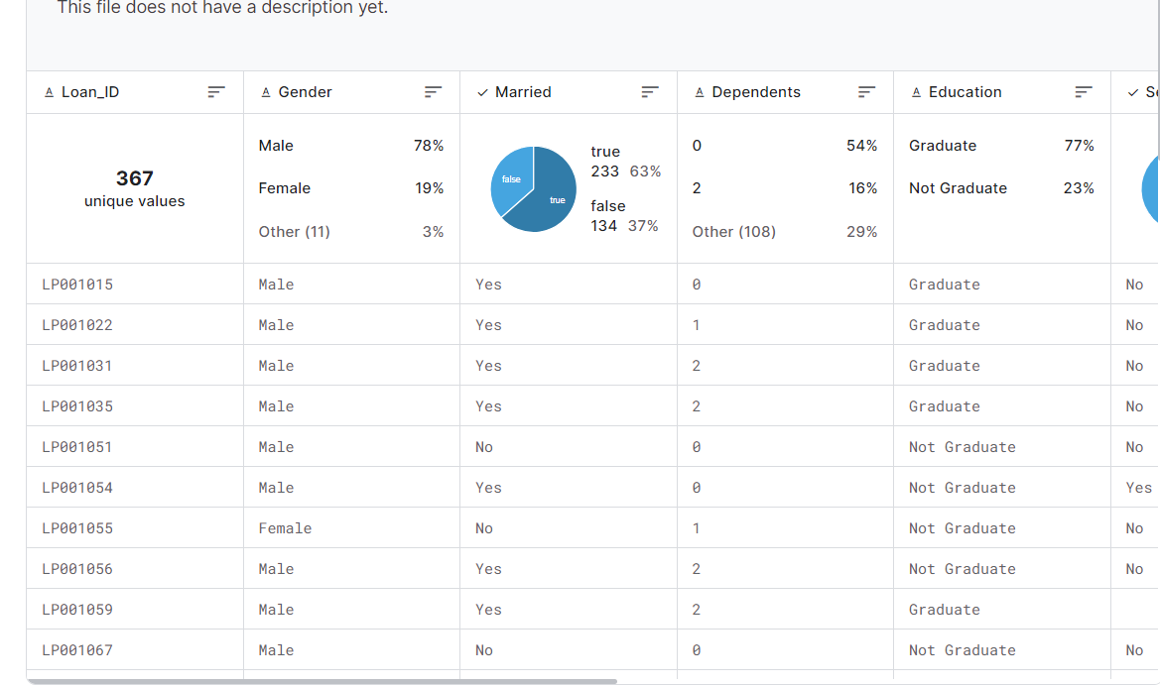

Link: <https://www.kaggle.com/datasets/krishnaraj30/finance-loan-approval-prediction-data/data>

Steps:

- ETL with Pandas and other when necessary

- Retrieve the data from SQL/Spark

- Machine learning (PySpark)

- Tableau (Visualizations)