Kubernetes使用ceph-docker持久化存储
https://github.com/larkguo/Kubernetes-docker/tree/master/ceph

目录
1 部署架构 3
1.1 主机 3
1.2 前提 3
2 Ceph集群 4
2.1 前提 4
2.2 mon/mgr/mds/rgw 4
2.3 osd 6
3 Kubernetes使用ceph 8
3.1 前提 8
3.1.1 版本 8
3.1.2 Ceph配置 9
3.1.3 安装ceph client 9
3.1.4 Ceph池创建 10
3.1.5 设置label 12
3.2 mount到本地使用 12
3.2.1 mount挂载ceph 12
3.2.2 app使用挂载路径 13
3.3 pv/pvc方式使用 15
3.3.1 创建pv/pvc 15
3.3.2 创建pod 18
3.4 StorageClass方式使用 20
3.4.1 创建StorageClass 20
3.4.2 创建deployment 22
4 附录 24
4.1 参考 24

部署架构

主机
主机名 | IP | ceph角色 | osd设备 | 宿主机目录  (配置和数据)
node1 | 192.168.120.173/24 | mon,mgr, mds, rgw,osd | /dev/sdb | /etc/ceph/  /var/lib/ceph/
node2 | 192.168.120.174/24 | osd | /dev/sdb | /etc/ceph/  /var/lib/ceph/
node3 | 192.168.120.172/24 | osd | /dev/sdb | /etc/ceph/  /var/lib/ceph/
k8s-master1 | 192.168.120.176/24 | client
k8s-node1 | 192.168.120.175/24 | client

前提
部署前在说有主机上进行时钟同步
yum clean all
yum install chrony -y
systemctl enable chronyd.service
systemctl restart chronyd.service

Ceph集群
Ceph集群部署到docker里.

前提

#在所有主机上拉取ceph 镜像,此处下载版本为ceph luminous,
#ceph/daemon官方镜像地址https://hub.docker.com/r/ceph/daemon/
docker pull ceph/daemon

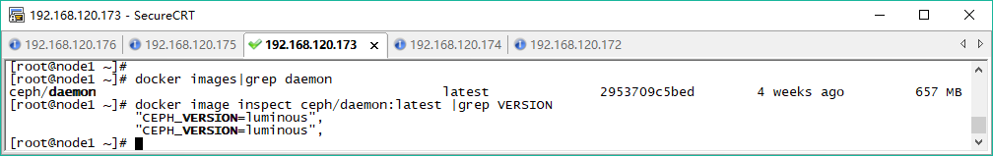

mon/mgr/mds/rgw
在node1安装mon，mgr，mds和rgw

#在所有宿主机准备目录
mkdir -p /etc/ceph
mkdir -p /var/lib/ceph/

#清除未用的container
docker container prune -f
rm -fr /etc/ceph/*
rm -fr /var/lib/ceph/*

# 安装mon，MON_IP就是宿主机的IP地址
docker run -d --net=host --name=mon --restart=always \
-v /etc/ceph:/etc/ceph \
-v /var/lib/ceph/:/var/lib/ceph/ \
-e MON_IP=192.168.120.173 \
-e CEPH_PUBLIC_NETWORK=192.168.120.0/24 \
ceph/daemon mon

#安装mgr
docker run -d --net=host --name=mgr --restart=always \
-v /etc/ceph:/etc/ceph \
-v /var/lib/ceph/:/var/lib/ceph/ \
ceph/daemon mgr

#安装mds
docker run -d --net=host --name=mds --restart=always \
-v /etc/ceph:/etc/ceph \
-v /var/lib/ceph/:/var/lib/ceph/ \
-e CEPHFS_CREATE=1 \
ceph/daemon mds

#安装rgw
docker run -d --net=host --name=rgw --restart=always \
-v /var/lib/ceph/:/var/lib/ceph/ \
-v /etc/ceph:/etc/ceph \
ceph/daemon rgw

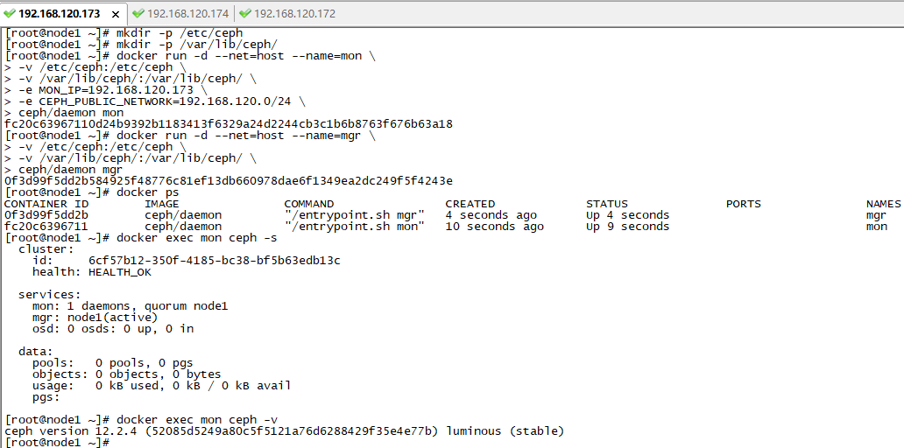
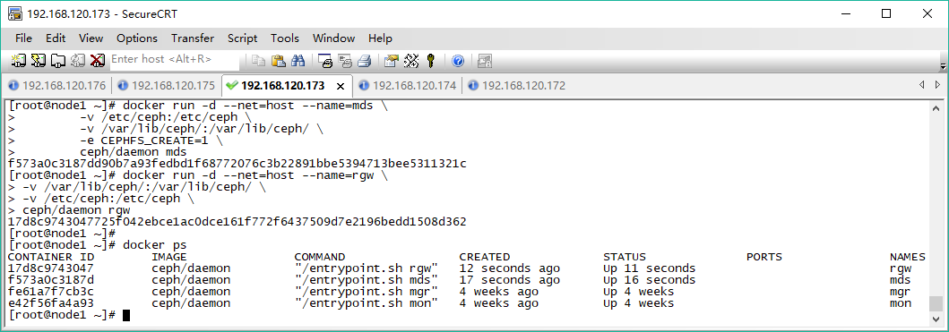

#复制配置文件
#将 node1 上的配置文件复制到 node02 和 node03,复制的路径包含/etc/ceph和#/var/lib/ceph/bootstrap-*下的所有内容。

ssh root@node2 mkdir -p /var/lib/ceph
scp -r /etc/ceph root@node2:/etc
scp -r /var/lib/ceph/bootstrap* root@node2:/var/lib/ceph

ssh root@node3 mkdir -p /var/lib/ceph
scp -r /etc/ceph root@node3:/etc
scp -r /var/lib/ceph/bootstrap* root@node3:/var/lib/ceph

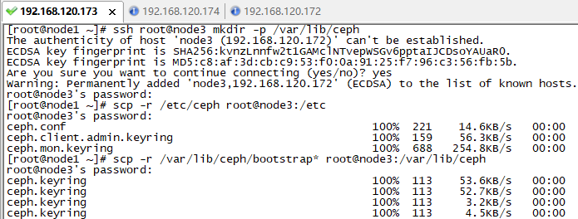

osd

#在三台osd主机上分别执行
docker run -d --restart=always \
--net=host \
-v /etc/ceph:/etc/ceph \
-v /var/lib/ceph/:/var/lib/ceph/ \
-v /dev/:/dev/ \
--privileged=true \
-e OSD_FORCE_ZAP=1 \
-e OSD_DEVICE=/dev/sdb \
ceph/daemon osd_ceph_disk

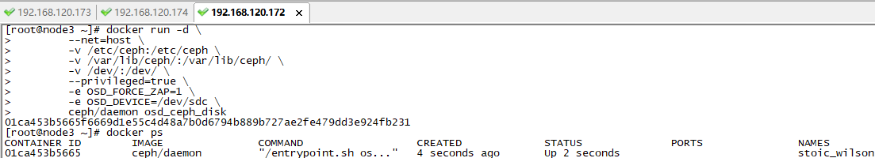

#在 mon主机上检查集群情况
docker exec mon ceph -s

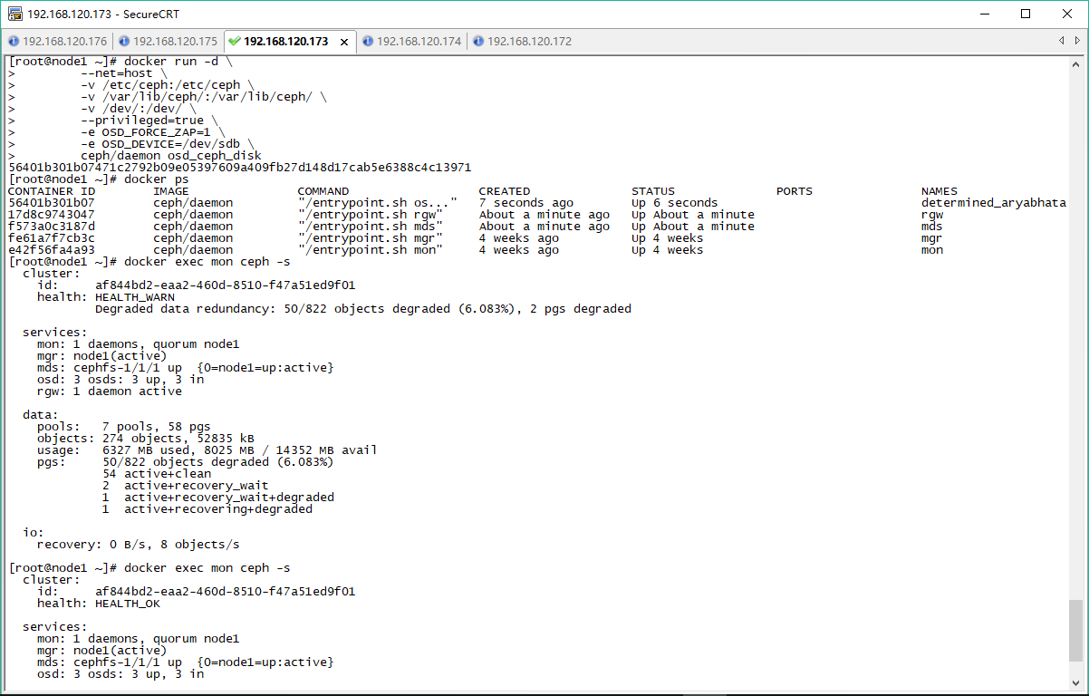

#在 osd主机上检查硬盘分区
fdisk -l /dev/sdb
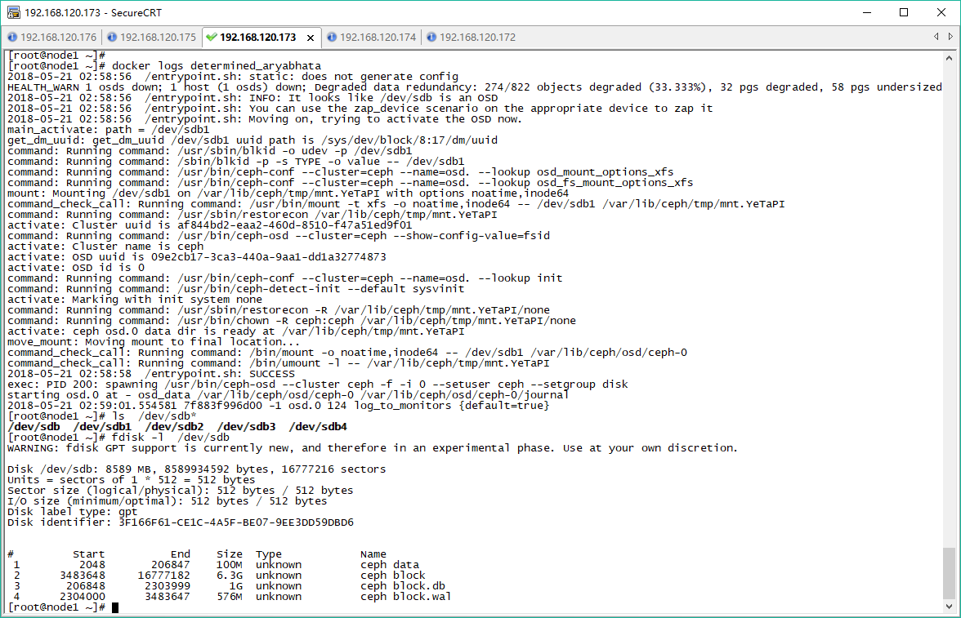

Kubernetes使用ceph

Kubernetes三种方式使用ceph进行持久化：
- mount到本地目录使用
- Pv/pvc方式持久化存储
- Storageclass方式持久化存储

前提

版本
kubectl get node -o wide
NAME STATUS ROLES AGE VERSION EXTERNAL-IP OS-IMAGE KERNEL-VERSION CONTAINER-RUNTIME
k8s-node1 Ready <none> 35d v1.9.2 <none> CentOS Linux 7 (Core) 3.10.0-514.el7.x86_64 docker://17.3.2
master1 Ready master 35d v1.9.2 <none> CentOS Linux 7 (Core) 3.10.0-693.21.1.el7.x86_64 docker://17.3.2
[root@master1 ~]#

Ceph配置
#ceph配置/etc/ceph拷贝到所有kubernetes主机节点,作为ceph的client使用
scp -r /etc/ceph root@k8s-master1:/etc
scp -r /etc/ceph root@k8s-node1:/etc
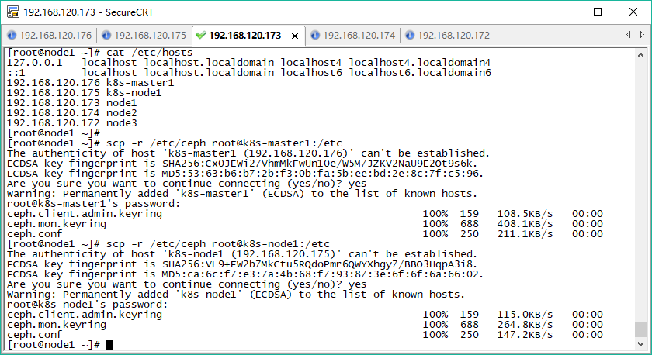

安装ceph client

#添加centos7 ceph安装源
cat > /etc/yum.repos.d/ceph.repo <<EOF
[ceph]
name=ceph
baseurl=http://mirrors.163.com/ceph/rpm-luminous/el7/x86_64/
gpgcheck=0
priority=1

[ceph-noarch]
name=cephnoarch
baseurl=http://mirrors.163.com/ceph/rpm-luminous/el7/noarch/
gpgcheck=0
priority=1

[ceph-source]
name=Ceph source packages
baseurl=http://mirrors.163.com/ceph/rpm-luminous/el7/SRPMS/
gpgcheck=0
priority=1
EOF

#kubernetes节点安装ceph客户端
yum clean all
yum install ceph-common -y
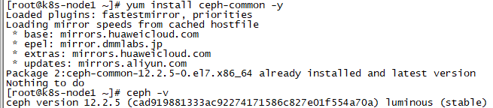

Ceph池创建
在执行创建该 Pod 之前，先在ceph client主机手动创建pool k8s-pool和 image foo，后续用到。
#ceph 集群创建一个新的存储池k8s-pool， Placement Group的个数为64
ceph osd pool create k8s-pool 64

#在ceph池k8s-pool中创建一个块设备 image镜像 foo
rbd create --size 1G k8s-pool/foo -m node1 --image-format 2 --image-feature layering

# map映射到本地
rbd map k8s-pool/foo --name client.admin -m node1 -k /etc/ceph/ceph.client.admin.keyring

#格式化块设备
mkfs.xfs /dev/rbd0

#指定pool应用类型为rbd
ceph osd pool application enable k8s-pool rbd

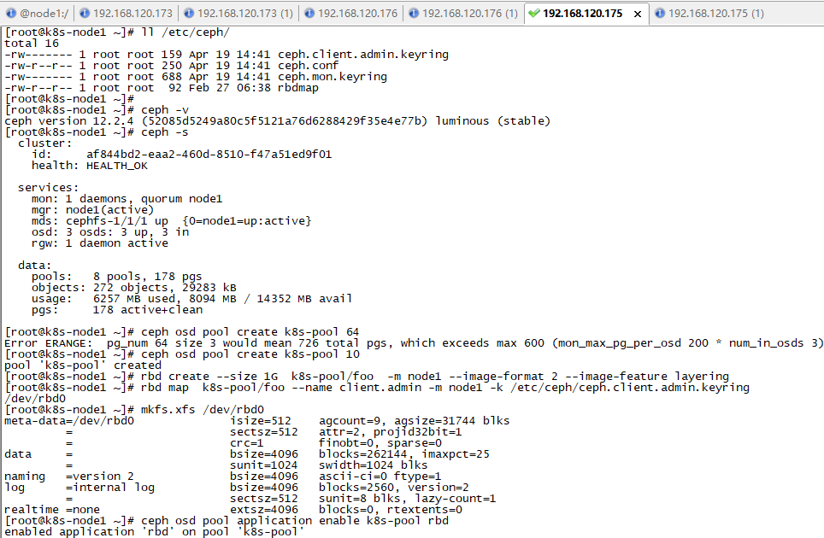

#查看已经映射的Block Device信息
rbd showmapped

#查看k8s-pool/foo的详细信息
rbd info k8s-pool/foo

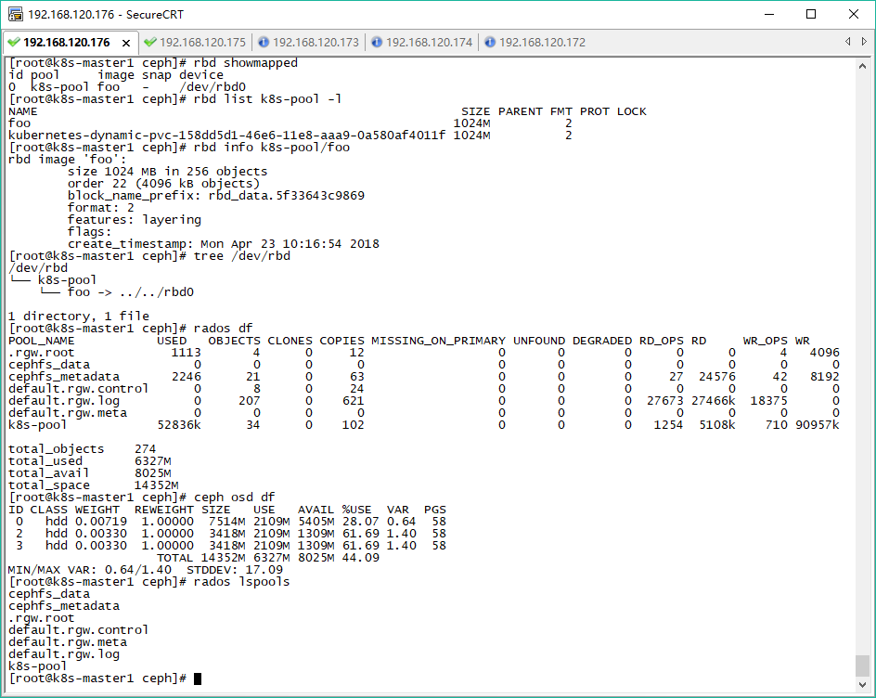

设置label
#给k8s-node1节点添加标签，后续kubernetes调度使用
kubectl label node k8s-node1 web=nginx
kubectl get node --show-labels

mount到本地使用

mount挂载ceph
#查看已经映射的Block Device信息
rbd showmapped

#ceph Client的User Space挂载(Mount)该RBD设备 /dev/rbd0到本地目录/mnt
#把rbd0挂载到本地目录
mount /dev/rbd0 /mnt

#查询
mount |grep /dev/rbd0

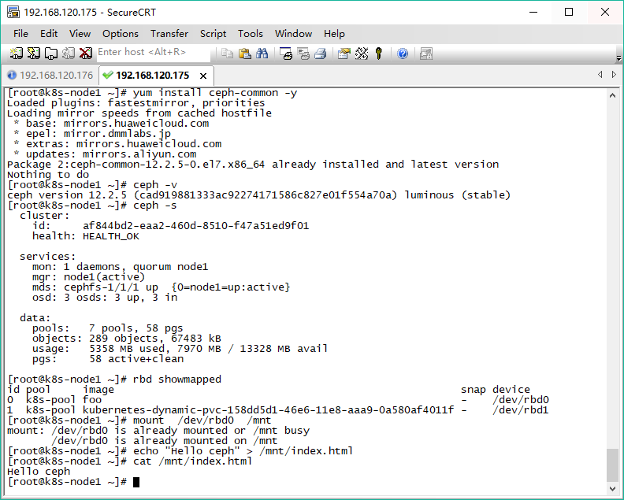

app使用挂载路径
nginx使用ceph挂载目录/mnt进行持久化存储，在master主机节点配置。

#定义nginx应用
cat > nginx.yaml <<EOF
apiVersion: extensions/v1beta1
kind: Deployment
metadata:
name: nginx
#namespace: kube-system
spec:
replicas: 1
template:
metadata:
labels:
app: nginx
spec:
nodeSelector:
web: nginx
containers:
- name: nginx
image: nginx:alpine
imagePullPolicy: IfNotPresent
ports:
- containerPort: 80
volumeMounts:
- name: httpd-storage
mountPath: /usr/share/nginx/html
volumes:
- name: httpd-storage
hostPath:
path: /mnt
---
apiVersion: v1
kind: Service
metadata:
name: nginx
labels:
app: nginx
spec:
type: NodePort
ports:
- port: 80
nodePort: 32001
protocol: TCP
selector:
app: nginx
EOF

#创建app
kubectl create -f nginx.yaml

#测试app
curl http://192.168.120.176:32001/
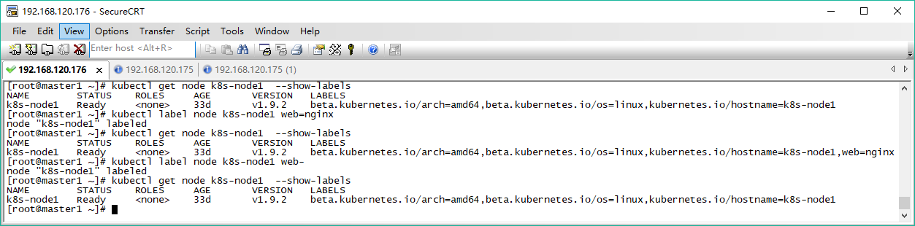
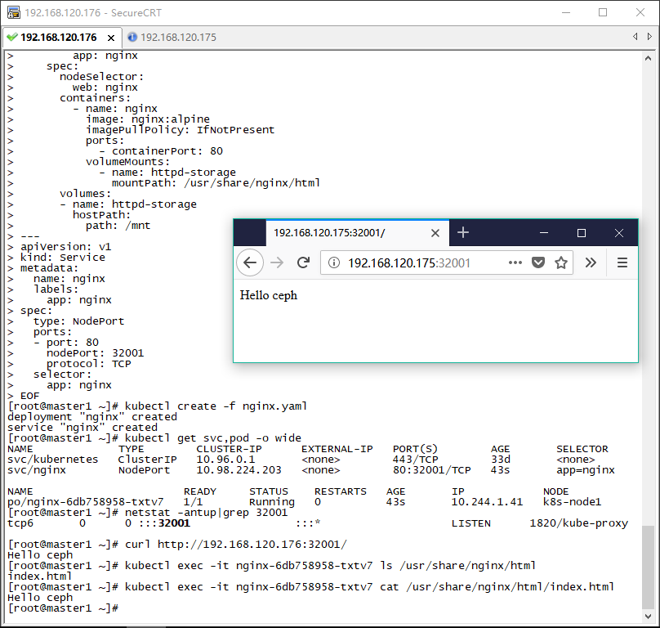

pv/pvc方式使用

创建pv/pvc
grep key /etc/ceph/ceph.client.admin.keyring |awk '{printf "%s", $NF}'|base64
QVFCMjROWmEyRDRYSFJBQTlLNjhmeXJydTkvL2h5dzNEcDBwZWc9PQ==
cat > ceph-secret.yaml <<EOF
apiVersion: v1
kind: Secret
metadata:
name: ceph-secret
namespace: default
type: "kubernetes.io/rbd"
data:
key: QVFCZmdTcFRBQUFBQUJBQWNXTmtsMEFtK1ZkTXVYU21nQ0FmMFE9PQ==
EOF

cat > pv.yaml <<EOF
apiVersion: v1
kind: PersistentVolume
metadata:
name: test-pv
namespace: default
spec:
capacity:
storage: 1Gi
accessModes:
- ReadWriteOnce
rbd:
monitors:
- '192.168.120.173:6789'
pool: k8s-pool
image: foo
fsType: xfs
readOnly: false
user: admin
secretRef:
name: ceph-secret
persistentVolumeReclaimPolicy: Recycle
EOF

cat > pvc.yaml <<EOF
kind: PersistentVolumeClaim
apiVersion: v1
metadata:
name: test-pvc
namespace: default
spec:
accessModes:
- ReadWriteOnce
resources:
requests:
storage: 1Gi
EOF

#创建 pvc/pv
kubectl create -f ceph-secret.yaml
kubectl create –f pv.yaml
kubectl create –f pvc.yaml

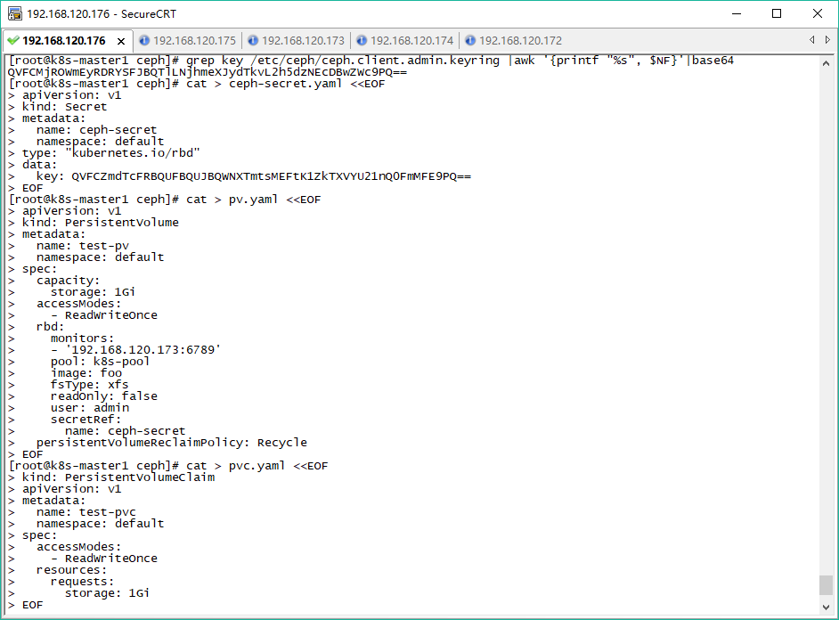
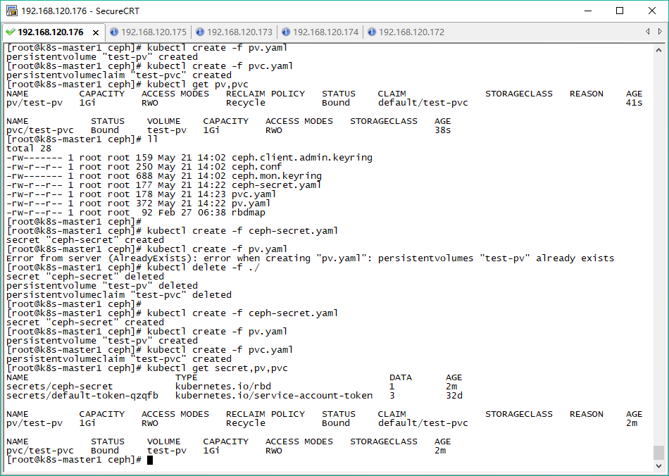

创建pod

# pod中目录/usr/share/nginx/html映射到ceph集群
cat > nginx.yaml <<EOF
apiVersion: extensions/v1beta1
kind: Deployment
metadata:
name: nginx-dm
namespace: default
spec:
replicas: 1
template:
metadata:
labels:
name: nginx
spec:
containers:
- name: nginx
image: nginx:alpine
imagePullPolicy: IfNotPresent
ports:
- containerPort: 80
volumeMounts:
- name: ceph-rbd-volume
mountPath: "/usr/share/nginx/html"
volumes:
- name: ceph-rbd-volume
persistentVolumeClaim:
claimName: test-pvc
EOF

#创建pod
kubectl create -f nginx.yaml

#进入pod操作

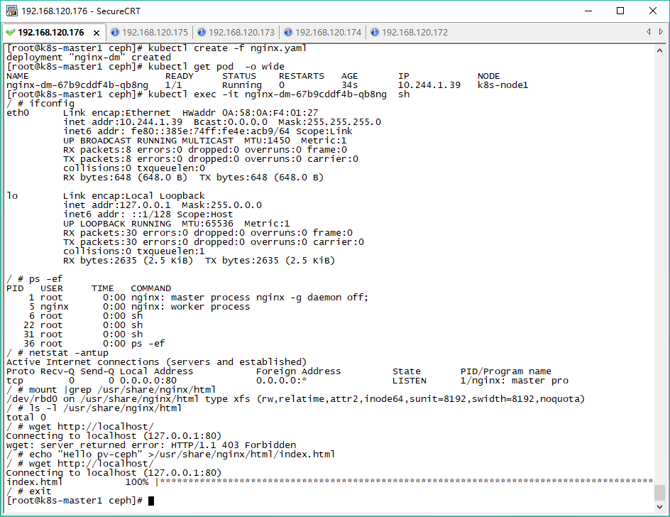

StorageClass方式使用

Yaml配置文件：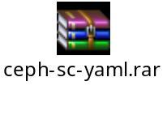

创建StorageClass
grep key /etc/ceph/ceph.client.admin.keyring |awk '{printf "%s", $NF}'|base64
QVFBWUl3SmJrY0RhQ2hBQXM5R0V0ZlFnZjNQTnFuUUtEV0lmR1E9PQ==
cat > ceph-secret.yaml <<EOF
apiVersion: v1
kind: Secret
metadata:
name: ceph-secret-admin
namespace: kube-system
type: kubernetes.io/rbd
data:
key: QVFCMjROWmEyRDRYSFJBQTlLNjhmeXJydTkvL2h5dzNEcDBwZWc9PQ==

EOF

cat > rbd-class.yaml <<EOF
apiVersion: storage.k8s.io/v1
kind: StorageClass
metadata:
name: fast
namespace: kube-system
provisioner: ceph.com/rbd
parameters:
monitors: 192.168.120.173:6789
adminId: admin
adminSecretName: ceph-secret-admin
adminSecretNamespace: kube-system
pool: k8s-pool
userId: admin
userSecretName: ceph-secret-admin
imageFormat: "2"
imageFeatures: "layering"
fsType: xfs
EOF

cat > ceph-pvc.yaml <<EOF
kind: PersistentVolumeClaim
apiVersion: v1
metadata:
name: ceph-claim-dynamic
namespace: kube-system
spec:
accessModes:
- ReadWriteOnce
resources:
requests:
storage: 1Gi
storageClassName: fast
EOF

cat > rbd-provisioner.yaml <<EOF
apiVersion: extensions/v1beta1
kind: Deployment
metadata:
name: rbd-provisioner
namespace: kube-system
spec:
replicas: 1
template:
metadata:
labels:
app: rbd-provisioner
spec:
containers:
- name: rbd-provisioner
image: "quay.io/external_storage/rbd-provisioner:latest"
serviceAccountName: persistent-volume-binder
EOF

#创建storageclass，rbd-provisioner.yaml创建成功后pvc状态变为Bound
kubectl create -f ceph-secret.yaml
kubectl create -f rbd-class.yaml
kubectl create -f ceph-pvc.yaml
kubectl create -f rbd-provisioner.yaml

#查看
kubectl get pvc,sc,deployment --all-namespaces
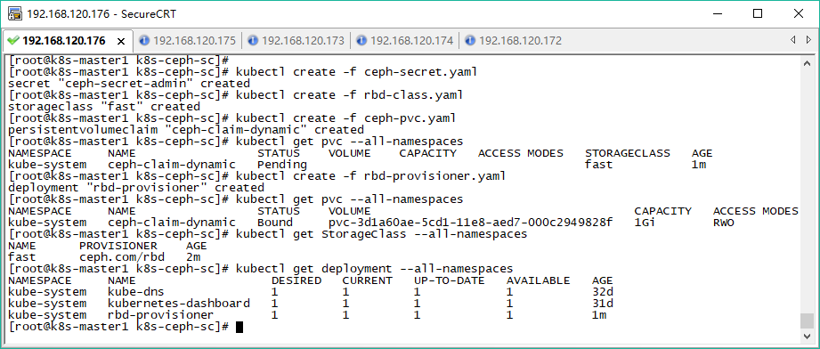
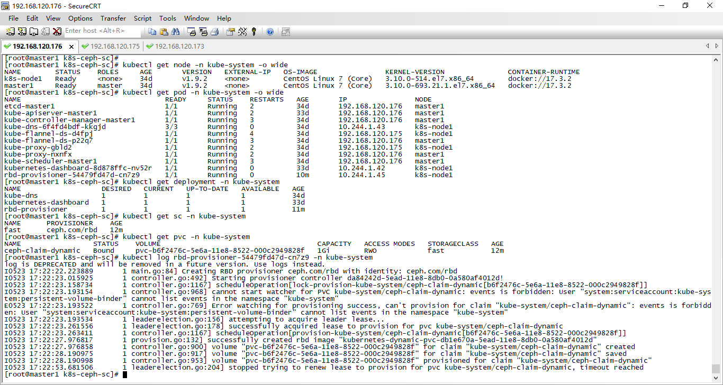

创建deployment

#pod中目录/usr/share/nginx/html映射到ceph集群
cat > deployment.yaml <<EOF
apiVersion: extensions/v1beta1
kind: Deployment
metadata:
name: nginx-dynamic
namespace: kube-system
spec:
replicas: 1
template:
metadata:
labels:
name: nginx
spec:
nodeSelector:
web: nginx
containers:
- name: nginx
image: nginx:alpine
imagePullPolicy: IfNotPresent
ports:
- containerPort: 80
volumeMounts:
- name: ceph-rbd-dynamic-volume
mountPath: /usr/share/nginx/html
volumes:
- name: ceph-rbd-dynamic-volume
persistentVolumeClaim:
claimName: ceph-claim-dynamic
EOF

kubectl create -f deployment.yaml

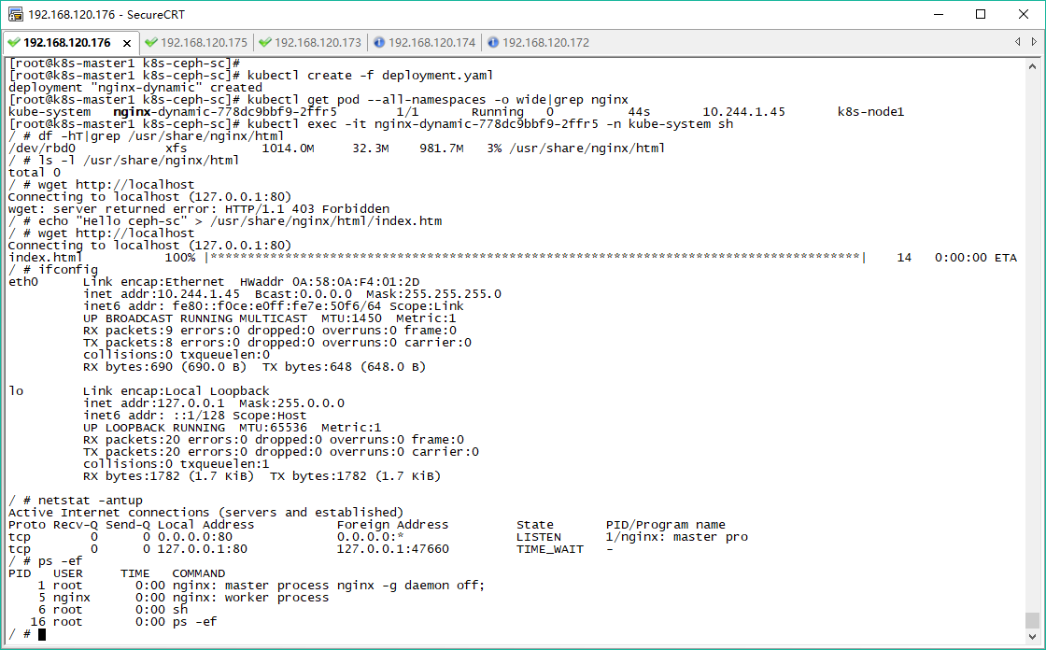

附录

参考

- 基于docker部署ceph以及修改docker image
https://ceph.com/planet/%E5%9F%BA%E4%BA%8Edocker%E9%83%A8%E7%BD%B2ceph%E4%BB%A5%E5%8F%8A%E4%BF%AE%E6%94%B9docker-image/
- kubernetes 使用ceph rbd作为持久存储
https://zhangchenchen.github.io/2017/11/17/kubernetes-integrate-with-ceph/

