

GlusterFS分布式文件系统使用

华录光存储研究院（大连）有限公司

目录
1 前提 3
1.1 网络 3
1.2 Hostname 3
1.3 时钟同步 4
1.4 防火墙 4
1.5 网络转发 5
2 Install 6
3 集群 6
4 卷操作 7
5 Client挂载 8
6 参考 9

前提

网络

Hostname | IP | 环境 | 组件
node129 | 192.168.209.129 | CentOS-7.3.1611  Docker-18.09.5  Glusterfs-4.1 | GlusterFS  GlusterFS Client
node130 | 192.168.209.130 | CentOS-7.3.1611  Docker-18.09.5  Glusterfs-4.1 | GlusterFS
node131 | 192.168.209.131 | CentOS-7.3.1611  Docker-18.09.5  Glusterfs-4.1 | GlusterFS

Hostname
在所有主机节点上配置自己的hostname,如在192.168.209.129上配置hostname为node129:
hostnamectl set-hostname node129
su
在所有主机节点上把集群所有节点配置到/etc/hosts
sed -i '$a\192.168.209.129 node129' /etc/hosts
sed -i '$a\192.168.209.130 node130' /etc/hosts
sed -i '$a\192.168.209.131 node131' /etc/hosts

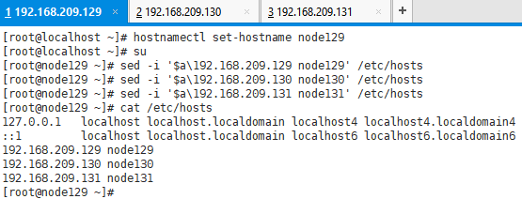
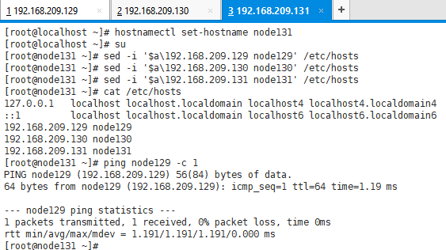

时钟同步
在所有主机节点上设置正确系统时区,系统时钟, 硬件时钟

设置时区
cp /usr/share/zoneinfo/Asia/Shanghai /etc/localtime
查看时区
ls -l /etc/localtime
与国家授时中心同步
ntpdate ntp.ntsc.ac.cn
将系统时钟设置到硬件时钟
hwclock -w
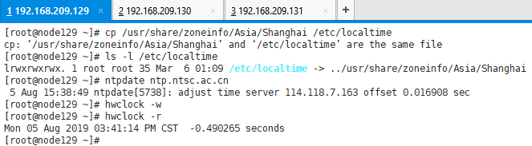

防火墙
在所有主机节点上关闭防火墙或者放开限制

systemctl stop firewalld
systemctl disable firewalld

setenforce 0
sed -i "s/^SELINUX=enforcing/SELINUX=disabled/g" /etc/sysconfig/selinux
sed -i "s/^SELINUX=enforcing/SELINUX=disabled/g" /etc/selinux/config
sed -i "s/^SELINUX=permissive/SELINUX=disabled/g" /etc/sysconfig/selinux
sed -i "s/^SELINUX=permissive/SELINUX=disabled/g" /etc/selinux/config

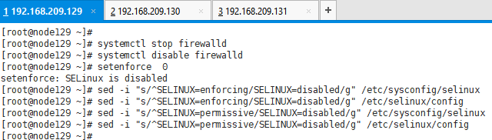

或者放开限制:
setsebool -P nis_enabled on
firewall-cmd --add-service=glusterfs --permanent
firewall-cmd --reload
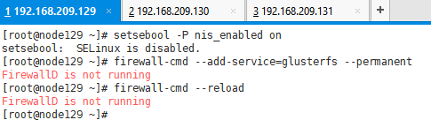

网络转发
在所有主机节点上配置转发:
echo "net.ipv4.ip_forward=1" >> /etc/sysctl.conf
systemctl restart network
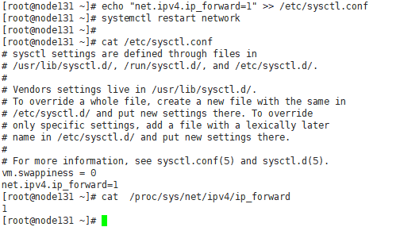

Install

所有主机节点上分别执行以下命令:

docker pull gluster/gluster-centos

docker stop glusterfs
docker rm glusterfs
rm -fr /glusterfs/distributed/

mkdir -p /etc/systemd/system/docker.service.d/
cat <<EOF > /etc/systemd/system/docker.service.d/clear_mount_propagation_flags.conf
[Service]
MountFlags=shared
EOF

docker run -v /etc/glusterfs:/etc/glusterfs:z \
-v /var/lib/glusterd:/var/lib/glusterd:z \
-v /var/log/glusterfs:/var/log/glusterfs:z \
-v /sys/fs/cgroup:/sys/fs/cgroup:ro \
-v /dev/:/dev \
-v /etc/localtime:/etc/localtime \
-v /glusterfs:/glusterfs:shared \
-d --privileged=true --net=host --restart=always \
--name glusterfs --log-opt max-size=10m \
gluster/gluster-centos
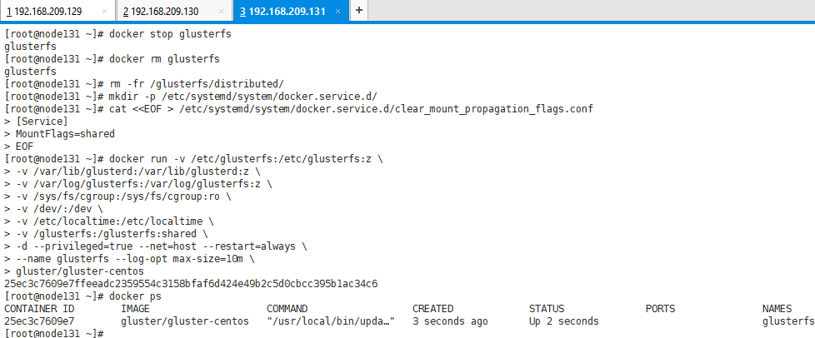

集群
组建GlusterFS分布式集群,只需在一台主机(如192.168.209.130)上执行以下命令:

docker exec -it glusterfs gluster peer detach node129
docker exec -it glusterfs gluster peer detach node130
docker exec -it glusterfs gluster peer detach node131

docker exec -it glusterfs gluster peer probe node129
docker exec -it glusterfs gluster peer probe node130
docker exec -it glusterfs gluster peer probe node131
docker exec -it glusterfs gluster pool list
docker exec -it glusterfs gluster peer status
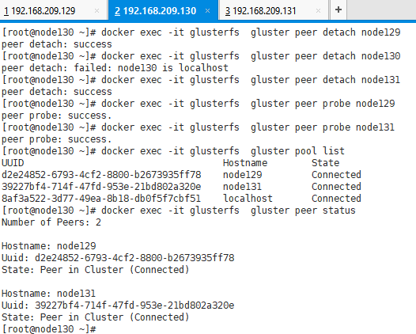

卷操作
创建卷,以distributed卷为例,只需在一台主机上执行以下命令:

docker exec -it glusterfs gluster volume create vol_distributed transport tcp \
node129:/glusterfs/distributed \
node130:/glusterfs/distributed \
node131:/glusterfs/distributed force

docker exec -it glusterfs gluster volume start vol_distributed
docker exec -it glusterfs gluster volume info
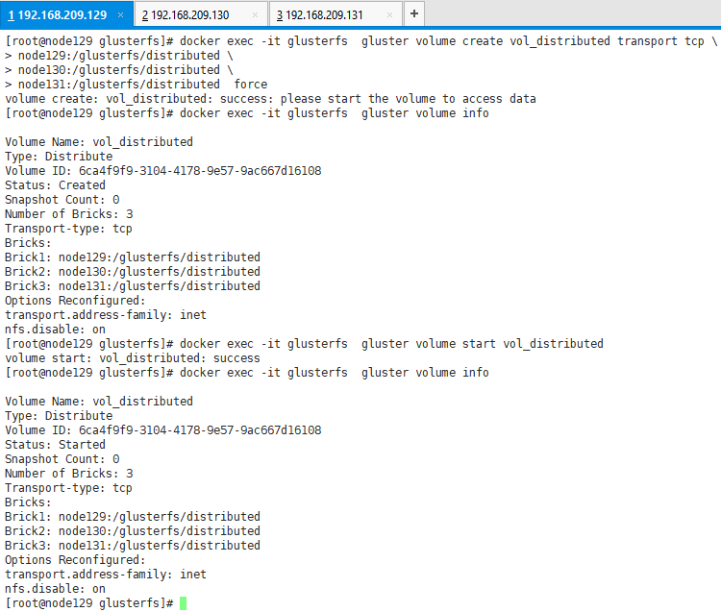

停止和删除卷:
docker exec -it glusterfs sh -c 'gluster volume stop vol_distributed force <<<y'
docker exec -it glusterfs sh -c "gluster volume delete vol_distributed <<<y"
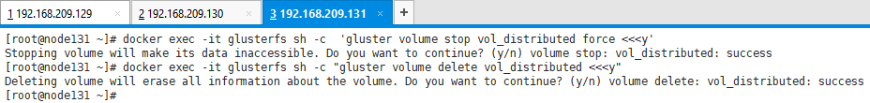

Client挂载
将卷挂载到Glusterfs Client,只需在一台主机上执行以下命令:

mkdir -p /glusterfs/mnt
docker exec -it glusterfs mount -t glusterfs localhost:/vol_distributed /glusterfs/mnt
docker exec -it glusterfs df -hT

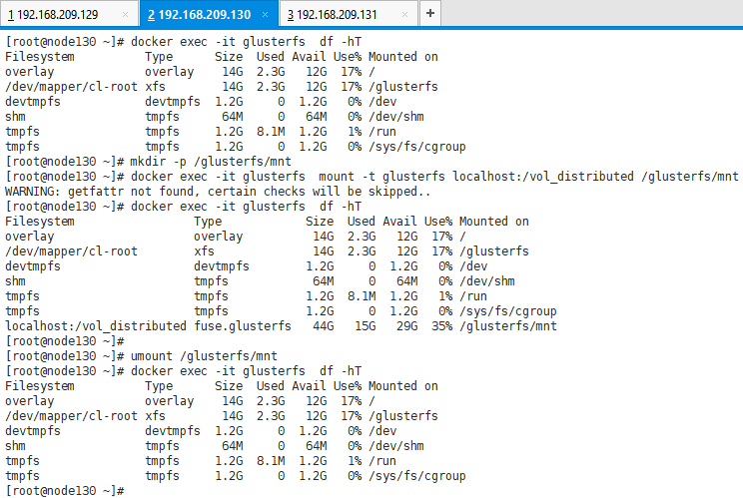
如上图, 容器(和宿主机)的/glusterfs/mnt目录容量是三台主机/glusterfs/distributed容量之和,任何一台主机/glusterfs/distributed目录下修改文件,容器(和宿主机)的/glusterfs/mnt目录下都能看到.

参考
https://github.com/gluster/gluster-containers
https://www.server-world.info/en/note?os=CentOS_7&p=glusterfs&f=1

