Database: gsv_votes
Summary: Mechanical turk records and associated properties of survey images. Records include GSV imagery and metadata, mechanical turk votes and metadata, website votes and metadata, and summary statistics include trueskill scores.

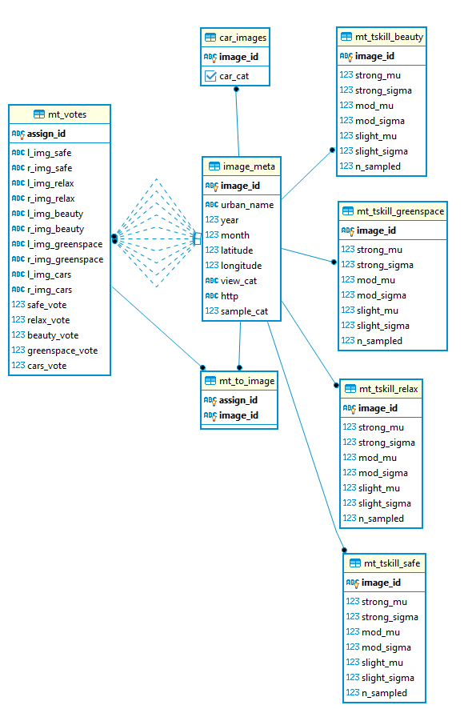

Table: gsv_votes.image_meta
Summary: Metadata for each GSV image included in the voting training dataset. This data was collected from the streetview python module when collecting GSV ids. Viewing angles were randomized, so the random viewing angle is included in the data and can vary widely.
image_meta
Field Name | Data type | field Length | Constraint | Range | Description
image_id | Text | 100 | Primary Key |  | GSV id
urban_name | Text | 10 | Not null |  | urban name from US Census
year | integer |  | Not null | 2000-2019 | year image was taken
month | integer |  | Not null | 1-12 | month image was taken
latitude | float |  | Not null | -90 to 90 | Latitude in WGS 84
longitude | Float |  | Not null | -180 to 180 | Longitude in WGS 84
view_cat | Text | 100 | Not null | 0-360 | viewing angle (0 is direction of vehicle)
http | Text | 100 | Not null |  | http address for image collection
sample_cat | Integer |  | Not null |  | urban development level

Table: gsv_votes.mt_votes
Summary: Voting data collected from mechanical turk, including id of candidate images, which images were selected by the worker, and the strength of selection.
mt_votes
Field Name | Data type | field Length | Constraint | Range | Description
assign_id | Text | 100 | Primary Key |  | unique id for each vote
l_img_safe | Text | 100 | Not null |  | GSV id for left safe image
r_img_safe | Text | 100 | Not null |  | GSV id for right safe image
l_img_relax | Text | 100 | Not null |  | GSV id for left relax image
r_img_relax | Text | 100 | Not null |  | GSV id for right relax image
L_img_beauty | Text | 100 | Not null |  | GSV id for left beauty image
R_img_beauty | Text | 100 | Not null |  | GSV id for right beauty image
l_img_greenspace | Text | 100 | Not null |  | GSV id for left greenspace image
R_img_greenspace | Text | 100 | Not null |  | GSV id for right greenspace image
L_img_cars | Text | 100 | Not null |  | GSV id for left car image
R_img_cars | Text | 100 | Not null |  | GSV id for right car image
Safe_vote | integer |  | Not null | 1-100 | Value of the safe slider
Relax_vote | integer |  | Not null | 1-100 | Value of the relax slider
Beauty_vote | Integer |  | Not null | 1-100 | Value of the beauty slider
Greenspace_vote | Integer |  | Not null | 1-100 | Value of the greenspace slider
Cars_vote | integer |  | Not null | 1-100 | Value of the cars slider

Table: gsv_votes.mt_tskill_beauty
Summary: Mechanical turk true skill beauty scores for each image
mt_tskill_beauty
Field Name | Data type | field Length | Constraint | Range | Description
image_id | Text | 100 | Primary Key |  | GSV id
Strong_mu | float |  | Not null | >=0 | True skill mean for strong ts
Strong_sigma | float |  | Not null | >=0 | True skil variance for strong
Mod_mu | float |  | Not null | >=0 | True skill mean for mod
Mod_sigma | float |  | Not null | >=0 | True skill variance for mod
Slight_mu | float |  | Not null | >=0 | true skill mean for slight
Slight_sigma | float |  | Not null | >=0 | true skill variance for
N_sampled | Int |  | Not null | >=0 | Number of votes

Table: gsv_votes.mt_tskill_greenspace
Summary: Mechanical turk true skill greenspace scores for each image
mt_tskill_greenspace
Field Name | Data type | field Length | Constraint | Range | Description
image_id | Text | 100 | Primary Key |  | GSV id
Strong_mu | float |  | Not null | >=0 | True skill mean for strong ts
Strong_sigma | float |  | Not null | >=0 | True skil variance for strong
Mod_mu | float |  | Not null | >=0 | True skill mean for mod
Mod_sigma | float |  | Not null | >=0 | True skill variance for mod
Slight_mu | float |  | Not null | >=0 | true skill mean for slight
Slight_sigma | float |  | Not null | >=0 | true skill variance for
N_sampled | Int |  | Not null | >=0 | Number of votes

Table: gsv_votes.mt_tskill_relax
Summary: Mechanical turk true skill relax scores for each image
mt_tskill_relax
Field Name | Data type | field Length | Constraint | Range | Description
image_id | Text | 100 | Primary Key |  | GSV id
Strong_mu | float |  | Not null | >=0 | True skill mean for strong ts
Strong_sigma | float |  | Not null | >=0 | True skil variance for strong
Mod_mu | float |  | Not null | >=0 | True skill mean for mod
Mod_sigma | float |  | Not null | >=0 | True skill variance for mod
Slight_mu | float |  | Not null | >=0 | true skill mean for slight
Slight_sigma | float |  | Not null | >=0 | true skill variance for
N_sampled | Int |  | Not null | >=0 | Number of votes

Table: gsv_votes.mt_tskill_safe
Summary: Mechanical turk true skill safe scores for each image
mt_tskill_safe
Field Name | Data type | field Length | Constraint | Range | Description
image_id | Text | 100 | Primary Key |  | GSV id
Strong_mu | float |  | Not null | >=0 | True skill mean for strong ts
Strong_sigma | float |  | Not null | >=0 | True skil variance for strong
Mod_mu | float |  | Not null | >=0 | True skill mean for mod
Mod_sigma | float |  | Not null | >=0 | True skill variance for mod
Slight_mu | float |  | Not null | >=0 | true skill mean for slight
Slight_sigma | float |  | Not null | >=0 | true skill variance for
N_sampled | Int |  | Not null | >=0 | Number of votes

Table: gsv_votes.mt_to_image
Summary: Table to link mechanical turk votes to image metadata
mt_to_image
Field Name | Data type | field Length | Constraint | Range | Description
assign_id | Text | 100 | Primary Key |  | unique id for each vote
image_id | Text | 100 | Primary Key |  | GSV id

