RICHFIELD GRADUATE INSTITUTE OF TECHNOLOGY
FACULTY OF INFORMATION TECHNOLOGY
MOBILE APP DEVELOPMENT 700
PRACTICAL ASSIGNMENT REPORT
SMART PANTRY MANAGER
Student name | [ENTER YOUR NAME]
Student ITS number | [ENTER YOUR STUDENT NUMBER]
Qualification / year | [ENTER DETAILS]
Semester | [ENTER SEMESTER]
Module | Mobile App Development 700
Submission date | [ENTER DATE]
GitHub repository | [PASTE YOUR REAL PUBLIC REPOSITORY URL]

DRAFT — NOT READY TO SUBMIT. This file does not contain real app screenshots, a verified GitHub URL, the student’s actual development reflections, a signed originality declaration, or the required narrated video. Complete and verify those items yourself.

Originality declaration: use the institution’s required declaration form. Review the applicable academic-integrity and AI-use rules before signing. Signature: __________________________ Date: __________________

Table of Contents
1. Introduction
2. System design
2.1 Screen flow and architecture
2.2 Data model
2.3 Strict recipe matching
3. Screenshots of outputs and core functions
4. Key code snippets
5. Challenges and solutions
6. Conclusion and reflection
7. References
Update the table of contents and page references in Word after inserting screenshots and completing the report.

1. Introduction
Food waste at household level is often linked to ingredients being forgotten, purchased in excess, or left unused because people are unsure what they can cook with what is already available. Smart Pantry Manager is an Android application concept for people who want a simple way to record their household ingredients and discover practical recipes without being told to buy missing items.
The application stores pantry names, quantities, units and optional expiry dates locally. A seeded collection of 18 recipes provides ingredient lists and preparation steps. The central design rule is deliberately strict: a recipe is suggested only when every required ingredient is present and the recorded amount is at least the required amount. This makes the app’s suggestions actionable and avoids implying that a partial match can be cooked immediately.
The prototype is implemented in Java for Android. It uses SQLite through SQLiteOpenHelper, native Activities and Intents, and custom BaseAdapter classes to populate ListViews. Android’s documentation describes Activity lifecycle callbacks, Intent-based component communication, adapter-backed lists, and SQLiteOpenHelper-managed database creation and versioning (Android Developers, n.d.-a; Android Developers, n.d.-b; Android Developers, n.d.-c; Android Developers, n.d.-d). The app does not use location, GPS, network services, payment functionality or maps. The intended users are household cooks who want to make better use of the food they already have.

2. System design

2.1 Screen flow and architecture
The Pantry List is the main entry point. The user can open the Add/Edit Ingredient form, view Suggested Recipes, or open Settings from the navigation bar. Selecting a recipe opens its detail screen. Intents pass a pantry record ID to the edit form and a recipe ID to the detail screen.
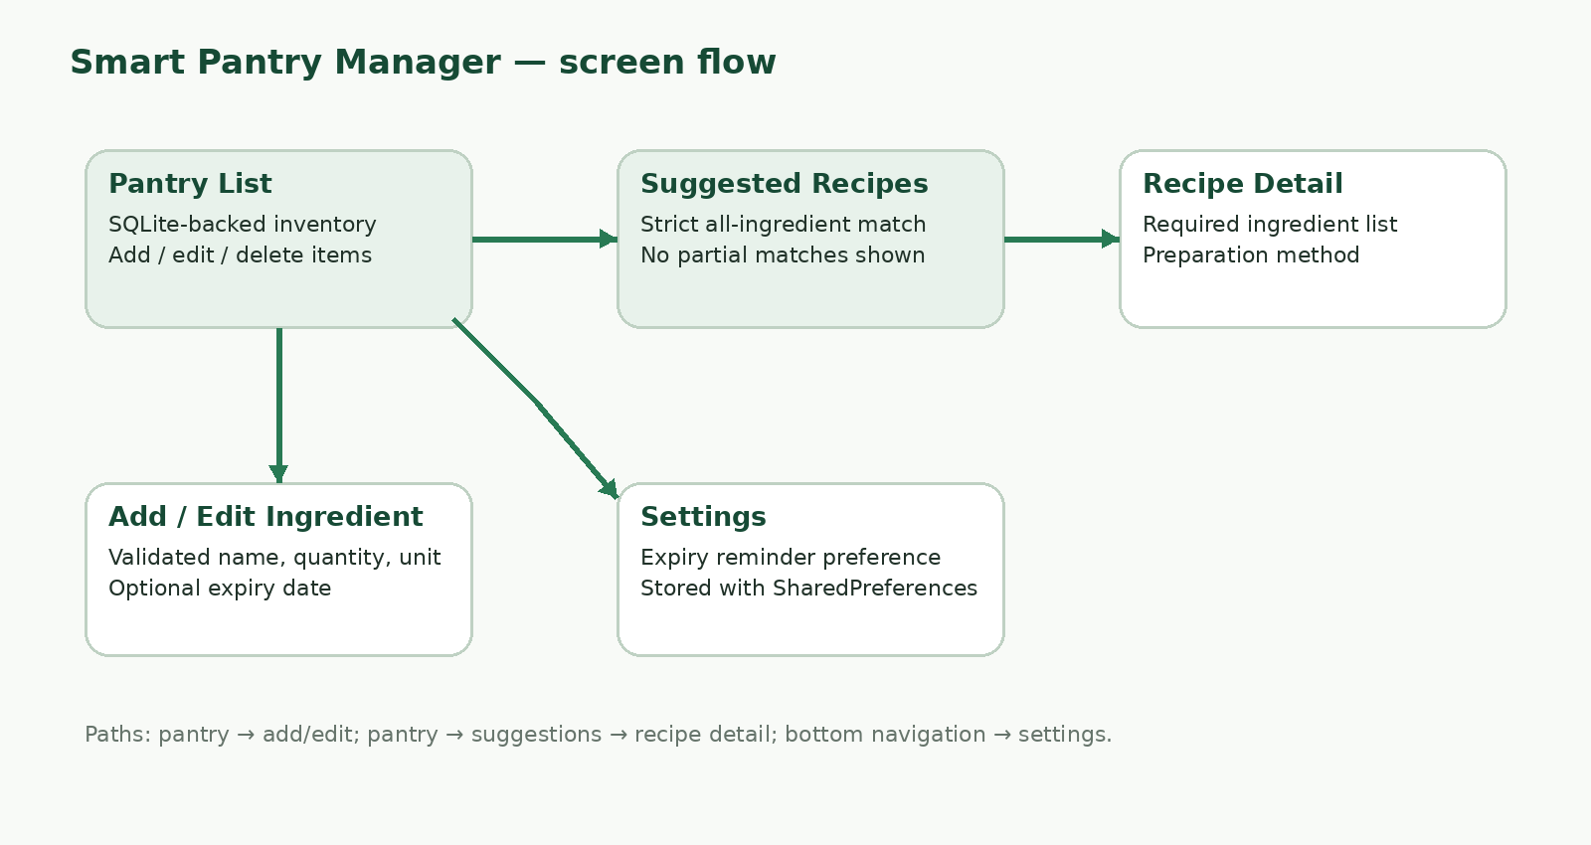
Figure 1. Screen-flow design diagram. This is a system-design illustration, not a screenshot of the running app.
The app uses five Activities: PantryActivity, IngredientFormActivity, SuggestedRecipesActivity, RecipeDetailActivity, and SettingsActivity. The pantry and suggestions lists reload persisted records when they resume; the form and recipe-detail screens fetch their selected records when opened, and Settings reads the saved preference.

2.2 Data model
The SQLite database has three tables. pantry_items contains user-managed inventory; recipes stores seeded recipe names, descriptions and methods; recipe_ingredients stores the quantities required by each recipe. The foreign key from recipe_ingredients.recipe_id to recipes._id expresses a one-to-many relationship. The settings preference is stored separately in SharedPreferences.
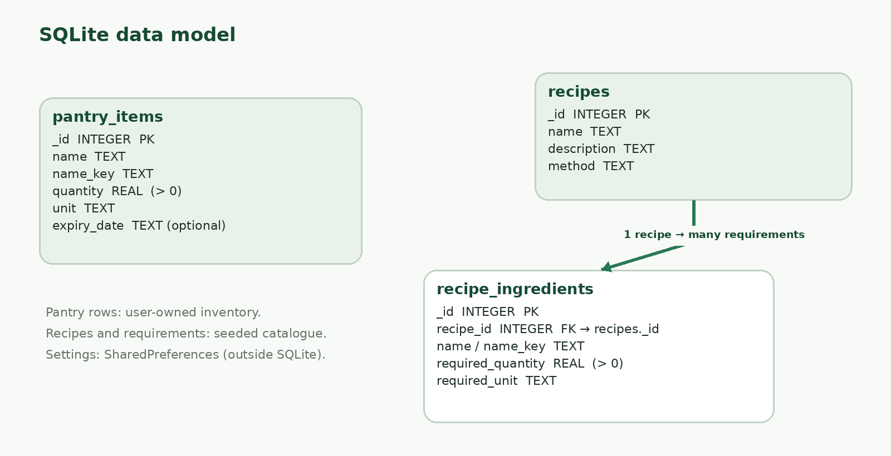
Figure 2. SQLite table relationship diagram. The diagram describes the project’s data model; it is not an app screenshot.

2.3 Strict recipe matching
StrictRecipeMatcher checks every RecipeIngredient required by a recipe. It normalizes ingredient names to tolerate common singular/plural variations, compares only compatible measures, aggregates duplicate pantry rows for the same normalized ingredient, and rejects the recipe as soon as an ingredient or quantity is insufficient. An empty pantry or a recipe with an unmet requirement therefore cannot create a suggested match. The main suggestions screen has no partial-match list.
Unit conversion is intentionally limited and predictable: common mass measures convert to grams, common volume measures to millilitres, and piece/count aliases to a count. Unit-specific measures such as a pinch or slice can be compared with the same measure type. The app does not guess a conversion between unrelated measures—for example, a cup of an ingredient is not silently converted to grams.

3. Screenshots of outputs and core functions
IMPORTANT: the assignment requires genuine screenshots of the student’s own running application. No emulator/device screenshots are included in this draft. Replace every capture prompt below with an actual screenshot and retain a concise caption. Do not submit the prompts as evidence or substitute mockups/stock images.
[STUDENT ACTION — INSERT A REAL SCREENSHOT FROM YOUR RUNNING ANDROID APP HERE]
Figure 3 — Pantry list with multiple saved ingredients
Figure caption (edit after capture): Pantry List displays records read from SQLite, quantities/units, and available edit/delete actions.

[STUDENT ACTION — INSERT A REAL SCREENSHOT FROM YOUR RUNNING ANDROID APP HERE]
Figure 4 — Empty pantry state
Figure caption (edit after capture): The empty inventory gives the user a clear prompt to add an ingredient.

[STUDENT ACTION — INSERT A REAL SCREENSHOT FROM YOUR RUNNING ANDROID APP HERE]
Figure 5 — Zero recipes match
Figure caption (edit after capture): The Suggested Recipes screen explains that no complete recipe currently matches; it is not blank.

[STUDENT ACTION — INSERT A REAL SCREENSHOT FROM YOUR RUNNING ANDROID APP HERE]
Figure 6 — Add ingredient form
Figure caption (edit after capture): The form accepts a name, positive quantity, unit, and optional expiry date.

[STUDENT ACTION — INSERT A REAL SCREENSHOT FROM YOUR RUNNING ANDROID APP HERE]
Figure 7 — Form validation error
Figure caption (edit after capture): Show an actual validation message for a blank name, zero quantity, missing unit, or invalid date.

[STUDENT ACTION — INSERT A REAL SCREENSHOT FROM YOUR RUNNING ANDROID APP HERE]
Figure 8 — Updated pantry item
Figure caption (edit after capture): Show the changed quantity/unit after editing an existing record.

[STUDENT ACTION — INSERT A REAL SCREENSHOT FROM YOUR RUNNING ANDROID APP HERE]
Figure 9 — Delete confirmation or post-delete list
Figure caption (edit after capture): Show a user-confirmed delete and verify the item is gone from the pantry list.

[STUDENT ACTION — INSERT A REAL SCREENSHOT FROM YOUR RUNNING ANDROID APP HERE]
Figure 10 — Positive strict-match result
Figure caption (edit after capture): Show the complete pantry quantities that allow a specific recipe to appear, such as Cheese Tomato Toast.

[STUDENT ACTION — INSERT A REAL SCREENSHOT FROM YOUR RUNNING ANDROID APP HERE]
Figure 11 — Negative strict-match result
Figure caption (edit after capture): Remove or reduce one required ingredient, then show that the same recipe is absent.

[STUDENT ACTION — INSERT A REAL SCREENSHOT FROM YOUR RUNNING ANDROID APP HERE]
Figure 12 — Recipe detail
Figure caption (edit after capture): Show the full required ingredient quantities and method for a selected recipe.

[STUDENT ACTION — INSERT A REAL SCREENSHOT FROM YOUR RUNNING ANDROID APP HERE]
Figure 13 — Settings
Figure caption (edit after capture): Show the expiry-reminder preference and its enabled/disabled state.

[STUDENT ACTION — INSERT A REAL SCREENSHOT FROM YOUR RUNNING ANDROID APP HERE]
Figure 14 — Persistence after relaunch
Figure caption (edit after capture): Close/reopen the app and show that the pantry data is still present.

4. Key code snippets
The excerpts below are short examples from the generated Java project. Verify them against the version you actually run, and be prepared to explain how the code behaves.

4.1 All-required-ingredients test (StrictRecipeMatcher.java)
for (RecipeIngredient required : recipe.getIngredients()) {
// compare the available amount with this requirement
if (available + EPSILON < requiredMeasure.baseQuantity) return false;
}
return true;
The comparison is performed for each required ingredient. Any missing/short item rejects the recipe immediately; true is returned only after the loop completes.

4.2 Quantity conversion (UnitConverter.java)
case "kg": return new Measure("mass", quantity * 1000.0);
case "g": return new Measure("mass", quantity);
case "ml": return new Measure("volume", quantity);
Compatible inputs are converted to a common base measure before comparison. Different dimensions are not treated as interchangeable.

4.3 SQLite update (PantryDbHelper.java)
return db.update("pantry_items", pantryValues(item), "_id = ?",
new String[]{String.valueOf(item.getId())}) > 0;
The record ID is passed as a selection argument rather than concatenated into SQL. The boolean result indicates whether a matching row was updated.

4.4 Validation before persistence (IngredientFormActivity.java)
if (Double.isNaN(quantity) || Double.isInfinite(quantity) || quantity <= 0) {
quantityField.setError("Quantity must be greater than zero");
quantityField.requestFocus();
return;
}
The form rejects a non-positive or invalid quantity before constructing the Ingredient record and writing to SQLite.

4.5 Intent data for recipe detail (SuggestedRecipesActivity.java)
Intent intent = new Intent(this, RecipeDetailActivity.class);
intent.putExtra(RecipeDetailActivity.EXTRA_RECIPE_ID, recipe.getId());
startActivity(intent);
The selected recipe ID is passed to the detail Activity, which reads the recipe and its required ingredients from SQLite.

5. Challenges and solutions
STUDENT ACTION REQUIRED: replace this section with two or three real issues you encountered while opening, testing, debugging or improving the application. The blank prompts below avoid inventing a personal development history. Use code files, test steps or screenshots as evidence where appropriate.
Actual issue encountered | How you diagnosed it | Solution you implemented | Evidence / file
[COMPLETE WITH YOUR OWN EXPERIENCE] | [COMPLETE WITH YOUR OWN EXPERIENCE] | [COMPLETE WITH YOUR OWN EXPERIENCE] | [COMPLETE WITH YOUR OWN EXPERIENCE]
[COMPLETE WITH YOUR OWN EXPERIENCE] | [COMPLETE WITH YOUR OWN EXPERIENCE] | [COMPLETE WITH YOUR OWN EXPERIENCE] | [COMPLETE WITH YOUR OWN EXPERIENCE]
[COMPLETE WITH YOUR OWN EXPERIENCE] | [COMPLETE WITH YOUR OWN EXPERIENCE] | [COMPLETE WITH YOUR OWN EXPERIENCE] | [COMPLETE WITH YOUR OWN EXPERIENCE]
Possible technical topics to consider only if they genuinely occurred in your work: plural ingredient names not matching; unit or quantity conversions; preserving records after app restart; ListView row updates after returning from an edit screen; or form validation for dates. Do not claim any of these as personal challenges unless you experienced and resolved them.

6. Conclusion and reflection
Smart Pantry Manager is designed to help household users reduce avoidable food waste by recording pantry quantities and presenting only recipes that are fully supported by those quantities. The Java prototype combines local SQLite persistence, native Android screens, form validation and custom ListView adapters. Its most important safeguard is the strict matching rule: missing ingredients and insufficient quantities exclude a recipe from the suggested list.
The current prototype is deliberately small. Further work could add richer but still transparent unit conversions, user-managed recipes, search and sorting, accessibility testing, and optional local notifications. Any enhancement should preserve the strict-matching promise and make its assumptions visible to the user.
[STUDENT REFLECTION — personalize this paragraph after you run the app: explain what you learned about Android Activities/lifecycle, SQLite, adapters/Intents, and strict matching; identify one verified limitation and one improvement you would implement. Do not leave this note in the final submission.]

7. References
Android Developers (n.d.-a) “Activities”. Available at: https://developer.android.com/guide/components/activities/intro-activities (Accessed: 7 October 2026).
Android Developers (n.d.-b) “Intents and intent filters”. Available at: https://developer.android.com/guide/components/intents-filters (Accessed: 7 October 2026).
Android Developers (n.d.-c) “BaseAdapter”. Available at: https://developer.android.com/reference/android/widget/BaseAdapter (Accessed: 7 October 2026).
Android Developers (n.d.-d) “SQLiteOpenHelper”. Available at: https://developer.android.com/reference/android/database/sqlite/SQLiteOpenHelper (Accessed: 7 October 2026).
[ADD any other documentation, tutorials, or materials you actually consulted. Keep the Harvard formatting consistent and ensure any in-text citations match this list.]

