Three models for willingness to accept payment

(chr, fct, num)

library(tidyverse)  
library(chibukuplasticscollection)

## Data preparation

* Prepare wta variable which has a positive linear relationship with income (monthly_earn1)

survey_model <- survey |>   
 select(id, age, gender, monthly_earn1) |>   
 # positive linear relationship for wta: with higher income, willingness to  
 # accept payment increases  
 mutate(wta = case_when(  
 monthly_earn1 == "Less than MWK25,000" ~ 5,  
 monthly_earn1 == "Between MWK25,000 to MWK49,999" ~ 10,  
 monthly_earn1 == "Between MWK50,000 to MWK74,999" ~ 20,  
 monthly_earn1 == "Between MWK75,000 to MWK99,999" ~ 40,  
 monthly_earn1 == "Between MWK100,000 to MWK124,999" ~ 60,  
 monthly_earn1 == "Between MWK125,000 to MWK149,999" ~ 90,  
 monthly_earn1 == "Between MWK150,000 to MWK174,999" ~ 120,  
 monthly_earn1 == "Between MWK175,000 to MWK200,000" ~ 160,  
 monthly_earn1 == "More than MWK200,000" ~ 220  
 ))  
  
# write csv  
survey_model |>  
 write_csv(here::here("data/intermediate/survey_small_wta_model.csv"))

## Data transformation

* nearly 50% of responses cannot be used (I don’t know, prefer not to say, NA)
* why so many NAs (20%) ?

survey_model |>   
 count(monthly_earn1) |>   
 mutate(percent = n / sum(n) * 100) |>   
 knitr::kable()

| monthly_earn1 | n | percent |
| --- | --- | --- |
| Between MWK100,000 to MWK124,999 | 35 | 6.317690 |
| Between MWK125,000 to MWK149,999 | 22 | 3.971119 |
| Between MWK150,000 to MWK174,999 | 40 | 7.220217 |
| Between MWK175,000 to MWK200,000 | 16 | 2.888087 |
| Between MWK25,000 to MWK49,999 | 31 | 5.595668 |
| Between MWK50,000 to MWK74,999 | 31 | 5.595668 |
| Between MWK75,000 to MWK99,999 | 35 | 6.317690 |
| I don’t know | 59 | 10.649819 |
| Less than MWK25,000 | 11 | 1.985560 |
| More than MWK200,000 | 65 | 11.732852 |
| Prefer not to say | 96 | 17.328520 |
| NA | 113 | 20.397112 |

# define levels for factor  
levels_monthly_earn <- c(  
 "Less than MWK25,000",  
 "Between MWK25,000 to MWK49,999",  
 "Between MWK50,000 to MWK74,999",  
 "Between MWK75,000 to MWK99,999",  
 "Between MWK100,000 to MWK124,999",  
 "Between MWK125,000 to MWK149,999",  
 "Between MWK150,000 to MWK174,999",  
 "Between MWK175,000 to MWK200,000",  
 "More than MWK200,000"  
)  
  
survey_model_clean <- survey_model |>   
 filter(!monthly_earn1 %in% c("Prefer not to say", "I don't know")) |>   
 filter(!is.na(monthly_earn1)) |>  
 rename(monthly_earn_chr = monthly_earn1) |>   
 mutate(monthly_earn_fct = fct_relevel(monthly_earn_chr, levels_monthly_earn)) |>   
 mutate(monthly_earn_num = case_when(  
 monthly_earn_chr == "Less than MWK25,000" ~ 12500,  
 monthly_earn_chr == "Between MWK25,000 to MWK49,999" ~ 37500,  
 monthly_earn_chr == "Between MWK50,000 to MWK74,999" ~ 62500,  
 monthly_earn_chr == "Between MWK75,000 to MWK99,999" ~ 87500,  
 monthly_earn_chr == "Between MWK100,000 to MWK124,999" ~ 112500,  
 monthly_earn_chr == "Between MWK125,000 to MWK149,999" ~ 137500,  
 monthly_earn_chr == "Between MWK150,000 to MWK174,999" ~ 162500,  
 monthly_earn_chr == "Between MWK175,000 to MWK200,000" ~ 187500,  
 monthly_earn_chr == "More than MWK200,000" ~ 225000  
 ))

## Data visualisation & modeling

### Income not ordered (i.e. alphabetically)

survey_model_clean |>   
 ggplot(aes(x = monthly_earn_chr, y = wta)) +  
 geom_point() +  
 theme(axis.text.x = element_text(angle = 90))

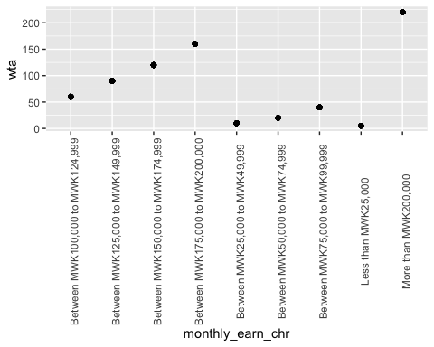

model_chr_fit <- lm(wta ~ monthly_earn_chr, data = survey_model_clean)

**Model summary**

summary(model_chr_fit)

Call:  
lm(formula = wta ~ monthly_earn_chr, data = survey_model_clean)  
  
Residuals:  
 Min 1Q Median 3Q Max   
-1.626e-12 -3.745e-14 0.000e+00 0.000e+00 2.868e-12   
  
Coefficients:  
 Estimate Std. Error  
(Intercept) 6.000e+01 4.543e-14  
monthly_earn_chrBetween MWK125,000 to MWK149,999 3.000e+01 7.313e-14  
monthly_earn_chrBetween MWK150,000 to MWK174,999 6.000e+01 6.221e-14  
monthly_earn_chrBetween MWK175,000 to MWK200,000 1.000e+02 8.112e-14  
monthly_earn_chrBetween MWK25,000 to MWK49,999 -5.000e+01 6.629e-14  
monthly_earn_chrBetween MWK50,000 to MWK74,999 -4.000e+01 6.629e-14  
monthly_earn_chrBetween MWK75,000 to MWK99,999 -2.000e+01 6.425e-14  
monthly_earn_chrLess than MWK25,000 -5.500e+01 9.291e-14  
monthly_earn_chrMore than MWK200,000 1.600e+02 5.635e-14  
 t value Pr(>|t|)   
(Intercept) 1.321e+15 <2e-16 ***  
monthly_earn_chrBetween MWK125,000 to MWK149,999 4.102e+14 <2e-16 ***  
monthly_earn_chrBetween MWK150,000 to MWK174,999 9.644e+14 <2e-16 ***  
monthly_earn_chrBetween MWK175,000 to MWK200,000 1.233e+15 <2e-16 ***  
monthly_earn_chrBetween MWK25,000 to MWK49,999 -7.542e+14 <2e-16 ***  
monthly_earn_chrBetween MWK50,000 to MWK74,999 -6.034e+14 <2e-16 ***  
monthly_earn_chrBetween MWK75,000 to MWK99,999 -3.113e+14 <2e-16 ***  
monthly_earn_chrLess than MWK25,000 -5.920e+14 <2e-16 ***  
monthly_earn_chrMore than MWK200,000 2.839e+15 <2e-16 ***  
---  
Signif. codes: 0 '***' 0.001 '**' 0.01 '*' 0.05 '.' 0.1 ' ' 1  
  
Residual standard error: 2.688e-13 on 277 degrees of freedom  
Multiple R-squared: 1, Adjusted R-squared: 1   
F-statistic: 3.013e+30 on 8 and 277 DF, p-value: < 2.2e-16

**Model coefficients**

broom::tidy(model_chr_fit)

# A tibble: 9 × 5  
 term estimate std.error statistic p.value  
 <chr> <dbl> <dbl> <dbl> <dbl>  
1 (Intercept) 60.0 4.54e-14 1.32e15 0  
2 monthly_earn_chrBetween MWK125,000 to MW… 30.0 7.31e-14 4.10e14 0  
3 monthly_earn_chrBetween MWK150,000 to MW… 60.0 6.22e-14 9.64e14 0  
4 monthly_earn_chrBetween MWK175,000 to MW… 100. 8.11e-14 1.23e15 0  
5 monthly_earn_chrBetween MWK25,000 to MWK… -50.0 6.63e-14 -7.54e14 0  
6 monthly_earn_chrBetween MWK50,000 to MWK… -40.0 6.63e-14 -6.03e14 0  
7 monthly_earn_chrBetween MWK75,000 to MWK… -20.0 6.43e-14 -3.11e14 0  
8 monthly_earn_chrLess than MWK25,000 -55.0 9.29e-14 -5.92e14 0  
9 monthly_earn_chrMore than MWK200,000 160. 5.64e-14 2.84e15 0

### Income ordered

survey_model_clean |>   
 ggplot(aes(x = monthly_earn_fct, y = wta)) +  
 geom_point() +   
 theme(axis.text.x = element_text(angle = 90))

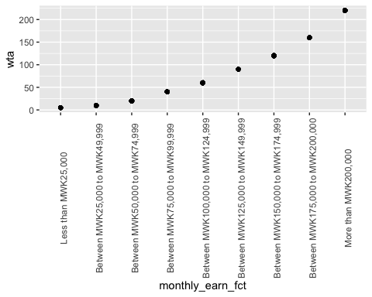

model_fct_fit <- lm(wta ~ monthly_earn_fct, data = survey_model_clean)

**Model summary**

summary(model_fct_fit)

Call:  
lm(formula = wta ~ monthly_earn_fct, data = survey_model_clean)  
  
Residuals:  
 Min 1Q Median 3Q Max   
-2.480e-12 0.000e+00 0.000e+00 3.517e-14 1.921e-12   
  
Coefficients:  
 Estimate Std. Error t value  
(Intercept) 5.000e+00 7.250e-14 6.896e+13  
monthly_earn_fctBetween MWK25,000 to MWK49,999 5.000e+00 8.439e-14 5.925e+13  
monthly_earn_fctBetween MWK50,000 to MWK74,999 1.500e+01 8.439e-14 1.777e+14  
monthly_earn_fctBetween MWK75,000 to MWK99,999 3.500e+01 8.312e-14 4.211e+14  
monthly_earn_fctBetween MWK100,000 to MWK124,999 5.500e+01 8.312e-14 6.617e+14  
monthly_earn_fctBetween MWK125,000 to MWK149,999 8.500e+01 8.880e-14 9.572e+14  
monthly_earn_fctBetween MWK150,000 to MWK174,999 1.150e+02 8.187e-14 1.405e+15  
monthly_earn_fctBetween MWK175,000 to MWK200,000 1.550e+02 9.419e-14 1.646e+15  
monthly_earn_fctMore than MWK200,000 2.150e+02 7.840e-14 2.742e+15  
 Pr(>|t|)   
(Intercept) <2e-16 ***  
monthly_earn_fctBetween MWK25,000 to MWK49,999 <2e-16 ***  
monthly_earn_fctBetween MWK50,000 to MWK74,999 <2e-16 ***  
monthly_earn_fctBetween MWK75,000 to MWK99,999 <2e-16 ***  
monthly_earn_fctBetween MWK100,000 to MWK124,999 <2e-16 ***  
monthly_earn_fctBetween MWK125,000 to MWK149,999 <2e-16 ***  
monthly_earn_fctBetween MWK150,000 to MWK174,999 <2e-16 ***  
monthly_earn_fctBetween MWK175,000 to MWK200,000 <2e-16 ***  
monthly_earn_fctMore than MWK200,000 <2e-16 ***  
---  
Signif. codes: 0 '***' 0.001 '**' 0.01 '*' 0.05 '.' 0.1 ' ' 1  
  
Residual standard error: 2.405e-13 on 277 degrees of freedom  
Multiple R-squared: 1, Adjusted R-squared: 1   
F-statistic: 3.765e+30 on 8 and 277 DF, p-value: < 2.2e-16

**Model coefficients**

broom::tidy(model_fct_fit)

# A tibble: 9 × 5  
 term estimate std.error statistic p.value  
 <chr> <dbl> <dbl> <dbl> <dbl>  
1 (Intercept) 5.00 7.25e-14 6.90e13 0  
2 monthly_earn_fctBetween MWK25,000 to MWK… 5.00 8.44e-14 5.92e13 0  
3 monthly_earn_fctBetween MWK50,000 to MWK… 15.0 8.44e-14 1.78e14 0  
4 monthly_earn_fctBetween MWK75,000 to MWK… 35.0 8.31e-14 4.21e14 0  
5 monthly_earn_fctBetween MWK100,000 to MW… 55.0 8.31e-14 6.62e14 0  
6 monthly_earn_fctBetween MWK125,000 to MW… 85.0 8.88e-14 9.57e14 0  
7 monthly_earn_fctBetween MWK150,000 to MW… 115 8.19e-14 1.40e15 0  
8 monthly_earn_fctBetween MWK175,000 to MW… 155. 9.42e-14 1.65e15 0  
9 monthly_earn_fctMore than MWK200,000 215 7.84e-14 2.74e15 0

### Income as numeric

survey_model_clean |>   
 ggplot(aes(x = monthly_earn_num, y = wta)) +  
 geom_point() +   
 geom_smooth(method = "lm") +  
 theme(axis.text.x = element_text(angle = 90))

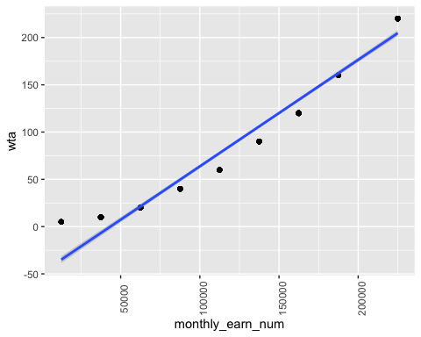

model_num_fit <- lm(wta ~ monthly_earn_num, data = survey_model_clean)

**Model summary**

summary(model_num_fit)

Call:  
lm(formula = wta ~ monthly_earn_num, data = survey_model_clean)  
  
Residuals:  
 Min 1Q Median 3Q Max   
-17.789 -14.167 -2.355 15.361 39.966   
  
Coefficients:  
 Estimate Std. Error t value Pr(>|t|)   
(Intercept) -4.906e+01 2.012e+00 -24.38 <2e-16 ***  
monthly_earn_num 1.128e-03 1.366e-05 82.52 <2e-16 ***  
---  
Signif. codes: 0 '***' 0.001 '**' 0.01 '*' 0.05 '.' 0.1 ' ' 1  
  
Residual standard error: 15.67 on 284 degrees of freedom  
Multiple R-squared: 0.96, Adjusted R-squared: 0.9598   
F-statistic: 6810 on 1 and 284 DF, p-value: < 2.2e-16

**Model coefficients**

broom::tidy(model_num_fit)

# A tibble: 2 × 5  
 term estimate std.error statistic p.value  
 <chr> <dbl> <dbl> <dbl> <dbl>  
1 (Intercept) -49.1 2.01 -24.4 1.32e- 71  
2 monthly_earn_num 0.00113 0.0000137 82.5 1.69e-200