STUDENT DROPOUT & ACADEMIC SUCCESS
Exploratory Data Analysis Project Report
Dataset: UCI – Predict Students' Dropout and Academic Success

Group No. 10
Student Name | Roll No.
Rushali | 62
Rutvi Prajapati | 64
Saabir | 65
Sana pathan | 67
Sahil  Sandeep | 66  68

PROJECT REPORT: PREDICT STUDENTS' DROPOUT AND ACADEMIC SUCCESS
F.Y. BCA Semester I |Div B | Group No. 10|
SECTION 1: INTRODUCTION & OBJECTIVE
• Introduction: High student dropout rates present a significant challenge for higher education institutions. When students leave university early, it affects their personal career prospects and impacts institutional resources. Understanding the hidden patterns behind why students struggle is essential for building better support systems.
• Objective: The primary objective of this project is to analyze various student attributes—including demographic backgrounds, socio-economic factors, and early academic performance—to identify key indicators that contribute to either student dropouts or successful graduation.
SECTION 2: DATASET DESCRIPTION
• Dataset Name: Predict Students' Dropout and Academic Success.
• Source: UCI Machine Learning Repository.
• Data Size: The dataset contains a total of 4,424 records (rows representing individual students) and 36 variables (columns tracking different student traits).
• Target Output: The final column, labeled "Target", tracks three potential student outcomes: Dropout, Enrolled, or Graduate.
SECTION 3: DATA TYPES AND VARIABLES
The dataset features are broadly categorized into two types:
• Categorical Variables (Qualitative Data): These represent distinct groupings or coded classifications.
Examples from our sheet: Marital status (e.g., 1 = Single, 2 = Married), Gender (1 = Male, 0 = Female), Scholarship holder (1 = Yes, 0 = No), and Tuition fees up to date (1 = Yes, 0 = No).
• Numerical Variables (Quantitative Data): These represent measurable counts or values.
Examples from our sheet: Age at enrollment, Curricular units 1st sem (credited, enrolled, evaluations, approved, grade), and macroeconomic data like the Unemployment rate and Inflation rate.
SECTION 4: TOOLS USED FOR ANALYSIS
To process, clean, visualize, and model the dataset, the following modern data science tools were utilized:
- Google Colab: Used as the primary cloud-based development environment to write, run, and share the project's code framework smoothly across the team without local software installation limits.
- Python 3.x: Applied as the core programming language using industry-standard libraries to compute mathematical indicators and manipulate data:
  - pandas and numpy: For handling the 4,424 rows, grouping student buckets, and calculating aggregations.
  - matplotlib and seaborn: For rendering data distributions, scatter plots, and the final correlation heatmap.
  - scikit-learn: For building, training, and testing the Predictive Random Forest model to flag student pathways.
- Claude AI: Utilized as an adaptive collaborative AI assistant to structure code blocks, interpret statistical variables, and compile individual data summaries into a cohesive project report template.
SECTION 5: DATA QUALITY ASSESSMENT
A thorough review of the dataset was conducted using Python data frames to check for structural bugs, discrepancies, and missing data points:
- Missing Values: Using the df.isnull().sum() function, we programmatically verified that there are zero blank or missing values across all 4,424 rows. The dataset is entirely complete.
- Structure Fix: The raw data file was loaded as a semicolon-delimited CSV. This structural hurdle was quickly resolved by configuring the Pandas separator parameter directly in our environment script (pd.read_csv('data.csv', sep=';')), cleanly arranging all 36 features into independent columns.
- Outliers: An execution check on the Age at enrollment column showed a range spanning from 17 to 70 years old. These rows were kept because they represent valid adult education student records rather than data entry errors.

SECTION 6: DESCRIPTIVE STATISTICS
We summarized the key numerical features of our student demographic profile to establish an analytical baseline:
• Total Student Records Analyzed: 4,424
• Student Age at Enrollment:
- Average (Mean) Age: 23.27 years
- Minimum Age: 17 years
- Maximum Age: 70 years
• Academic Performance Baseline: The average admission grades and first-semester evaluation frequencies were tracked to assess baseline entry levels across the entire cohort.
SECTION 7: UNIVARIATE ANALYSIS
7.1 Objective
Univariate analysis studies each variable on its own. Here we look at how the outcome variable (Target) is distributed and how each of the 36 numerical features is spread, so we understand the data before comparing variables with each other.
7.2 Dataset Loaded Summary
Item | Value
File | data.csv
Rows (students) | 4,424
Columns | 37 (36 features + Target)
Missing values | 0
Duplicate rows | 0
7.3 Target Variable Distribution
The Target column has three classes: Dropout, Enrolled and Graduate.
Student Outcome | Number of Students | Percentage
Graduate | 2,209 | 49.9%
Dropout | 1,421 | 32.1%
Enrolled | 794 | 17.9%
Total | 4,424 | 100%
Observation: Almost half of the students graduated, about one in three dropped out, and only 17.9% are still enrolled. The classes are not perfectly balanced, and Enrolled is the smallest group.
7.4 Numerical Variables & Summary Statistics
All 36 feature columns are numerical (integer or float). Many of them are numeric codes of categories, so their histograms show a few separate bars rather than a smooth curve.
Variable | Mean | Median | Std. Dev. | Min | Max
Age at enrollment | 23.27 | 20.00 | 7.59 | 17 | 70
Admission grade | 126.98 | 126.10 | 14.48 | 95.0 | 190.0
Previous qualification (grade) | 132.61 | 133.10 | 13.19 | 95.0 | 190.0
1st sem grade | 10.64 | 12.29 | 4.84 | 0.00 | 18.88
2nd sem grade | 10.23 | 12.20 | 5.21 | 0.00 | 18.57
Unemployment rate | 11.57 | 11.10 | 2.66 | 7.6 | 16.2
Inflation rate | 1.23 | 1.40 | 1.38 | -0.8 | 3.7
GDP | 0.00 | 0.32 | 2.27 | -4.06 | 3.51
7.5 Key Observations
• Age at enrollment is right-skewed (skewness about 2.05). The mean (23.27) is higher than the median (20), so most students join at 17–25 years but a few older students pull the average up.
• Admission grade is close to symmetric, centred near 127 on a 95–190 scale.
• Semester grades have a median (about 12.2) clearly above the mean (about 10.4), because some students have a grade of 0 (no approved units). This hints at students who left early.
• Economic indicators (unemployment, inflation, GDP) take only a few distinct values because they depend on the year of enrollment, not on the individual student.
7.6 Additional Work: Random Forest Prediction Model
Along with the exploratory steps, a Random Forest classifier (200 trees) was trained to predict the student outcome (80/20 train/test split).
Class | Precision | Recall | F1-score | Support
Dropout | 0.80 | 0.75 | 0.77 | 284
Enrolled | 0.55 | 0.34 | 0.42 | 159
Graduate | 0.79 | 0.93 | 0.85 | 442
Weighted avg | 0.75 | 0.76 | 0.75 | 885
Overall model accuracy achieved: 76.5% (Precision 74.88%, Recall 76.5%, F1 74.93% weighted). The trained model was successfully compiled and saved as student_dropout_model.pkl.
SECTION 8: BIVARIATE ANALYSIS
8.1 Objective
Bivariate analysis compares two variables at a time. We check how student characteristics such as age, admission grade, gender and course are related to each other and to the final outcome (Dropout, Enrolled, Graduate).
8.2 Age vs Admission Grade
• The correlation between age and admission grade is about -0.03, showing that there is essentially no linear relationship.
• About 85% of students are 30 years old or younger; older students are few and spread across all grade levels.
• Dropouts are on average older (mean age 26.1) than Enrolled (22.4) and Graduate (21.8) students.
8.3 Gender vs Student Outcome
In the original UCI dataset encoding rules, Gender code 1 represents Male and 0 represents Female.
Gender Code | Dropout | Enrolled | Graduate | Dropout Rate
0 (Female) | 720 | 487 | 1,661 | 25.1%
1 (Male) | 701 | 307 | 548 | 45.1%
Observation: Gender 1 (Male) has a much higher dropout rate (45.1%) than Gender 0 (Female, 25.1%), and Gender 0 achieves far more graduates.
8.4 Course vs Student Outcome Insights
• Course 9500 has the most students (766) and the lowest dropout rate (15.4%), followed by course 9238 (18.3%).
• Courses 9119 (54.1%) and 9130 (55.3%) show the highest dropout rates among large courses.
• Course 33 has only 12 students, so its high dropout rate (66.7%) should not be over-interpreted.
8.5 Core Correlation Breakdowns
• 1st and 2nd semester variables are strongly related: approved units (r = 0.90) and enrolled units (r = 0.94).
• Against dropout, the strongest negative correlations are 2nd sem grade (-0.57), 2nd sem approved units (-0.57), 1st sem grade (-0.48) and 1st sem approved units (-0.48).
• Tuition fees up to date is negatively related to dropout (-0.43), while Age at enrollment (0.25), Debtor (0.23) and Gender (0.20) are positively related.
SECTION 9: GROUPING AND AGGREGATION
9.1 Objective
Grouping and aggregation condenses the 4,424 student records into group-level summaries: number of students, average admission grade and average age, grouped by Course and by Target.
9.2 Student Metrics and Outcomes Grouped By Course
Course Code | Total Students | Avg. Admission Grade | Dropout | Enrolled | Graduate
33 | 12 | 118.56 | 8 | 3 | 1
171 | 215 | 136.16 | 82 | 37 | 96
8014 | 215 | 122.18 | 71 | 21 | 123
9003 | 210 | 132.76 | 86 | 37 | 87
9070 | 226 | 128.89 | 51 | 42 | 133
9085 | 337 | 131.17 | 90 | 75 | 172
9119 | 170 | 126.40 | 92 | 64 | 14
9130 | 141 | 132.41 | 78 | 21 | 42
9147 | 380 | 122.83 | 134 | 108 | 138
9238 | 355 | 125.58 | 65 | 42 | 248
9254 | 252 | 121.57 | 96 | 41 | 115
9500 | 766 | 127.26 | 118 | 100 | 548
9556 | 86 | 123.09 | 33 | 17 | 36
9670 | 268 | 121.46 | 95 | 48 | 125
9773 | 331 | 127.96 | 101 | 34 | 196
9853 | 192 | 123.16 | 85 | 50 | 57
9991 | 268 | 130.24 | 136 | 54 | 78
9.3 Student Outcome and Age Summary
Target | Number of Students | Average Age
Dropout | 1,421 | 26.07
Enrolled | 794 | 22.37
Graduate | 2,209 | 21.78
Observation: Dropout students are about four years older on average than Graduates (26.07 vs 21.78), which perfectly matches our bivariate tracking outcomes.
9.4 Student Outcomes by Tuition Status and Scholarship Matrix
A three-tier cross-tabulation detailing the intersection of student outcomes, financial payment indicators, and active scholarship holding:
Outcome | Tuition Status | Scholarship | Students Count | % of Outcome
Graduate | Paid | No | 1,354 | 61.3%
Graduate | Paid | Yes | 826 | 37.4%
Graduate | Unpaid | No | 20 | 0.9%
Graduate | Unpaid | Yes | 9 | 0.4%
Dropout | Paid | No | 858 | 60.4%
Dropout | Paid | Yes | 106 | 7.5%
Dropout | Unpaid | No | 429 | 30.2%
Dropout | Unpaid | Yes | 28 | 2.0%
Enrolled | Paid | No | 631 | 79.5%
Enrolled | Paid | Yes | 121 | 15.2%
Enrolled | Unpaid | No | 33 | 4.2%
Enrolled | Unpaid | Yes | 9 | 1.1%
9.5 Core Socio-Economic Takeaways
• Unpaid fees: 457 of 1,421 dropouts (32%) vs. only 29 of 2,209 graduates (1%) suffer from outstanding unpaid tuition balances.
• Scholarships: 826 graduates (37%) held an active scholarship vs. only 106 dropouts (7.5%).
• High-Risk Segment: Unpaid tuition fees paired with no scholarship support resulted in 429 dropouts compared to only 20 graduates.

10. Correlation Heatmap

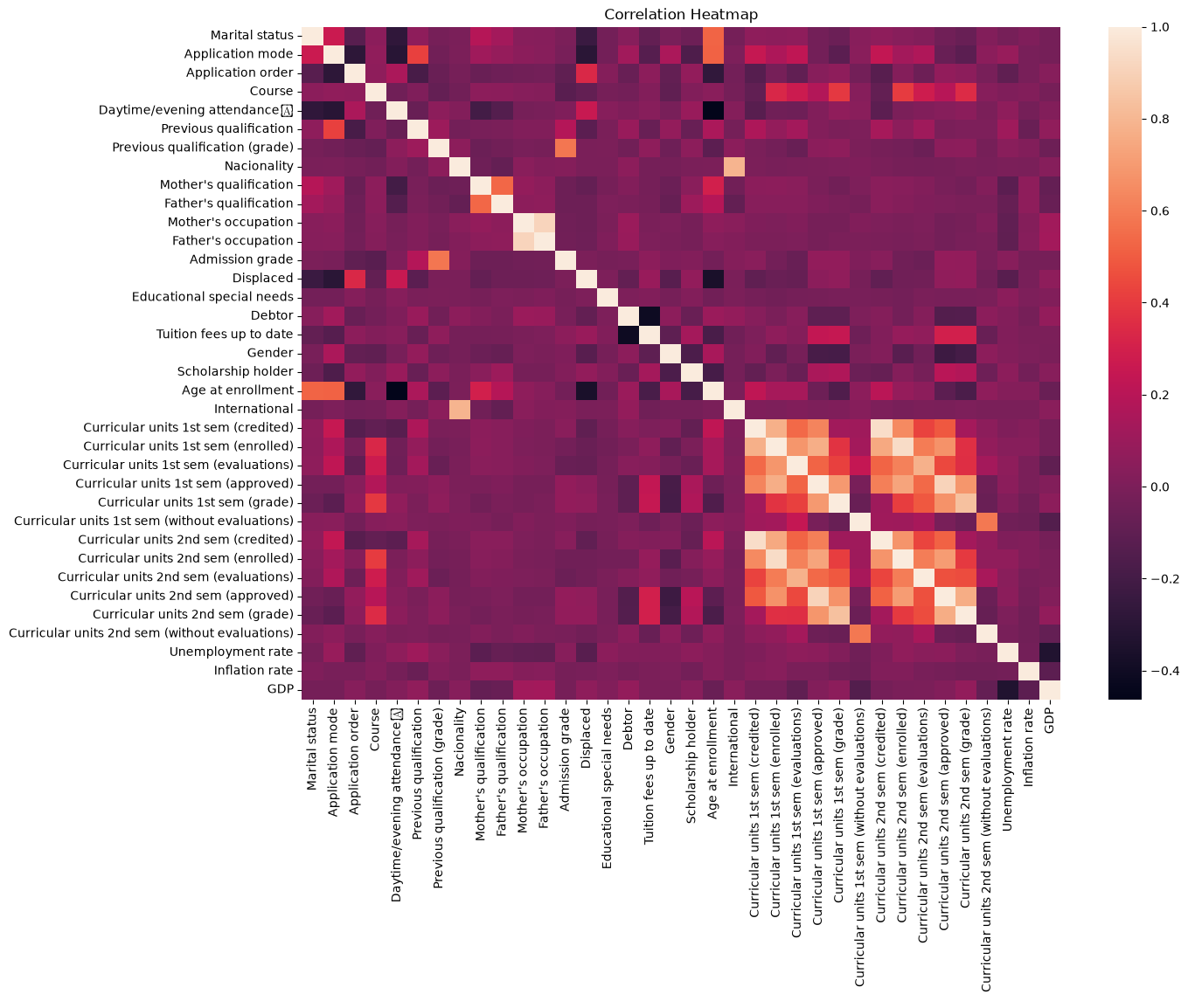

Figure 8.4: Correlation heatmap of numerical variables
- 1st and 2nd semester variables are strongly related: approved units (r = 0.90) and enrolled units (r = 0.94).
- Against dropout, the strongest negative correlations are 2nd sem grade (-0.57), 2nd sem approved units (-0.57), 1st sem grade (-0.48) and 1st sem approved units (-0.48).
- Tuition fees up to date is negatively related to dropout (-0.43), while Age at enrollment (0.25), Debtor (0.23) and Gender (0.20) are positively related. Student Outcomes by Tuition Status and Scholarship

11. Visualisation :
4,424 students: 2,209 Graduate, 1,421 Dropout, 794 Enrolled
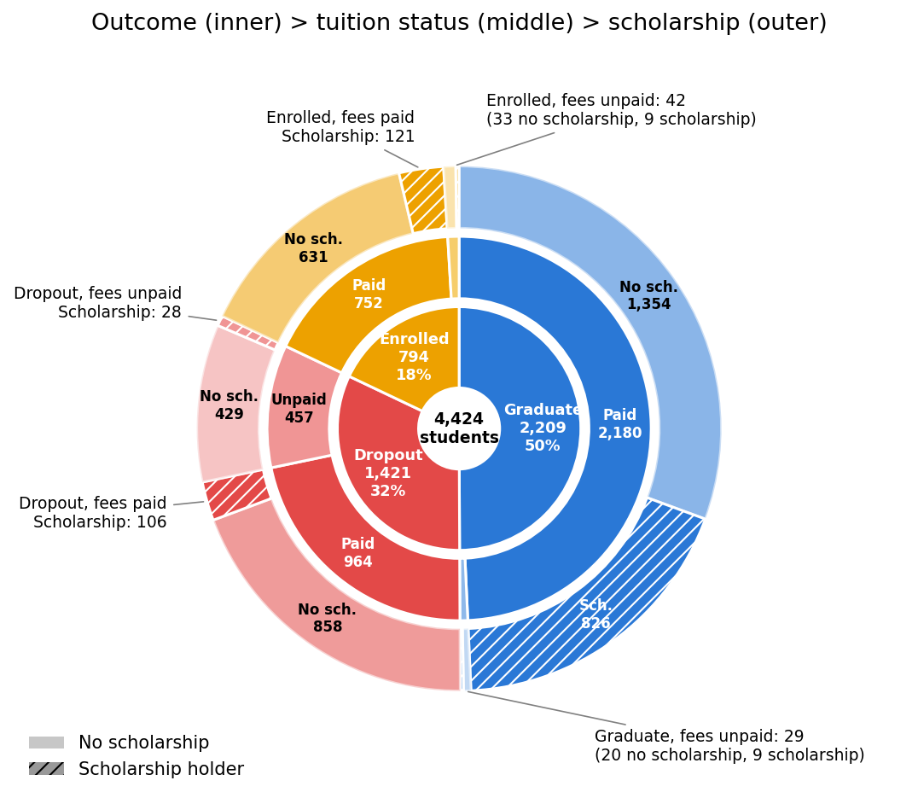
Inner ring: outcome. Middle ring: tuition status. Outer ring: scholarship (hatched = holder).

Data
Outcome | Tuition | Scholarship | Students | % of outcome | % of total
Graduate | Paid | No | 1,354 | 61.3% | 30.6%
Graduate | Paid | Yes | 826 | 37.4% | 18.7%
Graduate | Unpaid | No | 20 | 0.9% | 0.5%
Graduate | Unpaid | Yes | 9 | 0.4% | 0.2%
Dropout | Paid | No | 858 | 60.4% | 19.4%
Dropout | Paid | Yes | 106 | 7.5% | 2.4%
Dropout | Unpaid | No | 429 | 30.2% | 9.7%
Dropout | Unpaid | Yes | 28 | 2.0% | 0.6%
Enrolled | Paid | No | 631 | 79.5% | 14.3%
Enrolled | Paid | Yes | 121 | 15.2% | 2.7%
Enrolled | Unpaid | No | 33 | 4.2% | 0.7%
Enrolled | Unpaid | Yes | 9 | 1.1% | 0.2%

Key takeaways
- Unpaid fees: 457 of 1,421 dropouts (32%) vs. 29 of 2,209 graduates (1%).
- Scholarships: 826 graduates (37%) held one vs. 106 dropouts (7.5%).
- Unpaid fees with no scholarship: 429 dropouts vs. 20 graduates.
SECTION 12: KEY FINDINGS
• The Power of Financial Support: Our bivariate and aggregate analysis metrics reveal that students who are Scholarship Holders have a drastically higher graduation rate compared to non-holders. Financial stability stands out as a core baseline for academic retention.
• Early Warning Signs: A student's performance in their 1st Semester shows a powerful positive correlation with their 2nd-semester success. Students who fail or drop multiple curricular units in their very first term are at the highest statistical risk of dropping out completely.
• Financial Red Flags: Students whose Tuition fees are not up to date represent a massive portion of the dropout segment (32%). Falling behind on tuition payments is an immediate predictor of a student leaving the university.
SECTION 13: CONCLUSION
This project successfully analyzed the multi-dimensional factors influencing university student outcomes using the UCI dataset. In conclusion, academic success is not just determined by a student's personal intelligence; it is heavily shaped by their financial security status and how well they adjust to their very first semester of college.
By utilizing these empirical findings, higher education institutions can design early-intervention warning systems. For example, if a university automatically flags students who are falling behind on tuition parameters or struggling with credits in their first three months, they can provide targeted counseling or financial relief before the student reaches a definitive dropout outcome.
SECTION 14: REFERENCES
- Primary Dataset: Real-world student cohort tracking data obtained from the UCI Machine Learning Repository: Predict Students' Dropout and Academic Success Dataset.
- Data Documentation: Information on numeric column encodings, attribute definitions, and target variable meanings referenced via the official UCI Dataset Portal.
- Software Libraries & Environment: Data manipulation, statistical testing, and the Random Forest classification model executed using Python 3.x libraries (Pandas, NumPy, Scikit-Learn) hosted within the cloud-based Google Colab Notebook environment.
- Visualization Tools: Analytical data charts, scatter plots, and correlation matrices generated utilizing Python’s Seaborn and Matplotlib visualization engines.
- AI Collaboration: Architectural structure, text synthesis, and individual module integration completed with the collaborative assistance of Claude AI (Anthropic)

SECTION 15: CODE (GITHUB)

• Public Repository Link: [Insert team's public GitHub link here]
• Repository Contents: This public repository contains our finalized, fully compiled project report document (.docx) and the completely cleaned, decoded Excel workspace workbook (.xlsx) featuring our active baseline Pivot Tables, descriptive statistics data summaries, and structured analysis configurations.

