0 Basic summaries

0.1 Difference in demographics Global vs China
Demographic factor | Global | China
Gender (Female vs male) | ~3:1 | ~1:1
Age (<60 vs >= 60) | ~1:1 | ~4:1 (placebo, 15 mg)  ~3:1 (45 mg)
Baseline cough frequency
RCC/UCC | ~2:1 | ~1:10
Duration of chronic cough (years)  (<10 vs >=10) | ~1:1 | ~2:1

0.2 Descriptive summary
Summary of 24-hour coughs frequency (GM) over time by treatment
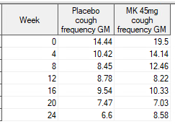

Summary of GMR (geometric mean of the ratio of post-baseline/baseline for 24-hour coughs frequency) over time by treatment (same as ERM)
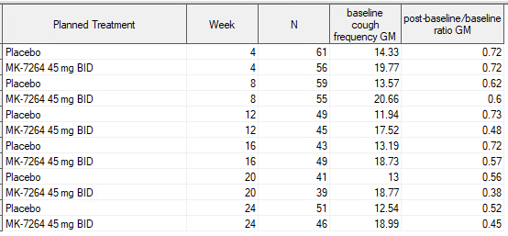

Sample GMR over time by gender

Sample GMR over time by primary diagnosis type (UCC vs RCC)

Sample GMR over time by duration of chronic cough (<10 years vs >= 10 years)

Sample GMR over time by age group (<60 yrs, =- 60 yrs)

0.3 DISTRIBUTION OF change from baseline on the log scale
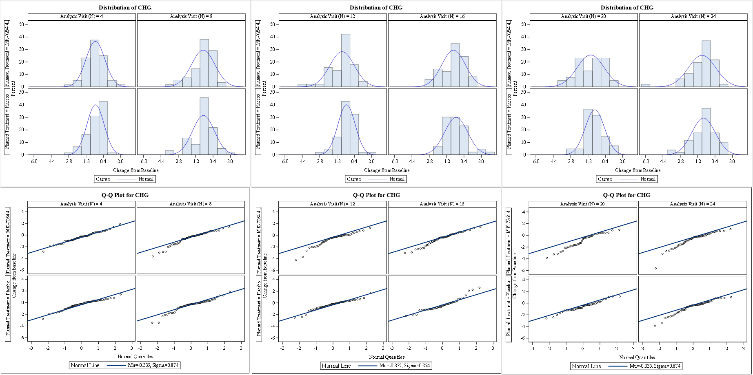

0.4 BOXPLOT change from baseline on the log scale
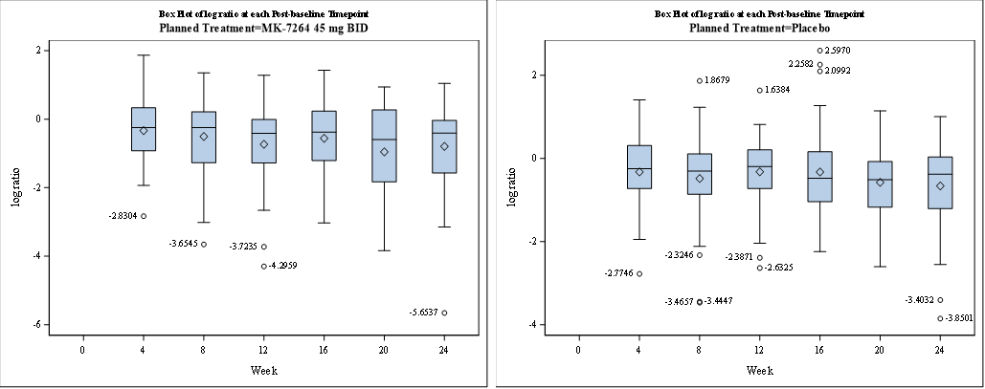

1. Run an ANCOVA model at each time point

proc sort data = v1; by avisitn trtpn sex; run;
proc mixed data=v1;
where avisitn in (4, 8, 12, 16, 20, 24);
by avisitn;
class usubjid trtpn(ref='1') avisitn sex;
model chg = base trtpn sex / noint ddfm = kr solution;
run;

Week 4:
Solution for Fixed Effects
Effect | Sex | Planned Treatment (N) | Estimate | Standard  Error | DF | t Value | Pr > |t|
BASE |  |  | -0.07583 | 0.06296 | 113 | -1.20 | 0.2309
TRTPN |  | 3 | -0.1688 | 0.2246 | 113 | -0.75 | 0.4538
TRTPN |  | 1 | -0.1858 | 0.2081 | 113 | -0.89 | 0.3739
SEX | F |  | 0.1238 | 0.1552 | 113 | 0.80 | 0.4269
SEX | M |  | 0 | . | . | . | .

Week 8:
Solution for Fixed Effects
Effect | Sex | Planned Treatment(N) | Estimate | Standard  Error | DF | t Value | Pr > |t|
BASE |  |  | -0.02673 | 0.08321 | 110 | -0.32 | 0.7487
TRTPN |  | 3 | -0.3947 | 0.2932 | 110 | -1.35 | 0.1810
TRTPN |  | 1 | -0.3783 | 0.2649 | 110 | -1.43 | 0.1560
SEX | F |  | -0.06149 | 0.1999 | 110 | -0.31 | 0.7590
SEX | M |  | 0 | . | . | . | .

Week 12:
Solution for Fixed Effects
Effect | Sex | Planned Treatment(N) | Estimate | Standard  Error | DF | t Value | Pr > |t|
BASE |  |  | -0.04928 | 0.08374 | 90 | -0.59 | 0.5577
TRTPN |  | 3 | -0.5396 | 0.2798 | 90 | -1.93 | 0.0569
TRTPN |  | 1 | -0.1353 | 0.2548 | 90 | -0.53 | 0.5968
SEX | F |  | -0.1208 | 0.2061 | 90 | -0.59 | 0.5593
SEX | M |  | 0 | . | . | . | .

Week 16:
Solution for Fixed Effects
Effect | Sex | Planned Treatment (N) | Estimate | Standard  Error | DF | t Value | Pr > |t|
BASE |  |  | -0.09503 | 0.09091 | 88 | -1.05 | 0.2988
TRTPN |  | 3 | -0.1729 | 0.3169 | 88 | -0.55 | 0.5867
TRTPN |  | 1 | 0.03506 | 0.2988 | 88 | 0.12 | 0.9069
SEX | F |  | -0.2224 | 0.2248 | 88 | -0.99 | 0.3252
SEX | M |  | 0 | . | . | . | .

Week 20:
Solution for Fixed Effects
Effect | Sex | Planned Treatment (N) | Estimate | Standard  Error | DF | t Value | Pr > |t|
BASE |  |  | -0.05674 | 0.09729 | 76 | -0.58 | 0.5615
TRTPN |  | 3 | -0.7177 | 0.3488 | 76 | -2.06 | 0.0431
TRTPN |  | 1 | -0.3621 | 0.3156 | 76 | -1.15 | 0.2548
SEX | F |  | -0.1269 | 0.2455 | 76 | -0.52 | 0.6067
SEX | M |  | 0 | . | . | . | .
Week 24:
Solution for Fixed Effects
Effect | Sex | Planned Treatment (N) | Estimate | Standard  Error | DF | t Value | Pr > |t|
BASE |  |  | -0.1614 | 0.09892 | 93 | -1.63 | 0.1062
TRTPN |  | 3 | -0.1854 | 0.3444 | 93 | -0.54 | 0.5916
TRTPN |  | 1 | -0.1243 | 0.3064 | 93 | -0.41 | 0.6858
SEX | F |  | -0.2476 | 0.2382 | 93 | -1.04 | 0.3013
SEX | M |  | 0 | . | . | . | .

As a comparison, here is the parameter estimate for the longitudinal ANCOVA model:
Solution for Fixed Effects
Effect | Sex | Planned Treatment (N) | Analysis Visit (N) | Estimate | Standard  Error | DF | t Value | Pr > |t|
BASE |  |  |  | -0.06020 | 0.06324 | 112 | -0.95 | 0.3431
TRTPN |  | 3 |  | -0.2614 | 0.2248 | 115 | -1.16 | 0.2473
TRTPN |  | 1 |  | -0.2518 | 0.2081 | 115 | -1.21 | 0.2288
AVISITN |  |  | 8 | -0.2832 | 0.2505 | 108 | -1.13 | 0.2607
AVISITN |  |  | 12 | -0.05763 | 0.2278 | 95 | -0.25 | 0.8008
AVISITN |  |  | 16 | 0.08002 | 0.2587 | 106 | 0.31 | 0.7577
AVISITN |  |  | 20 | -0.2524 | 0.2476 | 96.7 | -1.02 | 0.3105
AVISITN |  |  | 24 | -0.07577 | 0.2882 | 91.8 | -0.26 | 0.7932
AVISITN |  |  | 4 | 0 | . | . | . | .
TRTPN*AVISITN |  | 3 | 8 | -0.01233 | 0.1972 | 112 | -0.06 | 0.9503
TRTPN*AVISITN |  | 3 | 12 | -0.1968 | 0.1839 | 105 | -1.07 | 0.2870
TRTPN*AVISITN |  | 3 | 16 | -0.1703 | 0.2053 | 111 | -0.83 | 0.4086
TRTPN*AVISITN |  | 3 | 20 | -0.2344 | 0.1986 | 104 | -1.18 | 0.2407
TRTPN*AVISITN |  | 3 | 24 | 0.09299 | 0.2293 | 98.2 | 0.41 | 0.6860
TRTPN*AVISITN |  | 3 | 4 | 0 | . | . | . | .
TRTPN*AVISITN |  | 1 | 8 | 0 | . | . | . | .
TRTPN*AVISITN |  | 1 | 12 | 0 | . | . | . | .
TRTPN*AVISITN |  | 1 | 16 | 0 | . | . | . | .
TRTPN*AVISITN |  | 1 | 20 | 0 | . | . | . | .
TRTPN*AVISITN |  | 1 | 24 | 0 | . | . | . | .
TRTPN*AVISITN |  | 1 | 4 | 0 | . | . | . | .
BASE*AVISITN |  |  | 8 | 0.04525 | 0.08075 | 109 | 0.56 | 0.5764
BASE*AVISITN |  |  | 12 | -0.00243 | 0.07447 | 99.7 | -0.03 | 0.9740
BASE*AVISITN |  |  | 16 | -0.03137 | 0.08276 | 106 | -0.38 | 0.7055
BASE*AVISITN |  |  | 20 | 0.01998 | 0.07992 | 98.6 | 0.25 | 0.8031
BASE*AVISITN |  |  | 24 | -0.1126 | 0.09394 | 96.2 | -1.20 | 0.2334
BASE*AVISITN |  |  | 4 | 0 | . | . | . | .
SEX | F |  |  | 0.1098 | 0.1457 | 116 | 0.75 | 0.4526
SEX | M |  |  | 0 | . | . | . | .

2. Various subsets of covariates

model chg = trtpn avisitn trtpn * avisitn / noint ddfm = kr solution;

Solution for Fixed Effects
Effect | Planned Treatment (N) | Analysis Visit (N) | Estimate | Standard  Error | DF | t Value | Pr > |t|
TRTPN | 3 |  | -0.3880 | 0.1115 | 116 | -3.48 | 0.0007
TRTPN | 1 |  | -0.3567 | 0.1077 | 113 | -3.31 | 0.0012
AVISITN |  | 8 | -0.1660 | 0.1338 | 110 | -1.24 | 0.2175
AVISITN |  | 12 | -0.06315 | 0.1239 | 101 | -0.51 | 0.6115
AVISITN |  | 16 | -0.00072 | 0.1428 | 114 | -0.01 | 0.9960
AVISITN |  | 20 | -0.2002 | 0.1347 | 101 | -1.49 | 0.1404
AVISITN |  | 24 | -0.3595 | 0.1568 | 92.9 | -2.29 | 0.0241
AVISITN |  | 4 | 0 | . | . | . | .
TRTPN*AVISITN | 3 | 8 | 0.008938 | 0.1943 | 112 | 0.05 | 0.9634
TRTPN*AVISITN | 3 | 12 | -0.1917 | 0.1808 | 105 | -1.06 | 0.2915
TRTPN*AVISITN | 3 | 16 | -0.1785 | 0.2018 | 112 | -0.88 | 0.3784
TRTPN*AVISITN | 3 | 20 | -0.2230 | 0.1954 | 104 | -1.14 | 0.2564
TRTPN*AVISITN | 3 | 24 | 0.04926 | 0.2280 | 97 | 0.22 | 0.8294
TRTPN*AVISITN | 3 | 4 | 0 | . | . | . | .
TRTPN*AVISITN | 1 | 8 | 0 | . | . | . | .
TRTPN*AVISITN | 1 | 12 | 0 | . | . | . | .
TRTPN*AVISITN | 1 | 16 | 0 | . | . | . | .
TRTPN*AVISITN | 1 | 20 | 0 | . | . | . | .
TRTPN*AVISITN | 1 | 24 | 0 | . | . | . | .
TRTPN*AVISITN | 1 | 4 | 0 | . | . | . | .

model chg = trtpn avisitn trtpn * avisitn sex / noint ddfm = kr solution;

Solution for Fixed Effects
Effect | Sex | Planned Treatment (N) | Analysis Visit (N) | Estimate | Standard  Error | DF | t Value | Pr > |t|
TRTPN |  | 3 |  | -0.4353 | 0.1321 | 125 | -3.30 | 0.0013
TRTPN |  | 1 |  | -0.4064 | 0.1310 | 126 | -3.10 | 0.0024
AVISITN |  |  | 8 | -0.1644 | 0.1336 | 110 | -1.23 | 0.2213
AVISITN |  |  | 12 | -0.06190 | 0.1237 | 101 | -0.50 | 0.6180
AVISITN |  |  | 16 | 0.000487 | 0.1428 | 114 | 0.00 | 0.9973
AVISITN |  |  | 20 | -0.1988 | 0.1347 | 101 | -1.48 | 0.1432
AVISITN |  |  | 24 | -0.3586 | 0.1566 | 93 | -2.29 | 0.0243
AVISITN |  |  | 4 | 0 | . | . | . | .
TRTPN*AVISITN |  | 3 | 8 | 0.008144 | 0.1941 | 113 | 0.04 | 0.9666
TRTPN*AVISITN |  | 3 | 12 | -0.1922 | 0.1805 | 105 | -1.06 | 0.2895
TRTPN*AVISITN |  | 3 | 16 | -0.1795 | 0.2018 | 112 | -0.89 | 0.3754
TRTPN*AVISITN |  | 3 | 20 | -0.2243 | 0.1954 | 105 | -1.15 | 0.2538
TRTPN*AVISITN |  | 3 | 24 | 0.04899 | 0.2278 | 97.1 | 0.22 | 0.8302
TRTPN*AVISITN |  | 3 | 4 | 0 | . | . | . | .
TRTPN*AVISITN |  | 1 | 8 | 0 | . | . | . | .
TRTPN*AVISITN |  | 1 | 12 | 0 | . | . | . | .
TRTPN*AVISITN |  | 1 | 16 | 0 | . | . | . | .
TRTPN*AVISITN |  | 1 | 20 | 0 | . | . | . | .
TRTPN*AVISITN |  | 1 | 24 | 0 | . | . | . | .
TRTPN*AVISITN |  | 1 | 4 | 0 | . | . | . | .
SEX | F |  |  | 0.09671 | 0.1455 | 117 | 0.66 | 0.5077
SEX | M |  |  | 0 | . | . | . | .

model chg = trtpn avisitn trtpn * avisitn sex base / noint ddfm = kr solution;
Solution for Fixed Effects
Effect | Sex | Planned Treatment (N) | Analysis Visit (N) | Estimate | Standard  Error | DF | t Value | Pr > |t|
TRTPN |  | 3 |  | -0.2477 | 0.2162 | 124 | -1.15 | 0.2540
TRTPN |  | 1 |  | -0.2390 | 0.2012 | 122 | -1.19 | 0.2370
AVISITN |  |  | 8 | -0.1660 | 0.1338 | 110 | -1.24 | 0.2176
AVISITN |  |  | 12 | -0.06372 | 0.1240 | 100 | -0.51 | 0.6085
AVISITN |  |  | 16 | -0.00033 | 0.1429 | 114 | -0.00 | 0.9982
AVISITN |  |  | 20 | -0.2000 | 0.1348 | 100 | -1.48 | 0.1411
AVISITN |  |  | 24 | -0.3594 | 0.1566 | 93 | -2.30 | 0.0240
AVISITN |  |  | 4 | 0 | . | . | . | .
TRTPN*AVISITN |  | 3 | 8 | 0.008593 | 0.1943 | 112 | 0.04 | 0.9648
TRTPN*AVISITN |  | 3 | 12 | -0.1931 | 0.1808 | 104 | -1.07 | 0.2881
TRTPN*AVISITN |  | 3 | 16 | -0.1803 | 0.2019 | 112 | -0.89 | 0.3739
TRTPN*AVISITN |  | 3 | 20 | -0.2252 | 0.1955 | 104 | -1.15 | 0.2521
TRTPN*AVISITN |  | 3 | 24 | 0.04704 | 0.2278 | 97.2 | 0.21 | 0.8368
TRTPN*AVISITN |  | 3 | 4 | 0 | . | . | . | .
TRTPN*AVISITN |  | 1 | 8 | 0 | . | . | . | .
TRTPN*AVISITN |  | 1 | 12 | 0 | . | . | . | .
TRTPN*AVISITN |  | 1 | 16 | 0 | . | . | . | .
TRTPN*AVISITN |  | 1 | 20 | 0 | . | . | . | .
TRTPN*AVISITN |  | 1 | 24 | 0 | . | . | . | .
TRTPN*AVISITN |  | 1 | 4 | 0 | . | . | . | .
SEX | F |  |  | 0.1088 | 0.1458 | 116 | 0.75 | 0.4572
SEX | M |  |  | 0 | . | . | . | .
BASE |  |  |  | -0.06491 | 0.05997 | 115 | -1.08 | 0.2814

model chg = base trtpn avisitn trtpn * avisitn base * avisitn sex / noint ddfm = kr solution;
(the prespecified analysis)
Solution for Fixed Effects
Effect | Sex | Planned Treatment (N) | Analysis Visit (N) | Estimate | Standard  Error | DF | t Value | Pr > |t|
BASE |  |  |  | -0.06020 | 0.06324 | 112 | -0.95 | 0.3431
TRTPN |  | 3 |  | -0.2614 | 0.2248 | 115 | -1.16 | 0.2473
TRTPN |  | 1 |  | -0.2518 | 0.2081 | 115 | -1.21 | 0.2288
AVISITN |  |  | 8 | -0.2832 | 0.2505 | 108 | -1.13 | 0.2607
AVISITN |  |  | 12 | -0.05763 | 0.2278 | 95 | -0.25 | 0.8008
AVISITN |  |  | 16 | 0.08002 | 0.2587 | 106 | 0.31 | 0.7577
AVISITN |  |  | 20 | -0.2524 | 0.2476 | 96.7 | -1.02 | 0.3105
AVISITN |  |  | 24 | -0.07577 | 0.2882 | 91.8 | -0.26 | 0.7932
AVISITN |  |  | 4 | 0 | . | . | . | .
TRTPN*AVISITN |  | 3 | 8 | -0.01233 | 0.1972 | 112 | -0.06 | 0.9503
TRTPN*AVISITN |  | 3 | 12 | -0.1968 | 0.1839 | 105 | -1.07 | 0.2870
TRTPN*AVISITN |  | 3 | 16 | -0.1703 | 0.2053 | 111 | -0.83 | 0.4086
TRTPN*AVISITN |  | 3 | 20 | -0.2344 | 0.1986 | 104 | -1.18 | 0.2407
TRTPN*AVISITN |  | 3 | 24 | 0.09299 | 0.2293 | 98.2 | 0.41 | 0.6860
TRTPN*AVISITN |  | 3 | 4 | 0 | . | . | . | .
TRTPN*AVISITN |  | 1 | 8 | 0 | . | . | . | .
TRTPN*AVISITN |  | 1 | 12 | 0 | . | . | . | .
TRTPN*AVISITN |  | 1 | 16 | 0 | . | . | . | .
TRTPN*AVISITN |  | 1 | 20 | 0 | . | . | . | .
TRTPN*AVISITN |  | 1 | 24 | 0 | . | . | . | .
TRTPN*AVISITN |  | 1 | 4 | 0 | . | . | . | .
BASE*AVISITN |  |  | 8 | 0.04525 | 0.08075 | 109 | 0.56 | 0.5764
BASE*AVISITN |  |  | 12 | -0.00243 | 0.07447 | 99.7 | -0.03 | 0.9740
BASE*AVISITN |  |  | 16 | -0.03137 | 0.08276 | 106 | -0.38 | 0.7055
BASE*AVISITN |  |  | 20 | 0.01998 | 0.07992 | 98.6 | 0.25 | 0.8031
BASE*AVISITN |  |  | 24 | -0.1126 | 0.09394 | 96.2 | -1.20 | 0.2334
BASE*AVISITN |  |  | 4 | 0 | . | . | . | .
SEX | F |  |  | 0.1098 | 0.1457 | 116 | 0.75 | 0.4526
SEX | M |  |  | 0 | . | . | . | .

As a reference, here are the relative reductions corresponding to these models:
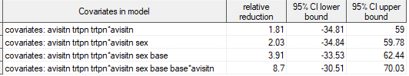

To explore additional gender-related covariates (sex*avisitn, sex*avisitn*trtpn) on top of the prespecified model.
model chg = base trtpn avisitn trtpn * avisitn base * avisitn sex sex*avisitn/ noint ddfm = kr solution;
Solution for Fixed Effects
Effect | Sex | Planned  Treatment (N) | Analysis  Visit (N) | Estimate | Standard  Error | DF | t Value | Pr > |t|
BASE |  |  |  | -0.06375 | 0.06342 | 111 | -1.01 | 0.3170
TRTPN |  | 3 |  | -0.2823 | 0.2258 | 112 | -1.25 | 0.2137
TRTPN |  | 1 |  | -0.2783 | 0.2098 | 111 | -1.33 | 0.1873
AVISITN |  |  | 8 | -0.2307 | 0.2608 | 106 | -0.88 | 0.3784
AVISITN |  |  | 12 | -0.03977 | 0.2376 | 92.5 | -0.17 | 0.8674
AVISITN |  |  | 16 | 0.1703 | 0.2693 | 106 | 0.63 | 0.5286
AVISITN |  |  | 20 | -0.1561 | 0.2578 | 97 | -0.61 | 0.5463
AVISITN |  |  | 24 | 0.04202 | 0.2970 | 89.2 | 0.14 | 0.8878
AVISITN |  |  | 4 | 0 | . | . | . | .
TRTPN*AVISITN |  | 3 | 8 | -0.02001 | 0.1978 | 110 | -0.10 | 0.9196
TRTPN*AVISITN |  | 3 | 12 | -0.1919 | 0.1855 | 103 | -1.03 | 0.3033
TRTPN*AVISITN |  | 3 | 16 | -0.1817 | 0.2047 | 109 | -0.89 | 0.3765
TRTPN*AVISITN |  | 3 | 20 | -0.2425 | 0.1984 | 104 | -1.22 | 0.2244
TRTPN*AVISITN |  | 3 | 24 | 0.08263 | 0.2277 | 96.4 | 0.36 | 0.7175
TRTPN*AVISITN |  | 3 | 4 | 0 | . | . | . | .
TRTPN*AVISITN |  | 1 | 8 | 0 | . | . | . | .
TRTPN*AVISITN |  | 1 | 12 | 0 | . | . | . | .
TRTPN*AVISITN |  | 1 | 16 | 0 | . | . | . | .
TRTPN*AVISITN |  | 1 | 20 | 0 | . | . | . | .
TRTPN*AVISITN |  | 1 | 24 | 0 | . | . | . | .
TRTPN*AVISITN |  | 1 | 4 | 0 | . | . | . | .
BASE*AVISITN |  |  | 8 | 0.05349 | 0.08175 | 108 | 0.65 | 0.5143
BASE*AVISITN |  |  | 12 | -0.00203 | 0.07599 | 98.7 | -0.03 | 0.9787
BASE*AVISITN |  |  | 16 | -0.01744 | 0.08301 | 104 | -0.21 | 0.8340
BASE*AVISITN |  |  | 20 | 0.03561 | 0.08046 | 98.6 | 0.44 | 0.6591
BASE*AVISITN |  |  | 24 | -0.09138 | 0.09425 | 95.2 | -0.97 | 0.3347
BASE*AVISITN |  |  | 4 | 0 | . | . | . | .
SEX | F |  |  | 0.1755 | 0.1559 | 113 | 1.13 | 0.2627
SEX | M |  |  | 0 | . | . | . | .
AVISITN*SEX | F |  | 8 | -0.1422 | 0.1972 | 111 | -0.72 | 0.4723
AVISITN*SEX | M |  | 8 | 0 | . | . | . | .
AVISITN*SEX | F |  | 12 | -0.03867 | 0.1854 | 103 | -0.21 | 0.8352
AVISITN*SEX | M |  | 12 | 0 | . | . | . | .
AVISITN*SEX | F |  | 16 | -0.2454 | 0.2036 | 109 | -1.21 | 0.2307
AVISITN*SEX | M |  | 16 | 0 | . | . | . | .
AVISITN*SEX | F |  | 20 | -0.2654 | 0.1979 | 103 | -1.34 | 0.1828
AVISITN*SEX | M |  | 20 | 0 | . | . | . | .
AVISITN*SEX | F |  | 24 | -0.3349 | 0.2273 | 95.8 | -1.47 | 0.1439
AVISITN*SEX | M |  | 24 | 0 | . | . | . | .
AVISITN*SEX | F |  | 4 | 0 | . | . | . | .
AVISITN*SEX | M |  | 4 | 0 | . | . | . | .

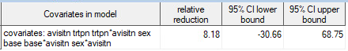

model chg = base trtpn avisitn trtpn * avisitn base * avisitn sex sex*avisitn sex*avisitn*trtpn/ noint ddfm = kr solution;
Solution for Fixed Effects
Effect | Sex | Planned  Treatment(N) | Analysis  Visit (N) | Estimate | Standard  Error | DF | t Value | Pr > |t|
BASE |  |  |  | -0.05922 | 0.06366 | 110 | -0.93 | 0.3542
TRTPN |  | 3 |  | -0.3606 | 0.2438 | 111 | -1.48 | 0.1419
TRTPN |  | 1 |  | -0.2246 | 0.2200 | 110 | -1.02 | 0.3095
AVISITN |  |  | 8 | -0.2852 | 0.2753 | 107 | -1.04 | 0.3026
AVISITN |  |  | 12 | -0.1121 | 0.2508 | 92.5 | -0.45 | 0.6560
AVISITN |  |  | 16 | 0.07969 | 0.2879 | 107 | 0.28 | 0.7824
AVISITN |  |  | 20 | -0.2952 | 0.2751 | 97.7 | -1.07 | 0.2859
AVISITN |  |  | 24 | -0.01468 | 0.3153 | 89.6 | -0.05 | 0.9630
AVISITN |  |  | 4 | 0 | . | . | . | .
TRTPN*AVISITN |  | 3 | 8 | 0.1101 | 0.2826 | 112 | 0.39 | 0.6977
TRTPN*AVISITN |  | 3 | 12 | -0.01917 | 0.2600 | 99.5 | -0.07 | 0.9414
TRTPN*AVISITN |  | 3 | 16 | 0.01539 | 0.2903 | 107 | 0.05 | 0.9578
TRTPN*AVISITN |  | 3 | 20 | 0.08054 | 0.2873 | 104 | 0.28 | 0.7798
TRTPN*AVISITN |  | 3 | 24 | 0.2106 | 0.3282 | 96 | 0.64 | 0.5226
TRTPN*AVISITN |  | 3 | 4 | 0 | . | . | . | .
TRTPN*AVISITN |  | 1 | 8 | 0 | . | . | . | .
TRTPN*AVISITN |  | 1 | 12 | 0 | . | . | . | .
TRTPN*AVISITN |  | 1 | 16 | 0 | . | . | . | .
TRTPN*AVISITN |  | 1 | 20 | 0 | . | . | . | .
TRTPN*AVISITN |  | 1 | 24 | 0 | . | . | . | .
TRTPN*AVISITN |  | 1 | 4 | 0 | . | . | . | .
BASE*AVISITN |  |  | 8 | 0.04978 | 0.08223 | 107 | 0.61 | 0.5462
BASE*AVISITN |  |  | 12 | -0.00692 | 0.07623 | 97.9 | -0.09 | 0.9278
BASE*AVISITN |  |  | 16 | -0.02088 | 0.08346 | 103 | -0.25 | 0.8030
BASE*AVISITN |  |  | 20 | 0.03007 | 0.08133 | 98.2 | 0.37 | 0.7124
BASE*AVISITN |  |  | 24 | -0.09452 | 0.09505 | 94.6 | -0.99 | 0.3226
BASE*AVISITN |  |  | 4 | 0 | . | . | . | .
SEX | F |  |  | 0.05219 | 0.2176 | 110 | 0.24 | 0.8109
SEX | M |  |  | 0 | . | . | . | .
TRTPN*AVISITN*SEX | F | 3 | 8 | -0.02082 | 0.3601 | 185 | -0.06 | 0.9540
TRTPN*AVISITN*SEX | M | 3 | 8 | 0 | . | . | . | .
TRTPN*AVISITN*SEX | F | 3 | 12 | 0.03560 | 0.3509 | 180 | 0.10 | 0.9193
TRTPN*AVISITN*SEX | M | 3 | 12 | 0 | . | . | . | .
TRTPN*AVISITN*SEX | F | 3 | 16 | -0.1872 | 0.3624 | 177 | -0.52 | 0.6061
TRTPN*AVISITN*SEX | M | 3 | 16 | 0 | . | . | . | .
TRTPN*AVISITN*SEX | F | 3 | 20 | -0.3261 | 0.3653 | 184 | -0.89 | 0.3732
TRTPN*AVISITN*SEX | M | 3 | 20 | 0 | . | . | . | .
TRTPN*AVISITN*SEX | F | 3 | 24 | -0.2133 | 0.3891 | 183 | -0.55 | 0.5842
TRTPN*AVISITN*SEX | M | 3 | 24 | 0 | . | . | . | .
TRTPN*AVISITN*SEX | F | 3 | 4 | 0.2626 | 0.3116 | 111 | 0.84 | 0.4012
TRTPN*AVISITN*SEX | M | 3 | 4 | 0 | . | . | . | .
TRTPN*AVISITN*SEX | F | 1 | 8 | -0.02059 | 0.2733 | 108 | -0.08 | 0.9401
TRTPN*AVISITN*SEX | M | 1 | 8 | 0 | . | . | . | .
TRTPN*AVISITN*SEX | F | 1 | 12 | 0.1227 | 0.2544 | 98.1 | 0.48 | 0.6306
TRTPN*AVISITN*SEX | M | 1 | 12 | 0 | . | . | . | .
TRTPN*AVISITN*SEX | F | 1 | 16 | -0.04979 | 0.2899 | 109 | -0.17 | 0.8639
TRTPN*AVISITN*SEX | M | 1 | 16 | 0 | . | . | . | .
TRTPN*AVISITN*SEX | F | 1 | 20 | 0.03114 | 0.2753 | 99 | 0.11 | 0.9102
TRTPN*AVISITN*SEX | M | 1 | 20 | 0 | . | . | . | .
TRTPN*AVISITN*SEX | F | 1 | 24 | -0.2139 | 0.3147 | 91 | -0.68 | 0.4983
TRTPN*AVISITN*SEX | M | 1 | 24 | 0 | . | . | . | .
TRTPN*AVISITN*SEX | F | 1 | 4 | 0 | . | . | . | .
TRTPN*AVISITN*SEX | M | 1 | 4 | 0 | . | . | . | .
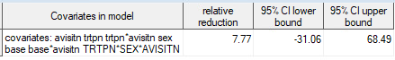

3. Nonparametric analysis

Treatment Group | Median of (Week 24 / Baseline) | Relative Difference (MK - PBO) / PBO
Placebo | 0.685
MK 45 mg | 0.664 | -3.14% (-43.5, 44.8)

No model is applied. For each subject, the ratio of Week 24 / Baseline is calculated. Then the median is taken within each group. After that, the relative difference is calculated where the confidence interval is based on bootstrap with 10,000 replications.

4. QQ plots for total daily counts based on negative binomial distribution

QQ Plot for TRTPN = 1 at Week 0
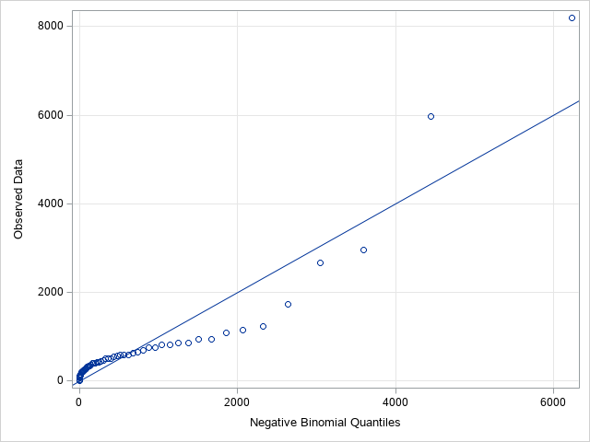

QQ Plot for TRTPN = 3 at Week 0

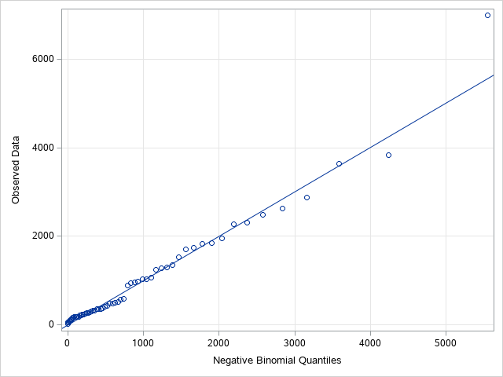

QQ Plot for TRTPN = 1 at Week 4
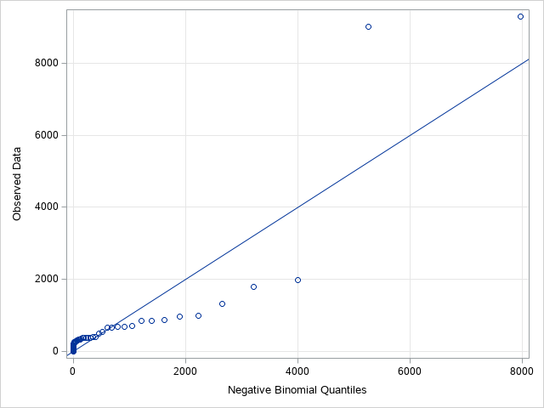

QQ Plot for TRTPN = 3 at Week 4
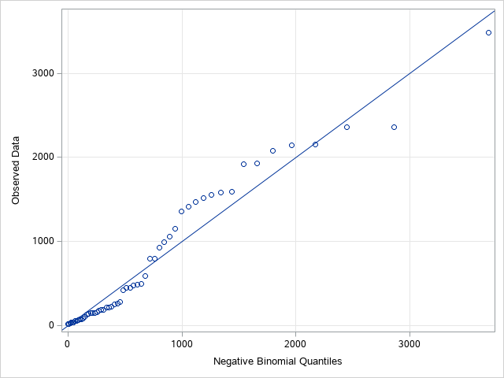

QQ Plot for TRTPN = 1 at Week 8
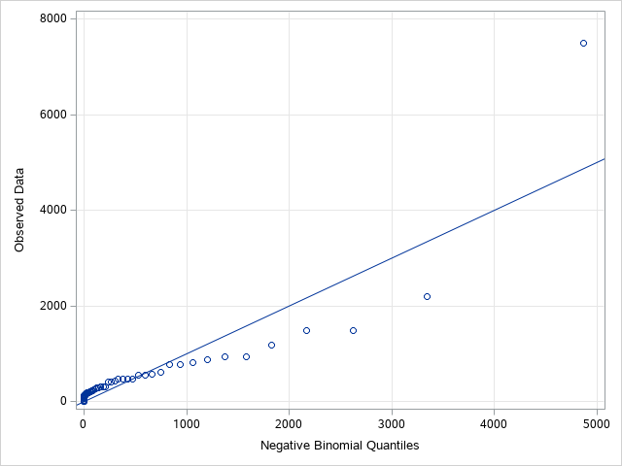

QQ Plot for TRTPN = 3 at Week 8
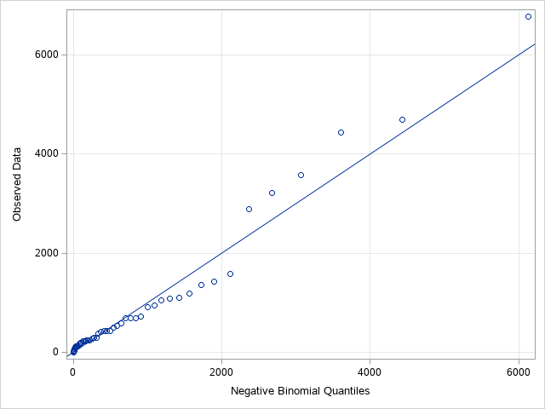

QQ Plot for TRTPN = 1 at Week 12
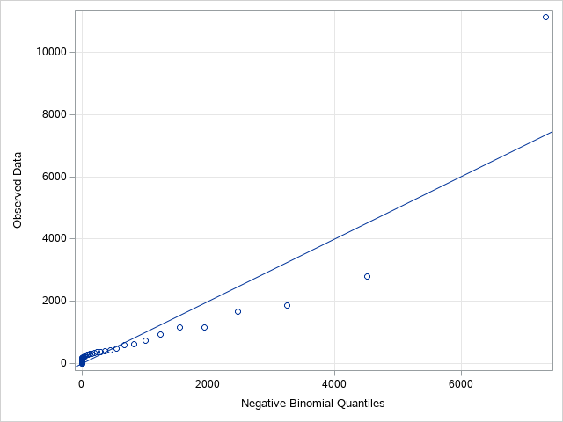

QQ Plot for TRTPN = 3 at Week 12
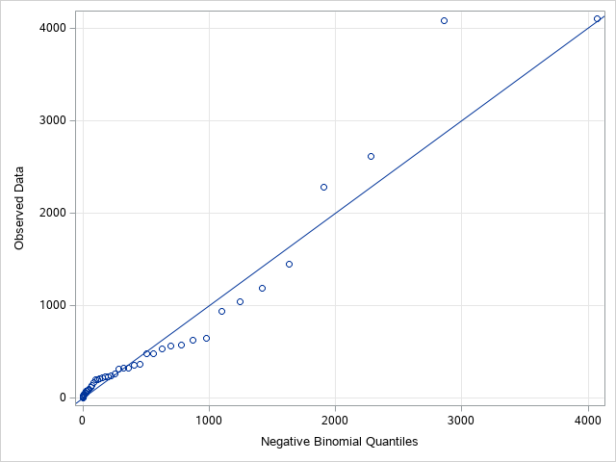

QQ Plot for TRTPN = 1 at Week 16
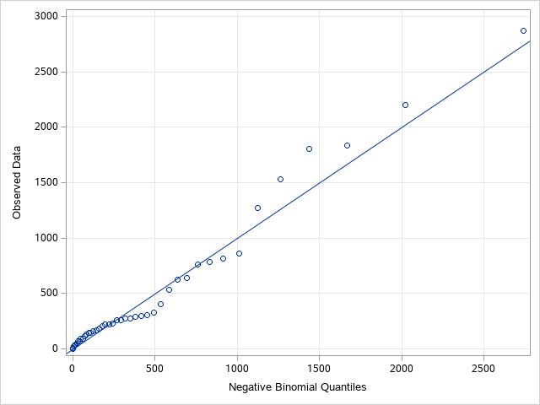

QQ Plot for TRTPN = 3 at Week 16
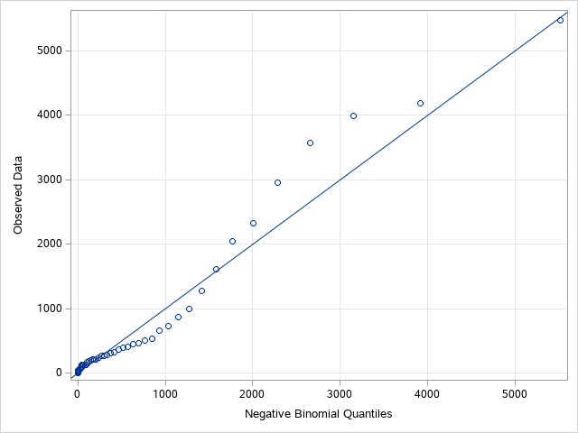
QQ Plot for TRTPN = 1 at Week 20
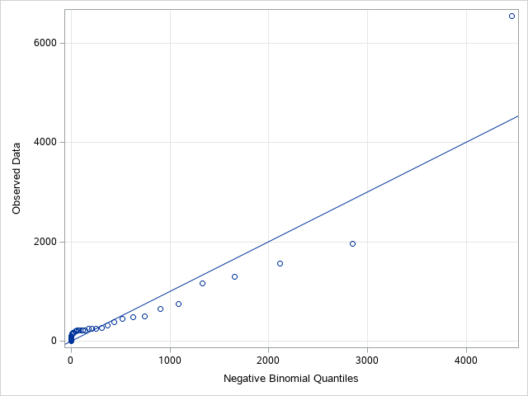
QQ Plot for TRTPN = 3 at Week 20
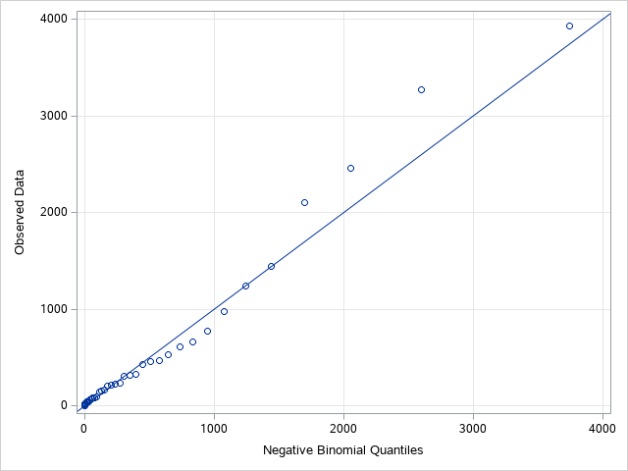
QQ Plot for TRTPN = 1 at Week 24
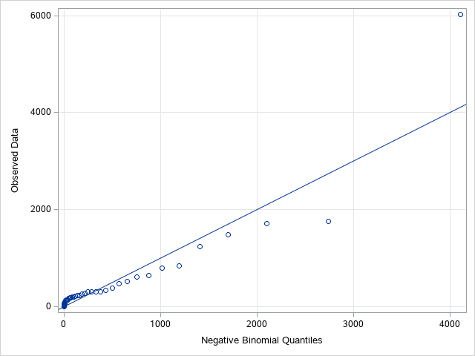
QQ Plot for TRTPN = 3 at Week 24
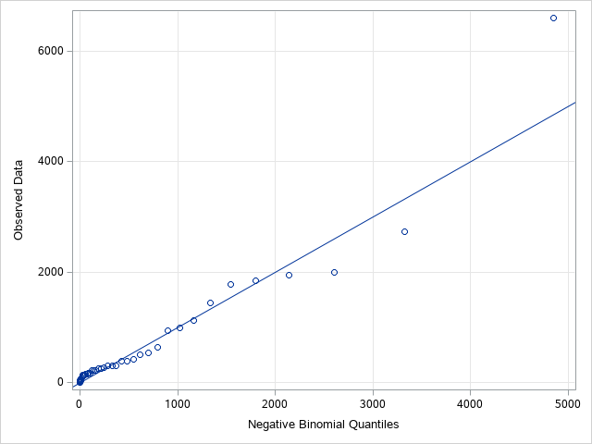

5. GEE to account for departure from normality of the repeated measures.
PROC GENMOD SETUP:
proc genmod data=_eff_cough ;
where avisitn in (4,8,12,16,20,24);
class usubjid trtpn(ref='1') avisitn(ref='4') sex ;
model chg= trtpn avisitn trtpn*avisitn /dist=normal link=identity noint;
repeated subject=usubjid / withinsubject=avisitn type=ar(1) corrw ;

lsmestimate trtpn*avisitn 'Placebo, at Week 24' [1, 2 5]/exp cl;
lsmestimate trtpn*avisitn 'MK-7264 45 mg, at Week 24' [1, 1 5]/exp cl;
lsmestimate trtpn*avisitn 'trtpn avisitn trtpn*avisitn' [1, 1 5] [-1, 2 5]/exp cl;
ods output lsmestimates = _est0;
run;

model chg= trtpn avisitn trtpn*avisitn/dist=normal link=identity noint;
Analysis Of GEE Parameter Estimates
Empirical Standard Error Estimates
Parameter |  |  | Estimate | Standard  Error | 95% Confidence Limits |  | Z | Pr > |Z|
Intercept |  |  | 0.0000 | 0.0000 | 0.0000 | 0.0000 | . | .
TRTPN | 3 |  | -0.3880 | 0.1169 | -0.6171 | -0.1589 | -3.32 | 0.0009
TRTPN | 1 |  | -0.3677 | 0.1047 | -0.5729 | -0.1625 | -3.51 | 0.0004
AVISITN | 8 |  | -0.1264 | 0.1269 | -0.3752 | 0.1223 | -1.00 | 0.3191
AVISITN | 12 |  | -0.0482 | 0.1071 | -0.2582 | 0.1617 | -0.45 | 0.6524
AVISITN | 16 |  | -0.0144 | 0.1500 | -0.3085 | 0.2796 | -0.10 | 0.9233
AVISITN | 20 |  | -0.1926 | 0.1242 | -0.4361 | 0.0508 | -1.55 | 0.1209
AVISITN | 24 |  | -0.3153 | 0.1565 | -0.6221 | -0.0086 | -2.01 | 0.0439
AVISITN | 4 |  | 0.0000 | 0.0000 | 0.0000 | 0.0000 | . | .
TRTPN*AVISITN | 3 | 8 | -0.0414 | 0.1943 | -0.4222 | 0.3394 | -0.21 | 0.8313
TRTPN*AVISITN | 3 | 12 | -0.1973 | 0.1758 | -0.5419 | 0.1473 | -1.12 | 0.2618
TRTPN*AVISITN | 3 | 16 | -0.2040 | 0.2072 | -0.6101 | 0.2020 | -0.98 | 0.3247
TRTPN*AVISITN | 3 | 20 | -0.2653 | 0.1995 | -0.6563 | 0.1257 | -1.33 | 0.1835
TRTPN*AVISITN | 3 | 24 | -0.0488 | 0.2337 | -0.5068 | 0.4093 | -0.21 | 0.8348
TRTPN*AVISITN | 3 | 4 | 0.0000 | 0.0000 | 0.0000 | 0.0000 | . | .
TRTPN*AVISITN | 1 | 8 | 0.0000 | 0.0000 | 0.0000 | 0.0000 | . | .
TRTPN*AVISITN | 1 | 12 | 0.0000 | 0.0000 | 0.0000 | 0.0000 | . | .
TRTPN*AVISITN | 1 | 16 | 0.0000 | 0.0000 | 0.0000 | 0.0000 | . | .
TRTPN*AVISITN | 1 | 20 | 0.0000 | 0.0000 | 0.0000 | 0.0000 | . | .
TRTPN*AVISITN | 1 | 24 | 0.0000 | 0.0000 | 0.0000 | 0.0000 | . | .
TRTPN*AVISITN | 1 | 4 | 0.0000 | 0.0000 | 0.0000 | 0.0000 | . | .

model chg= trtpn avisitn trtpn*avisitn SEX/dist=normal link=identity noint;
Analysis Of GEE Parameter Estimates
Empirical Standard Error Estimates
Parameter |  |  | Estimate | Standard  Error | 95% Confidence Limits |  | Z | Pr > |Z|
Intercept |  |  | 0.0000 | 0.0000 | 0.0000 | 0.0000 | . | .
TRTPN | 3 |  | -0.3793 | 0.1363 | -0.6465 | -0.1121 | -2.78 | 0.0054
TRTPN | 1 |  | -0.3586 | 0.1311 | -0.6155 | -0.1016 | -2.74 | 0.0062
AVISITN | 8 |  | -0.1265 | 0.1269 | -0.3753 | 0.1222 | -1.00 | 0.3187
AVISITN | 12 |  | -0.0483 | 0.1071 | -0.2582 | 0.1615 | -0.45 | 0.6517
AVISITN | 16 |  | -0.0146 | 0.1500 | -0.3087 | 0.2794 | -0.10 | 0.9223
AVISITN | 20 |  | -0.1928 | 0.1242 | -0.4362 | 0.0505 | -1.55 | 0.1204
AVISITN | 24 |  | -0.3154 | 0.1565 | -0.6221 | -0.0086 | -2.01 | 0.0439
AVISITN | 4 |  | 0.0000 | 0.0000 | 0.0000 | 0.0000 | . | .
TRTPN*AVISITN | 3 | 8 | -0.0413 | 0.1943 | -0.4222 | 0.3396 | -0.21 | 0.8316
TRTPN*AVISITN | 3 | 12 | -0.1974 | 0.1759 | -0.5421 | 0.1473 | -1.12 | 0.2616
TRTPN*AVISITN | 3 | 16 | -0.2038 | 0.2072 | -0.6099 | 0.2022 | -0.98 | 0.3252
TRTPN*AVISITN | 3 | 20 | -0.2649 | 0.1993 | -0.6556 | 0.1257 | -1.33 | 0.1838
TRTPN*AVISITN | 3 | 24 | -0.0483 | 0.2334 | -0.5059 | 0.4092 | -0.21 | 0.8360
TRTPN*AVISITN | 3 | 4 | 0.0000 | 0.0000 | 0.0000 | 0.0000 | . | .
TRTPN*AVISITN | 1 | 8 | 0.0000 | 0.0000 | 0.0000 | 0.0000 | . | .
TRTPN*AVISITN | 1 | 12 | 0.0000 | 0.0000 | 0.0000 | 0.0000 | . | .
TRTPN*AVISITN | 1 | 16 | 0.0000 | 0.0000 | 0.0000 | 0.0000 | . | .
TRTPN*AVISITN | 1 | 20 | 0.0000 | 0.0000 | 0.0000 | 0.0000 | . | .
TRTPN*AVISITN | 1 | 24 | 0.0000 | 0.0000 | 0.0000 | 0.0000 | . | .
TRTPN*AVISITN | 1 | 4 | 0.0000 | 0.0000 | 0.0000 | 0.0000 | . | .
SEX | F |  | -0.0180 | 0.1502 | -0.3124 | 0.2765 | -0.12 | 0.9048
SEX | M |  | 0.0000 | 0.0000 | 0.0000 | 0.0000 | . | .

model chg= trtpn avisitn trtpn*avisitn SEX BASE/dist=normal link=identity noint;
Analysis Of GEE Parameter Estimates
Empirical Standard Error Estimates
Parameter |  |  | Estimate | Standard  Error | 95% Confidence Limits |  | Z | Pr > |Z|
Intercept |  |  | 0.0000 | 0.0000 | 0.0000 | 0.0000 | . | .
TRTPN | 3 |  | -0.1427 | 0.2245 | -0.5827 | 0.2974 | -0.64 | 0.5252
TRTPN | 1 |  | -0.1489 | 0.1975 | -0.5360 | 0.2381 | -0.75 | 0.4507
AVISITN | 8 |  | -0.1278 | 0.1269 | -0.3766 | 0.1209 | -1.01 | 0.3138
AVISITN | 12 |  | -0.0517 | 0.1074 | -0.2621 | 0.1588 | -0.48 | 0.6305
AVISITN | 16 |  | -0.0185 | 0.1494 | -0.3112 | 0.2742 | -0.12 | 0.9014
AVISITN | 20 |  | -0.1981 | 0.1239 | -0.4409 | 0.0448 | -1.60 | 0.1099
AVISITN | 24 |  | -0.3225 | 0.1562 | -0.6286 | -0.0164 | -2.07 | 0.0389
AVISITN | 4 |  | 0.0000 | 0.0000 | 0.0000 | 0.0000 | . | .
TRTPN*AVISITN | 3 | 8 | -0.0398 | 0.1942 | -0.4205 | 0.3409 | -0.20 | 0.8378
TRTPN*AVISITN | 3 | 12 | -0.1977 | 0.1763 | -0.5433 | 0.1479 | -1.12 | 0.2622
TRTPN*AVISITN | 3 | 16 | -0.2045 | 0.2075 | -0.6113 | 0.2022 | -0.99 | 0.3244
TRTPN*AVISITN | 3 | 20 | -0.2663 | 0.1997 | -0.6578 | 0.1252 | -1.33 | 0.1825
TRTPN*AVISITN | 3 | 24 | -0.0473 | 0.2325 | -0.5030 | 0.4084 | -0.20 | 0.8389
TRTPN*AVISITN | 3 | 4 | 0.0000 | 0.0000 | 0.0000 | 0.0000 | . | .
TRTPN*AVISITN | 1 | 8 | 0.0000 | 0.0000 | 0.0000 | 0.0000 | . | .
TRTPN*AVISITN | 1 | 12 | 0.0000 | 0.0000 | 0.0000 | 0.0000 | . | .
TRTPN*AVISITN | 1 | 16 | 0.0000 | 0.0000 | 0.0000 | 0.0000 | . | .
TRTPN*AVISITN | 1 | 20 | 0.0000 | 0.0000 | 0.0000 | 0.0000 | . | .
TRTPN*AVISITN | 1 | 24 | 0.0000 | 0.0000 | 0.0000 | 0.0000 | . | .
TRTPN*AVISITN | 1 | 4 | 0.0000 | 0.0000 | 0.0000 | 0.0000 | . | .
SEX | F |  | 0.0045 | 0.1473 | -0.2842 | 0.2933 | 0.03 | 0.9755
SEX | M |  | 0.0000 | 0.0000 | 0.0000 | 0.0000 | . | .
BASE |  |  | -0.0828 | 0.0547 | -0.1900 | 0.0244 | -1.51 | 0.1302

model chg= trtpn avisitn trtpn*avisitn SEX BASE BASE*AVISITN/dist=normal link=identity noint;
Analysis Of GEE Parameter Estimates
Empirical Standard Error Estimates
Parameter |  |  | Estimate | Standard  Error | 95% Confidence Limits |  | Z | Pr > |Z|
Intercept |  |  | 0.0000 | 0.0000 | 0.0000 | 0.0000 | . | .
TRTPN | 3 |  | -0.2222 | 0.2525 | -0.7170 | 0.2726 | -0.88 | 0.3788
TRTPN | 1 |  | -0.2199 | 0.2239 | -0.6588 | 0.2190 | -0.98 | 0.3262
AVISITN | 8 |  | -0.2697 | 0.3295 | -0.9154 | 0.3760 | -0.82 | 0.4130
AVISITN | 12 |  | -0.0607 | 0.2190 | -0.4899 | 0.3685 | -0.28 | 0.7818
AVISITN | 16 |  | 0.0542 | 0.3192 | -0.5715 | 0.6798 | 0.17 | 0.8652
AVISITN | 20 |  | -0.2510 | 0.2607 | -0.7620 | 0.2601 | -0.96 | 0.3358
AVISITN | 24 |  | -0.0122 | 0.3281 | -0.6553 | 0.6309 | -0.04 | 0.9704
AVISITN | 4 |  | 0.0000 | 0.0000 | 0.0000 | 0.0000 | . | .
TRTPN*AVISITN | 3 | 8 | -0.0628 | 0.1891 | -0.4334 | 0.3079 | -0.33 | 0.7399
TRTPN*AVISITN | 3 | 12 | -0.1974 | 0.1756 | -0.5416 | 0.1469 | -1.12 | 0.2612
TRTPN*AVISITN | 3 | 16 | -0.1947 | 0.2052 | -0.5969 | 0.2076 | -0.95 | 0.3429
TRTPN*AVISITN | 3 | 20 | -0.2757 | 0.2002 | -0.6681 | 0.1168 | -1.38 | 0.1686
TRTPN*AVISITN | 3 | 24 | 0.0048 | 0.2232 | -0.4327 | 0.4422 | 0.02 | 0.9830
TRTPN*AVISITN | 3 | 4 | 0.0000 | 0.0000 | 0.0000 | 0.0000 | . | .
TRTPN*AVISITN | 1 | 8 | 0.0000 | 0.0000 | 0.0000 | 0.0000 | . | .
TRTPN*AVISITN | 1 | 12 | 0.0000 | 0.0000 | 0.0000 | 0.0000 | . | .
TRTPN*AVISITN | 1 | 16 | 0.0000 | 0.0000 | 0.0000 | 0.0000 | . | .
TRTPN*AVISITN | 1 | 20 | 0.0000 | 0.0000 | 0.0000 | 0.0000 | . | .
TRTPN*AVISITN | 1 | 24 | 0.0000 | 0.0000 | 0.0000 | 0.0000 | . | .
TRTPN*AVISITN | 1 | 4 | 0.0000 | 0.0000 | 0.0000 | 0.0000 | . | .
SEX | F |  | 0.0099 | 0.1473 | -0.2789 | 0.2987 | 0.07 | 0.9465
SEX | M |  | 0.0000 | 0.0000 | 0.0000 | 0.0000 | . | .
BASE |  |  | -0.0575 | 0.0607 | -0.1765 | 0.0615 | -0.95 | 0.3437
BASE*AVISITN | 8 |  | 0.0548 | 0.0956 | -0.1325 | 0.2421 | 0.57 | 0.5661
BASE*AVISITN | 12 |  | 0.0031 | 0.0645 | -0.1233 | 0.1294 | 0.05 | 0.9621
BASE*AVISITN | 16 |  | -0.0277 | 0.0909 | -0.2059 | 0.1505 | -0.30 | 0.7607
BASE*AVISITN | 20 |  | 0.0218 | 0.0790 | -0.1330 | 0.1766 | 0.28 | 0.7829
BASE*AVISITN | 24 |  | -0.1220 | 0.0966 | -0.3114 | 0.0674 | -1.26 | 0.2067
BASE*AVISITN | 4 |  | 0.0000 | 0.0000 | 0.0000 | 0.0000 | . | .

As a reference, here are the relative reductions corresponding to the above GENMOD models:
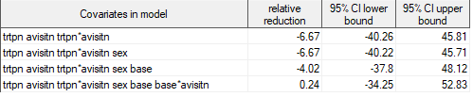
(mixed model in section 2)


model chg= trtpn avisitn trtpn*avisitn SEX BASE BASE*AVISITN SEX*AVISITN/dist=normal link=identity noint;
Analysis Of GEE Parameter Estimates
Empirical Standard Error Estimates
Parameter |  |  | Estimate | Standard  Error | 95% Confidence Limits |  | Z | Pr > |Z|
Intercept |  |  | 0.0000 | 0.0000 | 0.0000 | 0.0000 | . | .
TRTPN | 3 |  | -0.2941 | 0.2377 | -0.7601 | 0.1718 | -1.24 | 0.2160
TRTPN | 1 |  | -0.3036 | 0.2110 | -0.7172 | 0.1100 | -1.44 | 0.1502
AVISITN | 8 |  | -0.1933 | 0.3157 | -0.8120 | 0.4255 | -0.61 | 0.5404
AVISITN | 12 |  | -0.0202 | 0.2137 | -0.4391 | 0.3987 | -0.09 | 0.9247
AVISITN | 16 |  | 0.1690 | 0.2927 | -0.4046 | 0.7426 | 0.58 | 0.5636
AVISITN | 20 |  | -0.1302 | 0.2432 | -0.6070 | 0.3465 | -0.54 | 0.5924
AVISITN | 24 |  | 0.1487 | 0.3007 | -0.4406 | 0.7381 | 0.49 | 0.6208
AVISITN | 4 |  | 0.0000 | 0.0000 | 0.0000 | 0.0000 | . | .
TRTPN*AVISITN | 3 | 8 | -0.0781 | 0.1881 | -0.4469 | 0.2906 | -0.42 | 0.6779
TRTPN*AVISITN | 3 | 12 | -0.1967 | 0.1758 | -0.5413 | 0.1479 | -1.12 | 0.2633
TRTPN*AVISITN | 3 | 16 | -0.2098 | 0.2026 | -0.6069 | 0.1873 | -1.04 | 0.3005
TRTPN*AVISITN | 3 | 20 | -0.2894 | 0.1992 | -0.6799 | 0.1010 | -1.45 | 0.1463
TRTPN*AVISITN | 3 | 24 | -0.0061 | 0.2210 | -0.4392 | 0.4271 | -0.03 | 0.9782
TRTPN*AVISITN | 3 | 4 | 0.0000 | 0.0000 | 0.0000 | 0.0000 | . | .
TRTPN*AVISITN | 1 | 8 | 0.0000 | 0.0000 | 0.0000 | 0.0000 | . | .
TRTPN*AVISITN | 1 | 12 | 0.0000 | 0.0000 | 0.0000 | 0.0000 | . | .
TRTPN*AVISITN | 1 | 16 | 0.0000 | 0.0000 | 0.0000 | 0.0000 | . | .
TRTPN*AVISITN | 1 | 20 | 0.0000 | 0.0000 | 0.0000 | 0.0000 | . | .
TRTPN*AVISITN | 1 | 24 | 0.0000 | 0.0000 | 0.0000 | 0.0000 | . | .
TRTPN*AVISITN | 1 | 4 | 0.0000 | 0.0000 | 0.0000 | 0.0000 | . | .
SEX | F |  | 0.2117 | 0.1558 | -0.0937 | 0.5171 | 1.36 | 0.1743
SEX | M |  | 0.0000 | 0.0000 | 0.0000 | 0.0000 | . | .
BASE |  |  | -0.0661 | 0.0607 | -0.1851 | 0.0529 | -1.09 | 0.2762
BASE*AVISITN | 8 |  | 0.0667 | 0.0954 | -0.1202 | 0.2536 | 0.70 | 0.4845
BASE*AVISITN | 12 |  | 0.0039 | 0.0656 | -0.1247 | 0.1325 | 0.06 | 0.9529
BASE*AVISITN | 16 |  | -0.0148 | 0.0928 | -0.1967 | 0.1671 | -0.16 | 0.8733
BASE*AVISITN | 20 |  | 0.0392 | 0.0790 | -0.1157 | 0.1942 | 0.50 | 0.6196
BASE*AVISITN | 24 |  | -0.0979 | 0.0941 | -0.2824 | 0.0866 | -1.04 | 0.2985
BASE*AVISITN | 4 |  | 0.0000 | 0.0000 | 0.0000 | 0.0000 | . | .
AVISITN*SEX | 8 | F | -0.1968 | 0.1958 | -0.5806 | 0.1869 | -1.01 | 0.3147
AVISITN*SEX | 8 | M | 0.0000 | 0.0000 | 0.0000 | 0.0000 | . | .
AVISITN*SEX | 12 | F | -0.0789 | 0.1782 | -0.4282 | 0.2704 | -0.44 | 0.6581
AVISITN*SEX | 12 | M | 0.0000 | 0.0000 | 0.0000 | 0.0000 | . | .
AVISITN*SEX | 16 | F | -0.2817 | 0.2101 | -0.6936 | 0.1301 | -1.34 | 0.1800
AVISITN*SEX | 16 | M | 0.0000 | 0.0000 | 0.0000 | 0.0000 | . | .
AVISITN*SEX | 20 | F | -0.3190 | 0.2033 | -0.7175 | 0.0794 | -1.57 | 0.1166
AVISITN*SEX | 20 | M | 0.0000 | 0.0000 | 0.0000 | 0.0000 | . | .
AVISITN*SEX | 24 | F | -0.4311 | 0.2300 | -0.8819 | 0.0196 | -1.87 | 0.0608
AVISITN*SEX | 24 | M | 0.0000 | 0.0000 | 0.0000 | 0.0000 | . | .
AVISITN*SEX | 4 | F | 0.0000 | 0.0000 | 0.0000 | 0.0000 | . | .
AVISITN*SEX | 4 | M | 0.0000 | 0.0000 | 0.0000 | 0.0000 | . | .

6. Removing subjects with missing Week 20 but with Week 24 data

6.1 Removing at the subject level

Analysis Visit (N) | Planned Treatment (N) | Planned Treatment | NSUB | GEOBASE | GEOPOST | GMR
24 | 1 | Placebo | 39 | 12.44 | 6.01 | 0.48
24 | 3 | MK-7264 45 mg BID | 38 | 19.31 | 8.60 | 0.45

Statement Number | Label | Model Based Geometric Mean Ratio (Post-Baseline/Baseline) | 95% CI Lower | 95% CI Upper
1 | Placebo, at Week 24 | 0.44 | 0.30 | 0.63
2 | MK-7264 45 mg, at Week 24 | 0.52 | 0.36 | 0.75

Statement Number | Label | Model Based Relative Reduction | 95% CI Lower | 95% CI Upper | p-Value
3 | MK-7264 45 mg vs. Placebo, at Week 24 | 19.71 | -29.12 | 102.21 | 0.497

6.2 Removing at the observation level

Analysis Visit (N) | Planned Treatment (N) | Planned Treatment | NSUB | GEOBASE | GEOPOST | GMR
24 | 1 | Placebo | 39 | 12.44 | 6.01 | 0.48
24 | 3 | MK-7264 45 mg BID | 38 | 19.31 | 8.60 | 0.45

Statement Number | Label | Model Based Geometric Mean Ratio (Post-Baseline/Baseline) | 95% CI Lower | 95% CI Upper
1 | Placebo, at Week 24 | 0.44 | 0.31 | 0.63
2 | MK-7264 45 mg, at Week 24 | 0.52 | 0.37 | 0.74

Statement Number | Label | Model Based Relative Reduction | 95% CI Lower | 95% CI Upper | p-Value
3 | MK-7264 45 mg vs. Placebo, at Week 24 | 17.97 | -28.34 | 94.21 | 0.512

7. Summary of missing data pattern

Planned Treatment (N) | Planned Treatment | Included in the Analysis | WK4 | WK8 | WK12 | WK16 | WK20 | WK24
1 | Placebo | 65 | 61 | 59 | 49 | 43 | 41 | 51
3 | MK-7264 45 mg BID | 64 | 56 | 55 | 45 | 49 | 39 | 46

file://bardsar-prod/mk7264-cough/prot030-china-ext-main/outtable/apr0et0lda0over0time024hc0m0c.rtf

8. Other covariance structures

model chg = base trtpn avisitn trtpn * avisitn base * avisitn sex / noint ddfm = kr solution;
repeated avisitn / subject = usubjid type = vc;

Solution for Fixed Effects
Effect | Sex | Planned Treatment (N) | Analysis Visit (N) | Estimate | Standard  Error | DF | t Value | Pr > |t|
BASE |  |  |  | -0.06655 | 0.07701 | 575 | -0.86 | 0.3879
TRTPN |  | 3 |  | -0.08954 | 0.2690 | 575 | -0.33 | 0.7394
TRTPN |  | 1 |  | -0.09415 | 0.2458 | 575 | -0.38 | 0.7018
AVISITN |  |  | 8 | -0.2709 | 0.3471 | 575 | -0.78 | 0.4354
AVISITN |  |  | 12 | -0.04815 | 0.3555 | 575 | -0.14 | 0.8923
AVISITN |  |  | 16 | 0.07912 | 0.3651 | 575 | 0.22 | 0.8285
AVISITN |  |  | 20 | -0.2793 | 0.3735 | 575 | -0.75 | 0.4548
AVISITN |  |  | 24 | -0.08142 | 0.3575 | 575 | -0.23 | 0.8199
AVISITN |  |  | 4 | 0 | . | . | . | .
TRTPN*AVISITN |  | 3 | 8 | -0.02321 | 0.2732 | 575 | -0.08 | 0.9323
TRTPN*AVISITN |  | 3 | 12 | -0.4067 | 0.2872 | 575 | -1.42 | 0.1573
TRTPN*AVISITN |  | 3 | 16 | -0.2080 | 0.2888 | 575 | -0.72 | 0.4716
TRTPN*AVISITN |  | 3 | 20 | -0.3613 | 0.3006 | 575 | -1.20 | 0.2299
TRTPN*AVISITN |  | 3 | 24 | -0.06666 | 0.2852 | 575 | -0.23 | 0.8153
TRTPN*AVISITN |  | 3 | 4 | 0 | . | . | . | .
TRTPN*AVISITN |  | 1 | 8 | 0 | . | . | . | .
TRTPN*AVISITN |  | 1 | 12 | 0 | . | . | . | .
TRTPN*AVISITN |  | 1 | 16 | 0 | . | . | . | .
TRTPN*AVISITN |  | 1 | 20 | 0 | . | . | . | .
TRTPN*AVISITN |  | 1 | 24 | 0 | . | . | . | .
TRTPN*AVISITN |  | 1 | 4 | 0 | . | . | . | .
BASE*AVISITN |  |  | 8 | 0.04209 | 0.1110 | 575 | 0.38 | 0.7047
BASE*AVISITN |  |  | 12 | 0.01543 | 0.1156 | 575 | 0.13 | 0.8939
BASE*AVISITN |  |  | 16 | -0.03372 | 0.1157 | 575 | -0.29 | 0.7709
BASE*AVISITN |  |  | 20 | 0.008480 | 0.1193 | 575 | 0.07 | 0.9434
BASE*AVISITN |  |  | 24 | -0.1047 | 0.1159 | 575 | -0.90 | 0.3666
BASE*AVISITN |  |  | 4 | 0 | . | . | . | .
SEX | F |  |  | -0.09804 | 0.08512 | 575 | -1.15 | 0.2499
SEX | M |  |  | 0 | . | . | . | .

Statement Number | Label | Model Based Geometric Mean Ratio (Post-Baseline/Baseline) | 95% CI Lower | 95% CI Upper
1 | Placebo, at Week 24 | 0.50 | 0.37 | 0.66
2 | MK-7264 45 mg, at Week 24 | 0.47 | 0.35 | 0.63

Statement Number | Label | Model Based Relative Reduction | 95% CI Lower | 95% CI Upper | p-Value
3 | MK-7264 45 mg vs. Placebo, at Week 24 | -6.02 | -37.96 | 42.38 | 0.769

9. Dropping all Week 24 data

This is to show that after dropping all Week 24 data, the model performs as expected for the previous time points, so the issue is specific to Week 24, not baseline or any other visits.
Analysis Visit (N) | Planned Treatment | NSUB | GEOBASE | GEOPOST | GMR
0 | Placebo | 65 | 14.44 | 14.44 | 1.00
0 | MK-7264 45 mg BID | 65 | 19.50 | 19.50 | 1.00
4 | Placebo | 61 | 14.33 | 10.38 | 0.72
4 | MK-7264 45 mg BID | 56 | 19.77 | 14.14 | 0.72
8 | Placebo | 59 | 13.57 | 8.39 | 0.62
8 | MK-7264 45 mg BID | 55 | 20.66 | 12.46 | 0.60
12 | Placebo | 49 | 11.94 | 8.68 | 0.73
12 | MK-7264 45 mg BID | 45 | 17.52 | 8.40 | 0.48
16 | Placebo | 43 | 13.19 | 9.54 | 0.72
16 | MK-7264 45 mg BID | 49 | 18.73 | 10.69 | 0.57
20 | Placebo | 41 | 13.00 | 7.33 | 0.56
20 | MK-7264 45 mg BID | 39 | 18.77 | 7.22 | 0.38
24 | Placebo | 51 | 12.54 | 6.49 | 0.52
24 | MK-7264 45 mg BID | 46 | 18.99 | 8.58 | 0.45

Label | Model Based Geometric Mean Ratio (Post-Baseline/Baseline) | 95% CI Lower | 95% CI Upper
Placebo, at Week 4 | 0.69 | 0.56 | 0.86
MK-7264 45 mg, at Week 4 | 0.68 | 0.55 | 0.85
Placebo, at Week 8 | 0.60 | 0.45 | 0.79
MK-7264 45 mg, at Week 8 | 0.58 | 0.43 | 0.77
Placebo, at Week 12 | 0.66 | 0.51 | 0.86
MK-7264 45 mg, at Week 12 | 0.52 | 0.40 | 0.68
Placebo, at Week 16 | 0.69 | 0.51 | 0.92
MK-7264 45 mg, at Week 16 | 0.58 | 0.43 | 0.77
Placebo, at Week 20 | 0.56 | 0.42 | 0.74
MK-7264 45 mg, at Week 20 | 0.45 | 0.34 | 0.61

Label | Model Based Relative Reduction | 95% CI Lower | 95% CI Upper | p-Value
MK-7264 45 mg vs. Placebo, at Week 4 | -1.50 | -27.81 | 34.40 | 0.923
MK-7264 45 mg vs. Placebo, at Week 8 | -3.33 | -35.06 | 43.88 | 0.866
MK-7264 45 mg vs. Placebo, at Week 12 | -20.98 | -45.90 | 15.42 | 0.221
MK-7264 45 mg vs. Placebo, at Week 16 | -15.99 | -44.63 | 27.46 | 0.409
MK-7264 45 mg vs. Placebo, at Week 20 | -19.15 | -46.68 | 22.59 | 0.314

10. Completers only

“Completer” means the subject had Week 24 data.

Analysis Visit (N) | Planned Treatment | NSUB | GEOBASE | GEOPOST | GMR
0 | Placebo | 51 | 12.54 | 12.54 | 1.00
0 | MK-7264 45 mg BID | 46 | 18.99 | 18.99 | 1.00
4 | Placebo | 50 | 12.41 | 9.17 | 0.74
4 | MK-7264 45 mg BID | 41 | 20.19 | 14.08 | 0.70
8 | Placebo | 47 | 12.08 | 8.10 | 0.67
8 | MK-7264 45 mg BID | 45 | 19.76 | 10.49 | 0.53
12 | Placebo | 44 | 11.31 | 8.44 | 0.75
12 | MK-7264 45 mg BID | 38 | 18.65 | 8.53 | 0.46
16 | Placebo | 41 | 12.67 | 9.49 | 0.75
16 | MK-7264 45 mg BID | 44 | 19.04 | 9.85 | 0.52
20 | Placebo | 39 | 12.44 | 7.10 | 0.57
20 | MK-7264 45 mg BID | 38 | 19.31 | 7.57 | 0.39
24 | Placebo | 51 | 12.54 | 6.49 | 0.52
24 | MK-7264 45 mg BID | 46 | 18.99 | 8.58 | 0.45

Label | Model Based Geometric Mean Ratio (Post-Baseline/Baseline) | 95% CI Lower | 95% CI Upper
Placebo, at Week 24 | 0.50 | 0.36 | 0.69
MK-7264 45 mg, at Week 24 | 0.47 | 0.33 | 0.66

Label | Model Based Relative Reduction | 95% CI Lower | 95% CI Upper | p-Value
MK-7264 45 mg vs. Placebo, at Week 24 | -6.11 | -41.69 | 51.19 | 0.793

Label | Model Based Relative Reduction | 95% CI Lower | 95% CI Upper | p-Value
MK-7264 45 mg vs. Placebo, at Week 4 | -5.97 | -34.03 | 34.02 | 0.731
MK-7264 45 mg vs. Placebo, at Week 8 | -15.64 | -45.90 | 31.54 | 0.449
MK-7264 45 mg vs. Placebo, at Week 12 | -28.37 | -51.51 | 5.82 | 0.093
MK-7264 45 mg vs. Placebo, at Week 16 | -30.29 | -55.70 | 9.68 | 0.117
MK-7264 45 mg vs. Placebo, at Week 20 | -31.85 | -56.47 | 6.71 | 0.093
MK-7264 45 mg vs. Placebo, at Week 24 | -6.11 | -41.69 | 51.19 | 0.793

In addition, here is a summary for the non-completers (defined as missing Week 24 data). MK is almost consistently worse than placebo.
Analysis Visit (N) | Planned Treatment | NSUB | GEOBASE | GEOPOST | GMR
0 | Placebo | 14 | 24.11 | 24.11 | 1.00
0 | MK-7264 45 mg BID | 19 | 20.80 | 20.80 | 1.00
4 | Placebo | 11 | 27.51 | 18.20 | 0.66
4 | MK-7264 45 mg BID | 15 | 18.66 | 14.29 | 0.77
8 | Placebo | 12 | 21.35 | 9.64 | 0.45
8 | MK-7264 45 mg BID | 10 | 25.24 | 27.06 | 1.07
12 | Placebo | 5 | 19.26 | 11.07 | 0.57
12 | MK-7264 45 mg BID | 7 | 12.46 | 7.77 | 0.62
16 | Placebo | 2 | 30.26 | 10.67 | 0.35
16 | MK-7264 45 mg BID | 5 | 16.22 | 22.13 | 1.36
20 | Placebo | 2 | 30.40 | 13.73 | 0.45
20 | MK-7264 45 mg BID | 1 | 6.41 | 1.21 | 0.19

11. Disposition and Demographics (completer vs non-completer)

Participant Disposition
FAS
China Cohort
 | FAS Completer |  |  |  | FAS Non-completer
 | Placebo |  | 45 mg BID |  | Placebo |  | 45 mg BID
 | n | (%) | n | (%) | n | (%) | n | (%)
Participants in population | 51 |  | 46 |  | 16 |  | 20
Participants treated | 51 | (100.0) | 46 | (100.0) | 16 | (100.0) | 20 | (100.0)
Treatment Status for Main Study
Started | 51 | (100.0) | 46 | (100.0) | 16 | (100.0) | 20 | (100.0)
Completed | 49 | (96.1) | 43 | (93.5) | 5 | (31.3) | 2 | (10.0)
Discontinued | 2 | (3.9) | 3 | (6.5) | 11 | (68.8) | 18 | (90.0)
Adverse Event‡ | 0 | (0.0) | 1 | (2.2) | 0 | (0.0) | 4 | (20.0)
Withdrawal By Subject | 2 | (3.9) | 2 | (4.3) | 10 | (62.5) | 13 | (65.0)
Non-Compliance With Study Drug | 0 | (0.0) | 0 | (0.0) | 0 | (0.0) | 1 | (5.0)
Physician Decision | 0 | (0.0) | 0 | (0.0) | 1 | (6.3) | 0 | (0.0)

Participant Baseline Characteristics
FAS and Completers
China Cohort
 | Placebo |  | MK-7264 45 mg BID |  | Total
 | n | (%) | n | (%) | n | (%)
Participants in population | 51 |  | 46 |  | 97
Gender
Male | 25 | (49.0) | 21 | (45.7) | 46 | (47.4)
Female | 26 | (51.0) | 25 | (54.3) | 51 | (52.6)
Age (Years)
< 60 | 40 | (78.4) | 34 | (73.9) | 74 | (76.3)
≥ 60 | 11 | (21.6) | 12 | (26.1) | 23 | (23.7)
< 65 | 44 | (86.3) | 38 | (82.6) | 82 | (84.5)
≥ 65 | 7 | (13.7) | 8 | (17.4) | 15 | (15.5)
Mean | 44.8 |  | 49.9 |  | 47.3
SD | 15.7 |  | 13.5 |  | 14.9
Median | 46.0 |  | 51.0 |  | 49.0
Range | 21 to 75 |  | 25 to 71 |  | 21 to 75
Race
Asian | 51 | (100.0) | 46 | (100.0) | 97 | (100.0)
Ethnicity
Not Hispanic Or Latino | 51 | (100.0) | 46 | (100.0) | 97 | (100.0)
Weight (kg)
Participants with data | 51 |  | 46 |  | 97
Mean | 67.03 |  | 63.53 |  | 65.37
SD | 10.68 |  | 8.96 |  | 10.00
Median | 67.00 |  | 65.50 |  | 66.00
Range | 45 to 92 |  | 42 to 83 |  | 42 to 92
Height (cm)
Participants with data | 51 |  | 46 |  | 97
Mean | 165.60 |  | 164.29 |  | 164.98
SD | 8.39 |  | 7.63 |  | 8.02
Median | 165.50 |  | 163.00 |  | 164.00
Range | 150 to 184 |  | 150 to 187 |  | 150 to 187
Body Mass Index (kg/m²)
Participants with data | 51 |  | 46 |  | 97
Mean | 24.41 |  | 23.53 |  | 23.99
SD | 3.30 |  | 2.96 |  | 3.16
Median | 24.34 |  | 23.77 |  | 24.22
Range | 17 to 31 |  | 17 to 30 |  | 17 to 31

Participant Baseline Characteristics
FAS and Completers
China Cohort
 | Placebo |  | MK-7264 45 mg BID |  | Total
 | n | (%) | n | (%) | n | (%)
Region
Asia Pacific | 51 | (100.0) | 46 | (100.0) | 97 | (100.0)
Primary Diagnosis
Refractory chronic cough | 4 | (7.8) | 3 | (6.5) | 7 | (7.2)
Unexplained chronic cough | 47 | (92.2) | 43 | (93.5) | 90 | (92.8)
Duration of Chronic Cough (Years)
<10 | 35 | (68.6) | 28 | (60.9) | 63 | (64.9)
≥10 | 16 | (31.4) | 18 | (39.1) | 34 | (35.1)
Participants with data | 51 |  | 46 |  | 97
Mean | 8.84 |  | 10.83 |  | 9.78
SD | 8.45 |  | 10.36 |  | 9.41
Median | 6.00 |  | 7.00 |  | 6.00
Range | 2 to 32 |  | 2 to 41 |  | 2 to 41
Baseline Mean Weekly Cough Severity VAS Category (mm)
<60 | 23 | (45.1) | 14 | (30.4) | 37 | (38.1)
≥60 | 28 | (54.9) | 32 | (69.6) | 60 | (61.9)
Baseline Mean Weekly Cough Severity VAS (mm)
Participants with data | 51 |  | 46 |  | 97
Mean | 63.77 |  | 66.62 |  | 65.12
SD | 14.52 |  | 11.44 |  | 13.16
Median | 61.14 |  | 66.21 |  | 64.57
Range | 38 to 92 |  | 47 to 90 |  | 38 to 92
Baseline 24-Hour Coughs per Hour
<20 coughs/hr | 32 | (62.7) | 25 | (54.3) | 57 | (58.8)
≥20 coughs/hr | 19 | (37.3) | 21 | (45.7) | 40 | (41.2)
Participants with data | 51 |  | 46 |  | 97
Mean | 26.40 |  | 34.80 |  | 30.39
SD | 50.96 |  | 38.56 |  | 45.47
Median | 13.63 |  | 17.48 |  | 15.17
Range | 0 to 341 |  | 1 to 160 |  | 0 to 341
HARQ
Participants with data | 51 |  | 46 |  | 97
Mean | 38.16 |  | 37.59 |  | 37.89
SD | 14.64 |  | 11.57 |  | 13.21
Median | 39.00 |  | 37.00 |  | 38.00
Range | 8 to 64 |  | 16 to 65 |  | 8 to 65
HARQ = Hull Airway Reflux Questionnaire. VAS = Visual Analogue Scale.
Treatment arms are based on the randomization allocation at baseline regardless of the actual treatment received.

Participant Baseline Characteristics
FAS and Non-Completers
China Cohort
 | Placebo |  | MK-7264 45 mg BID |  | Total
 | n | (%) | n | (%) | n | (%)
Participants in population | 16 |  | 20 |  | 36
Gender
Male | 10 | (62.5) | 13 | (65.0) | 23 | (63.9)
Female | 6 | (37.5) | 7 | (35.0) | 13 | (36.1)
Age (Years)
< 60 | 14 | (87.5) | 15 | (75.0) | 29 | (80.6)
≥ 60 | 2 | (12.5) | 5 | (25.0) | 7 | (19.4)
< 65 | 15 | (93.8) | 18 | (90.0) | 33 | (91.7)
≥ 65 | 1 | (6.3) | 2 | (10.0) | 3 | (8.3)
Mean | 42.2 |  | 43.5 |  | 42.9
SD | 13.3 |  | 16.0 |  | 14.7
Median | 39.0 |  | 44.0 |  | 40.5
Range | 22 to 74 |  | 19 to 70 |  | 19 to 74
Race
Asian | 16 | (100.0) | 20 | (100.0) | 36 | (100.0)
Ethnicity
Not Hispanic Or Latino | 16 | (100.0) | 20 | (100.0) | 36 | (100.0)
Weight (kg)
Participants with data | 16 |  | 20 |  | 36
Mean | 67.80 |  | 61.34 |  | 64.21
SD | 18.52 |  | 6.85 |  | 13.53
Median | 65.00 |  | 61.80 |  | 62.25
Range | 40 to 118 |  | 49 to 73 |  | 40 to 118
Height (cm)
Participants with data | 16 |  | 20 |  | 36
Mean | 167.74 |  | 165.95 |  | 166.74
SD | 9.86 |  | 7.03 |  | 8.32
Median | 170.00 |  | 166.00 |  | 169.00
Range | 149 to 182 |  | 153 to 184 |  | 149 to 184
Body Mass Index (kg/m2)
Participants with data | 16 |  | 20 |  | 36
Mean | 23.76 |  | 22.34 |  | 22.97
SD | 4.43 |  | 2.79 |  | 3.62
Median | 23.22 |  | 22.29 |  | 22.45
Range | 17 to 36 |  | 18 to 27 |  | 17 to 36

Participant Baseline Characteristics
FAS and Non-Completers
China Cohort
 | Placebo |  | MK-7264 45 mg BID |  | Total
 | n | (%) | n | (%) | n | (%)
Region
Asia Pacific | 16 | (100.0) | 20 | (100.0) | 36 | (100.0)
Primary Diagnosis
Refractory chronic cough | 4 | (25.0) | 2 | (10.0) | 6 | (16.7)
Unexplained chronic cough | 12 | (75.0) | 18 | (90.0) | 30 | (83.3)
Duration of Chronic Cough (Years)
<10 | 8 | (50.0) | 18 | (90.0) | 26 | (72.2)
≥10 | 8 | (50.0) | 2 | (10.0) | 10 | (27.8)
Participants with data | 16 |  | 20 |  | 36
Mean | 11.00 |  | 5.70 |  | 8.06
SD | 9.30 |  | 4.47 |  | 7.42
Median | 10.00 |  | 5.00 |  | 5.50
Range | 2 to 34 |  | 2 to 21 |  | 2 to 34
Baseline Mean Weekly Cough Severity VAS Category (mm)
<60 | 4 | (25.0) | 9 | (45.0) | 13 | (36.1)
≥60 | 12 | (75.0) | 11 | (55.0) | 23 | (63.9)
Baseline Mean Weekly Cough Severity VAS (mm)
Participants with data | 16 |  | 20 |  | 36
Mean | 72.13 |  | 63.22 |  | 67.18
SD | 13.76 |  | 12.72 |  | 13.75
Median | 73.64 |  | 61.71 |  | 64.71
Range | 47 to 97 |  | 48 to 89 |  | 47 to 97
Baseline 24-Hour Coughs per Hour
<20 coughs/hr | 6 | (37.5) | 10 | (50.0) | 16 | (44.4)
≥20 coughs/hr | 8 | (50.0) | 9 | (45.0) | 17 | (47.2)
Missing | 2 | (12.5) | 1 | (5.0) | 3 | (8.3)
Participants with data | 14 |  | 19 |  | 33
Mean | 41.48 |  | 47.85 |  | 45.15
SD | 61.43 |  | 69.35 |  | 65.18
Median | 27.33 |  | 11.63 |  | 20.54
Range | 4 to 249 |  | 3 to 291 |  | 3 to 291
HARQ
Participants with data | 16 |  | 19 |  | 35
Mean | 37.56 |  | 30.79 |  | 33.89
SD | 11.78 |  | 8.36 |  | 10.48
Median | 35.00 |  | 31.00 |  | 33.00
Range | 21 to 58 |  | 18 to 45 |  | 18 to 58
HARQ = Hull Airway Reflux Questionnaire. VAS = Visual Analogue Scale.
Treatment arms are based on the randomization allocation at baseline regardless of the actual treatment received.

12. Exposure to MK 45 mg over time (completer vs non-completers)
COMPLETER | USUBJID | [wk 0, 4) | [wk 4, 8) | [wk 8, 12) | [wk 12, 16) | [wk 16, 20) | [wk 20, 24) | [wk 24, -
N | 7264-030_500000005 | 27 | 24 | 33 | 14
N | 7264-030_500000012 | 96 |  |  | 29 |  | 23
N | 7264-030_500000017 | 21 | 27 | 21
N | 7264-030_500100005 |  |  |  |  |  |  | 14
N | 7264-030_500300009 | 12
N | 7264-030_500500002 | 28 | 33 | 21 | 28
N | 7264-030_500800004 | 5
N | 7264-030_500800008 | 26 | 28 | 28 | 23
N | 7264-030_501000012 | 11
N | 7264-030_501200001 | 7
N | 7264-030_501200003 | 10
N | 7264-030_501200009 |  |  |  | 28 | 27 | 33 | 80
N | 7264-030_501400010 | 28 | 34
N | 7264-030_501400014 | 16 | 33 |  | 22 | 46
N | 7264-030_501400015 | 19 | 31 | 1
N | 7264-030_501700001 | 27
N | 7264-030_502100001 | 28 | 13
N | 7264-030_502100011 | 33 | 23 | 26
N | 7264-030_502200004 | 28
N | 7264-030_503500002 | 26 | 35 | 21 | 28 | 1
Y | 7264-030_500000010 | 22 | 23 | 61 |  | 29 | 25 | 1
Y | 7264-030_500000011 | 28 | 23 | 63 |  | 26 | 30 | 1
Y | 7264-030_500000016 | 28 | 31 | 25 | 29 | 26 | 31 | 1
Y | 7264-030_500000018 | 25 | 32 | 26 | 27 | 31 | 31 | 1
Y | 7264-030_500000020 | 31 | 28 | 25 | 31 | 28 | 25 | 1
Y | 7264-030_500000024 | 28 | 32 | 18 | 30 | 32 | 28 | 1
Y | 7264-030_500300004 | 28 | 28 | 33 | 22 | 24 | 25 | 1
Y | 7264-030_500300007 | 31 | 22 | 29 | 28 | 28 | 28 | 1
Y | 7264-030_500300014 | 15 | 1
Y | 7264-030_500500004 | 28 | 28 | 28 | 28 | 27 | 35 | 1
Y | 7264-030_500500005 | 28 | 25 | 29 | 28 | 28 | 29 | 1
Y | 7264-030_500800002 | 28 | 28 | 29 | 34 | 27 | 22 | 1
Y | 7264-030_500800005 | 31 | 28 | 22 | 28 | 34 | 22 | 1
Y | 7264-030_501200005 | 28 | 28 | 22 | 29 | 33 | 29 | 1
Y | 7264-030_501200008 | 27 | 28 | 35 | 16 | 25 | 29 | 1
Y | 7264-030_501400006 | 26 | 29 | 23 |  | 21 |  | 1
Y | 7264-030_501400009 | 30 | 32 | 24 | 28 | 31 | 21 | 1
Y | 7264-030_501400012 | 26 | 31 | 25 | 58 |  | 29 | 1
Y | 7264-030_501800006 | 23 | 27 | 29 | 33 | 23 | 27 | 1
Y | 7264-030_501800008 | 56 |  | 28 | 27 | 30 | 27 | 1
Y | 7264-030_501800009 | 25 | 30 | 26 | 26 | 29 | 27 | 1
Y | 7264-030_501800010 | 31 | 24 | 25 | 31 | 28 | 26 | 1
Y | 7264-030_501800013 | 30 | 32 | 28 | 24 | 53 |  | 1
Y | 7264-030_501800014 | 27 | 28 | 28 | 28 | 25 | 35 | 1
Y | 7264-030_502100007 | 26 | 36 | 22 | 27 | 28 | 28 | 1
Y | 7264-030_502200012 | 35 | 29 | 45 |  | 35 |  | 1
Y | 7264-030_502300002 | 27 | 23 | 30 | 30 | 26 | 29 | 1
Y | 7264-030_502400001 | 28 | 29 | 27 | 29 | 58 |  | 1
Y | 7264-030_502400002 | 55 |  | 28 | 28 | 51 |  | 1
Y | 7264-030_502400007 | 57 |  | 30 | 27 | 26 | 28 | 1
Y | 7264-030_502400013 | 29 | 29 | 57 |  | 53 |  | 1
Y | 7264-030_502400014 | 47 |  | 30 | 26 | 29 | 29 | 1
Y | 7264-030_502400016 | 29 | 28 | 24 | 22 | 24 | 26 | 1
Y | 7264-030_502400018 | 140 |  |  |  |  | 28 | 1
Y | 7264-030_502600002 | 30 | 25 | 32 | 23 | 1
Y | 7264-030_502900007 | 25 | 28 | 29 | 23 | 24 | 28 | 1
Y | 7264-030_502900008 | 22 | 28 | 27 | 27 | 53 |  | 1
Y | 7264-030_502900009 | 21 | 29 | 23 | 12 | 31 | 27 | 1
Y | 7264-030_502900013 | 26 | 25 | 25 | 30 | 28 | 30 | 1
Y | 7264-030_503200004 | 29 | 26 | 28 | 28 | 28 | 26 | 1
Y | 7264-030_503500005 | 29 | 33 | 25 | 24 | 28 | 28 | 1
Y | 7264-030_503500006 | 27 | 27 | 62 |  |  | 26 | 1
Y | 7264-030_503500007 | 28 | 27 |  | 2
Y | 7264-030_503500010 | 28 | 34 | 22 | 28 | 28 | 28 | 1
Y | 7264-030_503500012 | 32 | 32 | 33 |  | 28 | 32 | 11

Note:
- [wk xx, yy) denotes number of days exposed to mk 45 mg from week xx (inclusive) to week yy (exclusion) where cough data was collected at wk xx.
  - For example, [wk 0, 4) means number of days of exposure to 45 mg from week 0 up to week 4 where cough data were collected.
- Non-missing value under [wk xx, yy) means cough data was collected at week xx. Missing data under [wk xx, yy) means missing cough data at week xx.
  - For example, 7264-030_500000005 had cough data collected at week 0, 4, 8, 12.
- For patient with intermittent missing data, value under the column prior to the one with missing value should be interpretated with caution.
  - For example, for 7264-030_500000012, 96 under [wk 0, 4] does not mean 96 days exposed to 45 mg from week 0 up and prior to week 4. Rather it means there was no cough data collected at week 4 or week 8 and 96 is the total number of exposure days from week 0 up and prior to week 12 where cough data was collected.
- For patient with monotone-missing data, the value in terms of days of exposure should be interpretated in normal ways.
Comment: in 45 mg group, most non-completers discontinued early before week 24. Very few completers had early discontinuation prior to week 24 and most of them had stable and a good amount of exposure over time till week 24.

13. Normality of log change from baseline treatment and timepoint
FAS
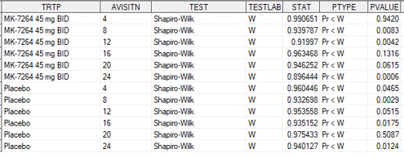

COMPLETER1 (defined as having week 24 cough data)
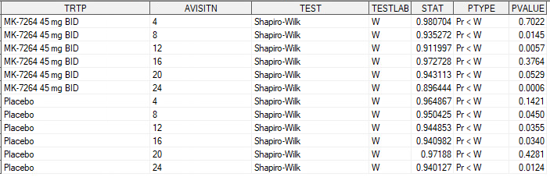
0.001
.

Completer2 of treatment of main period (EOTSTT1 = COMPLETED)
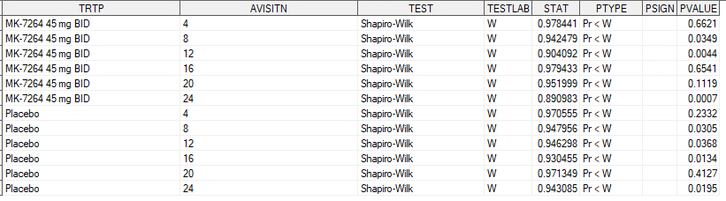

14. How completer1 and completer2 are related to each other

14.1 Population distribution and the overlap
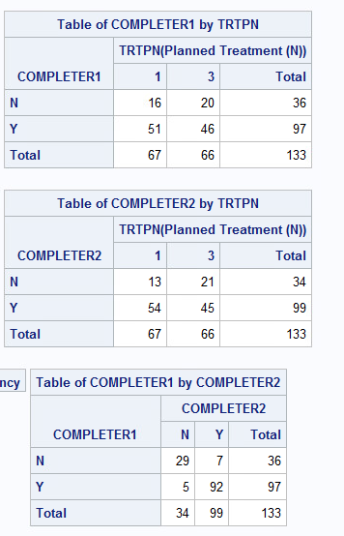
N=97 (completer 1)
N=99 (completer 2)
92 are shared in both.

14.2 Data points excluded. (top: completer1, bottom: completer2)
Descriptive:
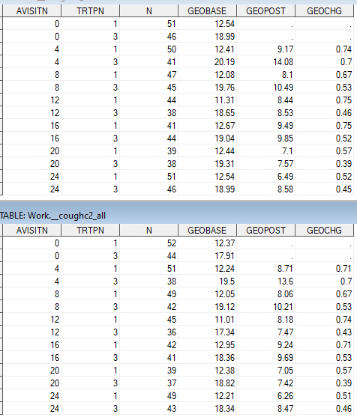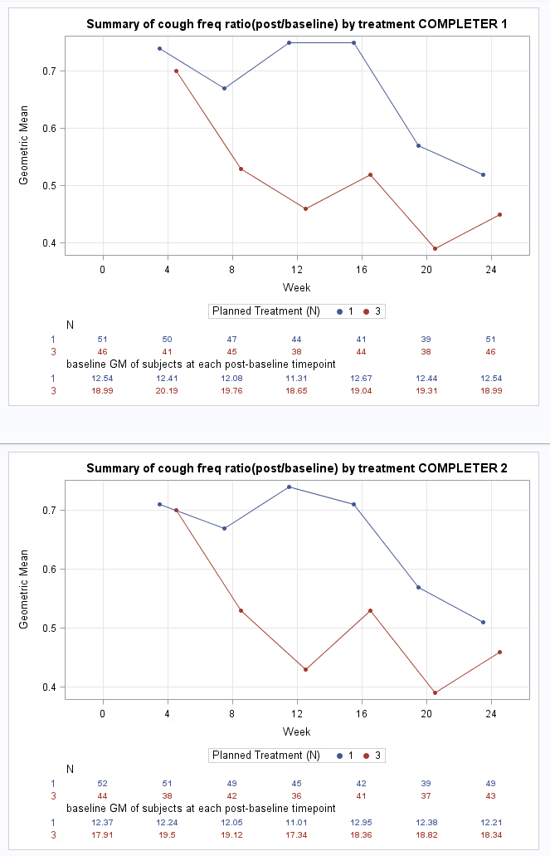

14.3 Primary endpoint. (top: completer1, bottom: completer2)

Model-based
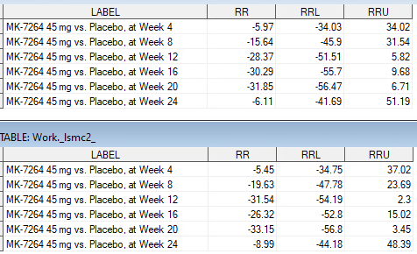

15. Other key endpoints (LCQ, CSD, CSDVAS): completer 1 vs completer 2 side-by-side

15.1 Awake cough frequency
descriptive
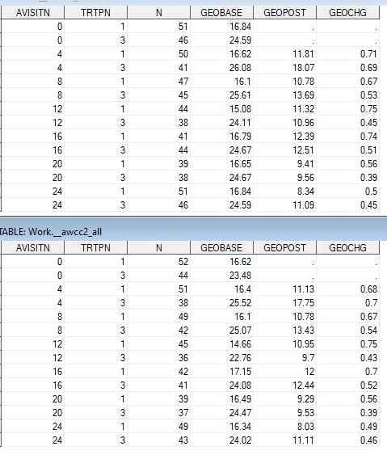

Model-based;
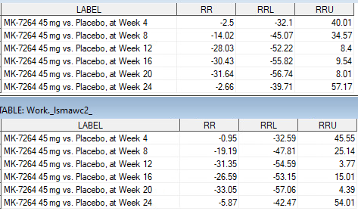

15.2 LCQ increase >=1.3
Descriptive (from top to bottom: FAS, completer1, completer2)
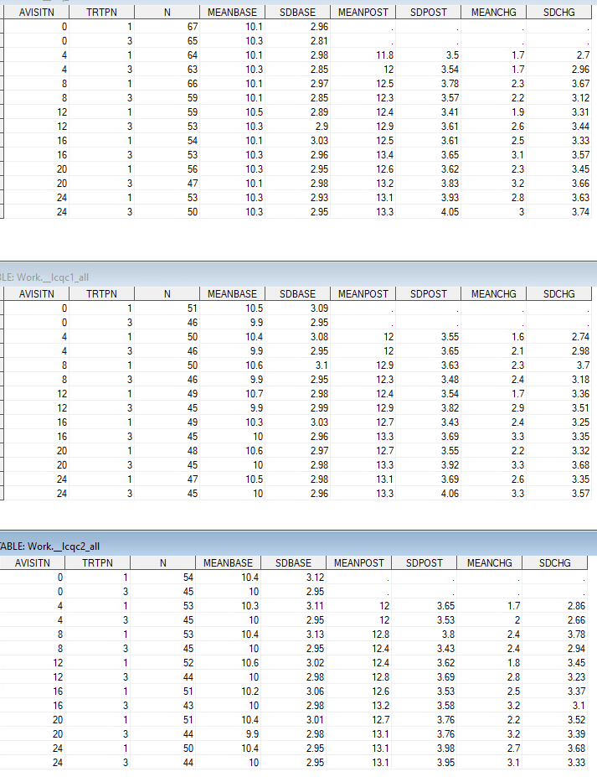
MODEL-BASED
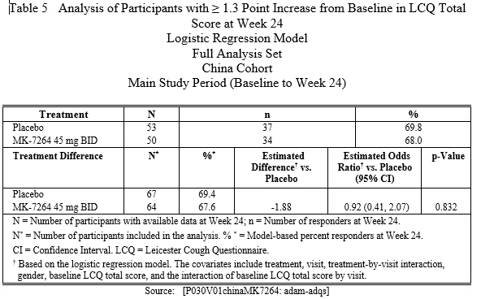
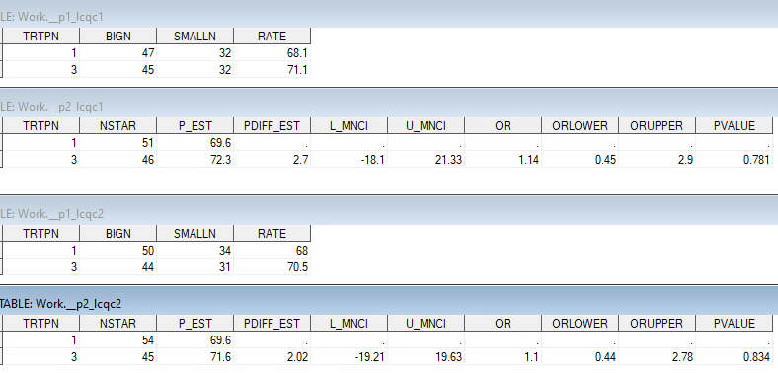

15.3 Reduction of 24-hr cough =>30%(from top to bottom: FAS, completer1, completer2)
Model-based
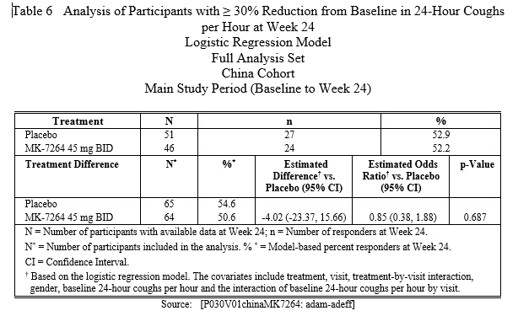
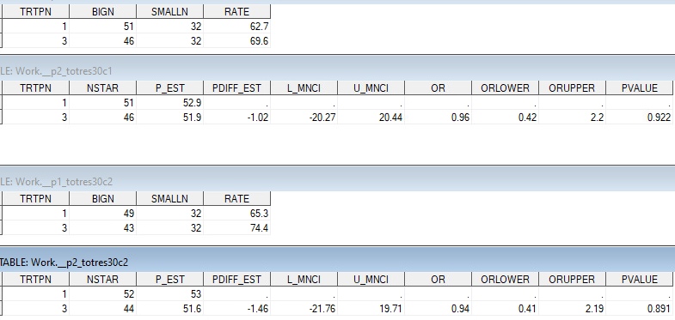

15.4 VAS reduction >=30mm
DESCRIPTIVE
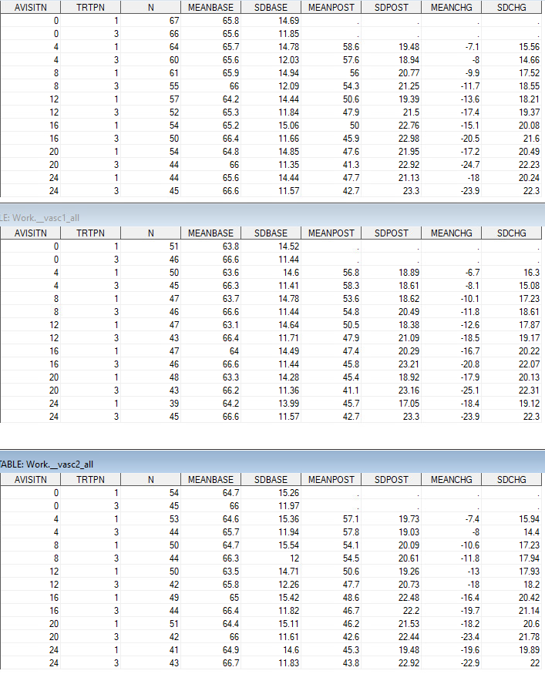
MODEL-BASED
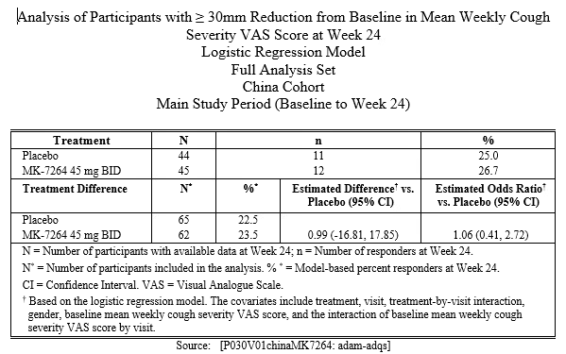
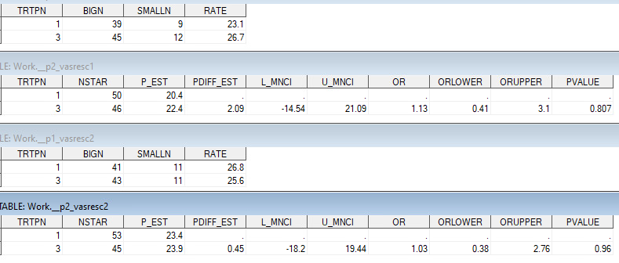

15.5 CSD reduction >=1.3
Descriptive
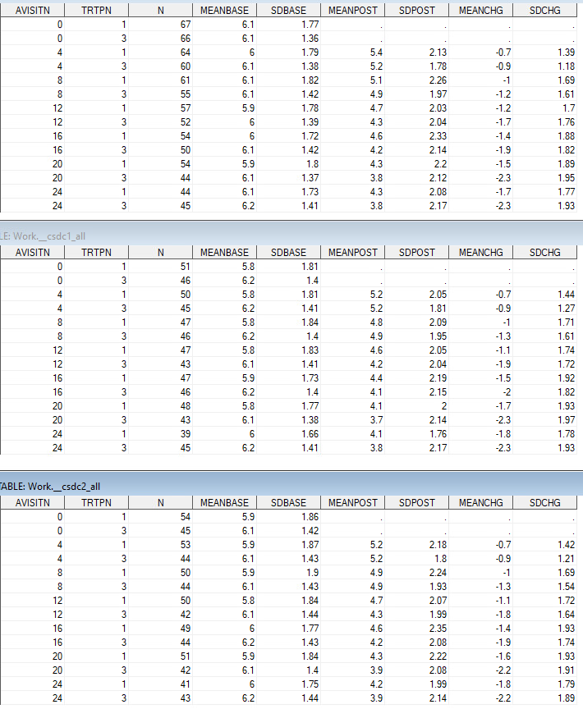
Model-based
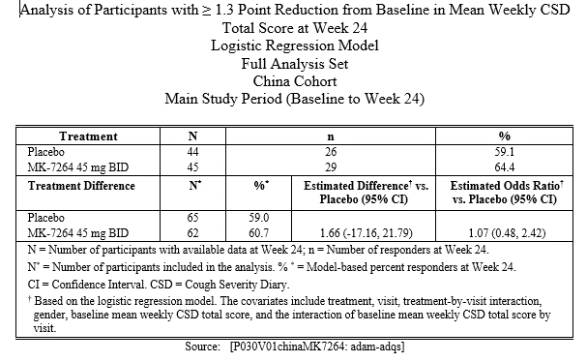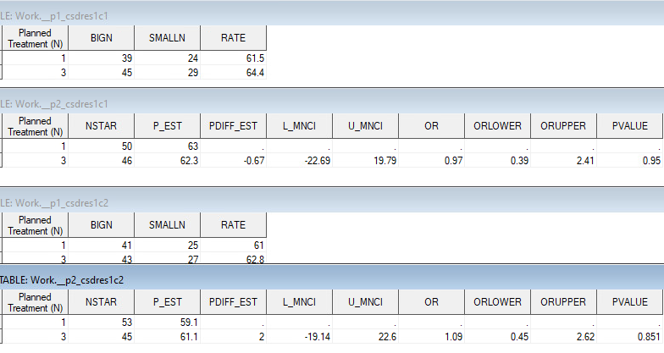

15.5 CSD reduction >=2.7
Model-based
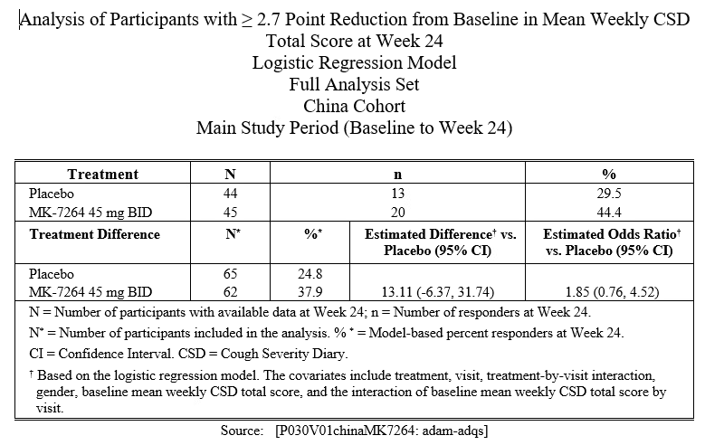
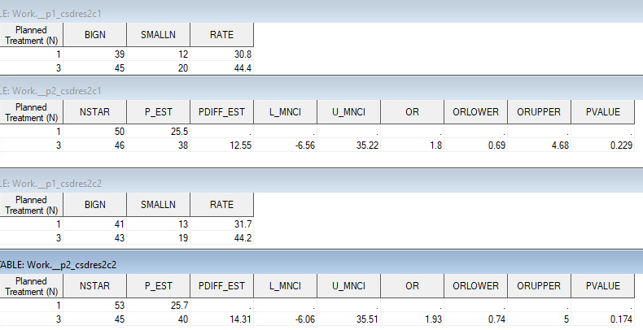

16. Individual data pattern - cough

16.1 FAS
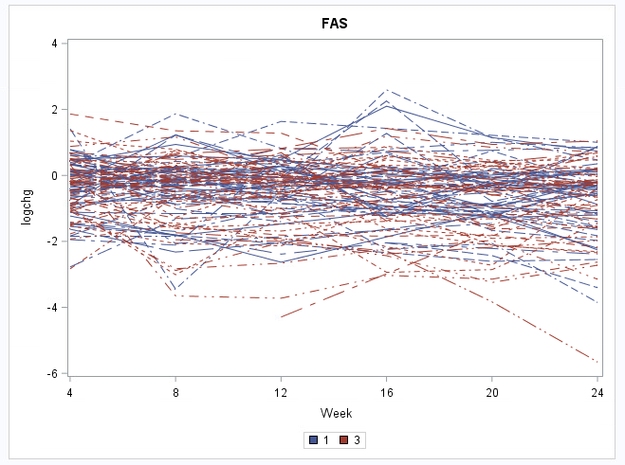

16.2 FAS excluded from completer 2
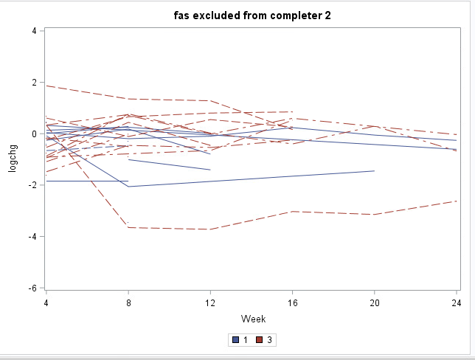

16.3 shared by completer 1 and 2
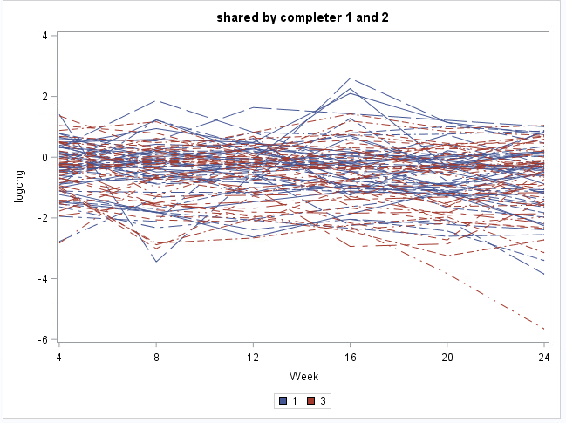

16.4 completer 1 exclusive (N=5)
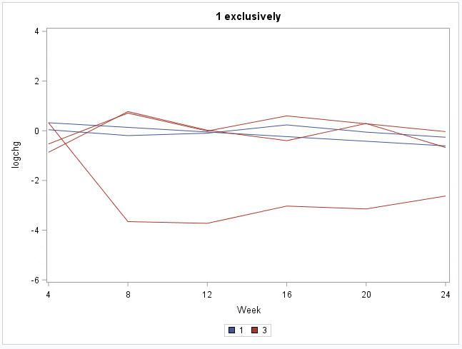

16.5 completer 2 exclusive (N=7)
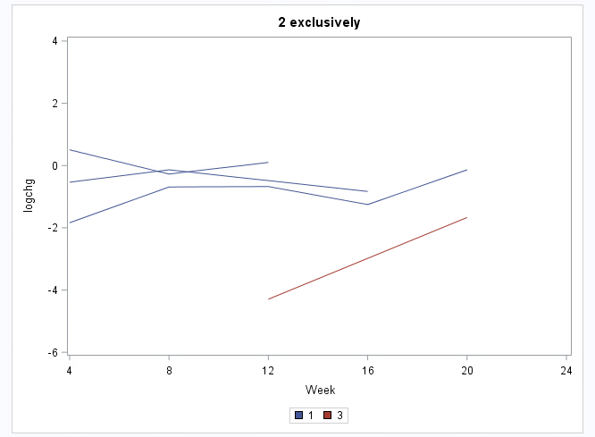
plb=3, mk=1 with available data

17. Individual data pattern - LCQ

17.1 FAS
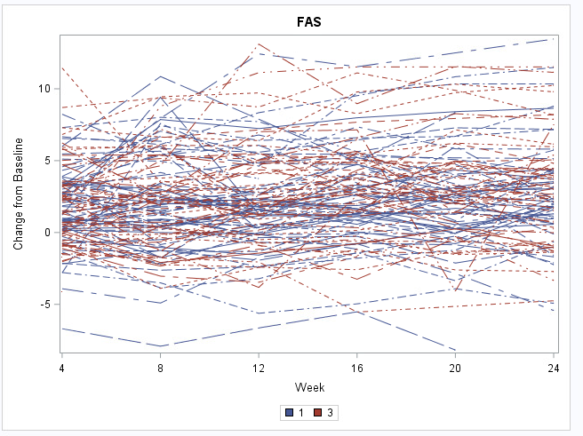

17.2 FAS excluded from completer 2
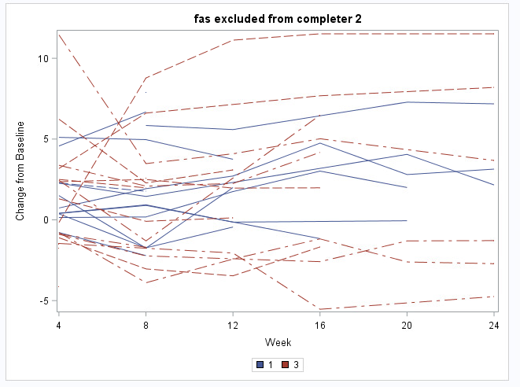

17.3 shared by completer 1 and 2
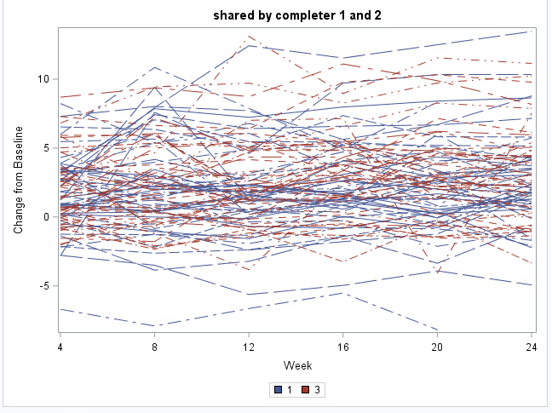

17.4 completer 1 exclusive
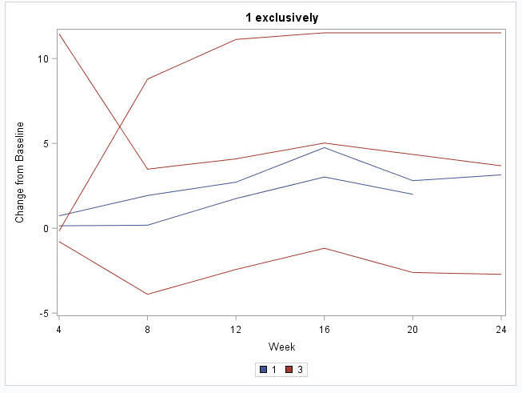

17.5 completer 2 exclusive
