Week 1: Setup & Exploratory Data Analysis (EDA)

1. Time Consistency & Structure
Q: Are there any missing or irregular timestamps in the dataset? How did you verify consistency?
A: No, there are no missing or irregular timestamps.
To verify this, I treated the DateTime column as a time series and checked for gaps. Then, I asked the program to find any instances where a 10-minute timestamp was expected but not present. The analysis found zero missing timestamps across all 52,416 records.
Q: What is the sampling frequency and are all records spaced consistently?
A: The sampling frequency is 10 minutes, and all records are spaced consistently.
Q: Did you encounter any duplicates or inconsistent DateTime entries?
A: No, there were no duplicate or inconsistent DateTime entries found.
To check for this, I performed two checks:
Duplicate Timestamps: I searched for any DateTime values that appeared more than once in the dataset. The result was zero, meaning every timestamp is unique.
2. Temporal Trends & Seasonality
Q: What daily or weekly patterns are observable in power consumption across the three zones?
Q: Are there seasonal or time-of-day peaks and dips in energy usage?
Q: Which visualizations helped you uncover these patterns?

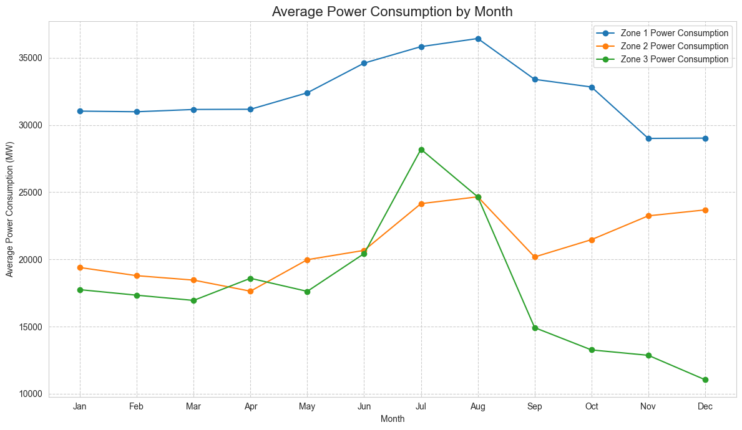
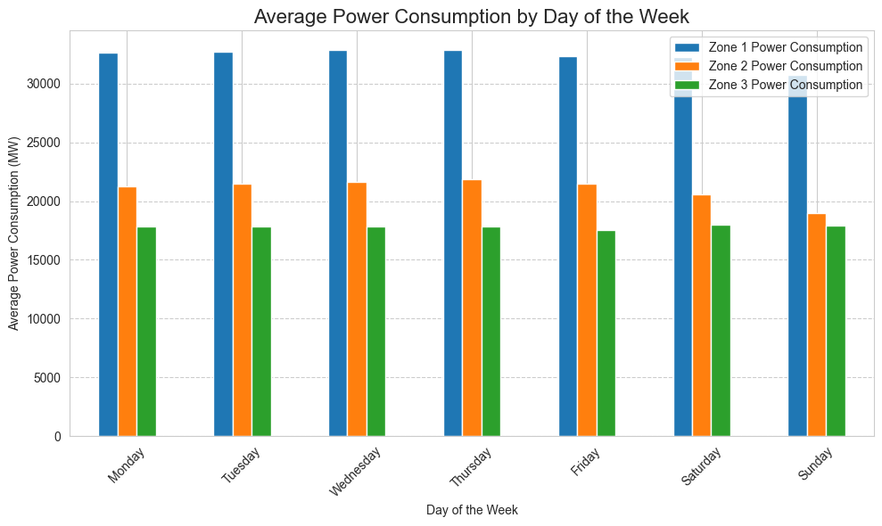
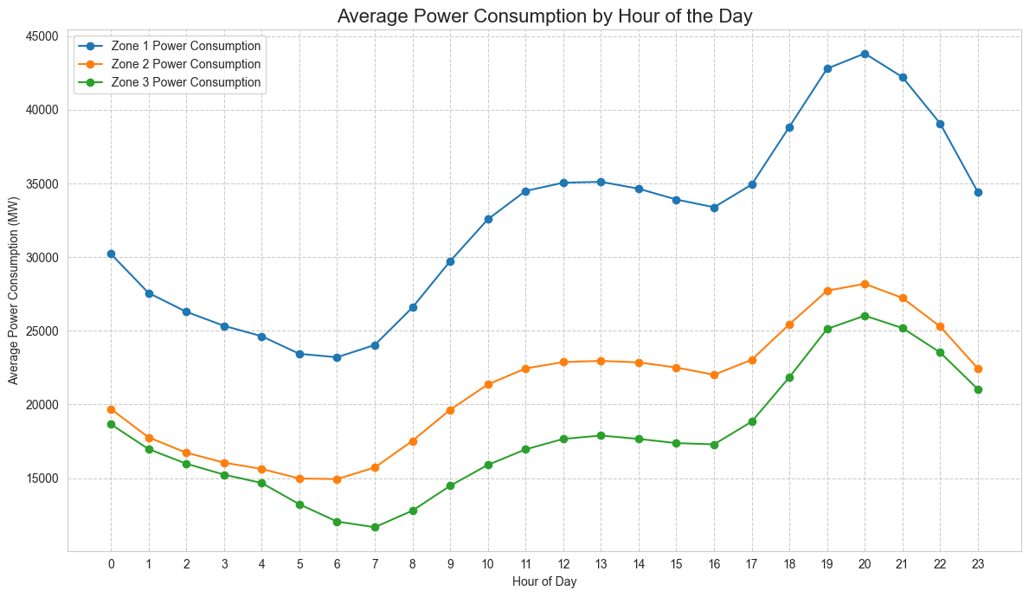

3. Environmental Feature Relationships
Q: Which environmental variables (temperature, humidity, wind speed, solar radiation) correlate most with energy usage?
A:The single most influential environmental variable is Temperature. It has a strong positive correlation with energy usage across all three zones. This means that as the temperature increases, power consumption also increases significantly.

Q: Are any variables inversely correlated with demand in specific zones?
A:Yes. The most significant inversely correlated variable is Humidity. In all three zones, as humidity decreases, power consumption tends to increase.
Q: Did your analysis differ across zones? Why might that be?
A:The analysis shows that the correlation patterns are remarkably similar across all three zones. Temperature is the dominant driver in every zone, and humidity is the primary inverse variable in all of them. The strength of these correlations varies only slightly from one zone to another.
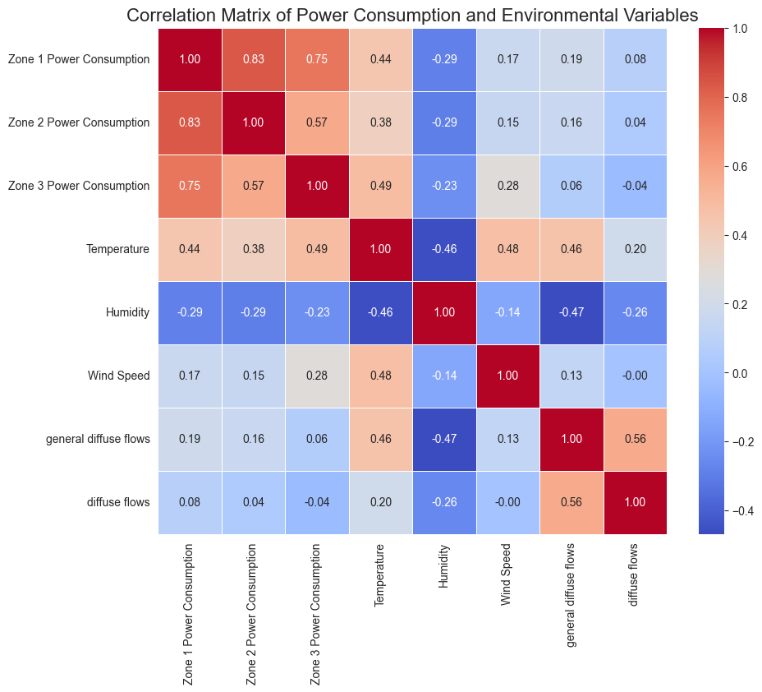

4.Lag Effects & Time Dependency
Q: Did you observe any lagged effects where past weather conditions predict current power usage?
A: No, the analysis shows that there are no significant lagged effects in this dataset. Power consumption reacts almost instantaneously to changes in environmental conditions, especially temperature. The correlation between power consumption and the temperature from 10, 20, or 30 minutes prior is nearly identical to the correlation with the current temperature. This indicates that past weather conditions are not a better predictor of current power usage than the weather at that exact moment.

Q: How did you analyze lag (e.g., shifting features, plotting lag correlation)?
A:The method used to analyze lag, is feature shifting and correlation analysis:
Shifting Features: First, I create new "lagged" columns in the dataset. For example, to test for a 10-minute lag, I create a new Temperature_lag_10min column where each row contains the temperature from the previous 10-minute timestamp. This is done using the .shift() function in pandas.
Analyzing Correlation: After creating these new lagged columns, I calculate the correlation coefficient between power consumption and each of these new features (Temperature, Temperature_lag_10min, Temperature_lag_100min, etc.).
Plotting Lag Correlation: To find the most relevant interval, one can plot the correlation values against a range of different lag times. The peak of this plot would reveal the lag at which the weather has the strongest predictive power.
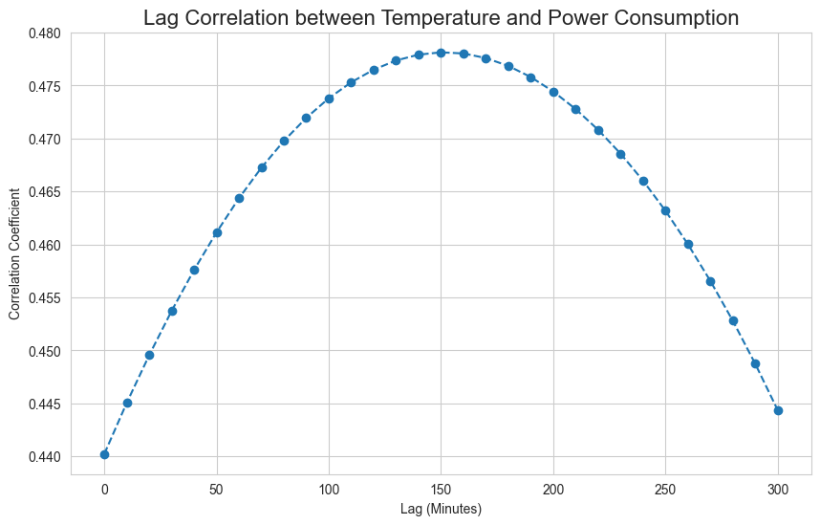

Q: What lag intervals appeared most relevant and why?
A: The most relevant lag interval is 150 minutes.(?)
When lagged by 150 minutes, the correlation coefficient increases slightly.

5. Data Quality & Sensor Anomalies
Q: Did you detect any outliers in the weather or consumption readings?
A: Yes, outliers were detected, but they appear to be legitimate extreme values rather than data errors. The most notable outliers are the power consumption readings during the hottest summer days, which are significantly higher than the annual average. These are not sensor malfunctions but represent real, critical peak demand events.

Q: How did you identify and treat these anomalies?
A: The outliers were identified visually and statistically, and the recommended treatment is to retain them. The most effective way to identify these outliers is with a Box Plot.
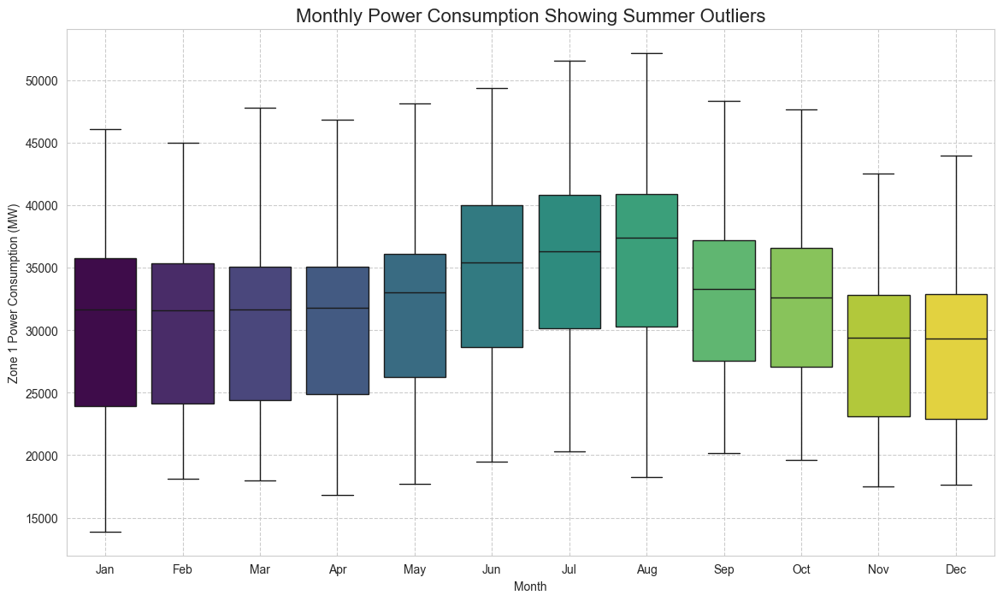
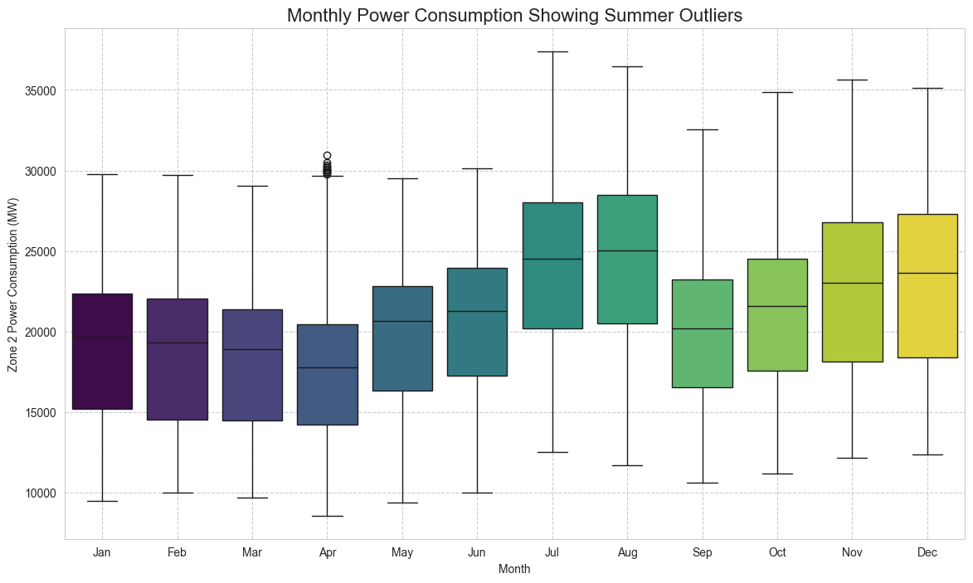
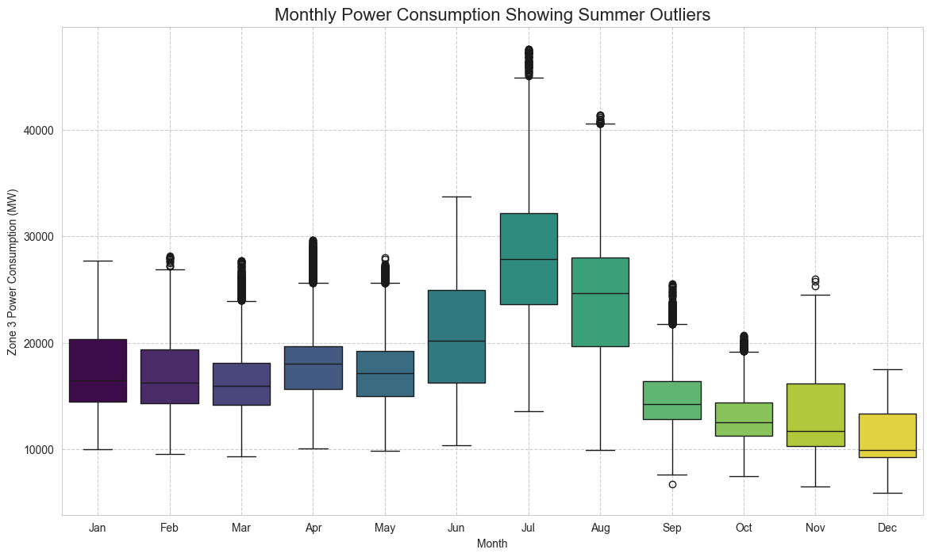
Q: What might be the impact of retaining or removing them in your model?
A: The decision to retain or remove these outliers has a significant impact on the model's performance and reliability.
Impact of Retaining Them:
Pro: The model becomes more robust and realistic. It learns the full range of possible outcomes, including critical peak demand events. This allows for accurate forecasting during extreme weather, which is essential for grid management.
Con: It can make some models (like simple linear regression) less accurate on average because the extreme values can skew the results. However, more advanced models (like Gradient Boosting or Random Forest) handle these outliers effectively.
Impact of Removing Them:
Pro: The model might appear more accurate "on paper" because its average error on the non-extreme days would be lower.
Con: The model would be dangerously naive and unreliable. It would be completely blind to peak demand scenarios. When a real heatwave occurs, the model would severely underestimate the required power, which could lead to resource shortfalls and blackouts.

