**Homework 5**

Department of Mechanical and Aerospace Engineering

University of California, San Diego

MAE 150

Lawrence Custodio

A08739279

21 February 2013

**Problem #2: Truss “warm-up”**

**Individual Stiffness Matrices:**

**k1 [Element 1]**

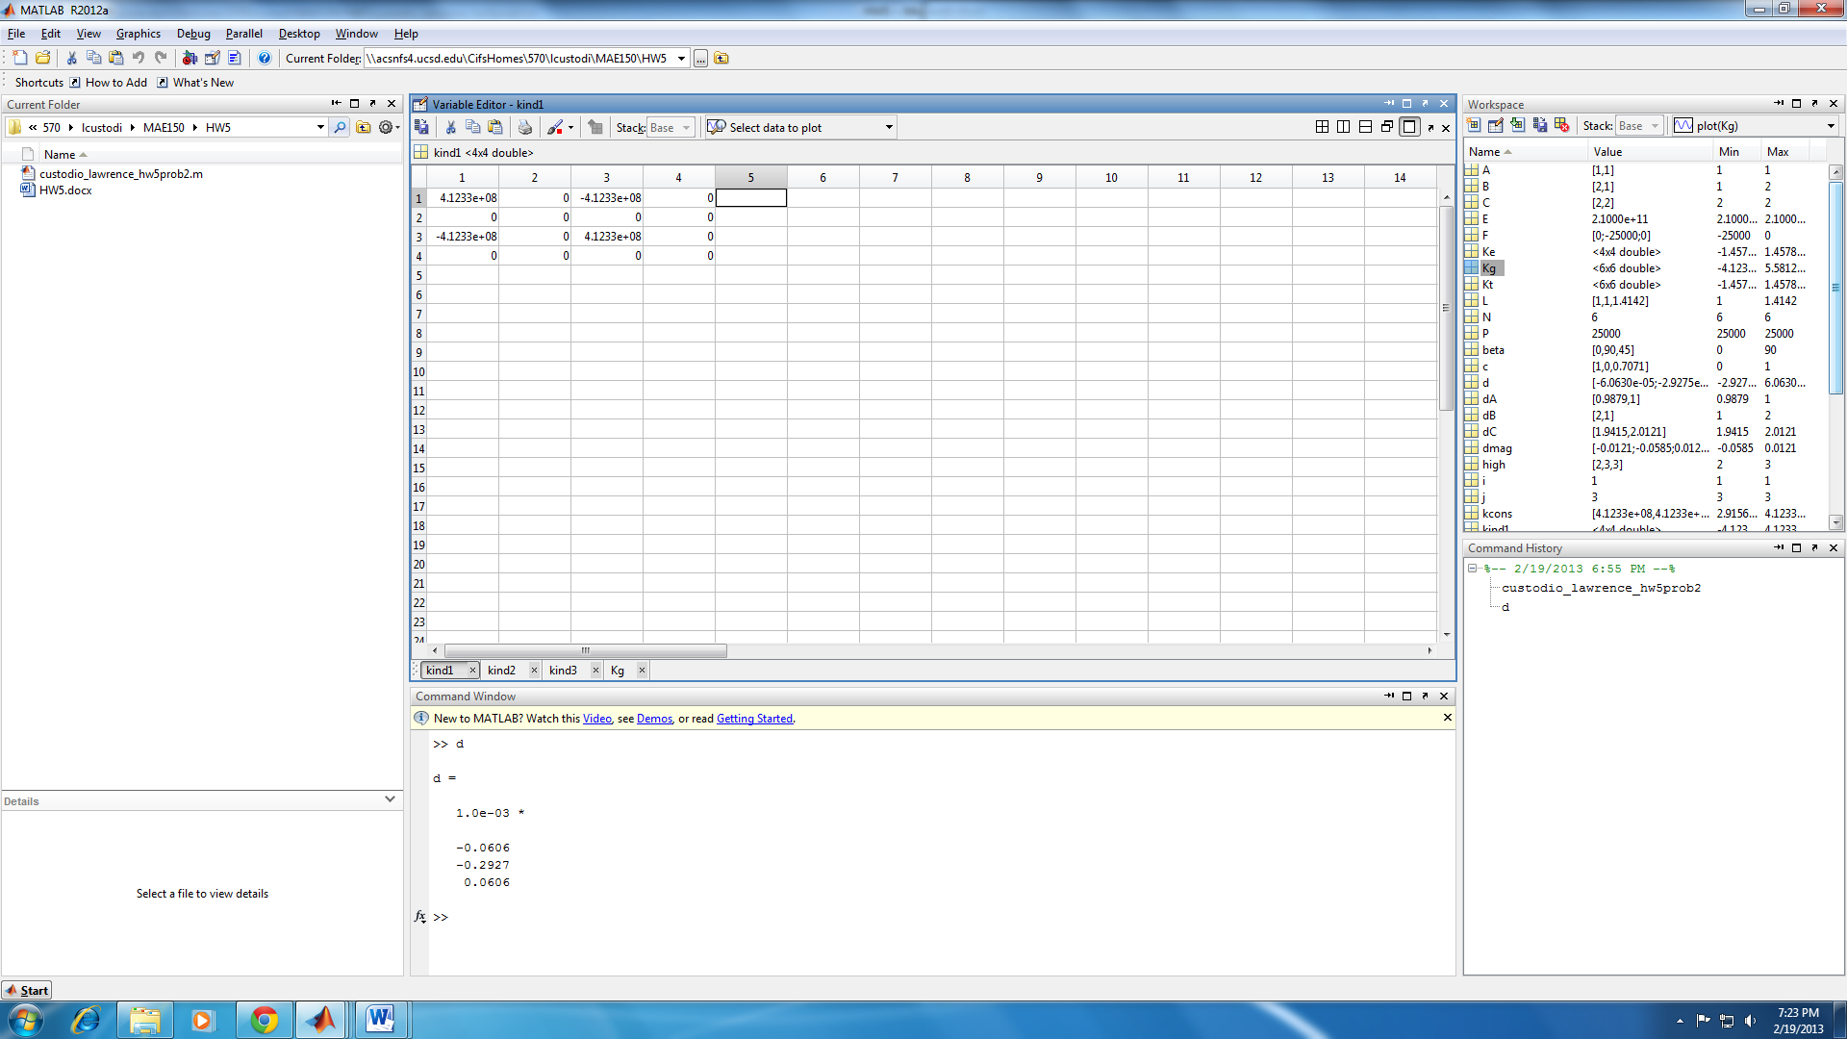

**k2 [Element 2]**

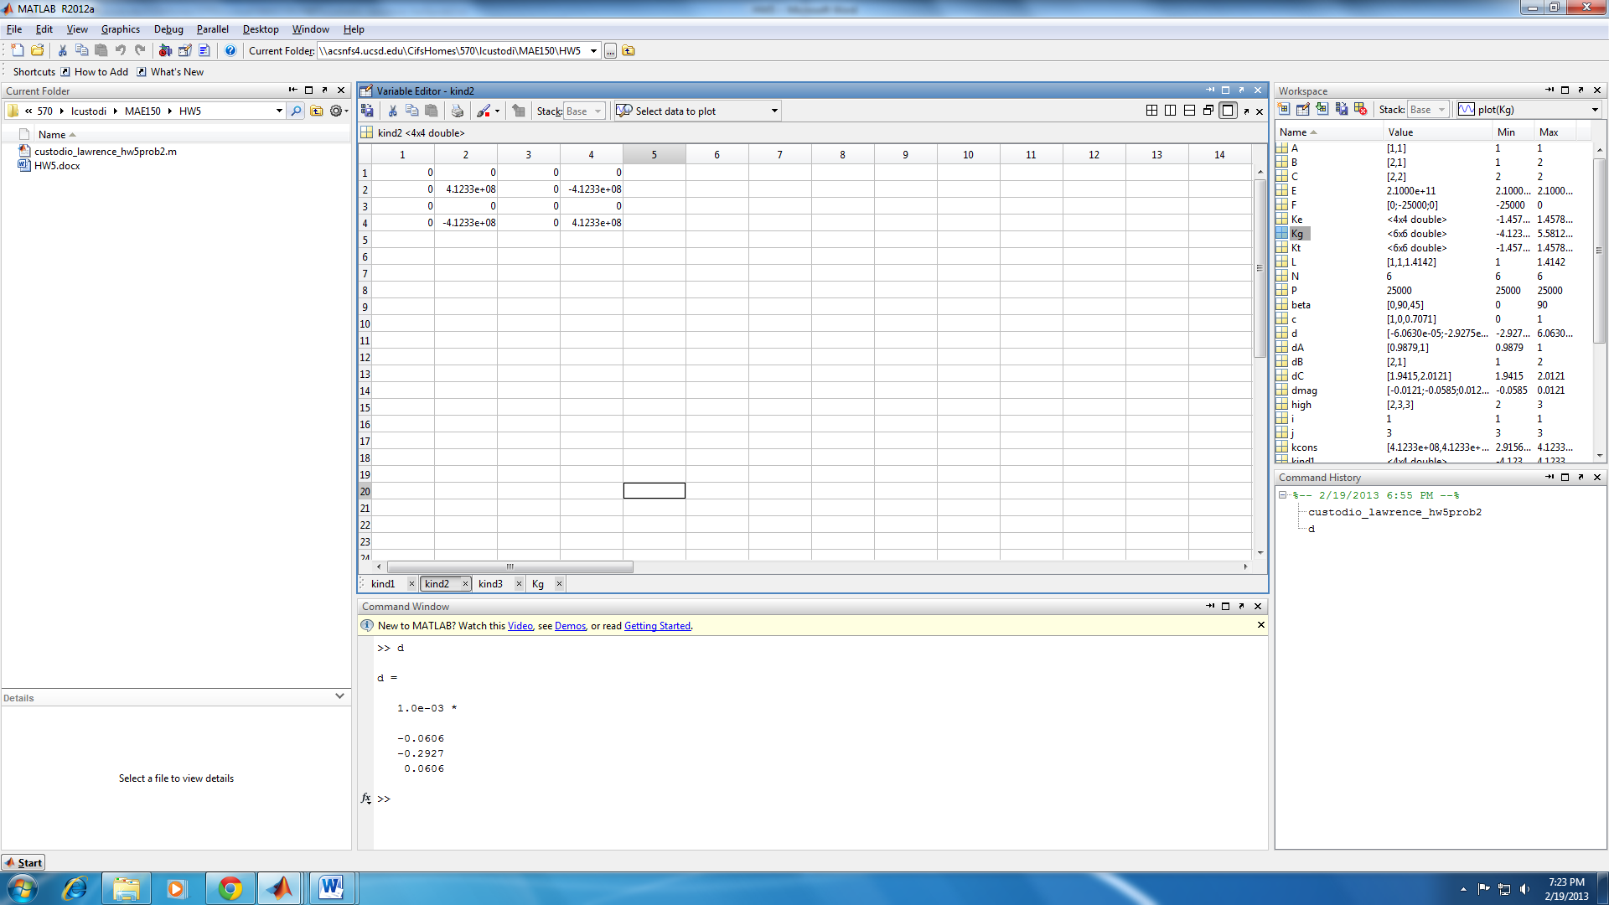

**k3 [Element 3]**

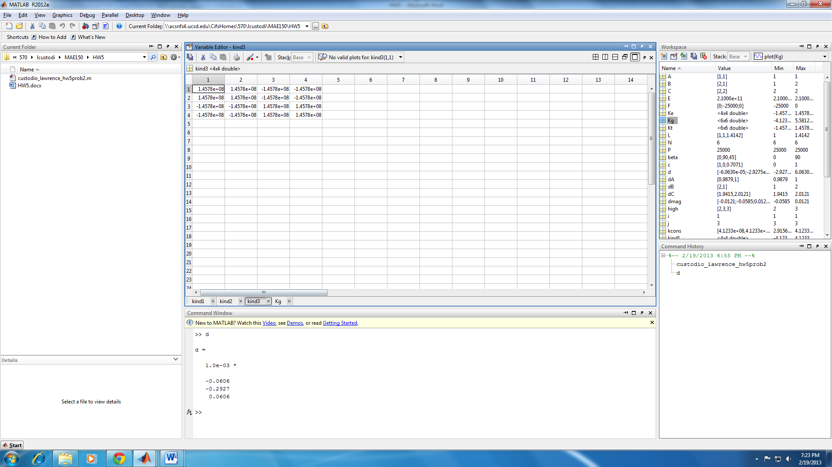

**Overall Global Stiffness Matrix K**

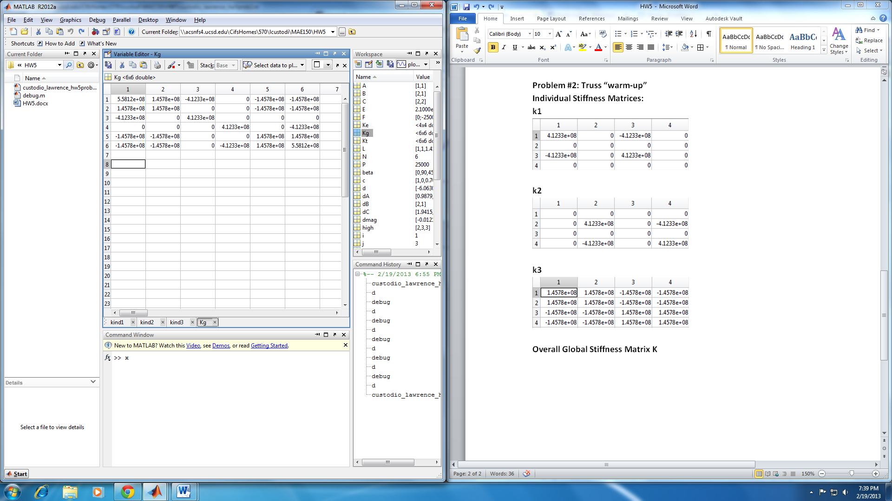

**Reaction Forces Displacements**

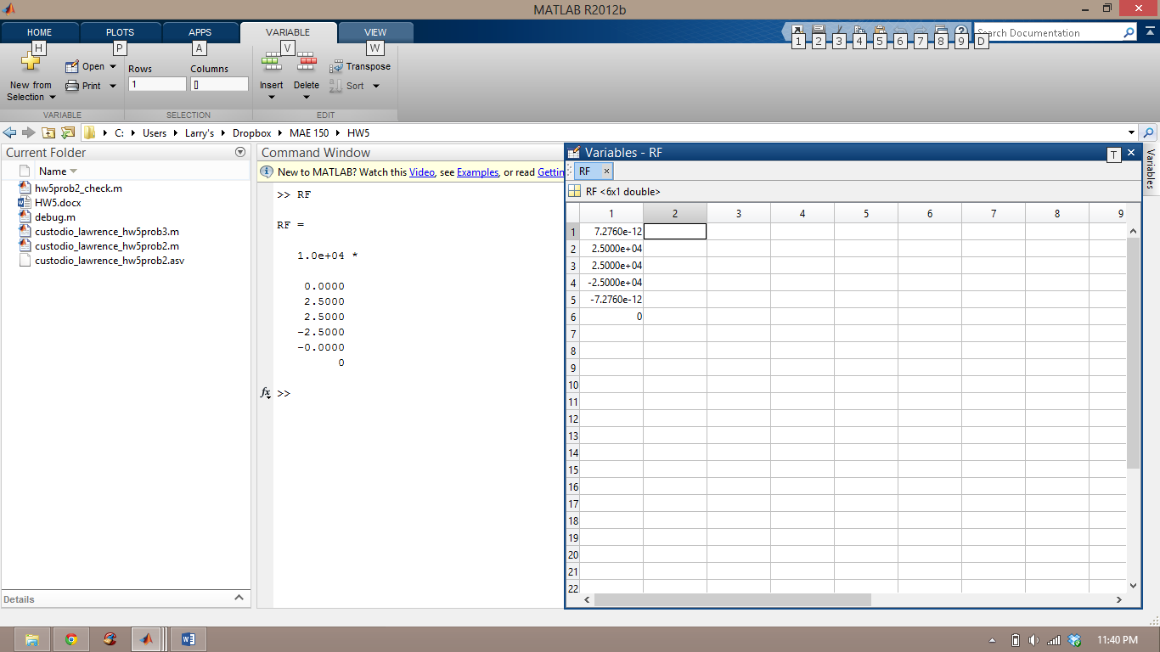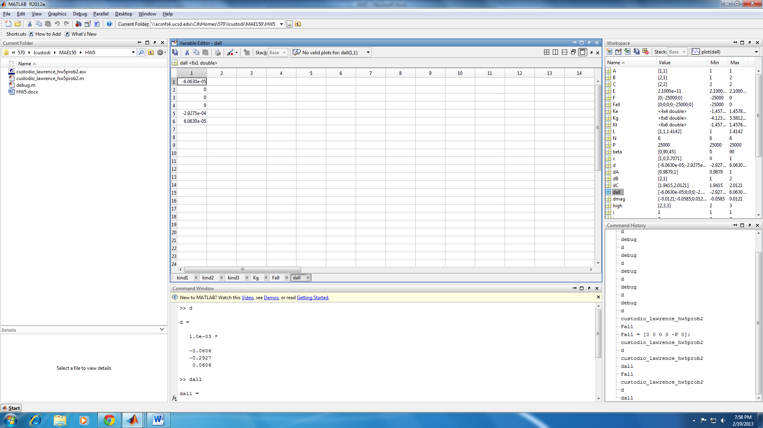

**Figure:**

**Solidworks**

**Axial Stress**

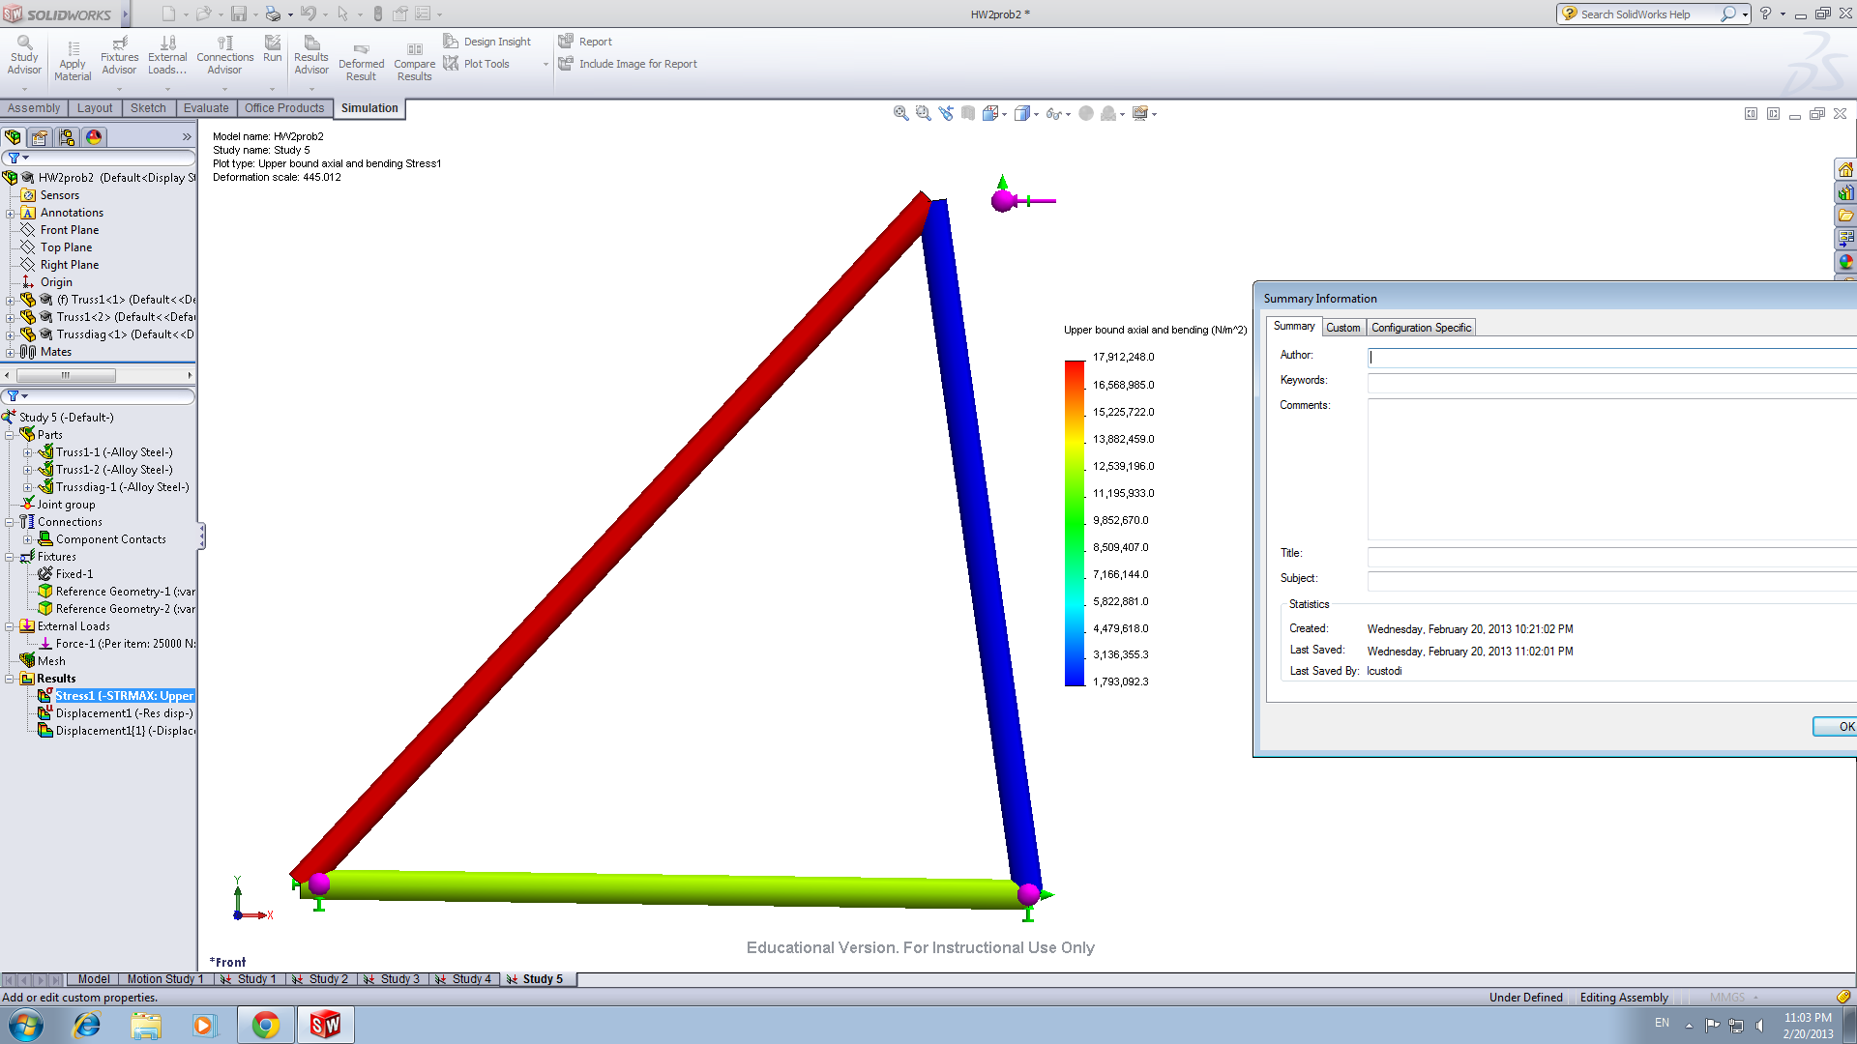

**Displacement**

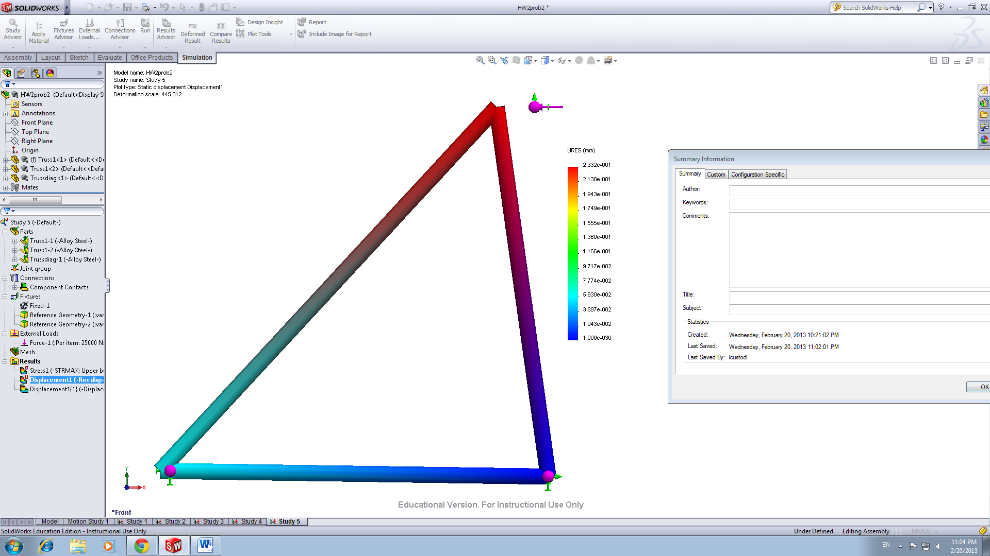

**Problem #3**

**Individual Stiffness Matrices  
Element 1**

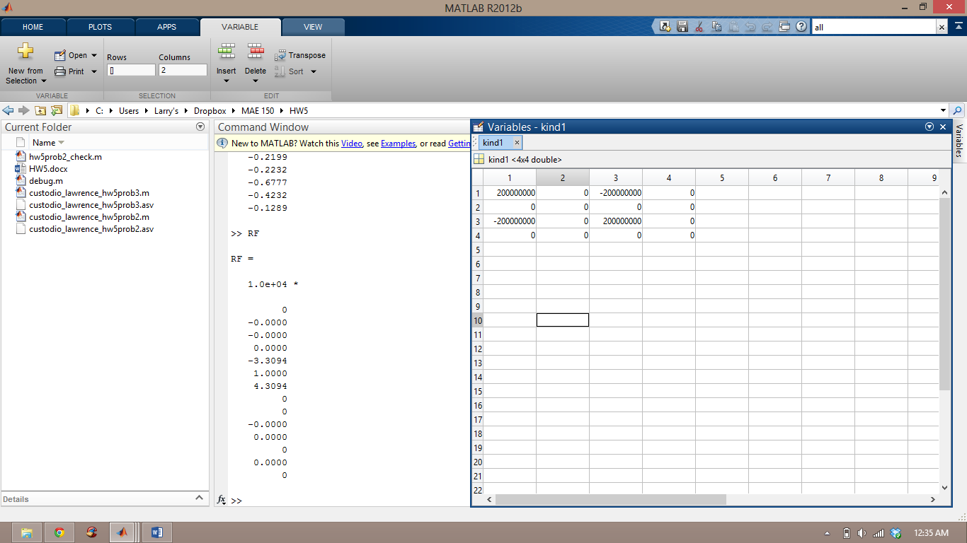

**Element 2**

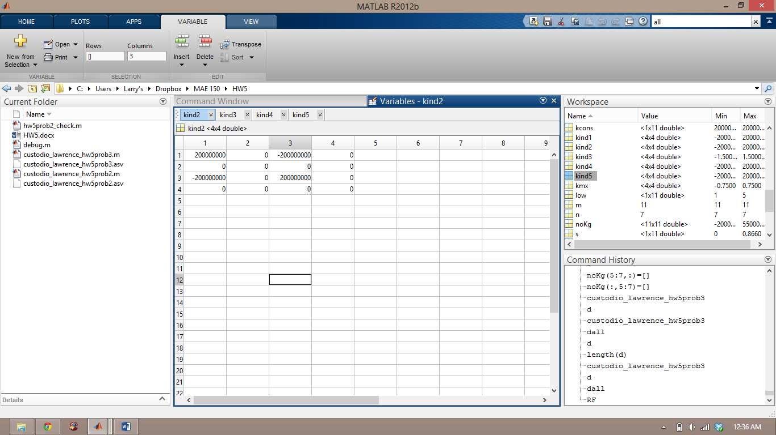

**Element 3**

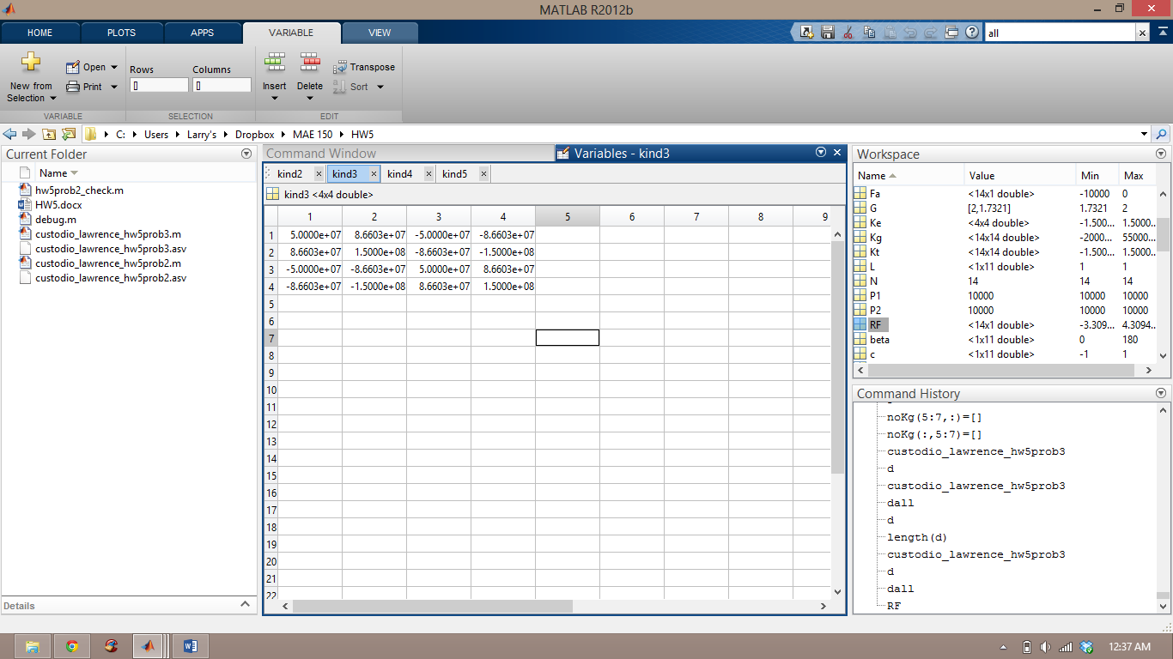

**Element 4**

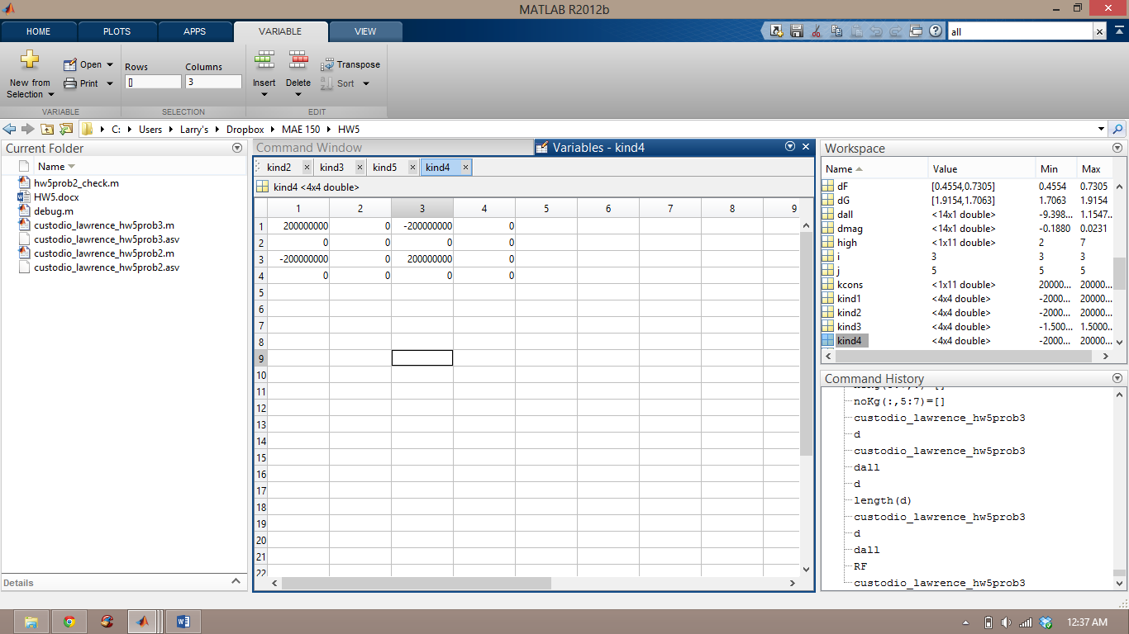

**Element 5**

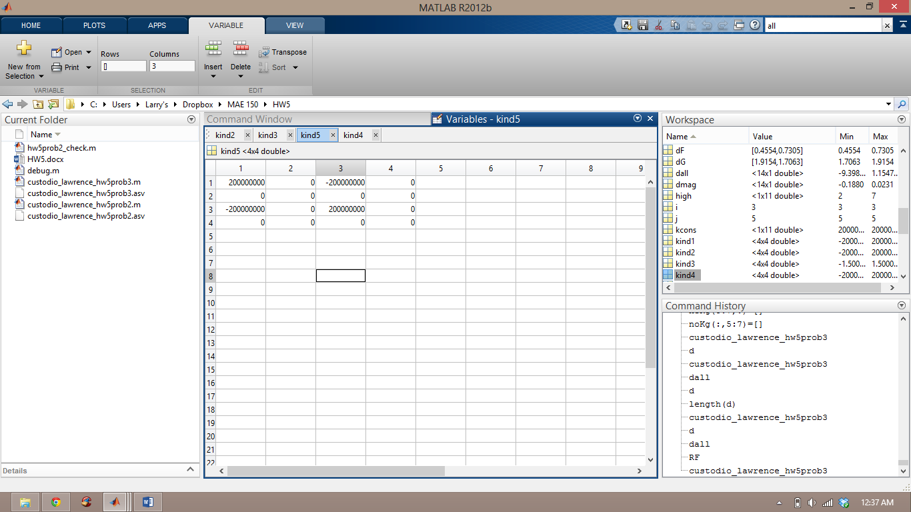

**Global Stiffness Matrix**

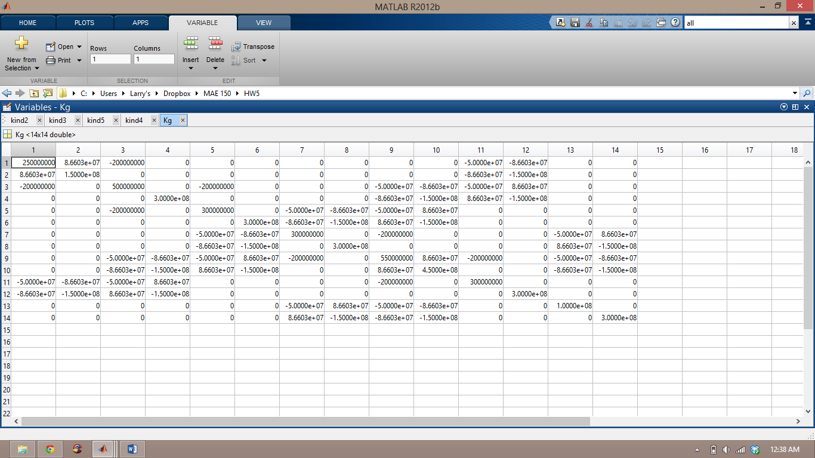

**Deflection Reaction Forces**

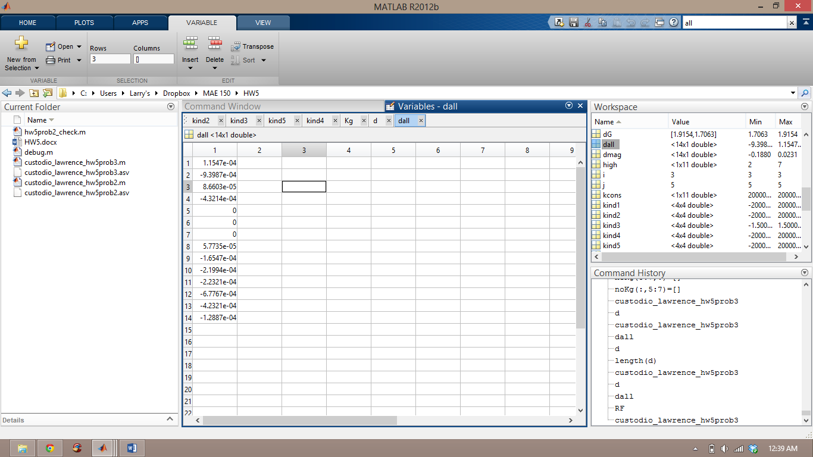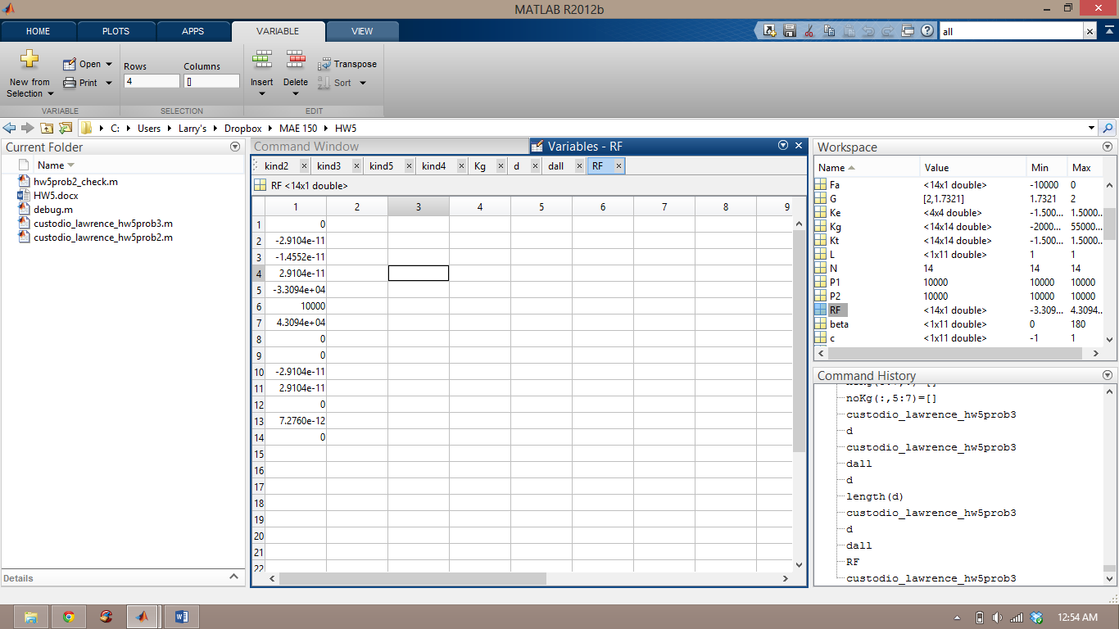

**Figure:**



**Appendix:**

**Problem 2**

clc;clear;close all;

%Lawrence Custodio

%Homework 5 Problem 2

%Given parameters:

n=3; %Number of Nodes

N=2*n; %Global Matrix size

E=210e9; %E-modulus

A=pi*(5e-2/2)^2; %Area at d=5cm

L = [1 1 sqrt(2)]; %Lengths of respective element

kcons = (A*E)*(L.^-1); %Material property

%Angles for respective elements:

beta = [0 90 45];

s = sind(beta);

c = cosd(beta);

Kg = zeros(N,N); %Preallocate global stiffness matrix

%Calculation of stiffness matrix:

for m = 1:length(L)

%General stiffness matrix Ke:

kmx=[(c(m))^2 c(m)*s(m) -(c(m))^2 -c(m)*s(m);

c(m)*s(m) (s(m))^2 -c(m)*s(m) -(s(m))^2;

-(c(m))^2 -c(m)*s(m) (c(m))^2 c(m)*s(m);

-c(m)*s(m) -(s(m))^2 c(m)*s(m) (s(m))^2];

Ke=kcons(m)*kmx;

%Individual stiffness matrices:

if m ==1 %For element 1

kind1 = Ke;

elseif m ==2 %For element 2

kind2 = Ke;

elseif m ==3 %For element 3

kind3 = Ke;

end

%Allocate nodes to elements:

low = [1 2 1]; %i-node

high = [2 3 3]; %j-node

i = low(m);

j = high(m);

%Auxiliary matrix: contribution of individual stiffness matrices to Kg

Kt = zeros(N,N);

Kt([2*i-1 2*i 2*j-1 2*j],[2*i-1 2*i 2*j-1 2*j]) = Ke(1:4,1:4);

Kg = Kg+Kt;

end

%forces

P = 25e3; %Applied force

Fall = [0 0 0 0 -P 0]'; %Force vector

F = Fall([1 5 6]); %Reduced force vector

%displacements

noKg = Kg([1 5 6],[1 5 6]); %reduced global stiffness matrix

d = noKg\F;

dall = zeros(N,1); %expanded displacement vector to calculate reaction forces

dall([1 5 6]) = d;

dmag= d*200; %Scaled displacement for visibility

RF = (Kg*dall)-Fall; %reaction forces

%Define truss structure

A = [1,1];

B = [2,1];

C = [2,2];

x = [A(1) B(1) C(1) A(1)];

y = [A(2) B(2) C(2) A(2)];

plot(x,y,'linewidth',2)

hold on

%Displacement vectors:

dA = [A(1)+dmag(1),A(2)];

dB = [B(1),B(2)];

dC = [C(1)+dmag(2),C(2)+dmag(3)];

xd = [dA(1) dB(1) dC(1) dA(1)];

yd = [dA(2) dB(2) dC(2) dA(2)];

plot(xd,yd,'r--','linewidth',2)

axis ([0.5 2.5 0.5 2.5])

grid on

title('HW 5 Problem 2: Truss Structure')

legend('Original','Deformed (scaled by a factor of 200')

**Problem 3**

clc;clear;close all;

%Lawrence Custodio

%Homework 5 Problem 3

%Parameters:

n=7; % # Nodes

N=2*n; %Global Matrix size

E=200e9; %E-modulus

A=10e-4; %Area at d=5cm

L = ones(1,11); %Element lengths

kcons = (A*E)*(L.^-1); %Material property

%Angles for respective elements:

beta = [0 0 60 180 180 60 120 60 120 60 120];

s = sind(beta);

c = cosd(beta);

Kg = zeros(N,N); %Preallocate global stiffness matrix

%Calculation of stiffness matrix:

for m = 1:length(L)

%General stiffness matrix Ke:

kmx=[(c(m))^2 c(m)*s(m) -(c(m))^2 -c(m)*s(m);

c(m)*s(m) (s(m))^2 -c(m)*s(m) -(s(m))^2;

-(c(m))^2 -c(m)*s(m) (c(m))^2 c(m)*s(m);

-c(m)*s(m) -(s(m))^2 c(m)*s(m) (s(m))^2];

Ke=kcons(m)*kmx;

%Individual stiffness matrices:

if m ==1 %For element 1

kind1 = Ke;

elseif m ==2 %For element 2

kind2 = Ke;

elseif m ==3 %For element 3

kind3 = Ke;

elseif m ==4 %For element 4

kind4 = Ke;

elseif m ==5 %For element 5

kind5 = Ke;

end

%Allocate nodes to elements:

low = [1 2 3 4 5 5 4 1 2 2 3]; %i-node

high = [2 3 4 5 6 7 7 6 6 5 5]; %j-node

i = low(m);

j = high(m);

%Auxiliary matrix: contribution of individual stiffness matrices to Kg

Kt = zeros(N,N);

Kt([2*i-1 2*i 2*j-1 2*j],[2*i-1 2*i 2*j-1 2*j]) = Ke(1:4,1:4);

Kg = Kg+Kt;

end

%Calculation of reaction forces + displacements

P1 = 10000;

P2 = P1;

Fa = zeros(N,1);

Fa(2) = -P1;

Fa(13) = -P2; %Overall force vector

F = Fa;

F(5:7) = []; %Reduced force vector

noKg = Kg;

noKg(5:7,:)=[];

noKg(:,5:7)=[];%Reduced global matrix

d = noKg\F;

dall = zeros(N,1);

dall(1:4)=d(1:4);

dall(5:7) = 0;

dall(8:14) = d(5:11);%expanded displacement vector

RF = (Kg*dall)-Fa; %reaction forces

dmag= dall*200; %Scaled displacement for visibility

%Defining truss structure: A = Node[1], B =Node[2],etc.

A = [0,0]; %Node 1

dA= A + [dmag(1) dmag(2)]; %displacement @ Node 1

B = [1,0]; %Node 2

dB = B + [dmag(3) dmag(4)];

C = [2,0]; %Node 3

dC = C + [dmag(5) dmag(6)];

D = C+[cosd(60),sind(60)]; %Node 4

dD = D + [dmag(7) dmag(8)]; %displacement @ Node 4

E = D-[1,0]; %Node 5

dE = E +[dmag(9) dmag(10)];

F = E-[1,0]; %Node 6

dF = F +[dmag(11) dmag(12)];

G = E+[cosd(60),sind(60)]; %Node 7

dG = G + [dmag(13) dmag(14)]; %displacement @ Node 7

%Original truss positions

%Elements 1-5:

x = [A(1) B(1) C(1) D(1) E(1) F(1)];

y = [A(2) B(2) C(2) D(2) E(2) F(2)];

plot(x,y,'linewidth',2);

hold on

%Elements 6 and 7:

x1 = [E(1) G(1) D(1)];

y1 = [E(2) G(2) D(2)];

plot(x1,y1,'linewidth',2);

%Elements 8-11:

x2 = [A(1) F(1) B(1) E(1) C(1)];

y2 = [A(2) F(2) B(2) E(2) C(2)];

plot(x2,y2,'linewidth',2);

%Displacements:

%Elements 1-5:

x = [dA(1) dB(1) dC(1) dD(1) dE(1) dF(1)];

y = [dA(2) dB(2) dC(2) dD(2) dE(2) dF(2)];

plot(x,y,'r','linewidth',2);

%Elements 6 and 7:

xd1 = [dE(1) dG(1) dD(1)];

yd1 = [dE(2) dG(2) dD(2)];

plot(xd1,yd1,'r','linewidth',2)

%Elements 8-11:

xd2 = [dA(1) dF(1) dB(1) dE(1) dC(1)];

yd2 = [dA(2) dF(2) dB(2) dE(2) dC(2)];

plot(xd2,yd2,'r','linewidth',2)

grid on

axis equal

title('Truss Structure Deformation Scale Factor =200')