
LAUNCH WEEK KIT

Your store is built, tested and ready. This is how you tell everyone.
PREPARED FOR
{{ org_name }}
{{ est_line }}
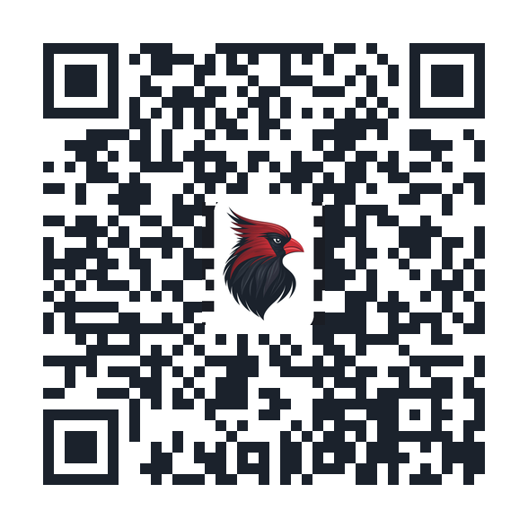
Your store is live at
{{ store_url_display }}
Steeple & Stitch Co. • A Division of The Williams Collective

YOUR STORE IS READY TO ANNOUNCE
Hello {{ org_short }} {{ leaders }},
The {{ store_name }} is finished. It is built and branded, the products are made from your {{ mark_word }}, checkout has been tested end to end, and your branded QR code is issued and scanning. There is nothing left to build.
So this kit is about one thing only: the announcement. Inside you will find a day-by-day plan for launch week, every piece of copy already written and ready to paste, print-ready artwork, and a short list of who needs to do what.
Anything that is still outstanding on the setup side has been moved to the appendix, because none of it holds up launch. Read the plan, set the date, and we will go.
THE ONLY DECISIONS WE NEED FROM YOU
Confirm these in writing with your point of contact and the rest of this kit falls into place.
Launch date: {{ launch_date_fmt }}
Who owns Instagram and Facebook that week: {{ social_owner_line }}
Postcards ordered by: ______________________
STORE AT A GLANCE
ITEM | DETAIL
Store name | {{ store_name }}
Store link | {{ store_url_display }}
QR code | Branded with your {{ mark_word }}, pointing at {{ redirect_url_display }}. Print files ship with this kit.
Launch lineup | {{ product_lineup }}
Sizes | {{ size_range }}
Fulfillment | Printed to order and shipped to the buyer in {{ fulfillment_days }}. No inventory, and nothing for the {{ office }} to hand out.
Back to {{ org_short }} | {{ margin_pct_fmt }}% of every order, paid out {{ payout_frequency_lower }}.
Status | Live and tested. Launching {{ launch_date_fmt }}.

1. THE LAUNCH WEEK PLAN
A launch lands hardest when everything arrives in the same week. This is the running order we recommend, with room to write down who owns each piece.
WHEN | DO THIS | OWNER
Two weeks out | Confirm the launch date with Steeple & Stitch.  Send the postcard PDF to your printer.  Decide who owns the social accounts that week. | ______________
Thursday before | Send the staff preview email.  Brief the {{ office }} so they can answer “where do I get one?” | ______________
Launch day | Email to {{ audience_all }}, first thing in the morning.  Launch-day post on Instagram and Facebook.  {{ announcement_slot }}.  Postcards handed out. | ______________
Day two | QR sign up in the lobby and at the front desk.  Postcards stacked where {{ audience_gather }}. | ______________
Day three | Midweek follow-up post, ideally a real photo.  Group text to {{ roster_word }}. | ______________
Day four | {{ alumni_word|sentence }} post and forward the link to that email list. | ______________
{{ big_event_title }} | {{ pa_context|sentence }}.  Postcards on the welcome table. | ______________
End of week | Thank-you post to the {{ audience }}.  First-week check-in with your point of contact. | ______________
BEFORE YOU ANNOUNCE ANYTHING
☐ Launch date confirmed in writing
☐ Postcards in hand and scan-tested — not just ordered
☐ Staff preview email already sent
☐ One person named as owner of the social accounts for the week
2. WHO DOES WHAT
Launch week goes sideways when everyone assumes someone else is posting. Fill this in before the date is set.
JOB | PERSON
Final go, and the launch date | ______________________________
All-family email | ______________________________
Instagram and Facebook | ______________________________
{{ announcement_slot }} | ______________________________
{{ office|sentence }} questions | ______________________________
{{ big_event_title }} announcement and table | ______________________________
Postcard printing and distribution | ______________________________
{{ alumni_word|sentence }} list | ______________________________
3. LAUNCH WEEK COPY
Everything below is written for {{ org_short }} and ready to use, in the order you will need it. The store link is already filled in — the only blanks are names and dates.
STAFF PREVIEW EMAIL
Send the Thursday before launch — two to four days ahead of {{ ahead_of }}.
Subject: {{ mascot }} gear — a first look before everyone else sees it
—
Team,
The {{ store_name }} opens to {{ audience }} on {{ launch_date_fmt }}. You get it first.
{{ product_lineup_short }}, printed to order and shipped to you. The performance long sleeve has been the staff favourite elsewhere.
Shop here: {{ store_url_display }}
One ask: if you order, wear it on launch day. People noticing leadership in the gear does more than any post we can write.
______________________
EMAIL TO {{ audience|upper }}
Launch day, first thing in the morning. Send this before you post.
Subject: The {{ store_name }} is open
Preview text: {{ product_lineup_short }}, shipped to your door.
—
{{ audience_address }},
We’re glad to share that the {{ store_name }} is now open.
You’ll find {{ product_lineup_lower }} — all carrying the {{ mark_word }}. Sizes run from {{ size_range_inline }}, and every item is printed once you order it and shipped to your door in {{ fulfillment_days }}. There is no inventory to manage and nothing to pick up from the {{ office }}.
Best of all, a share of every order comes straight back to {{ org_short }}.
Shop the store: {{ store_url_display }}
A postcard with a scannable code is coming home this week as well — keep it on the fridge.
{{ cheer }}
______________________
INSTAGRAM AND FACEBOOK — LAUNCH DAY
Launch day. Pair with a photo of someone in the gear.
It’s here, {{ audience_address }}. The {{ store_name }} is open.
{{ product_lineup_short }} — printed when you order and shipped straight to your door. {{ size_range_inline|sentence }}, so everyone can match.
A share of every single order comes right back to {{ org_short }}.
Scan the code on the postcard coming home this week or tap the link in our bio. {{ cheer }}
#{{ org_short }}{{ mascot_plural }}
{{ announcement_slot|upper }}
Launch day. About twenty-five seconds read aloud.
{{ audience_address }}, the {{ store_name }} is now open. {{ product_lineup_short }}, all with the {{ mark_word }} on them, shipped right to your house. Every order {{ supports_short }}. Look for the postcard going home this week and scan the code on the front or ask at the office for the link.
GROUP TEXT OR MESSAGING APP
Day three. Send to {{ roster_word }}.
{{ audience_address }} — the {{ store_name }} is live: {{ store_url_display }}
{{ size_range_inline|sentence }}, ships in {{ fulfillment_days }}, and a share of every order comes back to the school.
INSTAGRAM AND FACEBOOK — MIDWEEK FOLLOW-UP
Day three. Works best with a real photo of someone wearing it.
Spotted: {{ org_short }} colours in the hallway.
The Merch store is open all year, with new seasonal drops coming through the school year. {{ size_range_inline|sentence }}, shipped in {{ fulfillment_days }}.
Link in bio. #{{ org_short }}{{ mascot_plural }}
{{ alumni_word|upper }} POST
Day four. Forward the same copy to your {{ alumni_word }} email list.
Every class, every year — the {{ store_name }} is open to everyone who ever wore your colours. Same {{ mascot_lower }}, new gear, shipped to your door. Every order {{ supports_short }}. Link in bio.
{{ big_event_title|upper }} ANNOUNCEMENT
{{ big_event_title }}. About fifteen seconds — {{ pa_context }}.
{{ audience_address }} — want to represent {{ org_short }}? The {{ store_name }} is open. Scan the code on the postcards at the entrance table for {{ product_lineup_lower }}, and know that a share of every order comes back to {{ org_name }}. {{ cheer }}
END OF WEEK THANK-YOU POST
End of week. Ask your point of contact for the first-week number before posting.
{{ audience_address }} — thank you. ______ orders came through the Merch store in its first week, and every one of them sends a share straight back to {{ org_short }}.
The store stays open all year, so there is no rush. Link in bio whenever you need it. {{ cheer }}
{{ newsletter_title|upper }}
Any time. Roughly fifty words — sized for a {{ newsletter }} column.
{{ org_name }} gear is here. The official Merch store carries {{ product_lineup_lower }} in {{ size_range_inline }}. Everything is printed to order and shipped to your door in {{ fulfillment_days }}, and a share of every order {{ supports_short }}. Scan the code on the postcard or visit {{ store_url_display }}.

4. THE ARTWORK
Print-ready postcard artwork ships with this kit, front and back, six by four inches with bleed. Hand them out, stack them at the front desk, and put a pile on the welcome table at {{ event_plural }}.
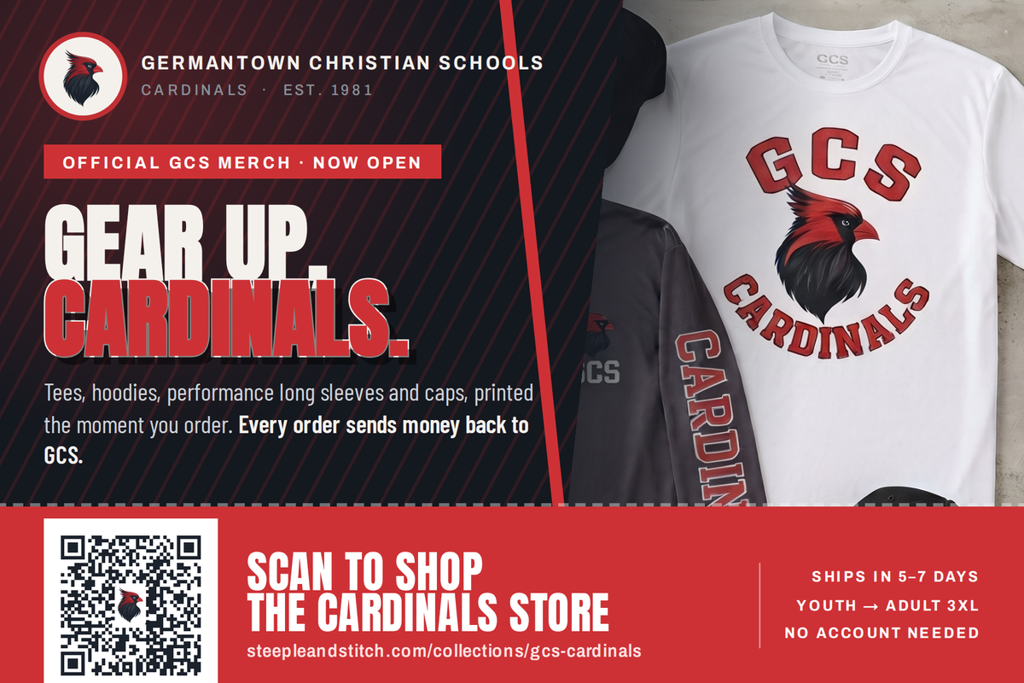
Front — the tear-off ticket band carries the scannable code and the store link.
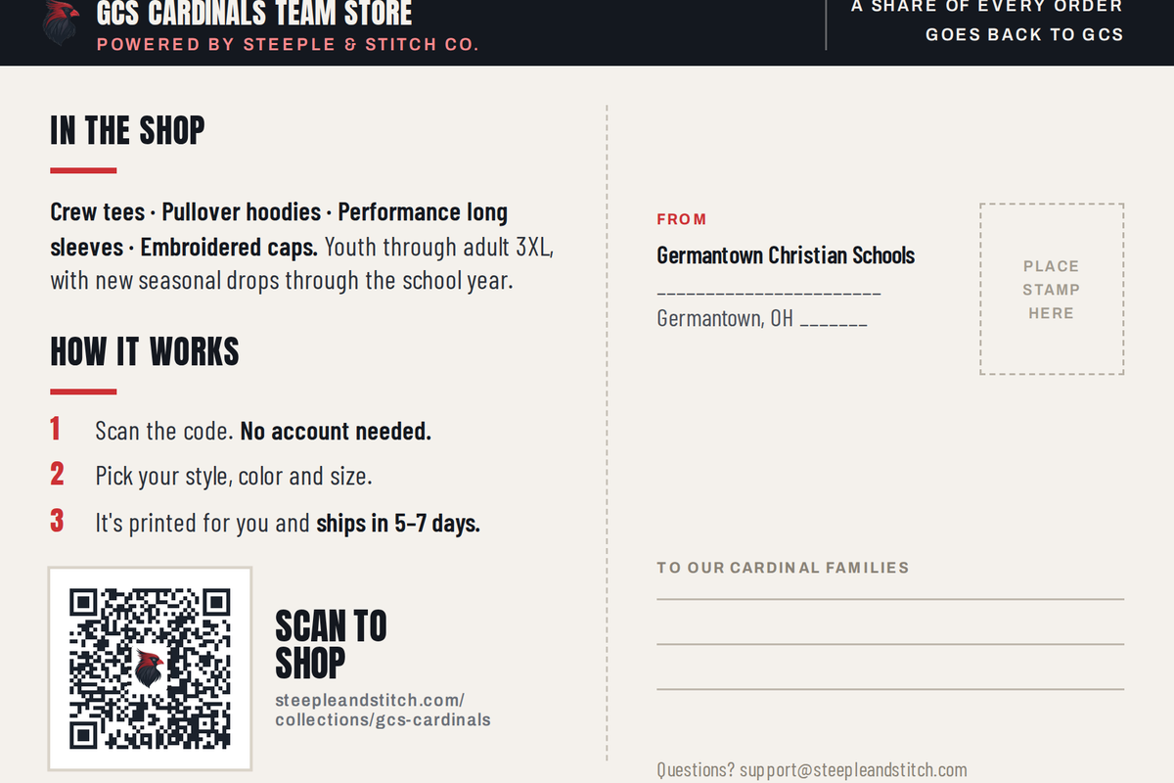
Back — what is in the shop, how it works, and a mailing panel if you send these out.
FILES INCLUDED
FILE | USE IT FOR
Postcard PRINT.pdf | Hand this to any commercial printer. Two pages, 6.25 x 4.25 inches with 0.125-inch bleed, trims to 6 x 4.
Postcard front / back PRINT bleed.png | 300 DPI with bleed, for printers who prefer image files.
Postcard front / back digital 6x4.png | Trimmed, no bleed. For email, social and screens.
QR print hires.png | The code on its own at 1,176 pixels. For lobby signs, posters, table tents and yard signs.
PRINTING IT
☐ Order roughly one and a half postcards per household so there are extras for the front desk and events
☐ Ask for 16pt cardstock with a matte or satin finish — gloss makes codes harder to scan under bright lights
☐ Send the PDF as is. Do not scale it, and do not let the printer “fit to page”
☐ Scan-test one card off the press before approving the full run
QR CODE RULES
The code is the whole point of the piece, so protect it:
☐ Never print it smaller than one inch square
☐ Keep the white border around it clear — no text or art inside that margin
☐ Do not recolor, stretch, rotate or add a second logo
☐ On dark backgrounds, place it on a white card as the postcard does
☐ Test-scan from about three feet with both an iPhone and an Android before printing anything
WHERE THE CODE SHOULD LIVE ALL YEAR
☐ Lobby or welcome area, at eye height
☐ {{ office|sentence }} counter
☐ Main entrance and welcome table
☐ Website footer, linked rather than scanned
☐ Email signatures for staff
☐ Back of the {{ newsletter }}, every issue

5. AFTER LAUNCH WEEK
The store stays open year round, so launch week is a start rather than a season. Here is what happens next.
WHEN | WHAT HAPPENS
End of week one | Your point of contact sends first-week order numbers and tells you which products moved.
Month one | We review the lineup together and drop anything that is not selling.
Quarterly | Payout, plus a seasonal drop if you want one — homecoming, Christmas, spring.
Any time | Products, sub-collections and campus stores can be added to a live store without taking it down.
WORTH ADDING ONCE LAUNCH SETTLES
☐ {{ extra_collection_1 }}
☐ {{ extra_collection_2 }}
☐ Staff collection
☐ {{ alumni_word|sentence }} collection
☐ Bulk event runs — camps, tournaments and seasonal events
☐ Separate storefronts by campus or {{ subgroups }}
6. WHO TO CONTACT
TOPIC | CONTACT
Launch week, anything urgent | Call or text your point of contact directly
Store changes and brand questions | {{ poc_contact_line }}
Order and fulfillment issues | {{ support_email }}
Payout and billing questions | {{ finance_contact_line }}
Response time is within one business day. During launch week, call or text rather than email.

APPENDIX: LOOSE ENDS
None of this blocks launch. Your store is built and scanning without it. Send it when you can and it will sharpen print quality and open up more product types.
BRAND ASSETS STILL WORTH SENDING
☐ Vector version of the {{ mark_word }} (.ai, .eps or .svg) — needed for embroidery and large-format print
☐ The full {{ org_name }} lockup as vector art
☐ The {{ org_short }} primary lockup as vector art
☐ {{ subgroups|sentence }} sub-logos you would like added
☐ Any tagline, motto or scripture reference approved for products
TIER CONFIRMATION
Service tier: {{ plan }}
PAYOUT DETAILS
Payout method: {{ payout_method }}
Payout account or mailing info: {{ payout_account or '_______________________' }}
Payout frequency: {{ payout_frequency }}
Finance contact: {{ finance_line }}
Designation for funds: {{ fund_designation }}
YOUR COLOR PALETTE
COLOR | HEX | WHERE IT IS USED
{{ color1_name }} | {{ color1_hex }} | {{ color1_role }}
{{ color2_name }} | {{ color2_hex }} | {{ color2_role }}
{{ color3_name }} | {{ color3_hex }} | {{ color3_role }}
Chalk | {{ color4_hex }} | {{ color4_role }}
Steel | {{ color5_hex }} | {{ color5_role }}
Sampled from your own artwork rather than guessed, so printed pieces match the merch exactly.

LAUNCH APPROVAL
☐ Launch date set and confirmed in writing
☐ Section 2 filled in — every job has a name against it
☐ Postcards printed and scan-tested
☐ Copy in Section 3 reviewed and the week’s posts scheduled
☐ Staff preview email sent
APPROVED BY
NAME | TITLE | LAUNCH DATE

