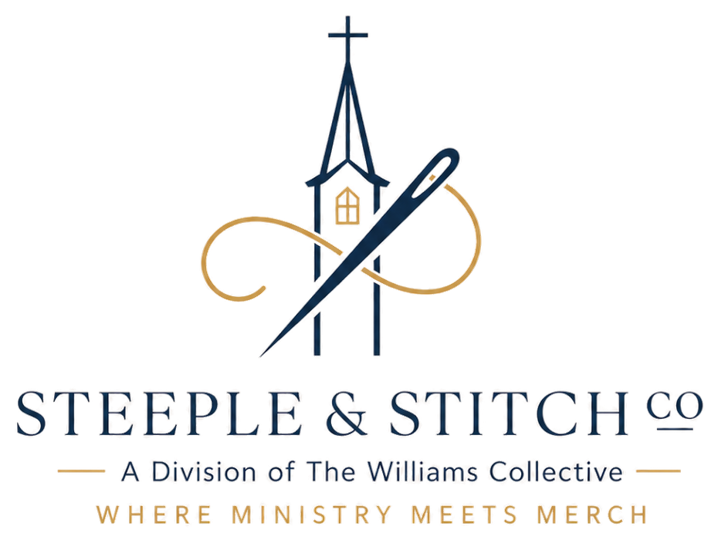
LAUNCH WEEK PROMO TEMPLATES
Copy, paste, and fill in the blanks — plain text, ready to use anywhere.
SOCIAL MEDIA POST (Instagram / Facebook)
Ready to use — {{ org_name }}
Our {{ org_word }} store is officially open! 🎉 Shop {{ org_name }} gear — tees, hoodies, hats, and more — and every purchase {{ supports }}. Link in bio, or shop now at {{ store_url_display }}.
EMAIL ANNOUNCEMENT
Ready to use — {{ org_name }}
Subject: The {{ store_name }} is live
Hey {{ org_name }} family,
We're excited to share that the official {{ org_name }} merch store is now open. Grab a tee, hoodie, or cap and represent {{ org_short }} wherever you go — and every purchase {{ supports }} directly.
Shop now: {{ store_url_display }}
{{ announcement_slot|upper }} / SLIDE
Ready to use — {{ org_name }}
{{ org_name }} Merch Is Here!
Visit {{ store_url_display }} or scan the QR code in the lobby to shop tees, hoodies, hats, and more — every order {{ supports }}.
GROUP TEXT / CHAT MESSAGE
Ready to use — {{ org_name }}
Hey everyone — the {{ org_name }} merch store just went live! Check it out here: {{ store_url_display }} 👕
Steeple & Stitch Co. • Questions? Contact {{ company_signer }}.

