
LAUNCH WEEK KIT

Your store is built, tested and ready. This is how you tell everyone.
PREPARED FOR
Germantown Christian Schools
Est. 1981
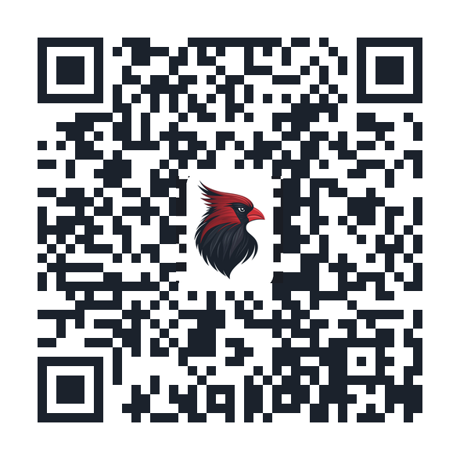
Your store is live at
steepleandstitch.com/collections/gcs-cardinals
Steeple & Stitch Co. • A Division of The Williams Collective

YOUR STORE IS READY TO ANNOUNCE
Hello GCS Leadership,
The GCS Cardinals Merch store is finished. It is built and branded, the products are made from your cardinal mark, checkout has been tested end to end, and your branded QR code is issued and scanning. There is nothing left to build.
So this kit is about one thing only: the announcement. Inside you will find a day-by-day plan for launch week, every piece of copy already written and ready to paste, print-ready artwork, and a short list of who needs to do what.
Anything that is still outstanding on the setup side has been moved to the appendix, because none of it holds up launch. Read the plan, set the date, and we will go.
THE ONLY DECISIONS WE NEED FROM YOU
Confirm these in writing with your point of contact and the rest of this kit falls into place.
Launch date: ______________________
Who owns Instagram and Facebook that week: ______________________
Postcards ordered by: ______________________
STORE AT A GLANCE
ITEM | DETAIL
Store name | GCS Cardinals Merch Store
Store link | steepleandstitch.com/collections/gcs-cardinals
QR code | Branded with your cardinal mark, pointing at the collection page. Print files ship with this kit.
Launch lineup | Crew tee, pullover hoodie, performance long sleeve and embroidered cap.
Sizes | Youth through adult 3XL. (4X & 5X available in some sizes)
Fulfillment | Printed to order and shipped to the buyer in five to seven days. No inventory, and nothing for the front office to hand out.
Back to GCS | A share of every order, paid out quarterly by default or monthly on request.
Status | Live and tested. Waiting on your launch date.

1. THE LAUNCH WEEK PLAN
A launch lands hardest when everything arrives in the same week. This is the running order we recommend, with room to write down who owns each piece.
WHEN | DO THIS | OWNER
Two weeks out | Confirm the launch date with Steeple & Stitch.  Send the postcard PDF to your printer.  Decide who owns the social accounts that week. | ______________
Thursday before | Send the staff and faculty preview email.  Brief the front office so they can answer “where do I get one?” | ______________
Launch day | Email to all families, first thing in the morning.  Launch-day post on Instagram and Facebook.  Morning announcement or chapel read.  Postcards home in folders or backpacks. | ______________
Day two | QR sign up in the lobby and at the front desk.  Postcards stacked where families wait at pickup. | ______________
Day three | Midweek follow-up post, ideally a real photo.  Group text or Remind message to team and class lists. | ______________
Day four | Alumni post and forward the link to your alumni email list. | ______________
Game day | PA read between quarters or sets.  Postcards on the entrance table. | ______________
End of week | Thank-you post to families.  First-week check-in with your point of contact. | ______________
BEFORE YOU ANNOUNCE ANYTHING
☐ Launch date confirmed in writing
☐ Postcards in hand and scan-tested — not just ordered
☐ Staff and faculty preview email already sent
☐ One person named as owner of the social accounts for the week
2. WHO DOES WHAT
Launch week goes sideways when everyone assumes someone else is posting. Fill this in before the date is set.
JOB | PERSON
Final go, and the launch date | ______________________________
All-family email | ______________________________
Instagram and Facebook | ______________________________
Morning announcements or chapel | ______________________________
Front office questions | ______________________________
Athletics PA read and the game table | ______________________________
Postcard printing and distribution | ______________________________
Alumni list | ______________________________
3. LAUNCH WEEK COPY
Everything below is written for GCS and ready to use, in the order you will need it. The store link is already filled in — the only blanks are names and dates.
STAFF AND FACULTY PREVIEW EMAIL
Send the Thursday before launch — two to four days ahead of families.
Subject: Cardinal gear — a first look before families sees it
—
Team,
The GCS Merch store opens to families on ______________. You get it first.
Tees, hoodies, performance long sleeves and caps, printed to order and shipped to you. The performance long sleeve has been the staff favorite at other schools.
Shop here: steepleandstitch.com/collections/gcs-cardinals
One ask: if you order, wear it on launch day. Students noticing teachers in the gear does more than any post we can write.
______________________
EMAIL TO FAMILIES
Launch day, first thing in the morning. Send this before you post.
Subject: The GCS Cardinals Merch store is open
Preview text: Tees, hoodies, caps and more, shipped to your door.
—
Cardinal families,
We’re glad to share that the official Germantown Christian Schools Merch store is now open.
You’ll find classic tees, pullover hoodies, performance long sleeves and embroidered caps — all carrying the cardinal. Sizes run from youth through adult 3XL, and every item is printed once you order it and shipped to your door in five to seven days. There is no inventory to manage and nothing to pick up from the front office.
Best of all, a share of every order comes straight back to GCS.
Shop the store: steepleandstitch.com/collections/gcs-cardinals
A postcard with a scannable code is coming home this week as well — keep it on the fridge.
Go Cards,
______________________
INSTAGRAM AND FACEBOOK — LAUNCH DAY
Launch day. Pair with a photo of a student in the gear.
It’s here, Cardinal families. The official GCS Merch store is open.
Tees, hoodies, performance long sleeves and caps — printed when you order and shipped straight to your door. Youth through adult 3XL, so the whole family can match on game day.
A share of every single order comes right back to GCS.
Scan the code on the postcard coming home this week or tap the link in our bio. Go Cards!
#GCSCardinals #GermantownChristian
MORNING ANNOUNCEMENT OR CHAPEL READ
Launch day. About twenty-five seconds read aloud.
Cardinals, the official GCS Merch store is now open. Tees, hoodies, long sleeves and caps, all with the cardinal on them, shipped right to your house. Every order sends money back to the school. Look for the postcard going home this week and scan the code on the front or ask at the office for the link.
GROUP TEXT, REMIND OR TEAM APP
Day three. Send to team, class and parent lists.
Cardinals — the GCS Merch store is live: steepleandstitch.com/collections/gcs-cardinals
Youth through adult 3XL, ships in five to seven days, and a share of every order comes back to the school.
INSTAGRAM AND FACEBOOK — MIDWEEK FOLLOW-UP
Day three. Works best with a real photo of a student, teacher or team.
Spotted: cardinal red in the hallway.
The Merch store is open all year, with new seasonal drops coming through the school year. Youth through adult 3XL, shipped in five to seven days.
Link in bio. #GCSCardinals
ALUMNI POST
Day four. Forward the same copy to your alumni email list.
Class of ’81 through the class of today — the GCS Merch store is open to everyone who ever wore the red and black. Same cardinal, new gear, shipped to your door. Every order supports the school. Link in bio.
GAME-DAY PA READ
Game day. About fifteen seconds — read between the first and second quarter, or between sets.
Cardinal fans — want to wear what the team wears? The official GCS Merch store is open. Scan the code on the postcards at the entrance table for tees, hoodies and caps, and know that a share of every order comes back to Germantown Christian Schools. Go Cards!
END OF WEEK THANK-YOU POST
End of week. Ask your point of contact for the first-week number before posting.
Cardinal families — thank you. ______ orders came through the Merch store in its first week, and every one of them sends a share straight back to GCS.
The store stays open all year, so there is no rush. Link in bio whenever you need it. Go Cards!
NEWSLETTER OR BULLETIN BLURB
Any time. Roughly fifty words — sized for a newsletter column or printed bulletin.
GCS Cardinal gear is here. The official Merch store carries tees, hoodies, performance long sleeves and embroidered caps in youth through adult 3XL. Everything is printed to order and shipped to your door in five to seven days, and a share of every order supports the school. Scan the code on the postcard or visit steepleandstitch.com/collections/gcs-cardinals.

4. THE ARTWORK
Print-ready postcard artwork ships with this kit, front and back, six by four inches with bleed. Send it home in folders, stack it at the front desk, and put a pile on the entrance table at games.
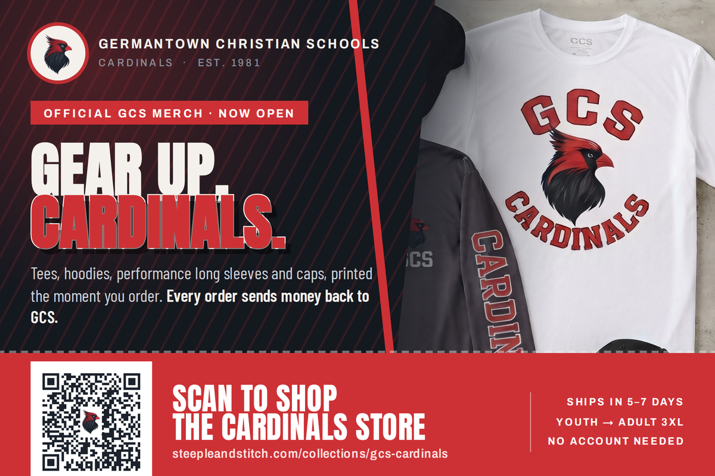
Front — the tear-off ticket band carries the scannable code and the store link.
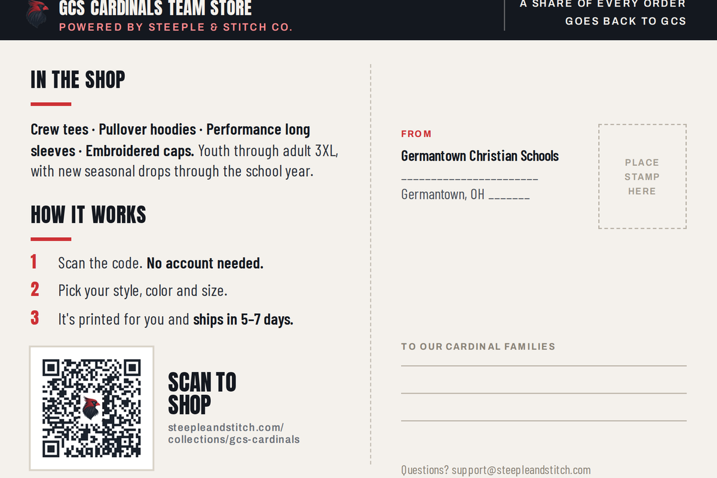
Back — what is in the shop, how it works, and a mailing panel if you send these out.
FILES INCLUDED
FILE | USE IT FOR
Postcard PRINT.pdf | Hand this to any commercial printer. Two pages, 6.25 x 4.25 inches with 0.125-inch bleed, trims to 6 x 4.
Postcard front / back PRINT bleed.png | 300 DPI with bleed, for printers who prefer image files.
Postcard front / back digital 6x4.png | Trimmed, no bleed. For email, social and screens.
QR print hires.png | The code on its own at 1,176 pixels. For lobby signs, posters, table tents and yard signs.
PRINTING IT
☐ Order roughly one and a half postcards per family so there are extras for the front desk and games
☐ Ask for 16pt cardstock with a matte or satin finish — gloss makes codes harder to scan under gym lights
☐ Send the PDF as is. Do not scale it, and do not let the printer “fit to page”
☐ Scan-test one card off the press before approving the full run
QR CODE RULES
The code is the whole point of the piece, so protect it:
☐ Never print it smaller than one inch square
☐ Keep the white border around it clear — no text or art inside that margin
☐ Do not recolor, stretch, rotate or add a second logo
☐ On dark backgrounds, place it on a white card as the postcard does
☐ Test-scan from about three feet with both an iPhone and an Android before printing anything
WHERE THE CODE SHOULD LIVE ALL YEAR
☐ Lobby or welcome area, at eye height
☐ Front office counter
☐ Gym entrance and concession table
☐ Athletics and school website footer, linked rather than scanned
☐ Email signatures for office and athletics staff
☐ Back of the school newsletter, every issue

5. AFTER LAUNCH WEEK
The store stays open year round, so launch week is a start rather than a season. Here is what happens next.
WHEN | WHAT HAPPENS
End of week one | Your point of contact sends first-week order numbers and tells you which products moved.
Month one | We review the lineup together and drop anything that is not selling.
Quarterly | Payout, plus a seasonal drop if you want one — homecoming, Christmas, spring.
Any time | Products, sub-collections and campus stores can be added to a live store without taking it down.
WORTH ADDING ONCE LAUNCH SETTLES
☐ Athletics sub-collection, by team
☐ Fine arts and music sub-collection
☐ Staff and faculty collection
☐ Alumni collection with a class-year treatment
☐ Bulk event runs — camps, tournaments, graduation, spirit week
☐ Separate storefronts by division, elementary and secondary
6. WHO TO CONTACT
TOPIC | CONTACT
Launch week, anything urgent | Call or text your point of contact directly
Store changes and brand questions | ______________________ · ______________________
Order and fulfillment issues | support@steepleandstitch.com
Payout and billing questions | ______________________ · ______________________
Response time is within one business day. During launch week, call or text rather than email.

APPENDIX: LOOSE ENDS
None of this blocks launch. Your store is built and scanning without it. Send it when you can and it will sharpen print quality and open up more product types.
BRAND ASSETS STILL WORTH SENDING
☐ Vector version of the cardinal mark (.ai, .eps or .svg) — needed for embroidery and large-format print
☐ The arched “Germantown Christian Cardinals · Est. 1981” lockup as vector art
☐ The GCS shield lockup as vector art
☐ Athletic team or program sub-logos you would like added
☐ Any tagline, motto or scripture reference approved for products
TIER CONFIRMATION
Service tier (Starter / Growth / Multi-Campus): _______________
PAYOUT DETAILS
Payout method (check / direct deposit / PayPal): ______________
Payout account or mailing info: _______________________________
Payout frequency (quarterly / monthly): _______________________
Finance contact: ______________________________________________
Designation for funds (general fund, athletics, tuition assistance): __________
YOUR COLOR PALETTE
COLOR | HEX | WHERE IT IS USED
Cardinal Red | CD3135 | Primary accent. Headlines, the postcard ticket band, buttons on the store.
Deep Cardinal | 8E2027 | Crest shadow. Secondary accent and link text on light backgrounds.
Cardinal Ink | 1B222C | The mark’s body. Backgrounds, garment color, body copy.
Chalk | F4F1EC | Light backgrounds and printed cardstock.
Steel | 8A9099 | Captions and secondary text only.
Sampled from your own artwork rather than guessed, so printed pieces match the merch exactly.

LAUNCH APPROVAL
☐ Launch date set and confirmed in writing
☐ Section 2 filled in — every job has a name against it
☐ Postcards printed and scan-tested
☐ Copy in Section 3 reviewed and the week’s posts scheduled
☐ Staff and faculty preview email sent
APPROVED BY
NAME | TITLE | LAUNCH DATE

