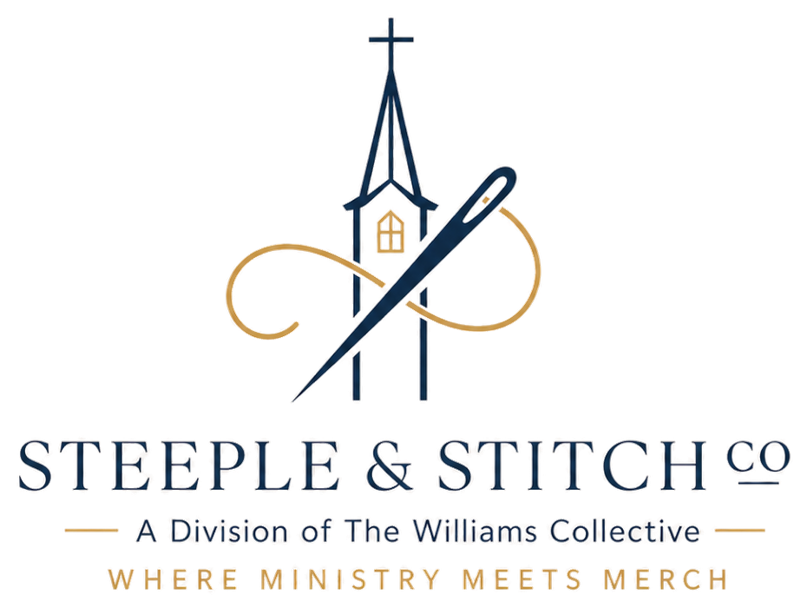
LAUNCH WEEK PROMO TEMPLATES
Copy, paste, and fill in the blanks — plain text, ready to use anywhere.
SOCIAL MEDIA POST (Instagram / Facebook)
Fill in: [Church Name], [store URL]
Our church store is officially open! 🎉 Shop [Church Name] gear — tees, hoodies, hats, and more — and every purchase supports our ministry. Link in bio, or shop now at [store URL].
EMAIL ANNOUNCEMENT
Fill in: [Church Name], [store URL]
Subject: Our Church Store Is Live!
Hey [Church Name] family,
We're excited to share that our official church merch store is now open! Grab a tee, hoodie, or cap and represent [Church Name] wherever you go. Every purchase helps support our ministry directly.
Shop now: [store URL]
SUNDAY BULLETIN / ANNOUNCEMENT SLIDE
Fill in: [Church Name], [store URL]
[Church Name] Merch Is Here!
Visit [store URL] or scan the QR code in the lobby to shop tees, hoodies, hats, and more — every order supports our ministry.
GROUP TEXT / CHAT MESSAGE
Fill in: [store URL]
Hey everyone — our church merch store just went live! Check it out here: [store URL] 👕
Steeple & Stitch Co. • Questions? Contact your point of contact from the Launch Kit.

