Predicting CONMEBOL World Cup Qualifier Scores
Home and away goals from pre-match information, with linear regression from scratch and a random forest
DA380A Machine Learning, HT2026, final project
Group 28: Lawrence Arciniegas and Gunnar Arias
Kristianstad University, October 2026

1. Introduction
Football is considered the most popular sport in South America, and the World Cup qualifiers of CONMEBOL, the South American football confederation, are often called the hardest qualifying competition in the world. The ten national teams play each other twice, at home and away, which gives 90 matches over two years. The qualifiers are known for a very strong home advantage. Part of it comes from long trips and loud crowds, but part of it is geography: Bolivia plays its home matches in La Paz and El Alto, 3,600 to 4,100 metres above sea level, and Ecuador plays in Quito at 2,850 metres.
Predicting the score of a match is difficult, because goals are rare and one lucky goal can change the result. Still, what is known before kick-off, such as the strength of the two teams, their recent form and where the match is played, clearly says something about the expected score. In this project we predict the number of goals scored by the home team and by the away team, which makes it a regression problem. As the project guidelines require, we use two algorithms: linear regression, which we implemented ourselves with NumPy, and a random forest from scikit-learn (Pedregosa et al., 2011). All the code is in the notebook and the src folder of our repository, so this report focuses on how the methods work and on what the results mean.

2. Project aim
Our aim is to predict the home score and the away score of an international match using only information that is known before the match starts, and to test the predictions on the 90 CONMEBOL qualifiers of the 2026 World Cup cycle, played between September 2023 and September 2025. We want to answer three questions:
- How much better than simple baselines can we predict the score from team strength, recent form, earlier meetings and the venue?
- Does a random forest, which can learn non-linear effects, predict better than a linear regression that we implement from scratch?
- What do the models get right and wrong in the CONMEBOL qualifiers, especially the home advantage and the matches at high altitude?

3. Dataset description
We use the dataset International football results from 1872 by Mart Jürisoo (2026), published on Kaggle. The author keeps it up to date on GitHub, where we downloaded our copy on 13 October 2026. The main file, results.csv, has 49,945 men’s international matches from 30 November 1872 to 6 October 2026, with nine columns: the date, the home team, the away team, the home score, the away score, the tournament, the city, the country and whether the venue was neutral. The two scores are our targets; they are whole numbers from 0 and up. The file has no missing values and no duplicated rows. A second file lists 36 former team names (for example Dahomey for Benin), and the files with goal scorers and penalty shoot-outs were not needed.
The dataset only contains results, so all the features had to be built by us from the earlier matches of each team (section 4.2). The scores are small and skewed. In our training data (1994 to August 2023) the home team scored 0, 1 and 2 goals in 26%, 30% and 22% of the matches, and six or more in only 2.8% (the highest was 31). On average the home team scored 1.62 goals and the away team 1.08, and the home team won 48.6% of the matches, against 27.8% for the away team.
In the CONMEBOL qualifiers the home advantage is bigger. In the 593 qualifiers between CONMEBOL teams from the seven cycles 1998–2022, the home team scored 1.67 goals against 0.95 and won 54.0% of the matches, while the away team won only 21.8%. Figure 1 shows that every team does much better at home, and that the gap is largest for the two teams that play at high altitude: Bolivia takes 1.59 points per match at home and only 0.13 away, and Ecuador 2.13 against 0.72. In the 2026 cycle, our main test set, the home teams won 54.4% of the matches, 30.0% were draws, and the away teams scored only 0.60 goals per match.
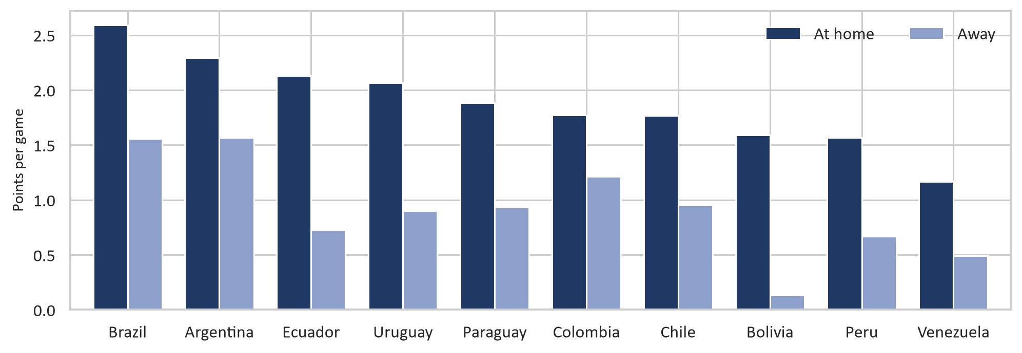
Figure 1. Points per match (3 for a win, 1 for a draw) of the ten CONMEBOL teams at home and away in the 593 qualifiers between CONMEBOL teams from 1996 to 2022 (training data).

4. Data preprocessing

4.1 Cleaning and filtering
The data was already clean, so this step was mostly about choosing which matches to use:
- Team names. We applied the list of former names so that a team keeps one name through its whole history. No match in our version still used an old name, but the step keeps the code correct for older versions of the file.
- Only FIFA national teams. We kept the 217 teams that have played a World Cup or a World Cup qualifier, and removed 120 regional or unrecognised teams, such as Catalonia and Tibet, together with their 2,565 matches, some of which had extreme results.
- Time windows. Football has changed a lot in 150 years, so we train on matches from 1994 only. The training period (2 January 1994 to 31 August 2023) has 25,266 matches and the test period (2 September 2023 to 9 September 2025) has 2,269, including the 90 CONMEBOL qualifiers. The older matches are only used to build the features, for example to warm up the team ratings.

4.2 Features
We built the 17 features in Table 1 ourselves. The most important rule was that a feature may only use matches that were played before the match it describes. Otherwise, the model could see the result it is supposed to predict, which is data leakage. Our code goes through the matches in date order, and for every match it first reads the values of both teams and only then updates them with the result. Unit tests check this, for example that changing the score of a match changes no feature of that match or of any earlier match. In total the repository has 50 tests (pytest).
Team strength is measured with Elo ratings, calculated with the method of the World Football Elo Ratings (n.d.). Every team starts with 1,500 points. Before a match, the expected result of the home team is W_{e} = 1 / (10^{−dr/400} + 1), where dr is the rating difference plus 100 points for the home team when the venue is not neutral. After the match both ratings change by K · G · (W − W_{e}), where W is 1, 0.5 or 0 for a win, draw or loss, K depends on how important the match is (from 60 for the World Cup down to 20 for friendlies) and G grows with the goal difference. We calculated the ratings over all matches since 1872, so that they are already meaningful when the training data starts.
Table 1. The 17 features. All of them are calculated from matches played before the match that is predicted.
Feature | What it measures
elo_home, elo_away | Elo rating of each team before the match
form_gf_home, form_gf_away | Goals scored per match in the team’s last 10 matches
form_ga_home, form_ga_away | Goals conceded per match in the team’s last 10 matches
form_pts_home, form_pts_away | Points per match in the team’s last 10 matches (3 / 1 / 0)
h2h_gd | Mean goal difference, seen from the home team, in the last 5 meetings of the two teams (0 if they never met)
h2h_n | Number of earlier meetings used for h2h_gd (0 to 5)
neutral | 1 if the match is played at a neutral venue, otherwise 0
altitude_km | Altitude of the venue in km for the 26 cities at 1,500 m or higher (for example El Alto 4.09, La Paz 3.64, Quito 2.85), otherwise 0
is_world_cup, is_continental_final, is_qualifier, is_other_tournament | Type of match, one-hot encoded; friendlies are the reference group
year | Calendar year, for long-term trends in scoring

Altitude was not in our first plan; we added it after seeing the gaps of Bolivia and Ecuador in Figure 1. The difference between the two Elo ratings was not used as a feature, because it is exactly elo_home minus elo_away and would make the matrix in the normal equation (section 5.1) singular.

4.3 Missing values, scaling and the train/test split
The only missing values are the form features of nine training matches in which a team played its very first match. We filled them with the median of the training data. The type of match, the only categorical information, is one-hot encoded. Our linear regression standardises the features with the mean and standard deviation of the training data (section 5.1), while the random forest does not need scaling, since a split only compares one feature with a threshold. We did not transform the targets, and we kept the very high scores, because they are real results.
Matches form a time series, so we split the data by date: the models are trained on the matches before 1 September 2023 and tested on the matches after it. A random 80/20 split would let the model learn from matches played after the ones it predicts and make the test score look better than it really is. Only 593 training matches are CONMEBOL qualifiers, which is too few to train on, so we train on all international matches. Our main test set is the 90 qualifiers of the 2026 cycle, and since that is a small set, we also report the results for all 2,269 matches in the test period.

5. Methods

5.1 Algorithm 1: Linear regression from scratch
Our first algorithm is linear regression, which we wrote ourselves in the class LinearRegressionScratch (src/linear_regression.py) using only NumPy. The input is a matrix X with one row per match and the 17 features as columns (m × 17), and the output is a matrix Y with two columns, the home goals and the away goals. The model adds a column of ones to X for the intercept (we call the result X_{b}) and predicts both targets at once:
Ŷ = X_{b} θ
Here θ has 18 rows (the intercept and one weight per feature) and one column per target, which gives the same result as two separate regressions on the same features; we checked this in a test. The model minimises the mean squared error (MSE) plus an L2 penalty (ridge regression), where λ sets the strength of the penalty and the intercept is not penalised (Géron, 2019, ch. 4). For each target column k the cost is
J(θ_{k}) = (1/m) Σ_{i} (ŷ_{ik} − y_{ik})² + λ Σ_{j=1..17} θ_{jk}²
and the total cost is the mean over the two targets. We implemented two ways of finding the θ that minimises it:
- Normal equation. Setting the gradient of the cost to zero gives (X_{b}^{T}X_{b} + mλI*) θ = X_{b}^{T}Y, where I* is the identity matrix with a 0 for the intercept. Instead of calculating the inverse of the matrix, which is slower and less accurate, we solve this system with np.linalg.solve. It gives the exact optimum in a fraction of a second, and it is the method used for our final model.
- Batch gradient descent. Starting from θ = 0, the model repeatedly takes a step against the gradient: θ ← θ − η [(2/m) X_{b}^{T}(X_{b}θ − Y) + 2λI*θ], where η is the learning rate. It stops when the cost improves by less than 10⁻¹⁰ or after a maximum number of iterations, and it stops with an error message if the cost starts to grow, which means that the learning rate is too large.
Before fitting, the model standardises every feature with the training mean and standard deviation and stores them, so that new data is scaled the same way in predict. Without this, gradient descent would hardly move, since the Elo ratings are around 1,500 while most other features are between 0 and 3. After standardisation the largest eigenvalue of X_{b}^{T}X_{b}/m is 3.70, so gradient descent converges for learning rates below 1/3.70 ≈ 0.27. Figure 2 confirms this: the larger the learning rate, the faster the cost reaches its minimum, while with η = 0.3 the cost exploded after 49 iterations. With η = 0.1 and a stricter tolerance of 10⁻¹², gradient descent stopped after 414 iterations with a θ within 7·10⁻⁶ of the normal equation solution, so the two methods agree.
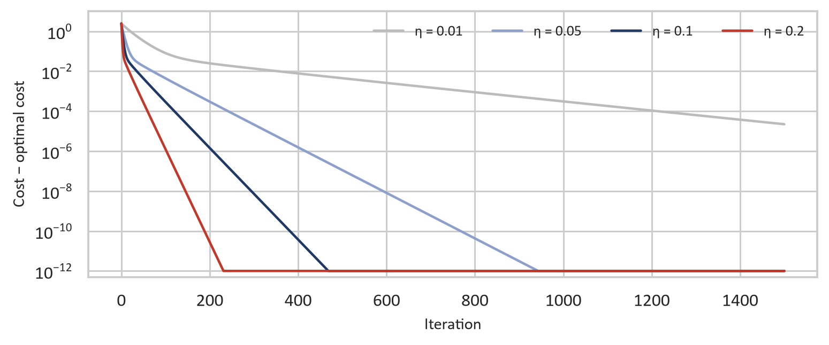
Figure 2. Gradient descent with four learning rates: distance between the cost and the minimum from the normal equation (log scale). The lines flatten at 10⁻¹², the limit of floating-point precision.
Ten unit tests check the class, for example that both methods find the true θ for synthetic data, that the solution equals NumPy’s least-squares solution, that the cost never increases during gradient descent with a small learning rate, and that the penalty shrinks the weights but not the intercept.

5.2 Algorithm 2: Random forest
Our second algorithm is the RandomForestRegressor from scikit-learn. A random forest is an average of many decision trees (Breiman, 2001). Every tree is trained on a bootstrap sample of the training matches, drawn with replacement, and at every split it only looks at a random subset of the features. A single deep tree overfits, but since the trees differ from each other, their errors partly cancel out when they are averaged (Géron, 2019, ch. 7). Unlike linear regression, a forest can learn non-linear effects and interactions, for example that the home advantage is different for strong and weak teams. Every leaf stores the mean home and away goals of its training matches, so one forest predicts both scores, and since its predictions are averages of real scores, they can never be negative.

5.3 Tuning and validation
Both models were tuned on the training data only, with the same five time-series folds (TimeSeriesSplit). The training period is divided into six blocks in date order; the first fold trains on block 1 and validates on block 2, the second trains on blocks 1–2 and validates on block 3, and so on. The model is therefore always validated on later matches than it was trained on, just like in the real test. The score is the RMSE, averaged over home and away goals.
For the linear regression we tried six values of λ (0, 0.001, 0.01, 0.1, 1 and 10) with our own loop over the folds. For the random forest we ran a grid search over 54 combinations: the number of trees (200 or 500), the maximum depth (none, 10 or 20), the smallest number of matches in a leaf (1, 5 or 20) and the share of the features tried at each split (all, half, or the square root of the number, 4 of 17). That is 270 forests, which took about 20 minutes on our laptops, so the result is saved in the repository together with a fingerprint of the training data, and the notebook only reuses it if the data has not changed.

5.4 Evaluation
We use the regression metrics from the guidelines, MAE, MSE, RMSE and R², for home goals, away goals and their average. We compare the models with two baselines: the mean baseline always predicts the average home and away goals of the training data (1.62 and 1.08), and the venue baseline the averages of the training matches with the same kind of venue (home ground or neutral). To make the results easier to read, we also turn the predicted scores into a result (home win, draw or away win, where a draw is predicted when the difference is smaller than a draw band chosen on the training data), and we count how often the exact score is right after rounding, with negative predictions set to 0. Finally, a paired bootstrap with 2,000 resamples of the test matches shows how certain the differences between the models are, and permutation importance shows which features the models rely on.

6. Results
Table 2 shows the results of the two baselines and the two tuned models on the test data, and Figure 3 shows the RMSE, our main metric.
Table 2. Results on the test data. MAE, MSE and RMSE are averaged over home and away goals. W/D/L is the share of correctly predicted results and Exact the share of exactly correct scores. The best value in each column is in bold.
Model | MAE | MSE | RMSE | R² home | R² away | W/D/L | Exact
All 2,269 test matches
Mean baseline | 1.079 | 2.079 | 1.432 | 0.000 | −0.001 | 47.0% | 6.8%
Venue baseline | 1.074 | 2.063 | 1.427 | 0.010 | 0.004 | 47.0% | 8.7%
Linear regression | 0.934 | 1.520 | 1.227 | 0.291 | 0.232 | 59.9% | 11.3%
Random forest | 0.936 | 1.517 | 1.225 | 0.289 | 0.239 | 59.5% | 10.6%
90 CONMEBOL qualifiers of the 2026 cycle
Mean baseline | 0.996 | 1.486 | 1.208 | −0.019 | −0.265 | 54.4% | 7.8%
Venue baseline | 0.974 | 1.463 | 1.196 | −0.030 | −0.189 | 54.4% | 7.8%
Linear regression | 0.907 | 1.244 | 1.109 | 0.185 | −0.141 | 50.0% | 5.6%
Random forest | 0.942 | 1.305 | 1.139 | 0.179 | −0.270 | 52.2% | 4.4%
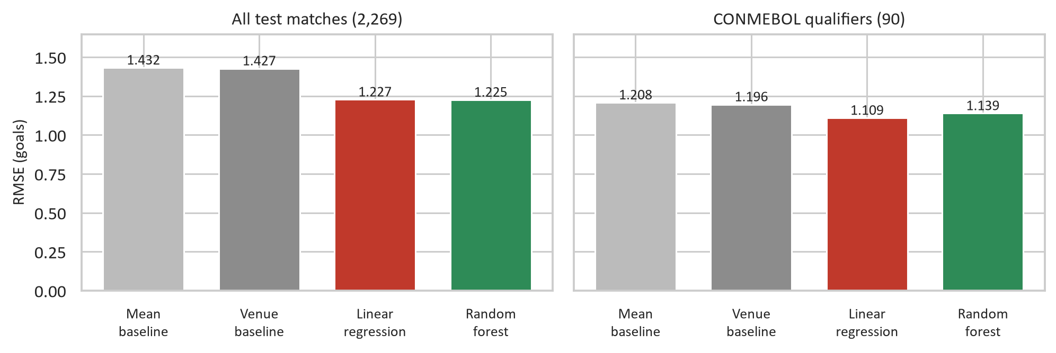
Figure 3. Test RMSE (average of home and away goals) of the baselines and the two models. Lower is better.
On all 2,269 test matches both models are clearly better than the baselines: the RMSE drops from 1.427 for the venue baseline to 1.227 for the linear regression and 1.225 for the random forest. The models explain about 29% of the variance in home goals and 23–24% in away goals, while the baselines explain almost nothing, and they predict the right result in about 60% of the matches, against 47% for the baselines, which always predict a home win. Between the two models there is almost no difference (0.002 goals in RMSE).
On the 90 CONMEBOL qualifiers the linear regression is the best model on all regression metrics, with an RMSE of 1.109 against 1.139 for the forest and 1.196 for the venue baseline. These matches also show the weak points of our models. R² for away goals is negative for all models, so they predict the away goals worse than the average of these 90 matches would. For the results, the baselines are best (54.4%), simply because they always predict a home win, which happened in 49 of the 90 matches. Neither model predicted a single draw, because the best draw band on the training data was 0, while 30% of the qualifiers ended in a draw.

6.1 Tuning and overfitting
Table 3. RMSE (average of home and away goals) on the whole training data, in the five validation folds (mean) and on the two test sets. The best values in the validation and test columns are in bold (a low training RMSE alone is not a good sign).
Model | Training | Validation | Test (all) | Test (CONMEBOL)
Linear regression (λ = 0.01) | 1.266 | 1.253 | 1.227 | 1.109
Random forest, default settings | 0.475 | 1.275 | 1.248 | 1.181
Random forest, tuned | 1.153 | 1.243 | 1.225 | 1.139

Table 3 shows that the linear regression does not overfit: the training, validation and test errors are very close, and they only differ because they are measured on different matches. Regularisation therefore hardly matters. The best λ was 0.01, only 0.0002 better than no penalty, and every λ from 0.1 and up was worse in all five folds. With 25,266 matches and 17 features there is simply not much to overfit.
The random forest with default settings overfits a lot. Its trees grow until the leaves are pure (11,682 leaves per tree on average), so it almost learns the training matches by heart (training RMSE 0.475) but does worse on new matches (1.275 in validation). The grid search chose 500 trees, a maximum depth of 10, at least 5 matches per leaf and half of the features at each split. These trees have only 399 leaves on average, and the validation RMSE improved from 1.275 to 1.243, better than the linear regression (1.253), although the forest still overfits a little. On the test data the tuning improved the RMSE from 1.248 to 1.225 on all matches and from 1.181 to 1.139 on the qualifiers. The worst combinations in the grid had fully grown trees (one match per leaf and no or a high depth limit), while the best ones were very close: 21 of the 54 combinations were within 0.005 of the best.

6.2 What the models learned
Figure 4 shows the permutation importance on the test data, that is, how much the RMSE increases when one feature is shuffled. Both models rely mostly on the Elo ratings: shuffling the rating of the away team increases the RMSE by 0.26 goals for the linear regression and 0.18 for the forest, and the rating of the home team almost as much. After that, the linear regression uses the recent form, especially goals conceded and points, while the forest uses the head-to-head goal difference more. Altitude and the neutral venue hardly matter here, because they only concern a small part of the 2,269 matches.
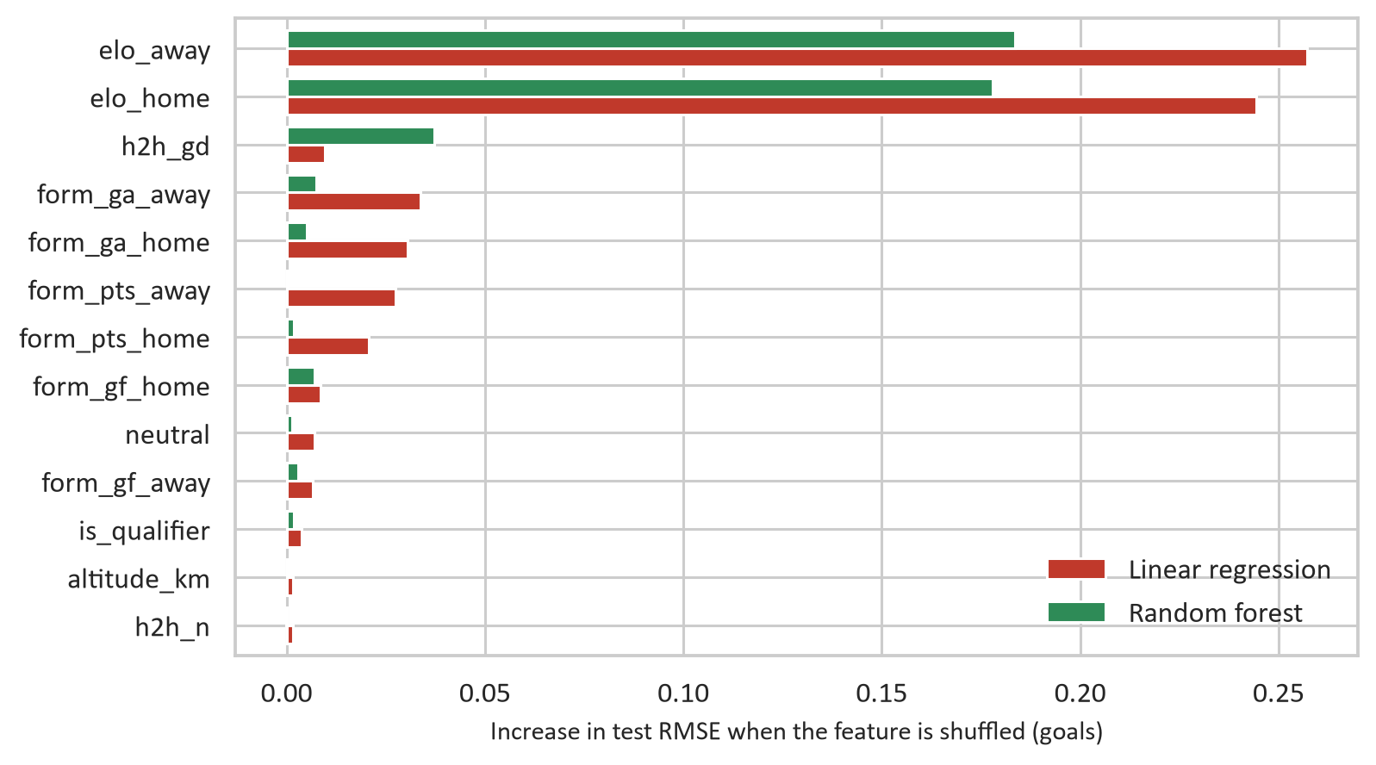
Figure 4. Permutation importance on all test matches: the increase in RMSE when one feature is shuffled (mean of 10 repetitions). Features below 0.001 for both models are not shown.
The coefficients of the linear model can also be read directly. In the original units, 100 extra Elo points for the home team mean 0.23 more home goals and 0.15 fewer away goals, a neutral venue means 0.19 fewer goals for the home team and 0.29 more for the away team, and every kilometre of altitude gives the home team 0.06 more goals and the away team 0.10 fewer. Many features are correlated (a team with a high rating usually also has good form), so single coefficients should be read with care.

6.3 The CONMEBOL qualifiers
Figure 5 compares the predicted and the actual goal difference in the 90 qualifiers. Both models mostly get the direction right, but their predictions are much less spread out than the real results: the standard deviation of the actual goal difference is 1.59, against 1.11 for the linear regression and only 0.73 for the forest. The forest predicts most matches as close games, which is one reason why it does worse here.
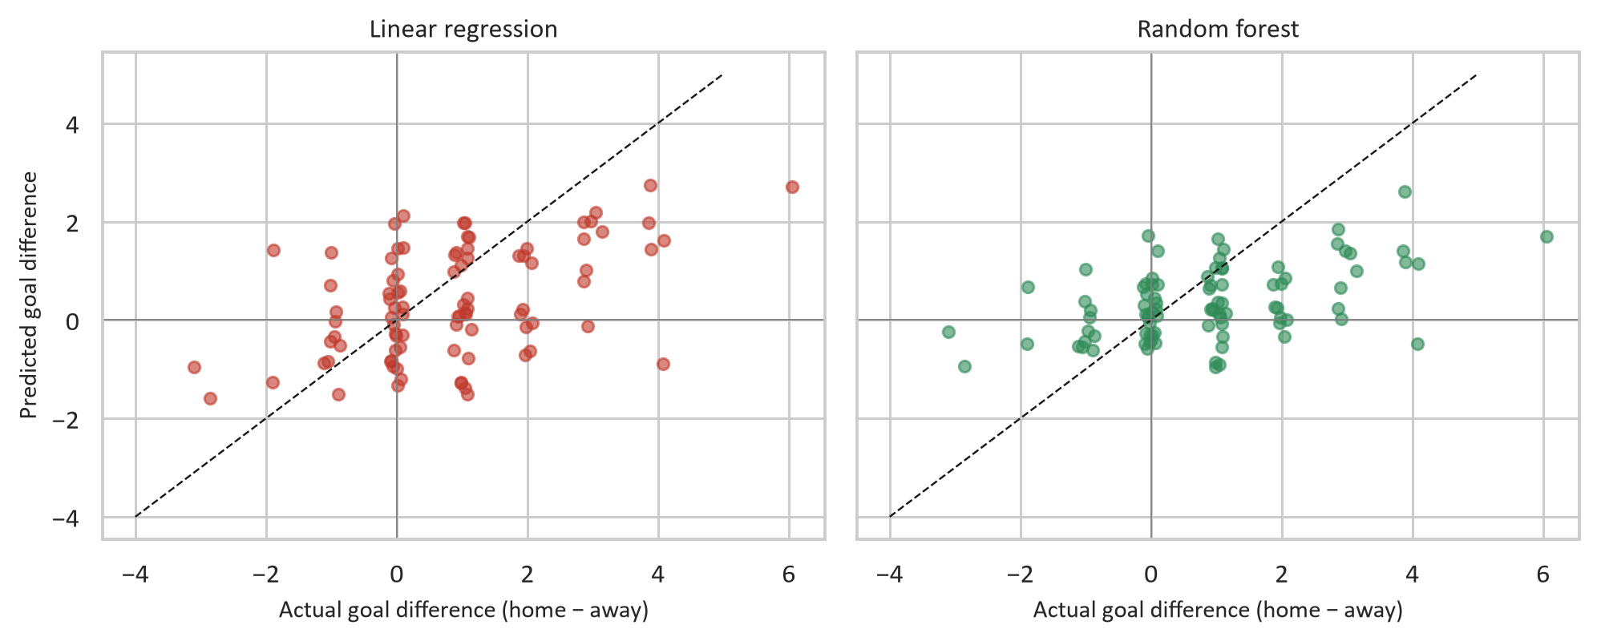
Figure 5. Predicted against actual goal difference (home minus away) in the 90 CONMEBOL qualifiers of the 2026 cycle. Points on the dashed line are perfect predictions; the actual values are moved slightly sideways so that equal results don’t overlap.
The biggest problem is the away goals. The away teams scored only 0.60 goals per match in the 2026 cycle, but the linear regression predicted 0.98 and the forest 1.12 on average, while the home goals were predicted quite well (1.36 and 1.47, against 1.43). This explains the negative R² for away goals and the many predicted away wins: the linear regression predicted 36 away wins, but only 14 happened, and it got 10 of them right.
Bolivia is the clearest example. It played six home matches in El Alto, at about 4,100 metres, a venue that was never used in the training period. The linear regression predicted a higher score for the opponent in four of the six, for example 0.4–1.7 against Brazil, but Bolivia won four of them, including 1–0 against Brazil, and drew the other two. Already in the training data, the model predicted Bolivia to score 1.20 goals per home qualifier, while in reality they scored 1.66.

7. Comparison and discussion

7.1 Which model is better?
On all 2,269 test matches the two models are equally good. The paired bootstrap gives a 95% confidence interval for the difference in RMSE (linear regression minus forest) from −0.010 to +0.012 goals, which includes 0, and the linear regression was better in only 38% of the resamples. Both models beat the venue baseline by about 0.20 goals, with intervals far from 0. They also agree with each other: their predictions correlate 0.93 for home goals and 0.90 for away goals, and they predict the same result in 92% of the matches, which makes sense since both mainly use the Elo ratings.
On the 90 CONMEBOL qualifiers the linear regression is better by 0.030 goals and was better in 93% of the resamples, but the interval (−0.067 to +0.010) still includes 0, so with only 90 matches we cannot be sure. Here even the improvement over the venue baseline is not certain, for either model. The bootstrap also treats the matches as independent, which they are not quite, since the same teams play many times, so the real uncertainty is probably somewhat larger.
The models differ most in very uneven matches. When we group the test matches by the Elo gap between the teams (including the home advantage), the linear regression is slightly better in all groups up to 400 points, and the forest only wins when the gap is larger (RMSE 1.430 against 1.451). In these matches the linear model keeps adding goals along a straight line: 112 of its 117 negative predictions are in this group, typically for the weak team. The forest cannot do that, since it predicts averages of real scores.
We choose the linear regression as our final model. It is as good as the forest on all matches and probably a little better on the CONMEBOL qualifiers, which is our topic. It is also much simpler: it is fitted in a fraction of a second instead of after 20 minutes of grid search, it does not overfit, and its coefficients can be explained. Its negative predictions are easy to handle by setting them to 0. We should point out that we made this choice after seeing the test results. Everything that was tuned (λ, the forest’s hyperparameters and the draw band) was chosen on the training data only, and no test number changed after that, but the test set is not an independent check of the choice. The next qualifying cycle would be.

7.2 Why the random forest is not better
We expected the random forest to win, because it can learn non-linear effects. We think there are two reasons why it not developed better. First, most of the useful information is already summarised in one number per team, the Elo rating, and the expected goals seem to change fairly smooth with it, so there is not much left for the forest to find. Second, a forest predicts the average of groups of similar training matches, which pulls its predictions towards the overall mean. That makes it careful and stable (Figure 5), but it gives up the large predicted differences that the qualifiers, with their strong home advantage, would need.

7.3 Limitations
- Football is random. If the goals of a team follow a Poisson distribution, as is often assumed (Maher, 1982), their variance equals their mean, so with the average goals of the test period (1.62 and 1.11) even the true expected goals would leave an RMSE of about 1.16. Our models reach 1.23, which suggests that most of the remaining error is randomness that pre-match information cannot explain.
- Goals are counts. Linear regression treats goals as a continuous number and can predict negative values (117 of the 4,538 predicted scores in the test period). Poisson regression, which can never go below zero, is the usual model for football scores (Maher, 1982; Dixon & Coles, 1997).
- The training data is broad. Only 593 of the 25,266 training matches are CONMEBOL qualifiers, so the models mostly learned what an average international match looks like. That is why they underestimate the home advantage in the qualifiers, and why one altitude feature, learned mostly from venues like Kigali, Nairobi and Mexico City, cannot capture La Paz or El Alto. The 2026 cycle was also unusual, with 0.60 away goals per match against 0.95 in the earlier cycles.
- No draws and a small test set. Predicted expected goals are almost never equal, so no draws were predicted; a model that predicts the probability of each result would handle draws better. And 90 matches give wide confidence intervals, so the CONMEBOL results should be read with care.
- Limited features. We only used what can be calculated from the results. Injuries, the players in the squad, travel distance and rest days are not in the dataset.

8. Conclusion
In this project we predicted the home and away goals of CONMEBOL World Cup qualifiers from information known before the match. Since the dataset only contains results, a large part of the work was to build pre-match features without leakage: Elo ratings, recent form, earlier meetings, the venue and its altitude. We implemented linear regression from scratch with both the normal equation and gradient descent, checked that the two agree, and compared it with a tuned random forest using a chronological split. Both models clearly beat the baselines on all 2,269 test matches (RMSE about 1.23 against 1.43) and are practically equally good. On the 90 CONMEBOL qualifiers the linear regression was the best model (RMSE 1.109, against 1.139 for the forest and 1.196 for the best baseline), although the difference is not certain with so few matches. We chose the linear regression because it is just as accurate, simpler, faster and easier to explain. The biggest weakness of both models is the strong home advantage in South America: they predicted too many away goals and did not see Bolivia’s results in El Alto coming.
With more time we would try Poisson regression, which fits goal counts better and gives a probability for each result, including draws, and add features for the home advantage of each team or confederation. Player data, such as squad strength or rest days, would probably help as well. A natural next test is the next qualifying cycle, which would also be an independent check of our choice of model.

References
Breiman, L. (2001). Random forests. Machine Learning, 45(1), 5–32.
Dixon, M. J., & Coles, S. G. (1997). Modelling association football scores and inefficiencies in the football betting market. Journal of the Royal Statistical Society: Series C (Applied Statistics), 46(2), 265–280.
Géron, A. (2019). Hands-On Machine Learning with Scikit-Learn, Keras, and TensorFlow (2nd ed.). O’Reilly Media.
Jürisoo, M. (2026). International football results from 1872 [Data set]. Kaggle. https://www.kaggle.com/datasets/martj42/international-football-results-from-1872-to-2017
Maher, M. J. (1982). Modelling association football scores. Statistica Neerlandica, 36(3), 109–118.
Pedregosa, F., Varoquaux, G., Gramfort, A., Michel, V., Thirion, B., Grisel, O., et al. (2011). Scikit-learn: Machine learning in Python. Journal of Machine Learning Research, 12, 2825–2830.
World Football Elo Ratings. (n.d.). The World Football Elo Rating System. Retrieved October 2026, from https://www.eloratings.net/about

