Lab 2: Classification Models
Predicting the price class of car listings with logistic regression and a random forest
DA380A Machine Learning, HT2026
Group 28: Lawrence Arciniegas and Gunnar Arias
Kristianstad University, October 2026

1. Introduction
For this lab we chose the CarData dataset. It contains 266,847 car listings from the website cars.com, with the brand and its country of origin, the type of car, its age and mileage, whether it is sold new, used or certified, the customer rating, the number of reviews, the dealer’s state and the price. The variable we try to predict is PRICE RANGE, which puts every listing in one of four classes: Low, Medium, High or Luxury. It is a multiclass problem, since every car gets exactly one of more than two classes. A model like this could tell a buyer or a dealer which price tier a car belongs in, based on what is known about the car but without looking at the price.
We picked this dataset because it was the most practical one to work with. The target was ready to use, the four classes are almost equally large, and most columns could be used without parsing any text. The other datasets had a very imbalanced target (NetworkEvent, where 96% of the rows belong to one class), no natural class to predict (musicdata), or their most useful feature stored as a text list that would have to be parsed first (perfumes).
We compare two classification models: logistic regression and a random forest. As a baseline we also use a dummy model that always predicts the most common class. All the code is in the notebook we hand in with this report, so here we focus on what the results mean.

2. Data and preparation
The raw file has 266,847 rows and 19 columns. At first it looked clean, with only one row missing the target and almost no empty cells, but while exploring it we found a few problems that were not visible straight away:
- 25,919 listings were exact copies of other listings, apart from a different car ID and image link, so the same car had been collected twice. We removed them, because otherwise the same car could end up in both the training set and the test set, which would make the test score look better than it really is. This left 240,927 listings.
- RATING and REVIEW had no empty cells, but their smallest value was −1. This is a code for “no rating” or “no reviews yet”, not a real value, and after removing the duplicates it was used for 48,181 ratings (about 20%) and 43 review counts. We turned these into missing values. In AGE OF CAR, on the other hand, −1 is real: the age is calculated as 2024 minus the model year, so cars from 2025 get −1.
- Some categories were written in different ways. The same country appeared as both “USA” and “United States” (and “UK” and “United Kingdom”), and STOCK TYPE had 35 values: New, Used and 33 brand-specific labels for certified used cars, such as “BMW Certified”. We merged them into New, Used and Certified.
The most important thing we found was data leakage. PRICE RANGE is made from the price, so PRICE($) more or less tells the model the answer. What surprised us was that the price ranges of the classes overlap: a Low car can cost up to $61,000 and a Luxury car as little as $33,000. When we looked closer, we saw that inside each car type the four classes are about 25% each, and that the simple rule “rank the price among cars of the same type and cut it into four equal parts” gives the correct class for 82.1% of the listings. So the class actually means how expensive a car is compared with other cars of the same type. A random forest that only gets the car type and the price reaches 88.0% accuracy (notebook section 7.5), far more than anything we got from the other features. That model would be useless in practice, because the whole point is to estimate the price class without knowing the price, so PRICE($) was removed.
We also removed columns that can’t help: the car ID and image link (unique for every row), MODEL (it is just 2024 minus the age), PARENT COMPANY (almost the same information as BRAND), and the model name, dealer name and dealer city, which have thousands of different values. The features we kept are MAKE ORIGIN, BRAND, CAR TYPE, STOCK TYPE and DEALER LOCATION (STATE), which are categorical, and MILEAGE, REVIEW, AGE OF CAR and RATING, which are numeric. As in Lab 1, we worked with a random sample of 40,000 listings (random_state = 42) to keep the cross-validation and the grid search down to a few minutes.
All preprocessing that learns something from the data is done in a scikit-learn pipeline (Pedregosa et al., 2011), so it is only fitted on the training data, also inside every cross-validation fold. Missing numeric values are filled with the median, and we also add a column that says whether the value was missing, since “no rating yet” could tell the model something by itself. MILEAGE and REVIEW have very long tails (mileage goes up to about 480,000 in our sample), so we use log(1 + x) for them, and then all numeric columns are standardised, which logistic regression needs. The categorical columns are one-hot encoded, because there is no natural order between, for example, brands or states. After preprocessing there are 169 columns.
The classes are well balanced in our sample (between 24.2% and 26.4%), so accuracy is a meaningful metric here and we didn’t need any resampling. Figure 1 shows what we found most interesting while exploring. The stock type separates the classes quite well: 45% of the used cars are Low and only 10% are Luxury, while 44% of the new cars are Luxury and only 5% are Low. Mileage and age tell a similar story. Low cars have a median age of 6 years and about 74,000 miles, and Medium cars 2 years and about 22,500 miles. But both High and Luxury cars are mostly new, with a median age and mileage of 0. Already at this point we expected High and Luxury to be the hardest classes to tell apart.
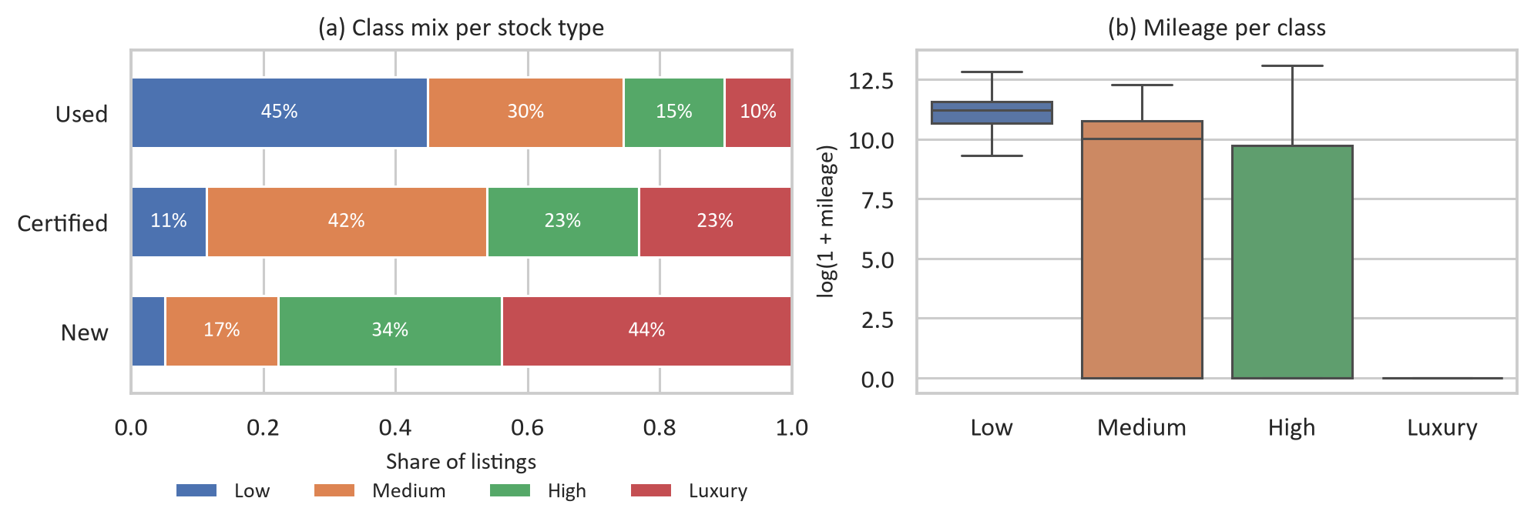
Figure 1. (a) Share of each price class among new, certified and used cars. (b) Mileage per class on a log scale. For High and Luxury the median mileage is 0, since most of these cars are new.
Before fitting any model we split the data into a training set (32,000 listings) and a test set (8,000 listings). The split is stratified, so every class has the same share in both sets. The test set was only used for the final evaluation. For comparing models and tuning we used 5-fold cross-validation on the training set, which scikit-learn also stratifies for classifiers.

3. Results
All models were trained on the same data with the same preprocessing. We report accuracy, precision, recall and F1 as defined in Lecture 3 (Tarlani, 2026). For precision, recall and F1 we use the macro average, the plain mean of the four class scores, because it treats every class as equally important, which fits the question of which classes are easy and which are hard. Since the classes are balanced, the weighted average gives almost the same numbers. The lab instructions only suggest ROC-AUC for binary problems, so we didn’t use it. As the lab instructions ask, we compared and tuned the models with 5-fold cross-validation on the training set only. Table 1 shows the mean cross-validation results before and after tuning (section 3.2). The test set was only used at the end, for the two selected models (section 3.3).
Table 1. Five-fold cross-validation results on the training set (32,000 listings), before and after tuning. Precision, recall and F1 are macro averages, and the best value in each column is in bold.
Model | Accuracy | Precision | Recall | F1
Dummy (most frequent) | 0.264 | 0.066 | 0.250 | 0.104
Logistic Regression | 0.580 | 0.565 | 0.575 | 0.564
Logistic Regression (tuned, C = 10) | 0.581 | 0.568 | 0.576 | 0.567
Random Forest | 0.635 | 0.629 | 0.632 | 0.630
Random Forest (tuned) | 0.640 | 0.635 | 0.637 | 0.635

The dummy model always predicts Luxury, the largest class, and is right 26.4% of the time, which is about what you get by guessing. Its macro F1 is only 0.104, because it never predicts the other three classes. Logistic regression more than doubles the accuracy, to 58.0%, and the random forest reaches 63.5%, or 64.0% after tuning.
The standard deviation of the macro F1 over the five folds was below 0.01 for both models (0.005 for logistic regression and 0.007 for the forest), so we don’t think the difference between the models comes from a lucky split.

3.1 Underfitting or overfitting?
In cross-validation, logistic regression gets 58.8% accuracy on the training folds and 58.0% on the validation folds. The two are close and neither is high, so the model is underfitting: it is too simple for the problem. The default random forest gets 92.5% on the training folds but only 63.5% on the validation folds. That gap of 29 percentage points shows that it overfits a lot, because its trees can grow until a leaf holds a single car. Its validation score is still clearly the best, though, and larger leaves make the gap smaller (sections 3.2 and 3.3).

3.2 Did tuning help?
For logistic regression we tuned C, which controls how strongly the model is regularised (a small C means strong regularisation). The grid search tried 0.01, 0.1, 1 and 10 and picked C = 10, the weakest regularisation, but the result hardly changed (cross-validation macro F1 0.564 before and 0.567 after, accuracy 0.580 and 0.581). Just like Ridge in Lab 1, this makes sense: regularisation fights overfitting, and our linear model has the opposite problem.
For the random forest we tried 100 and 300 trees, max_features = sqrt or 0.3 (how many of the 169 columns each split may look at, about 13 or about 50), and min_samples_leaf = 1 or 3. The best combination was 300 trees, max_features = 0.3 and min_samples_leaf = 3. The cross-validation macro F1 went from 0.630 to 0.635 and the accuracy from 0.635 to 0.640. That is a small but consistent gain. Letting each split look at more columns (0.3 instead of sqrt) helped the most. Interestingly, bigger leaves only helped together with max_features = 0.3; with sqrt they made the forest worse (0.616 to 0.618). With 300 trees the forest scored almost the same as with 100 (0.635 against 0.634), but each fit took about 69 seconds instead of 30 during the grid search, so in practice 100 trees would be enough.

3.3 Final evaluation on the test set
Based on cross-validation alone we selected the two tuned models: logistic regression with C = 10, and the random forest with 300 trees, max_features = 0.3 and min_samples_leaf = 3, which had the highest cross-validation macro F1 of all models (0.635). Only then did we evaluate them, once, on the held-out test set. Table 2 shows the results, with the dummy model as a reference.
Table 2. Results of the selected models on the held-out test set (8,000 listings). Precision, recall and F1 are macro averages, and the best value in each column is in bold.
Model | Accuracy | Precision | Recall | F1
Dummy (most frequent, reference) | 0.264 | 0.066 | 0.250 | 0.104
Logistic Regression (tuned, C = 10) | 0.576 | 0.562 | 0.571 | 0.563
Random Forest (tuned) | 0.642 | 0.638 | 0.639 | 0.639

The test results are very close to the cross-validation results (accuracy 0.642 against 0.640 for the forest and 0.576 against 0.581 for logistic regression), so the choice we made with cross-validation also holds for new listings. With four classes, 64% may not sound very high, but most of the mistakes are near misses: 81% of the wrong predictions of the tuned forest are only one class away from the right one, for example High predicted as Luxury (78% for logistic regression). We come back to this in section 4. On the training data the tuned logistic regression gets 59.0% accuracy and the tuned forest 82.1%, against 57.6% and 64.2% on the test set, so even with min_samples_leaf = 3 the forest still overfits, but its test score is clearly the best.

4. Which classes are predicted well and which are difficult?
Figure 2 shows the confusion matrices of the two tuned models. Each row shows where the cars of one true class ended up, so the diagonal is the share of each class that was classified correctly, which is the recall of that class. Normalising every row like this is the error analysis Géron (2019, ch. 3) recommends, because it makes the classes comparable no matter how large they are. Table 3 gives the recall and the F1 score of every class.
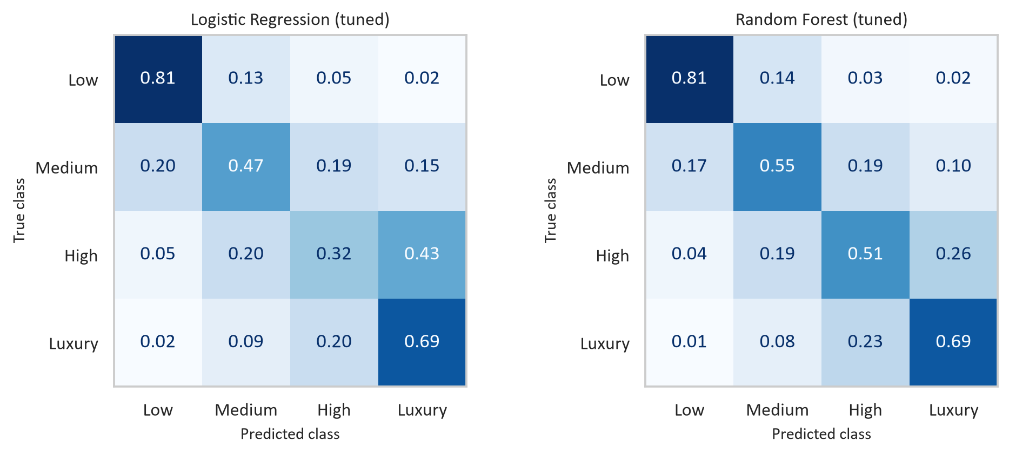
Figure 2. Confusion matrices of the tuned models on the test set, normalised per row. Rows are the true class and columns the predicted class (the scikit-learn layout), and every row adds up to 1.
Low is the easiest class for both models. 81% of the Low cars are found, and the F1 score is 0.78 for logistic regression and 0.80 for the forest. This makes sense after Figure 1: Low cars are mostly older used cars with a lot of miles, and that is easy to see in the data. Luxury comes second, with 69% found by both models (F1 0.62 and 0.67). Here the brand helps a lot, since for brands like Volvo and Porsche more than half of the listings are Luxury.
The middle classes are much harder, and High is the hardest of all. Logistic regression only finds 32% of the High cars and puts 43% of them in Luxury instead, so its F1 score for High is just 0.36. It predicts Luxury too often in general: in cross-validation the recall of Luxury is 0.72 but its precision only 0.56 (notebook section 5). The random forest is much better here and finds 51% of the High cars (F1 0.52), but 26% of them still end up as Luxury and 19% as Medium. Medium lies in between: both models mix it up with both of its neighbours, Low and High.
Table 3. Recall and F1 score per class on the test set for the two tuned models (LR = logistic regression, RF = random forest).
Class | Recall LR | Recall RF | F1 LR | F1 RF
Low | 0.81 | 0.81 | 0.78 | 0.80
Medium | 0.47 | 0.55 | 0.49 | 0.56
High | 0.32 | 0.51 | 0.36 | 0.52
Luxury | 0.69 | 0.69 | 0.62 | 0.67

We think the main reason is the one we already saw in Figure 1(b). High and Luxury cars are both mostly new with 0 miles, so the strongest features (mileage, age and stock type) can’t tell them apart, and the model has to rely on the brand, the car type and the origin. On top of that, the class is defined compared with other cars of the same type, so a High car of one type can look very similar to a Luxury car of another type. The good news is that almost all mistakes are between neighbouring classes. Only 19% of the forest’s errors are two or more classes away, like a Low car predicted as Luxury, and those are the mistakes that would really matter to a buyer.

5. Strengths and weaknesses
To see which features the models rely on, we used permutation importance on the test set. We shuffle one column at a time, so it no longer has anything to do with the class, and measure how much the accuracy drops (Figure 3). Like in Lab 1 we chose this method because it works the same way for both models and on the original columns, so we didn’t have to add up the one-hot columns of BRAND or CAR TYPE.
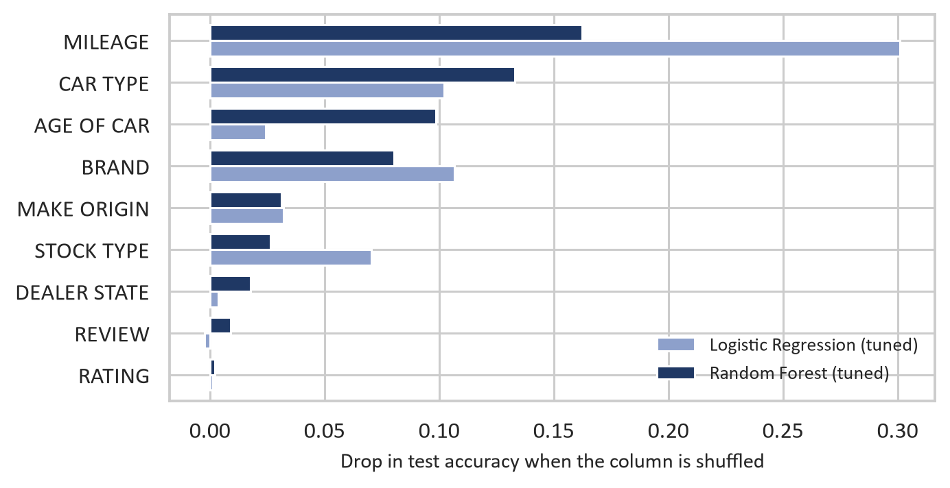
Figure 3. Permutation importance on the test set for the two tuned models: how much the accuracy drops when one column is shuffled.
MILEAGE is the most important feature for both models. Shuffling it lowers the accuracy by 0.30 for logistic regression and by 0.16 for the forest. After that the models differ. Logistic regression relies on BRAND (0.11), CAR TYPE (0.10) and STOCK TYPE (0.07), while the forest uses CAR TYPE (0.13), AGE OF CAR (0.10) and BRAND (0.08). CAR TYPE is interesting, because on its own it says almost nothing about the class (every type is about 25% per class), and still it is one of the most important features for both models. We think this is because the class is defined relative to the type, so the type works as a reference point for the other features. RATING and REVIEW hardly matter to either model.
Logistic regression is fast to train (a few seconds) and easy to interpret, because every feature gets one weight per class, and through the softmax function it gives a probability for each class. It is also very stable, with almost no difference between the training and the test results or between the cross-validation folds. Its weakness is that its decision boundaries are linear, so every feature adds a fixed amount to the score of each class. It can’t learn combinations like “this brand is Luxury only when the car is new and has few miles”, and that is exactly what is needed to separate High from Luxury. Tuning C doesn’t change that.
The random forest is more accurate on every class, and the improvement is largest for the difficult middle classes (F1 0.52 against 0.36 for High). It finds non-linear effects and combinations of features by itself, and it doesn’t need scaling (Géron, 2019, ch. 7). On the other hand, it is much slower to tune (the grid search took about four and a half minutes, against well under a minute for logistic regression) and harder to interpret, since we needed permutation importance just to see what it uses. It also overfits, as the gap between 82.1% training accuracy and 64.2% test accuracy shows.

6. Our recommendation
We recommend the tuned random forest for this dataset. On the test set it gets an accuracy of 0.642 and a macro F1 of 0.639, against 0.576 and 0.563 for the tuned logistic regression, which means 2,865 wrong predictions instead of 3,396 out of 8,000. It is better on all four classes, and most of all on High and Medium, where logistic regression struggles. Most of its mistakes are also near misses, 81% of them are only one class off. Logistic regression is still useful for explaining the data, but it puts almost half of the High cars in the wrong class, so we wouldn’t use it to estimate price tiers.
Our results have some limitations. We only used 40,000 of the 240,927 listings, and we left out the model name and the dealer city, which probably say a lot about the price but have thousands of different values. The class is also relative to the car type, which the features can only partly describe. With more time we would train on the full data, add the mo del name with the rare models grouped together, and try gradient boosting. Since the classes have a natural order (Low, Medium, High, Luxury), it would also be worth trying an ordinal method or at least reporting how often the prediction is within one class, because predicting High instead of Luxury is a much smaller mistake than predicting Low.

7. Conclusion
In this lab we predicted the price class of car listings from their brand, type, age, mileage, stock type and a few other features. Like in Lab 1, one of the most important steps was the data preparation: the class is made from the price, so the price had to be removed, and we also had to find duplicated listings and ratings of −1 that really meant “missing”. Of the models we tried, the random forest was clearly the best (test accuracy 0.642 against 0.576), mainly because it can combine features, which matters most for the difficult High class. Tuning only helped a little. The next things we would try are adding the model name and using a method that takes the order of the classes into account.

References
Géron, A. (2019). Hands-On Machine Learning with Scikit-Learn, Keras, and TensorFlow (2nd ed.). O’Reilly Media.
Pedregosa, F., Varoquaux, G., Gramfort, A., Michel, V., Thirion, B., Grisel, O., et al. (2011). Scikit-learn: Machine learning in Python. Journal of Machine Learning Research, 12, 2825–2830.
Tarlani, R. (2026). Lecture 3: Classification [Lecture slides]. DA380A Machine Learning, Kristianstad University.

