**Projects:**

DiskWorld build 1 Artifact

**Members of team 6:**

Parinaz Barakhshan (ID# 7675518)  
Niloufar Behrouzy (ID# 7676727)  
Gay Hazan (ID# 3974650)  
Lawrence Ng (ID# 5739411)

**Due Date:**

February 5th, 2015

**Design Diagram:**

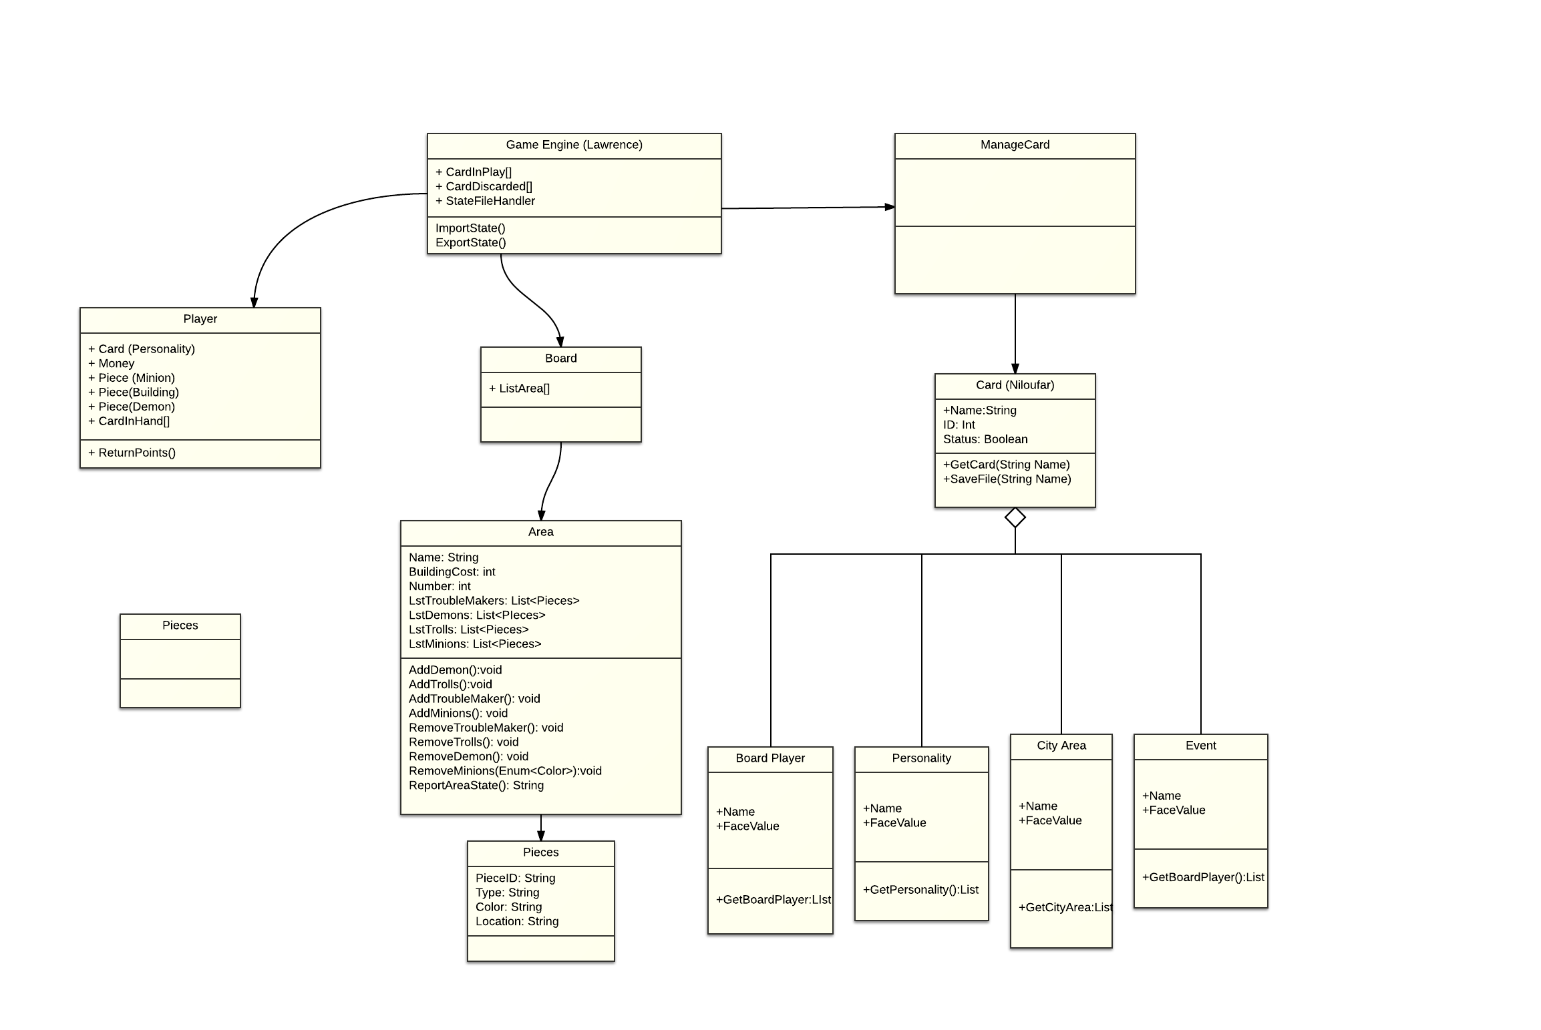

Points we considered when doing the architecture:

Board

Card and GameManager:

Player

GameEngine