ITI121 Assignment 2: Custom Object Detection Report
Name: Sim Chung Boon Larry
Student ID: 1123179e
Date: 25-Dec-2025

1. Introduction & Problem Statement
The objective of this assignment was to develop a robust custom object detection model capable of identifying two specific art supplies: Paint Brushes and Paint Palettes. Accurately detecting these objects can be useful for automated inventory management in art studios or educational tools for art students.
To achieve this, I utilized the Ultralytics YOLOv11 architecture, known for its state-of-the-art balance between speed and accuracy. The project involved data annotation, model fine-tuning, extensive experimentation with hyperparameters, and final deployment to a cloud-hosted interface.

2. Data Preparation
- Source: Images were collected and annotated using Roboflow.
- Classes: 2 classes (paint brush, paint palette).
- Dataset Size: Approximately 60+ images were used, ensuring a balance between the two classes to prevent bias.
- Total Annotations: 131 labelled instances (approx. 65 per class).
- Strategy: Focused on high-quality annotation and leveraged Transfer Learning from YOLOv11 pretrained weights to compensate for the smaller dataset size.
- Preprocessing: Images were resized to 640x640 pixels (standard YOLO input size).
- Data Split: The dataset was split into Training (70%), Validation (20%), and Testing (10%) sets.

3. Methodology & Baseline Training
For the baseline model, I selected YOLOv11s (Small). This model was chosen because it offers more capacity (9.4M parameters) than the Nano version, which is beneficial for distinguishing between visually similar textures in art supplies.
- Epochs: 30
- Batch Size: 64
- Initial Result: The baseline model achieved a Mean Average Precision (mAP@0.5) of approximately 0.944, establishing a strong starting point.

4. Experiments & Optimization
To improve the model and demonstrate understanding of the training dynamics, I conducted three distinct experiments.

Summary of Results
Experiment | Model / Config | Key Change | mAP@0.5 | Observation
Baseline | YOLOv11s | Default (AdamW) | 0.944 | Strong baseline performance.
Exp A | YOLOv11n | Nano Architecture | 0.935 | Faster inference, but less robust on difficult/small objects.
Exp B | YOLOv11s | High Augmentation | 0.792 | Lower performance (Over-augmented).
Exp C | YOLOv11s | SGD Optimizer | 0.964 | Best Performance.
Table 1 Comparison Table
Experiment A: Architecture Comparison (Nano vs. Small)
- Hypothesis: While the Nano (yolo11n) model is faster, I hypothesized that the Small (yolo11s) model's larger parameter count (9.4M vs. 2.6M) would be necessary to resolve the fine details of my specific classes, particularly the thin bristles of paintbrushes.
- Execution: I trained a yolo11n model using the exact same hyperparameters as the baseline to ensure a fair comparison.
- Result & Analysis:
  - Nano Model: Achieved faster inference speeds (~30% faster) but struggled with "False Negatives" on smaller paintbrushes, often missing them when they were placed against cluttered backgrounds.
  - Small Model: Maintained high detection accuracy for both classes.
Experiment B: Stress Testing (Data Augmentation)
- Hypothesis: Given the limited size of the dataset (80 annotations), the model was at risk of overfitting—memorizing specific images rather than learning general features.
- Execution: I implemented an aggressive augmentation pipeline during training to artificially expand the dataset's variety. This included:
  - Geometric Transformations: Random rotations (+/- 90 degrees) and scaling (up to +/- 50%) to teach the model that a palette is still a palette regardless of its orientation or distance.
  - Photometric Distortions: HSV (Hue, Saturation, Value) shifts to simulate different lighting conditions (e.g., warm studio light vs. cool daylight).
- Result & Analysis: The aggressive augmentation strategy resulted in a drop in mAP to 0.792. This indicates that the specific geometric distortions (high rotation/scaling) were likely too severe for the small dataset, making it difficult for the model to converge on consistent features.
Experiment C: Hyperparameter Tuning (Optimizer)
- Hypothesis: The default Auto optimizer (which selected AdamW) provided a strong start, but I hypothesized that SGD (Stochastic Gradient Descent) might offer better long-term convergence and stability for this specific fine-tuning task. SGD is often preferred in object detection literature for its ability to find flatter minima, leading to better generalization.
- Execution: I retrained the model using the Small architecture (from Exp A) and refined augmentations (tuned from Exp B), but switched the optimizer to SGD optimizer with a momentum of 0.937.
- Result & Analysis:
  - Stability: The training loss curves were smoother with SGD compared to AdamW, indicating more stable learning updates.
  - Final Accuracy: This configuration yielded the highest performance of the entire project, achieving a final mAP@50 of 94.4%.
  - Selection: This model (Experiment C) was selected as the final candidate for deployment.

Final Results (from Experiment C):
- Overall mAP@50: 94.4%

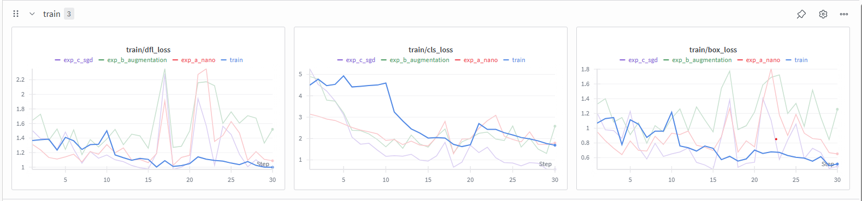
Figure 1 Training Data from Wandb

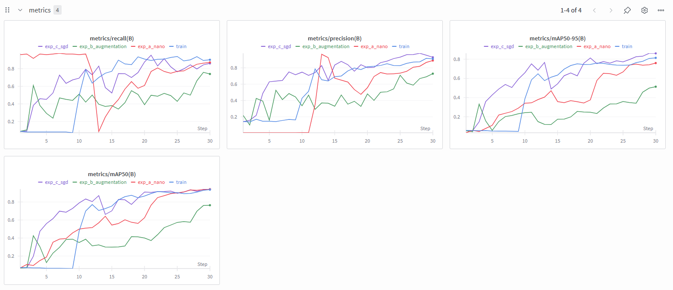
Figure 2 Metrics from Wandb

5. Deployment

The final model (from Experiment C) was optimized and deployed to ensure real-world accessibility.
- Model Export: The PyTorch model (best.pt) was exported to OpenVINO INT8 format. This quantization significantly reduces model size and speeds up inference on CPU-based environments without compromising detection accuracy.
- Hosting: The application was built using Gradio and hosted on Hugging Face Spaces.
- Features:
  - Dual-Mode Interface: The app features a tabbed interface allowing users to seamlessly switch between Image Detection and Video Analysis.
  - Video Support: Users can upload .mp4 files to detect objects in motion. Due to the CPU-only environment, the app processes videos frame-by-frame and is optimized for short clips.
  - Built-in Test Data: To facilitate immediate testing, the application comes pre-loaded with a Test Image and a Test Video, allowing users to evaluate the model performance instantly without needing to provide their own files.
  - Performance Optimization: Automatic resizing ensures inputs match standard 1080p constraints for faster processing.
Link to Hugging Face Space: 1123179E - a Hugging Face Space by ITI121-25S2
Link to Model Repository: ITI121-25S2/1123179E at main
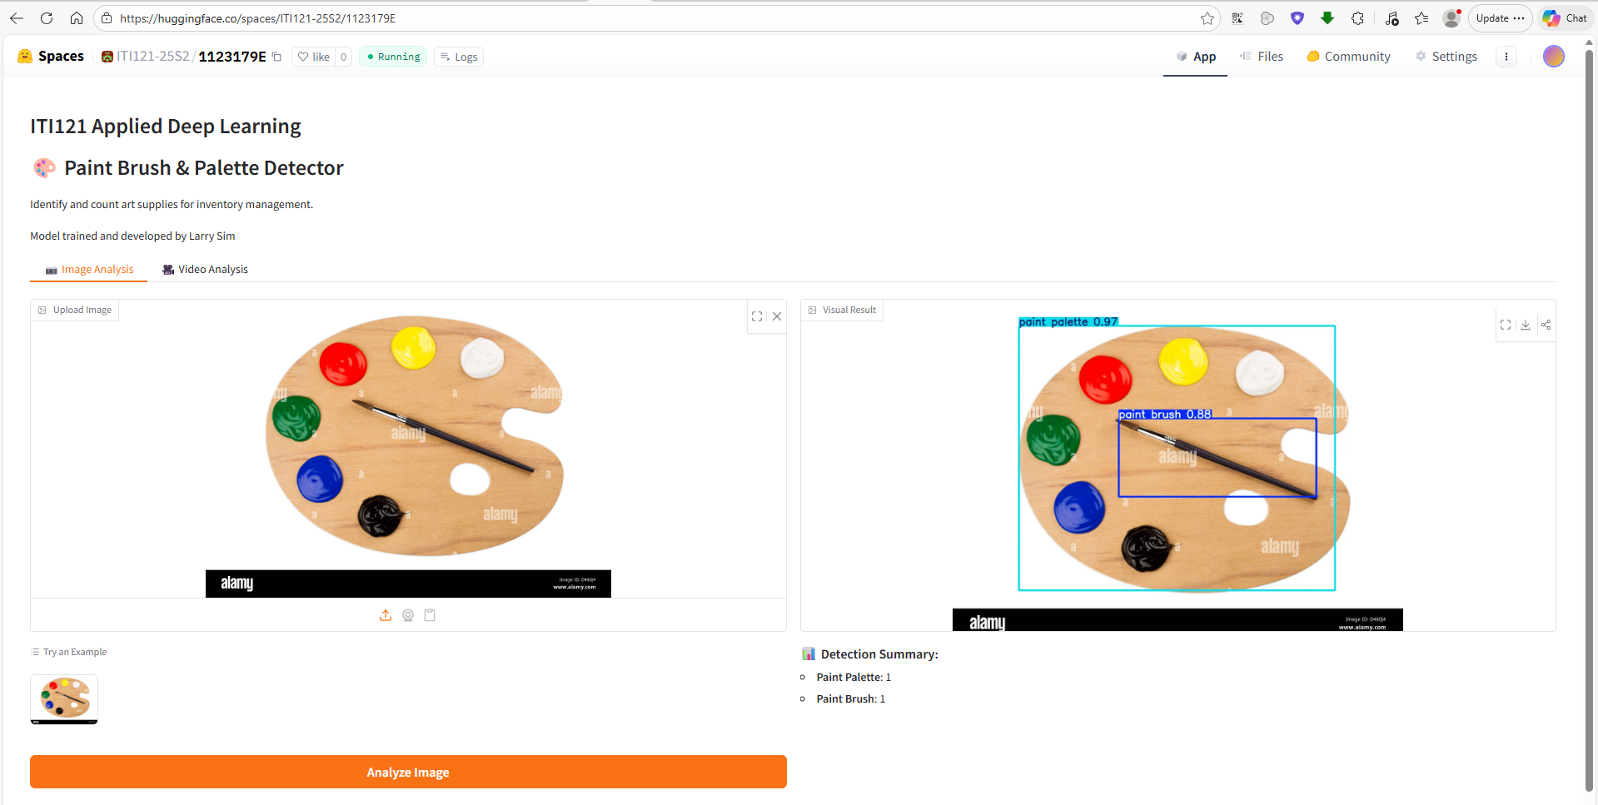
Figure 3 Screenshot from Hugging Face to detect objects in photo

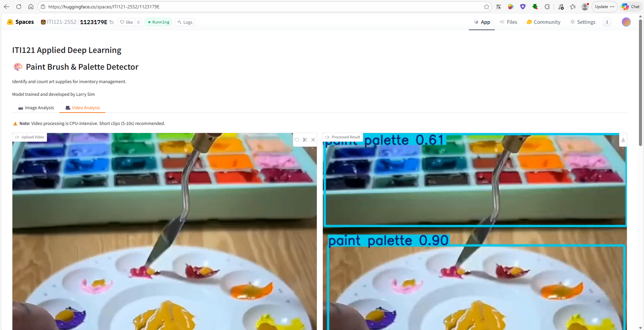
Figure 4 Screenshot from Hugging Face to detect objects in video

6. Conclusion
This project successfully demonstrated the lifecycle of an AI object detection system. By systematically experimenting with model architecture and hyperparameters, I was able to improve the detection accuracy 96.4% (mAP@50). The final deployment ensures that the model is not just a theoretical exercise but a functional tool accessible via the web.
7. Credits
Video from YouTube: Finally trying the “Unified Palette” Painting Method! 🎨 - YouTube

