CSS Tutorial

CSS is the language we use to style an HTML document.

CSS describes how HTML elements should be displayed.

## **What is CSS?**

* CSS stands for Cascading Style Sheets
* CSS describes how HTML elements are to be displayed on screen, paper, or in other media
* CSS saves a lot of work. It can control the layout of multiple web pages all at once
* External stylesheets are stored in CSS files

## **CSS Syntax**

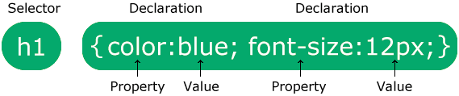

The selector points to the HTML element you want to style.

The declaration block contains one or more declarations separated by semicolons.

Each declaration includes a CSS property name and a value, separated by a colon.

Multiple CSS declarations are separated with semicolons, and declaration blocks are surrounded by curly braces.

p {  
  color: red;  
  text-align: center;  
}

## **Three Ways to Insert CSS**

There are three ways of inserting a style sheet:

* External CSS
* Internal CSS
* Inline CSS

## **External CSS**

With an external style sheet, you can change the look of an entire website by changing just one file!

Each HTML page must include a reference to the external style sheet file inside the <link> element, inside the head section.

<!DOCTYPE html>  
<html>  
<head>  
<link rel="stylesheet" href="mystyle.css">  
</head>  
<body>  
  
<h1>This is a heading</h1>  
<p>This is a paragraph.</p>  
  
</body>  
</html>

## **Internal CSS**

An internal style sheet may be used if one single HTML page has a unique style.

The internal style is defined inside the <style> element, inside the head section.

<!DOCTYPE html>  
<html>  
<head>  
<style>  
body {  
  background-color: linen;  
}  
  
h1 {  
  color: maroon;  
  margin-left: 40px;  
}  
</style>  
</head>  
<body>  
  
<h1>This is a heading</h1>  
<p>This is a paragraph.</p>  
  
</body>  
</html>

## **Inline CSS**

An inline style may be used to apply a unique style for a single element.

To use inline styles, add the style attribute to the relevant element. The style attribute can contain any CSS property.

<!DOCTYPE html>  
<html>  
<body>  
  
<h1 style="color:blue;text-align:center;">This is a heading</h1>  
<p style="color:red;">This is a paragraph.</p>  
  
</body>  
</html>