

Project Number: 101136379
Project Acronym: CERTAINTY
A Cellular Immunotherapy Virtual Twin for Personalized Cancer Treatment

WP2 and WP3
OMOP Codebook

 | This project was funded by the European Union under Grant Agreement number 101136379. Views and opinions expressed are however those of the author(s) only and do not necessarily reflect those of the European Union. Neither the European Union nor the granting authority can be held responsible for them.

Project

Acronym: | CERTAINTY
Title: | A CEllulaR immunoTherapy virtuAl twin for personalized cancer treatmeNT
Coordinator: | Fraunhofer Gesellschaft Zur Forderung Der Angewandten Forschung e.V.
Project Number: | 101136379
Type of action: | Horizon-RIA
Programme: | Horizon Europe Framework Programme (HORIZON)
Call: | HORIZON-HLTH-2023-TOOL-05
Duration | 54 Months
Website | https://www.certainty-virtualtwin.eu
Consortium: | Participating Organisation Legal Name | Country | Role
 | Fraunhofer Gesellschaft Zur Forderung Der Angewandten Forschung e.V. (FHG) | DE | Coordinator
 | Universitaet Leipzig (ULEI) | DE | Partner
 | Singleron Biotechnologies (Singleron) | DE | Partner
 | Collaborate Project Management (SPM) | DE | Partner
 | Myeloma Patients Europe (MPE) | BE | Partner
 | TriNetX Oncology (TriNetX) | DE | Partner
 | Masarykova Univerzita (MU) | CZ | Partner
 | Information Technology for Translational Medicine (ITTM) | LU | Partner
 | Universitaetsklinikum Wuerzburg (UKW) | DE | Partner
 | Institut Curie (IC) | FR | Partner
 | Universite de Namur (UNAM) | BE | Partner
 | Universitair Medisch Centrum Utrecht (UMCU) | NL | Partner
 | Charite (Charite) | DE | Partner
 | European Society for Blood and Marrow Transplantation (EBMT) | NL | Partner
 | HealthTree Foundation (HealthTree) | US | Partner
 | Helmholtz-Zentrum Dresden-Rossendorf e.V. (HZDR) | DE | Partner

HISTORY OF CHANGES
Version | Date | Change
1.0 |  | - Initial version
1.1
1.2
1.3
1.4

Acknowledgement: This project has received funding from the European Union’s Horizon Europe Research and Innovation Programme under Grant Agreement No. 101136379.

Table of Contents
1. Introduction 5
1.1 OMOP CDM Version 6
2. Semantic Mapping 6
2.1 Standard Concepts and Vocabularies 6
2.2 Custom Vocabulary 6
3. Structural Mapping 9
3.1 Overview 9
3.2 Tables 10
3.2.1 person 10
3.2.2 observation_period 10
3.2.3 condition_occurrence 11
3.2.4 death 11
3.2.5 visit_occurrence 11
3.2.6 drug_exposure 11
3.2.7 procedure_occurrence 12
3.2.8 measurement 12
3.2.9 observation 14
3.2.10 episode 14
3.2.11 episode_event 16
3.3 Example Patient Trajectory 17
4. Further Mapping Conventions 18
4.1 Date and Datetime 19
4.2 CDM Source 19
4.3 Death Table 19
4.4 _type_concept_id 19
5. Key Concepts 21
Key drug concepts 21
Key procedure concepts 21
Key measurement concepts 21
Key observation concepts 22

Introduction

1.1 OMOP CDM Version
CERTAINTY datasets will be converted to OMOP CDM version 5.4. Please, see the specifications here. The zipped folder containing the files to instantiate the CDM tables for all supported SQL dialects is available here. In case any dataset has already been mapped to OMOP version 5.3.1, the changes from version 5.3 to version 5.4 can be found here.

Semantic Mapping

2.1 Standard Concepts and Vocabularies
Terms found in the source data are mapped to concepts in the OMOP standard vocabularies to achieve semantic interoperability. The latest version of the OMOP vocabularies can be downloaded from Athena. In most cases, a mapping to a standard concept with the same meaning as the source term can be made. If no standard concepts that appropriately represent the source meaning are available, then the source term is mapped to a non-standard concept. In case no non-standard concepts match the source term, the solution is to create a custom ‘CERTAINTY’ concept.
To summarise, three options for semantic mapping can be followed, in decreasing order of priority:
- Mapping to a standard concept. These concepts are flagged with an ‘S’ in the standard_concept_id field from the concept table.
- Mapping to a non-standard concept.
- Mapping to an existing custom CERTAINTY concept or create a new one.
Additional notes:
- In the person table: Set variables “ethnicity_concept_id” and “race_concept_id” to “0”, if not collected.

2.2 Custom Vocabulary
Whenever appropriate concepts are missing in the OMOP vocabularies, custom CERTAINTY concepts are used. They will be collected in a master file shared within CERTAINTY (OMOP_codebook, CERTAINTY_custom_concepts_template.xlsx).

When new custom CERTAINTY concepts need to be created, follow the steps below:
- Download the master file CERTAINTY_custom_concepts_template.xlsx
- Create a new entry in the concept sheet, assigning a suitable concept_name and domain_id (Observation, Measurement, etc.) to the new concept.
- Concept IDs from the CERTAINTY vocabulary start from 2000010001. Verify the last ID used in the master file and store the next ID in the concept_id and concept_code columns.
- Use ‘01/01/1970’ and ‘31/12/2099’ as valid_start_date and valid_end_date, respectively.
- Assign a suitable concept_class_id to the new concept. In case a custom concept_class needs to be created, follow the same procedure explained here to add a new custom concept in the concept sheet, choosing a unique concept_id greater than 2000010001, setting domain_id to ‘Metadata’. Then edit the sheet concept_class, adding a new entry using the same concept_id just created as concept_class_concept_id and choosing an appropriate concept_class_id and concept_class_name.
- If needed, it is possible to create a relationship between custom concepts by editing the sheet concept_relationship. Use ‘01/01/1970’ and ‘31/12/2099’ as valid_start_date and valid_end_date, respectively.
- Once you have finished adding new concepts, rename the file by replacing ‘template’ with the abbreviation of your organization.
- Upload the renamed file to the SharePoint OMOP_codebook.
In the event that a custom concept from the CERTAINTY vocabulary becomes obsolete during the ETL development process, it should not be removed. Instead, assign a “D” (Deleted) in the standard_concept column of the CERTAINTY custom vocabulary file. Do not forget to change from this deleted custom concept to the newly defined concept replacing it the mapping, ETL and data, where relevant.

Structural Mapping

3.1 Overview
In the following table, we describe some of the most important tables and how they can be used for modeling:
Table | Primary Key | Description
person | person_id | Serves as the central identity management for all patients in the database
observation_period | observation_period_id | Defines the span of time during which clinical events are recorded. Most importantly, we utilize observation_period_end_date as the censoring time for survival analysis.
condition_occurrence | condition_occurrence_id | Contains diseases and medical conditions (e.g., Multiple Myeloma (MM) or comorbidities), starting with the respective date of diagnosis.
death | None
visit_occurrence | visit_occurrence_id | Contains all recorded healthcare encounters (e.g., inpatient visits, outpatient visits, laboratory visits, …).  The visit_occurrence_id is most importantly used in other event tables such as ‘measurement’ and ‘observation’.
drug_exposure | drug_exposure_id | Contains a list of all drugs administered in the observation period.
procedure_occurrence | procedure_occurrence_id | In the MM setting, this most importantly covers stem cell transplantations and the steps of CAR T cell therapy.
measurement | measurement_id | Structured values (numerical/categorical) obtained through systematic and standardized examination (e.g, laboratory results, ISS, ECOG).
observation | observation_id | Contains clinical facts about a patient that cannot be represented by any other domain (e.g., treatment response).
episode | episode_id | Aggregates clinical events into a higher-level structure
episode_event | None | Links individual events (drug exposure, procedures, measurements, …) to their respective episodes.

A complete description of each table can be found here.
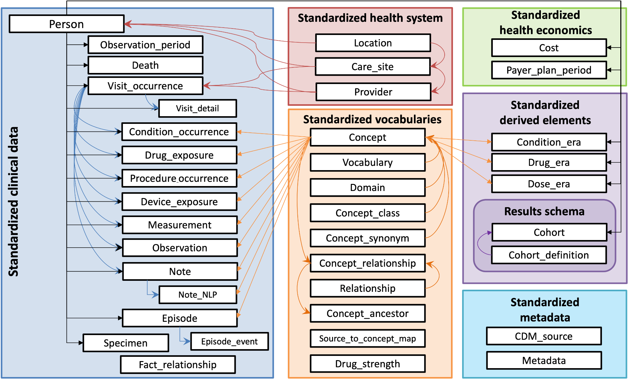

3.2 Tables

3.2.1 person
Field | Is Foreign Key to … | Notes
person_id
gender_concept_id | concept table
year_of_birth
month_of_birth
day_of_birth

3.2.2 observation_period
Field | Is Foreign Key to … | Notes
observation_period_id
person_id | person
observation_period_
start_date
observation_period_  end_date |  | Used for censoring time in survival analysis
period_type_concept_id | concept

3.2.3 condition_occurrence
Field | Is Foreign Key to … | Notes
condition_occurrence_id
person_id | person
condition_start_date |  | For MM, the date of diagnosis of symptomatic MM. Smoldering myeloma should be a separate condition.
condition_end_date
visit_occurrence_id | visit_occurrence | Visit of diagnosis
condition_concept_id | concept | E.g., 437233 for MM or 4184985 for smoldering myeloma

3.2.4 death
Field | Is Foreign Key to … | Notes
person_id | person | No dedicated primary key for the death table
death_date |  | Used for OS in survival analysis

3.2.5 visit_occurrence
Field | Is Foreign Key to … | Notes
visit_occurrence_id
person_id | person
visit_concept_id | concept | Describes the type of visit (inpatient, outpatient, remote)
visit_start_date
visit_end_date

3.2.6 drug_exposure
Field | Is Foreign Key to … | Notes
drug_exposure_id
person_id | person
drug_concept_id | concept | Usually from the RxNorm vocabulary
drug_exposure_start_date
drug_exposure_end_date
visit_occurrence_id | visit_occurrence | Visit during which the drug was prescribed, administered, or dispensed.

3.2.7 procedure_occurrence
Field | Is Foreign Key to … | Notes
procedure_occurrence_id
person_id | person
procedure_concept_id | concept | From the SNOMED vocabulary for stem cell transplant
procedure_date
procedure_type_concept_id | concept
visit_occurrence_id | visit_occurrence | Visit during which the procedure occurred.

3.2.8 measurement
Depending on the type of measurement, the measured value must be represented in a different way, utilizing different fields of the table:
- Categorical measurements:
  - value_as_concept_id
  - There is only a finite number of possible values, and each one has a uniquely defined concept id
  - Examples include the ISS and the ECOG performance status
- Binary measurements:
  - value_as_concept_id
  - These are measurements that have only two possible values
  - Most importantly, this covers tests for chromosomal abnormalities, where the possible values are positive (9191) and negative (9189)
- Continuous measurements:
  - value_as_number and unit_concept_id
  - This includes measurements that can take any real-valued number as a value
  - Examples include height, weight, and certain laboratory measurements
  - The unit_concept_id is required for the correct interpretation of the measured value
- Thresholded measurements:
  - operator_concept_id, value_as_number, and unit_concept_id
  - In some cases, the exact measured values of a continuous measurement are not recorded, but substituted by an operator and a threshold, turning an otherwise continuous variable into a discrete one
  - For example, albumin in the blood could be recorded as “> 3.5 g/dL” which is mapped to
    - operator_concept_id = 4172704 = “>”
    - value_as_number = 3.5
    - unit_concept _id = 8713 = “g/dL”
  - If the operator_concept_id is missing (=None), it is assumed to be “=”
- Measurements missing value:
  - In some cases, the result of the measurement is missing from the source data, even though the measurement was actually performed. In such cases, it is accepted to have the measurement without any value in value_as_concept_id nor value_as_number.
  - This does not apply to situations where it is unknown if the measurement was performed at all.
Field | Is Foreign Key to … | Notes
measurement_id
person_id | person
measurement_concept_id | concept
measurement_date
operator_concept_id | concept | Field for Meas Value Operator  Empty field means “=” (4172703)
value_as_number |  | For measurements that have continuous values (e.g., body height and weight)
unit_concept_id | concept | UCUM concepts for units
value_as_concept_id | concept | For measurements that have categorical values (e.g., ISS 1-3)
visit_occurrence_id | visit_occurrence

3.2.9 observation
The observation table is structured similarly to the measurement table. It should only be used as a fallback option for variables that do not fit in the measurement table.
Field | Is Foreign Key to … | Notes
observation_id
person_id | person
observation_concept_id | concept
observation_date
qualifier_concept_id | concept
observation_type_concept_id | concept
value_as_number
unit_concept_id | concept | UCUM concepts for units
value_as_concept_id | concept
visit_occurrence_id | visit_occurrence

3.2.10 episode
We aggregate individual clinical events (e.g., measurements or observations) into higher-level concepts (episodes). Each episode represents a treatment or disease phase in the patient's trajectory.
Field | Is Foreign Key to … | Notes
episode_id
person_id | person
episode_concept_id | concept | Concept for the type of episode (see list above)
episode_start_date |  | Key field for time-to-event and multi-state analysis. Especially for LoT-Episodes.
episode_end_date
episode_parent_id | episode | Internal reference to another episode (e.g., the LoT-Episode of a SCT-Episode)
episode_number |  | LoT number (integer)
episode_object_concept_id | concept | Further details on the episodes (e.g., the exact HemOnc concept for treatment regimen episode)

The list of all standard OMOP concepts for this can be found here. For now, focus on the following episode concepts:
- Disease Episode (32533)
  - Each patient should have one overarching episode for MM with episode_object_concept_id 437233 (MM in SNOMED)
  - The episode_start_date should be the date of diagnosis, i.e., equal to condition_occurrence_start_date for the symptomatic MM
- Cancer Drug Treatment (32941)
  - Represents a Line of Therapy (LoT)
  - The number is given by the field episode_number
  - The episode_object_concept_id should be a Procedure or Regimen domain concept_id that represents the LoT (chemotherapy, CAR-T therapy...)
- Cancer Surgery (32939)
  - SNOMED concepts for episode_object_concept_id
  - Using episode_parent_id to reference the associated LoT episode
- Progression (32949)
  - If disease progression is recorded, the associated observation event should also be represented in the episode table, with the episode_start_date being the observation_date for the event
  - The episode_object_concept_id should be the concept for MM (437233)
- Treatment Regimen (32531)
  - HemOnc concepts for episode_object_concept_id
  - Using episode_parent_id to reference the associated LoT episodes
  - Due to the limited number of standard concepts for treatment regimen given in HemOnc, the use of regimen episodes is not required

3.2.11 episode_event
This table is used to link clinical events to their respective episodes. It does not require an own primary key but is only used to connect other tables and give the database more structure. For example, it allows querying all events related to a specific LoT or a procedure. Events include visits, drug exposure, procedures, measurements and observations.
Field | Is Foreign Key to … | Notes
episode_id | episode
event_id | visit_occurrence,  drug_exposure,  procedure_occurrence  measurement  or observation
episode_event_field_concept_id | concept | OMOP field concepts (see list below)

Each event_id is a foreign key to an event table. The episode_event_field_concept_id is used to identify this event table. More specifically, it is an OMOP metadata concept for the primary key in the event table:
- visit_occurrence_visit_occurrence_id (1147070)
- drug_exposure.drug_exposure_id (1147094)
- procedure_occurrence.procedure_occurrence_id (1147082)
- measurement.measurement_id (1147138)
- observation.observation_id (1147165)
A single event can be mapped to multiple episodes. We suggest the following connections for episodes and events:
- MM Disease Episode (32533) connects to
  - all measurements and observations at the time of diagnosis
- Cancer Treatment / LoT Episode (32941) connects to
  - all measurements and observations at the start of the LoT
  - all drugs for MM given during the complete LoT
  - all procedures (SCT and CAR T) that occurred during the LoT
- Cancer Surgery Episode (32939) connects to
  - the associated procedure_occurrence_id
  - all steps that are part of the respective procedure (e.g., high dose melphalan before SCT or leukapheresis for CAR T)
  - any observations and measurements directly related to the procedure (e.g., adverse events)
- Progression Episode (32949) connects to
  - the associated observation_id for disease progression
  - all measurements that were used for determining disease progression
- Treatment Regimen Episode (32531) connects to
  - all individual drugs that are part of the regimen (e.g., bortezomib, lenalidomide and dexamethasone for VRd)

3.3 Example Patient Trajectory
In the following, we showcase the OMOP data for a single patient. For simplicity, we omit the person_id , episode_start_date and other field in the tables.

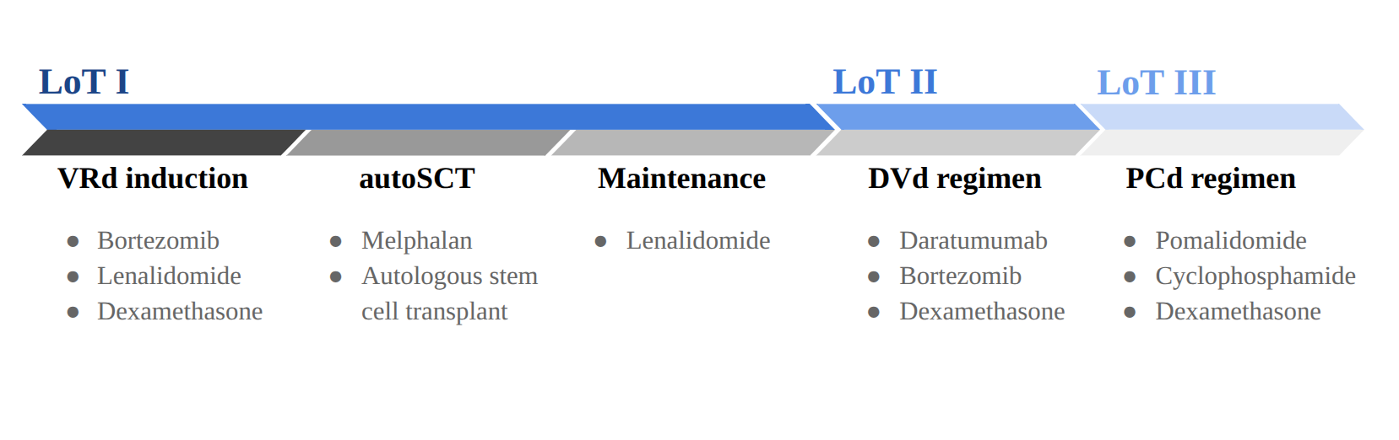

episode_id | episode_  concept_id | episode_  number | episode_  parent_id | episode_object_  concept_id | Notes
1001 | 32533 |  |  | 437233 | MM episode
1002 | 32941 | 1 |  | Episode entries from the ‘Treatment Episode’ concept class should have an episode_object_concept_id that comes from the ‘Procedure’ domain or ‘Regimen’ concept class. | LoT I
1003 | 32531 | 1 | 1002 | 35806260 | VRd regimen
1004 | 32939 | 1 | 1002 | 4144157 | autoSCT
1005 | 32531 | 1 | 1002 | 35803596 | Len maintenance
1006 | 32941 | 2 |  |  | LoT II
1007 | 32531 | 2 | 1006 | 35806312 | DVd regimen
1008 | 32941 | 3 |  |  | LoT III
1009 | 32531 | 3 | 1008 | 35806316 | PCd regimen

Further Mapping Conventions

4.1 Date and Datetime
Populate both the _date (required in v5) and the _datetime. If there is no time component, set the time to 00:00:00.
When only year is stored in the data (and month and day are missing), the first of July (07-01) is used as a proxy. This day will be, on average, the closest to the actual date.
When year is not stored in the dataset, the following steps and conventions are followed:
- In general, if the date is entirely missing, skip the record
- If the record is essential to preserve:
- Try to derive the year from the context.
- Copy the date of the associated episode.
- In case of medical history: capture as ‘History of’ and use date of capturing this medical history.
Exception: When observation_period.observation_period_end_date cannot be derived, take last follow up date (last visit_occurrence or episode).

4.2 CDM Source
A record is created in this table, using the ETL execution date as cdm_release_date and the source extraction date as the source_release_date.
The value of cdm_source_abbreviation must uniquely identify a data source within CERTAINTY, therefore the following format will be used: organization acronym_XXX. The value of cdm_release_date is required, as it is used together with cdm_source_abbreviation to create a unique identifier for a dataset (i.e. multiple versions of a data source can be provided if needed). The value of cdm_source_name is used to show the name of a dataset in ATLAS, make sure to choose a concise name.

4.3 Death Table
To capture a death, we have to create a record in the death table with at least the person_id and death_date. This may also include the primary cause of death.
Contributory causes of death can be stored in the CONDITION_OCCURRENCE table.

4.4 _type_concept_id
Every event table of the CDM (e.g. condition_occurrence, observation) has a _type_concept field, which stores the record provenance. The main purpose is to determine the reliability of the record. For example:
- Patient self-report (32865)
- eCRF (32809)
- EHR (32817)
A list of valid type concepts can be found here.

CAR T

Key Concepts

Key drug concepts
Drug | Group | concept_id
Thalidomide | IMiD | 19137042
Lenalidomide | IMiD | 19026972
Pomalidomide | IMiD | 43014237
Daratumumab | MA | 35605744
Elotuzumab | MA | 35604032
Isatuximab | MA | 37498969
Ixazomib | PI | 35606214
Bortezomib | PI | 1336825
Carfilzomib | PI | 42873638
idecabtagene vicleucel | CAR T | 36026868
ciltacabtagene autoleucel | CAR T | 779144
Talquetamab | T cell engager | 746340
Elranatamab | T cell engager | 746391
Teclistamab | T cell engager | 905786
Fludarabine | purine analog; inhibits DNA synthesis
Melphalan | Alkylating Agent | 1301267
Cyclophosphamide | Alkylating Agent | 1310317
Bendamustine | Alkylating Agent | 19015523
Dexamethasone | Glucocorticoid
Tocilizumab | recombinant humanized monoclonal antibody of the immunoglobulin IgG1 subclass against the interleukin-6 receptor
Anakinra | recombinant humanized monoclonal antibody of the immunoglobulin IgG1 subclass against the interleukin-6 receptor
Granulocyte colony-stimulating factor (G-CSF) | Growth factor
thrombopoietin receptor agonists (TPO-RAs), e.g. romiplostim (Nplate) | fusion protein analog to thrombopoietin; peptidbody
haematopoietic stem cell (HSC) boost (CD34+ cells) | Autologous cellular product

Key procedure concepts
Procedure | Group | concept_id
Allogeneic peripheral blood stem cell transplantation | SCT | 4143404
Autologous peripheral blood stem cell transplantation | SCT | 4144157
Leukapheresis | CAR T | 4298124
Chimeric antigen receptor T-cell immunotherapy | CAR T | 608175
Lymphodepletion | CAR T | 1395557; 1310317; 19015523
Bridging therapy | CAR T

Key measurement concepts
Measurement | Category | Values | concept_id
Albumin [Mass/volume] in Serum or Plasma | continuous |  | 3024561
Beta-2-Microglobulin [Mass/volume] in Serum or Plasma | continuous |  | 3013201
Body height | continuous |  | 3036277
Body weight | continuous |  | 3025315
Body mass index (BMI) | continuous |  | 3038553
ISS finding | discrete | Stage 1: 1633361  Stage 2: 1634176  Stage 3: 1633524 | 734337
ECOG performance status | discrete | Status 0: 4175026  Status 1: 4173614  Status 2: 4172043  Status 3: 4174241  Status 4: 4174251 | 4167763
del(13q) measurement | binary | Negative: 9189  Positive: 9191 | 35977004
del(17p) measurement | binary | Negative: 9189  Positive: 9191 | 19641187
t(4;14) measurement | binary | Negative: 9189  Positive: 9191 | 19641006
t(14;16)(q32;q23) measurement | binary | Negative: 9189  Positive: 9191 | 19476524
t(6;14) measurement | binary | Negative: 9189  Positive: 9191 | 19642743
Hypoploidy | binary | Negative: 9189  Positive: 9191 | 4048414
Hyperploidy | binary | Negative: 9189  Positive: 9191 | 4208087
Lactate dehydrogenase (LDH) | continuous |  | 3016436

Key observation concepts
Observation | Category | Values | concept_id
Plasmacytoma, extramedullary (not occurring in bone) | binary | Negative: 9189  Positive: 9191 | 4028858
Cancer disease progression | discrete | Improved: 45883920  No evidence of disease: 1620321  Stable: 45879403  Undetermined: 45880649  Worsened: 1620411 | 1617595

