Originally from <https://docs.microsoft.com/en-us/azure/logic-apps/quickstart-create-logic-apps-visual-studio-code>

# Quickstart: Create and manage automated logic app workflows - Visual Studio Code

For this demo, you can create the same logic app as in the [quickstart for creating a logic app in the Azure portal](https://github.com/MicrosoftDocs/azure-docs/blob/master/articles/logic-apps/quickstart-create-first-logic-app-workflow.md), which focuses more on the basic concepts. In Visual Studio Code, the logic app looks like this example:

[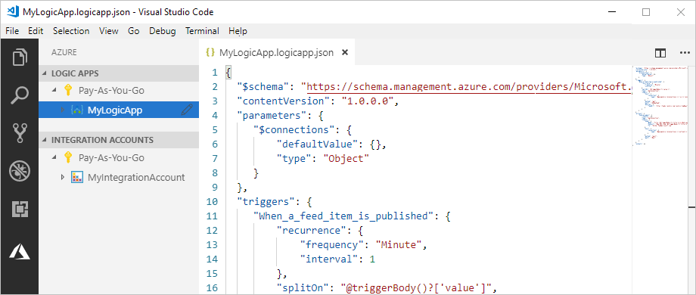](https://github.com/MicrosoftDocs/azure-docs/blob/master/articles/logic-apps/media/create-logic-apps-visual-studio-code/overview.png)

Before you start, make sure you have these items:

* If you don't have an Azure subscription, [sign up for a free Azure account](https://azure.microsoft.com/free/).
* Basic knowledge about [logic app workflow definitions](https://github.com/MicrosoftDocs/azure-docs/blob/master/articles/logic-apps/logic-apps-workflow-definition-language.md) and their structure, which uses JavaScript Object Notation (JSON)

If you're new to Logic Apps, try the quickstart that walks you through [how to create your first logic app in the Azure portal](https://github.com/MicrosoftDocs/azure-docs/blob/master/articles/logic-apps/quickstart-create-first-logic-app-workflow.md), which focuses more on the basic concepts.

* Access to the web for signing in to Azure and your Azure subscription
* Download and install these tools, if you don't have them already:
  + [Visual Studio Code version 1.25.1 or later](https://code.visualstudio.com/), which is free
  + Visual Studio Code extension for Azure Logic Apps

You can download and install this extension from the [Visual Studio Marketplace](https://marketplace.visualstudio.com/items?itemName=ms-azuretools.vscode-logicapps) or directly from inside Visual Studio Code. Make sure you reload Visual Studio Code after installing.

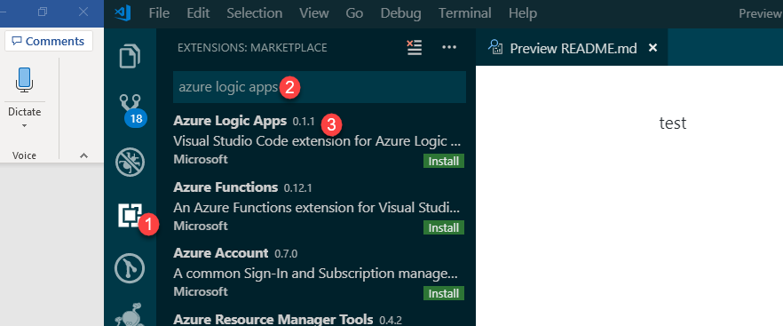

## Sign in to Azure

1. Open Visual Studio Code. On the Visual Studio Code toolbar, select the Azure icon.

[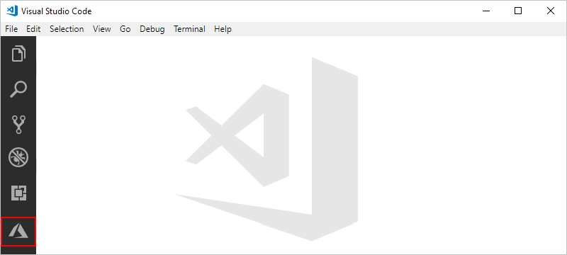](https://github.com/MicrosoftDocs/azure-docs/blob/master/articles/logic-apps/media/create-logic-apps-visual-studio-code/open-extension.png)

1. In the Azure window, under **Logic Apps**, select **Sign in to Azure**.

[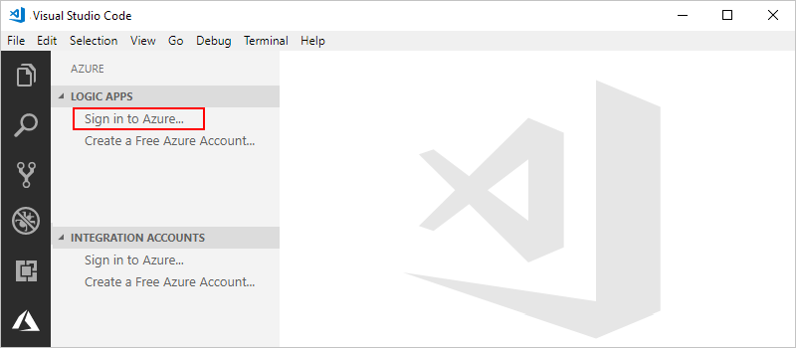](https://github.com/MicrosoftDocs/azure-docs/blob/master/articles/logic-apps/media/create-logic-apps-visual-studio-code/sign-in-azure.png)

You're now prompted to sign in by using the provided authentication code.

1. Copy the authentication code, and then choose **Copy & Open**, which opens a new browser window.

[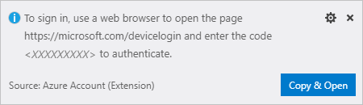](https://github.com/MicrosoftDocs/azure-docs/blob/master/articles/logic-apps/media/create-logic-apps-visual-studio-code/sign-in-prompt.png)

1. Enter your authentication code. When prompted, choose **Continue**.

[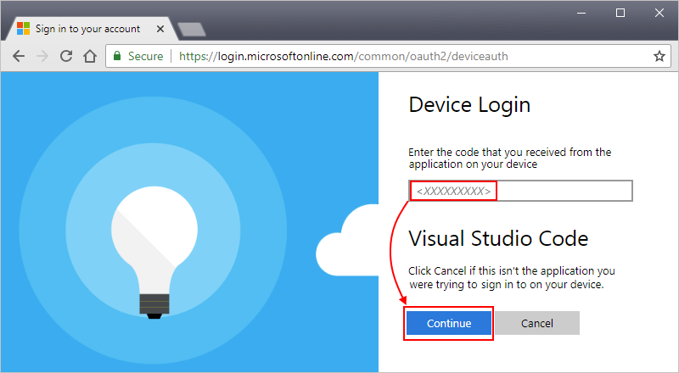](https://github.com/MicrosoftDocs/azure-docs/blob/master/articles/logic-apps/media/create-logic-apps-visual-studio-code/authentication-code.png)

1. Select your Azure account. After you sign in, you can close your browser, and return to Visual Studio Code.

In the Azure window, the Logic Apps pane and Integration Accounts pane now show the Azure subscriptions in your account.

[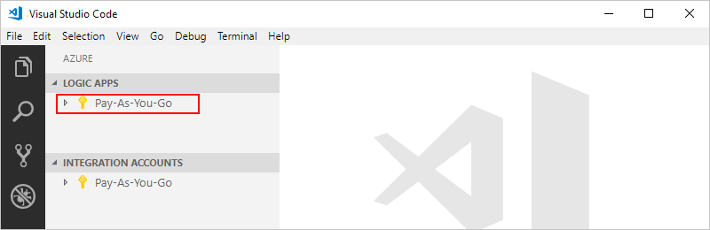](https://github.com/MicrosoftDocs/azure-docs/blob/master/articles/logic-apps/media/create-logic-apps-visual-studio-code/select-azure-subscription.png)

If you don't see the subscriptions you expect, next to **Logic Apps** label, choose **Select Subscriptions** (filter icon). Find and select the subscriptions you want.

1. To view any existing logic apps or integration accounts in your Azure subscription, expand your subscription.

[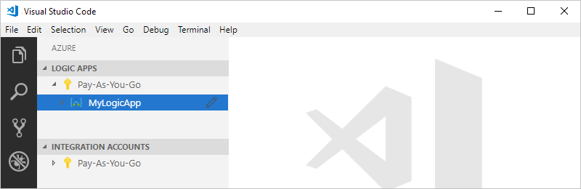](https://github.com/MicrosoftDocs/azure-docs/blob/master/articles/logic-apps/media/create-logic-apps-visual-studio-code/existing-logic-apps.png)

## Create logic app

1. If you haven't signed in to your Azure subscription from inside Visual Studio Code, follow the steps in this article to [sign in now](https://github.com/MicrosoftDocs/azure-docs/blob/master/articles/logic-apps/quickstart-create-logic-apps-visual-studio-code.md#sign-in-azure).
2. From your subscription's context menu, select **Create**.

[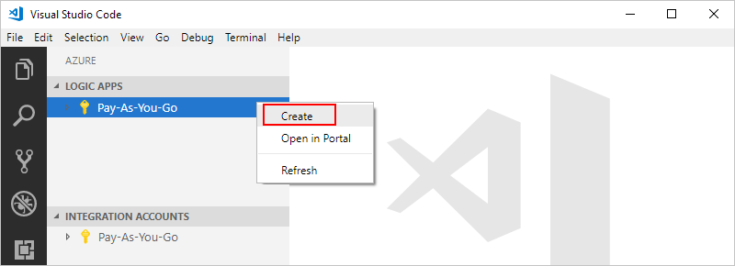](https://github.com/MicrosoftDocs/azure-docs/blob/master/articles/logic-apps/media/create-logic-apps-visual-studio-code/create-logic-app.png)

1. From the list that shows Azure resource groups in your subscription, select an existing resource group or **Create a new resource group**.

This example creates a new resource group:

[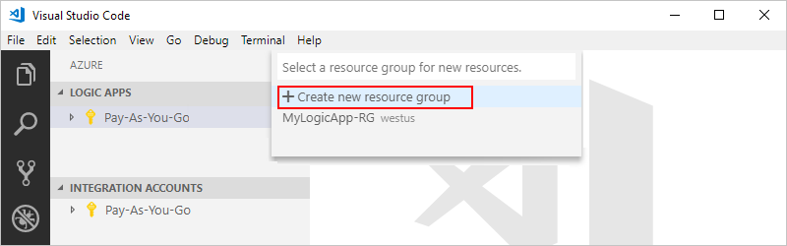](https://github.com/MicrosoftDocs/azure-docs/blob/master/articles/logic-apps/media/create-logic-apps-visual-studio-code/select-or-create-azure-resource-group.png)

1. Provide a name for your Azure resource group, and then press ENTER.

[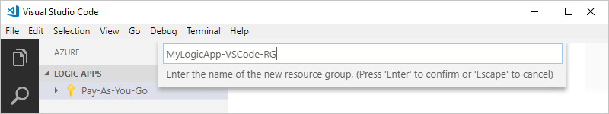](https://github.com/MicrosoftDocs/azure-docs/blob/master/articles/logic-apps/media/create-logic-apps-visual-studio-code/enter-name-resource-group.png)

1. Select the datacenter location for where to save your logic app's metadata.

[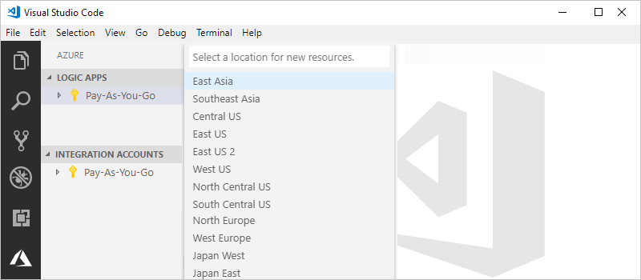](https://github.com/MicrosoftDocs/azure-docs/blob/master/articles/logic-apps/media/create-logic-apps-visual-studio-code/select-location.png)

1. Provide a name for your logic app, and then press ENTER.

[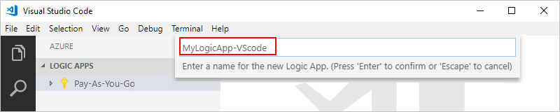](https://github.com/MicrosoftDocs/azure-docs/blob/master/articles/logic-apps/media/create-logic-apps-visual-studio-code/enter-name-logic-app.png)

Your new logic app now appears in the Azure window, under your Azure subscription. Now you can start creating your logic app's workflow definition.

1. From your logic app's shortcut menu, select **Open in Editor**.

[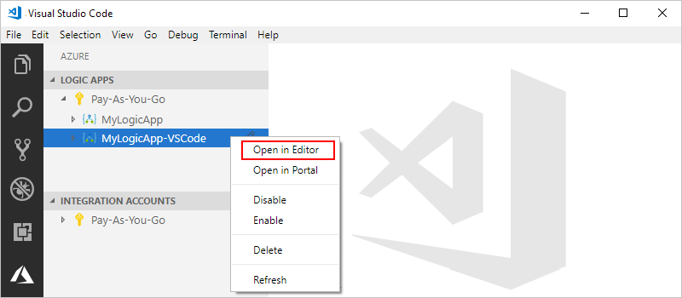](https://github.com/MicrosoftDocs/azure-docs/blob/master/articles/logic-apps/media/create-logic-apps-visual-studio-code/open-new-logic-app.png)

Visual Studio Code opens a logic app workflow definition template (.logicapp.json file) so you can start creating your logic app's workflow.

[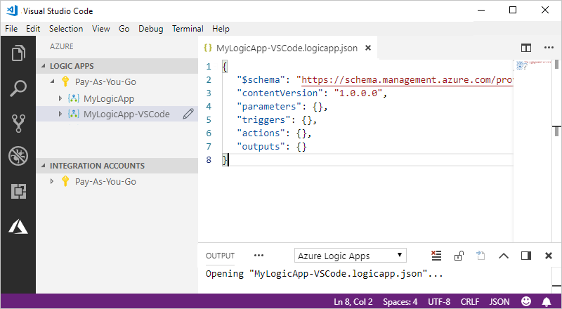](https://github.com/MicrosoftDocs/azure-docs/blob/master/articles/logic-apps/media/create-logic-apps-visual-studio-code/blank-logic-app-workflow-definition.png)

1. In the logic app workflow definition template file, start building your logic app's workflow definition. For technical reference, see the [Workflow Definition Language schema for Azure Logic Apps](https://github.com/MicrosoftDocs/azure-docs/blob/master/articles/logic-apps/logic-apps-workflow-definition-language.md).

Here is an example logic definition. Usually, JSON elements appear alphabetically within each section, but this sample shows these elements roughly in the order that the logic app's steps appear on the designer.

{

"$schema": "https://schema.management.azure.com/providers/Microsoft.Logic/schemas/2016-06-01/workflowdefinition.json#",

"contentVersion": "1.0.0.0",

"parameters": {

"$connections": {

"defaultValue": {},

"type": "Object"

}

},

"triggers": {

"When_a_feed_item_is_published": {

"recurrence": {

"frequency": "Minute",

"interval": 1

},

"splitOn": "@triggerBody()?['value']",

"type": "ApiConnection",

"inputs": {

"host": {

"connection": {

"name": "@parameters('$connections')['rss']['connectionId']"

}

},

"method": "get",

"path": "/OnNewFeed",

"queries": {

"feedUrl": "http://feeds.reuters.com/reuters/topNews"

}

}

}

},

"actions": {

"Send_an_email": {

"runAfter": {},

"type": "ApiConnection",

"inputs": {

"body": {

"Body": "Title: @{triggerBody()?['title']}\n\nDate published: @{triggerBody()?['publishDate']}\n\nLink: @{triggerBody()?['primaryLink']}",

"Subject": "New RSS item: @{triggerBody()?['title']}",

"To": "Sophie.Owen@contoso.com"

},

"host": {

"connection": {

"name": "@parameters('$connections')['outlook']['connectionId']"

}

},

"method": "post",

"path": "/Mail"

}

}

},

"outputs": {}

}

1. When you're done, save your logic app definition file. When Visual Studio Code prompts you to confirm uploading your logic app definition to your Azure subscription, choose **Upload**.

[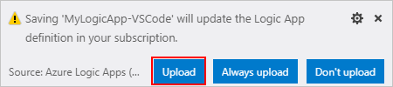](https://github.com/MicrosoftDocs/azure-docs/blob/master/articles/logic-apps/media/create-logic-apps-visual-studio-code/upload-new-logic-app.png)

After Visual Studio Code publishes your logic app to Azure, you can find your app now live and running in the Azure portal.

[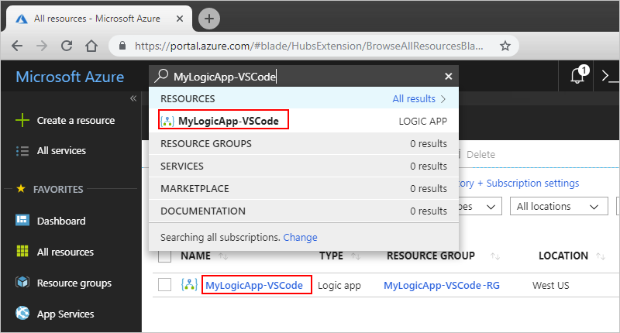](https://github.com/MicrosoftDocs/azure-docs/blob/master/articles/logic-apps/media/create-logic-apps-visual-studio-code/published-logic-app.png)

## Edit logic app

To work on an existing logic app that's already deployed in Azure, you can open that app's workflow definition file in Visual Studio Code.

1. If you haven't signed in to your Azure subscription from inside Visual Studio Code, follow the steps in this article to [sign in now](https://github.com/MicrosoftDocs/azure-docs/blob/master/articles/logic-apps/quickstart-create-logic-apps-visual-studio-code.md#sign-in-azure).
2. In the Azure window, under **Logic Apps**, expand your Azure subscription, and select the logic app you want.
3. From your logic app's menu, select **Open in Editor**. Or, next to your logic app's name, choose the edit icon.

[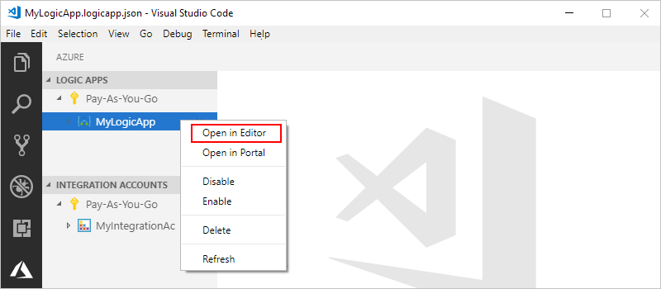](https://github.com/MicrosoftDocs/azure-docs/blob/master/articles/logic-apps/media/create-logic-apps-visual-studio-code/open-editor-existing-logic-app.png)

Visual Studio Code opens the .logicapp.json file for your logic app's workflow definition.

[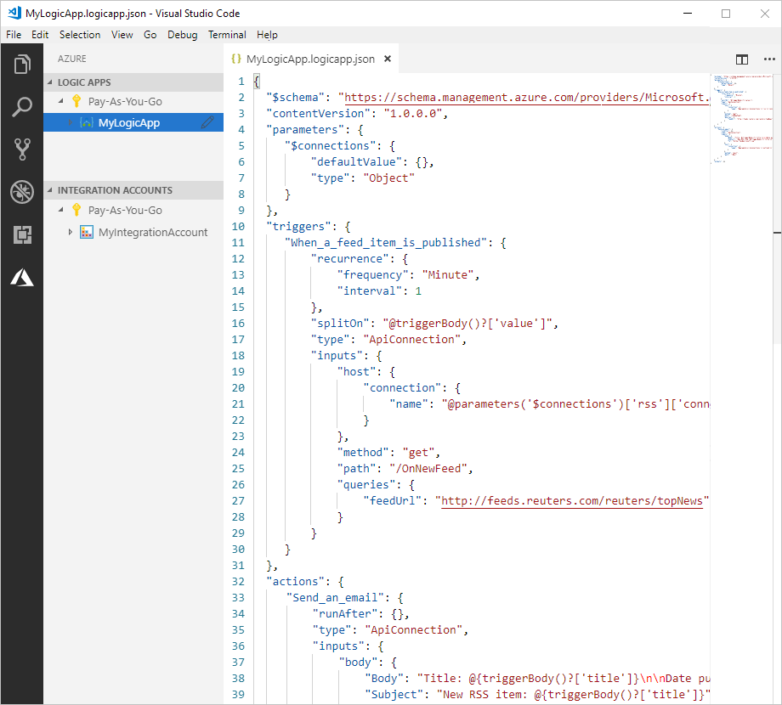](https://github.com/MicrosoftDocs/azure-docs/blob/master/articles/logic-apps/media/create-logic-apps-visual-studio-code/edit-logic-app-workflow-definition-file.png)

1. Make your changes in your logic app's definition.
2. When you're done, save your changes.
3. When Visual Studio Code prompts you to update your logic app definition in your Azure subscription, choose **Upload**.

[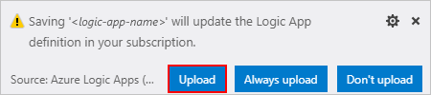](https://github.com/MicrosoftDocs/azure-docs/blob/master/articles/logic-apps/media/create-logic-apps-visual-studio-code/upload-logic-app-changes.png)