Originally from https://docs.microsoft.com/en-us/azure/logic-apps/logic-apps-monitor-your-logic-apps.

You will need to have a functional Logic app that is up and enabled. The more complex, the better.

## View runs and trigger history for your logic app

1. To find your logic app in the [Azure portal](https://portal.azure.com/), on the main Azure menu, choose **All services**. In the search box, type "logic apps", and choose **Logic apps**.

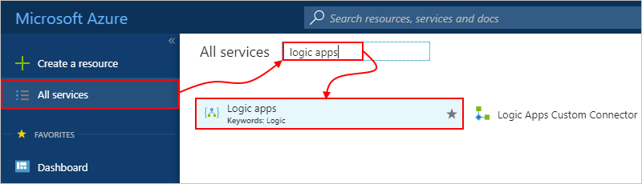

The Azure portal shows all the logic apps that are associated with your Azure subscription.

1. Select your logic app, then choose **Overview**.

The Azure portal shows the runs history and trigger history for your logic app. For example:

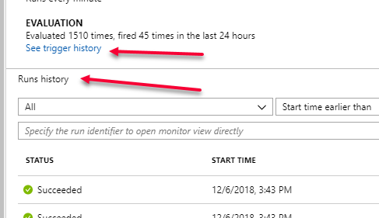

* + **Runs history** shows all the runs for your logic app.
  + **Trigger History** shows all the trigger activity for your logic app.

1. Click on one of the items in the **Run history** chart. From here you can show what steps the workflow took and then click on each individual action to see inputs and outputs.
2. In the Logic app run blade, click on **Run Details** to get deeper details on the execute of the logic app. You can also click on the **Show raw outputs** link on each input and output.
3. Go back to the logic apps Overview blade and click on the **See trigger history** link.
4. Click on one of the items in the trigger list and look at the history tab over on the right. Click on **Inputs Link** and **Outputs Link**.

## Turn on diagnostics logging for your logic app

For richer debugging with runtime details and events, you can set up diagnostics logging with [Azure Log Analytics](https://github.com/MicrosoftDocs/azure-docs/blob/master/articles/log-analytics/log-analytics-overview.md). Log Analytics is a service in Azure that monitors your cloud and on-premises environments to help you maintain their availability and performance.

Before you start, you need to have a Log Analytics workspace. Learn [how to create a Log Analytics workspace](https://github.com/MicrosoftDocs/azure-docs/blob/master/articles/azure-monitor/learn/quick-create-workspace.md).

1. In the [Azure portal](https://portal.azure.com/), find and select your logic app.
2. On the logic app blade menu, under **Monitoring**, choose **Diagnostic Settings**.

[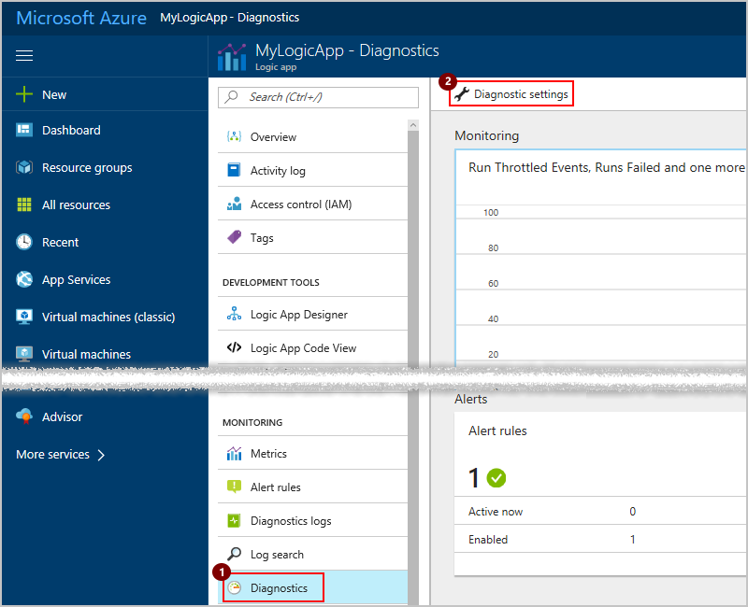](https://github.com/MicrosoftDocs/azure-docs/blob/master/articles/logic-apps/media/logic-apps-monitor-your-logic-apps/logic-app-diagnostics.png)

1. Under **Diagnostics settings**, choose **Turn on diagnostics**.

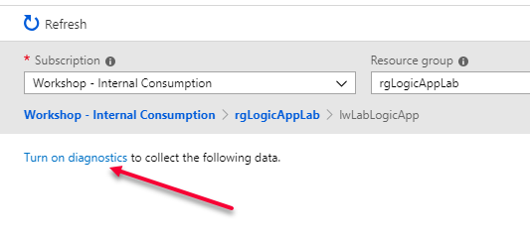

1. Now select the Log Analytics workspace and event category for logging as shown:
   1. Select **Send to Log Analytics**.
   2. Under **Log Analytics**, choose **Configure**.
   3. Under **OMS workspaces**, select the workspace to use for logging.

[!NOTE] OMS workspaces are now referred to as Log Analytics workspaces.

* 1. Under **Log**, select the **WorkflowRuntime** category.
  2. Choose the metric interval.
  3. Give your diagnostic setting a name.
  4. When you're done, choose **Save**.

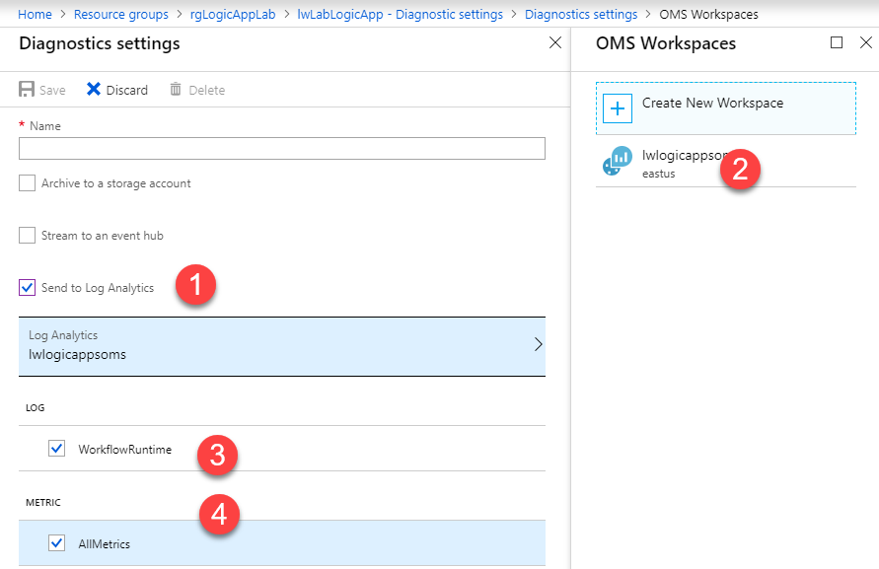

Now, you can find events and other data for trigger events, run events, and action events.

## Find events and data for your logic app

To find and view events in your logic app, like trigger events, run events, and action events, follow these steps.

1. In the [Azure portal](https://portal.azure.com/), choose **All Services**. Search for "log analytics", then choose **Log Analytics** as shown here:

[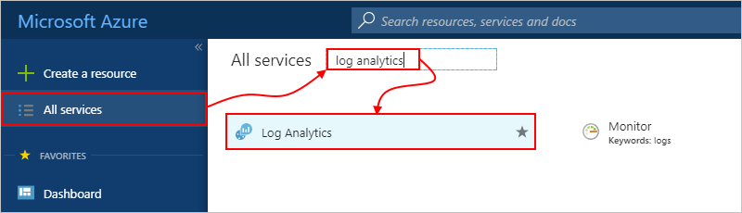](https://github.com/MicrosoftDocs/azure-docs/blob/master/articles/logic-apps/media/logic-apps-monitor-your-logic-apps/browseloganalytics.png)

1. Under **Log Analytics**, find and select your Log Analytics workspace.

[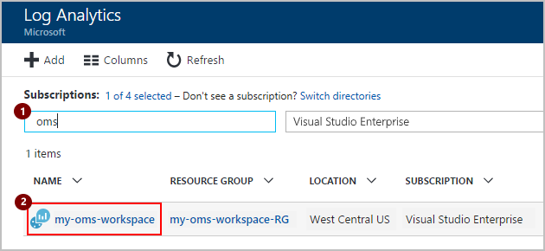](https://github.com/MicrosoftDocs/azure-docs/blob/master/articles/logic-apps/media/logic-apps-monitor-your-logic-apps/selectla.png)

1. Under **General**, choose **Logs**.

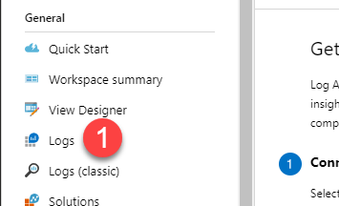

1. In the search box, specify a field that you want to find, and press **Enter**. When you start typing, you see possible matches and operations that you can use.

For example, to find the top 10 events that happened, enter and select this search query: **search Category == "WorkflowRuntime" | limit 10**

[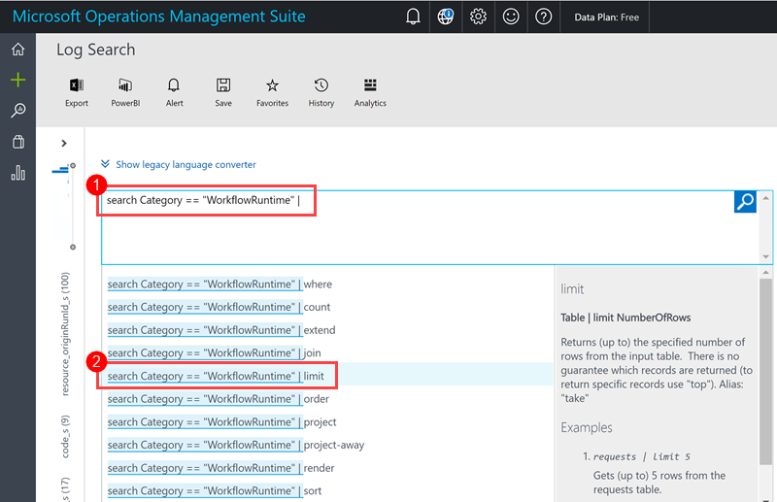](https://github.com/MicrosoftDocs/azure-docs/blob/master/articles/logic-apps/media/logic-apps-monitor-your-logic-apps/oms-start-query.png)

Learn more about [how to find data in Log Analytics](https://github.com/MicrosoftDocs/azure-docs/blob/master/articles/log-analytics/log-analytics-log-searches.md).

1. Write an additional query:

search Category == “WorkflowRuntime” | where (status_s == “Running”)

1. To save your query for future use, choose **Save**. Learn [how to save your query](https://github.com/MicrosoftDocs/azure-docs/blob/master/articles/logic-apps/logic-apps-track-b2b-messages-omsportal-query-filter-control-number.md#save-oms-query).