**Recon Scribbler­­**

By: Da Wei, InSoo Choo, Jimmy YoungJin Kim,

Kevin Carruthers, Shida Li and Yi Fei Chen

SE 101

Dr. Edgar Mateos Santillan

October 5th 2012

**Table of Contents**

|  |  |
| --- | --- |
| Abstract | 3 |
| Introduction | 4 |
| Background | 5 |
| Description | 6 |
| Project Scheduling | 7 |
| Bibliography | 7 |

**Abstract**

There are many reasons why an area may need to be mapped out; however, that area may not always be accessible to humans. As such, we intend to aid in this endeavor by programming a robot in such a way that it will navigate itself through an area, avoiding any obstacles as necessary, and create a map. This map will be created through the aid of the robot's sensors, which will be able to capture the physical location of any objects. This map will be output to a computer terminal, so that any human observers which could not enter the area will have data about the area's size, shape, contents, and general configuration. In addition, the robot will be able to take a picture of an area from each of its corners, again to be sent to the computer terminal, in such a way that a representation of the contents of the area from each angle can be captured. This should allow any area which is inaccessible to humans to be represented digitally in such a way that the humans will be able to collect all pertinent physical data about the area.

**Introduction**

Information technology (IT) is one of the central factors that shapes and defines the modern world. Its utility, which ranges from performing complex calculation used in various fields of study to minor functions in our daily lives, has revolutionized our way of living. Among the numerous components of IT, software developing is one that is particularly important, since hardware are all but useful without a complete software implementation that is able to utilize the former’s full potential.

With this project, we attempt to let the Scribbler, a multifunction robot, take on the role of an unmanned recon robot. This kind of robot, in real life, is extremely useful for exploring an environment exposed to harmful chemicals or extreme conditions such as intense heat. Through the integration of our creativity, programming skills, and engineering principles, we will combine many of the Scribbler’s functions such as its IR sensors, camera, movement ability, picture processing, and sound to create a comprehensive system that will be able to explore an area unguided, and return relevant information to the user in the form of maps and photos.

**Background**

One of our group's members has had an experience on 2D mapping from a game called Minecraft. This will help us transfer the data obtained by the robot to a 2D map. However, the difference would be that in our approach, we are taking 3D inputs and transcribing them onto a 2D map. Also, we will face the additional uncertainty involved in a real world setting. Thus, we expect experimental errors and many unexpected issues during the process of this project.

**Description**

The robot will be designed to explore an open area, using an obstacle avoiding algorithm; it will record obstacles and walls of the entire room. The algorithm will divide the room into squares of the same size as the robot and fill in the data it collects (a square can be empty space, walls, or obstacles). The robot will take advantage of the infrared sensors to avoid walls and obstacles on the way, and will beep whenever it encounters obstacles as an indicator for the user. The robot will also use its internal mini camera to capture images of each room from all corners of the room and save the image into memory. After collecting all the data required, the program will build an image representation of the floor plan of the area, indicating where walls and obstacles are. The map will also include locations where it took photos so that the users will know where the pictures of the rooms (taken by the mini camera) are located. The robot will also use it camera to take images at critical points to provide additional information. Critical points will be defined by the parameter of our program. For example it can record all places where bright light sources are located using the brightness sensors. It will then take a picture of the critical location and mark it distinctly on the map. The end result will be a robot capable of navigating through a complex floor and creating a floor map of the area containing critical information such as corners, obstacles and critical locations containing very bright light, such as a fire. The map will also contain images that can be shown on the computer screen on demand.

**Project Scheduling**

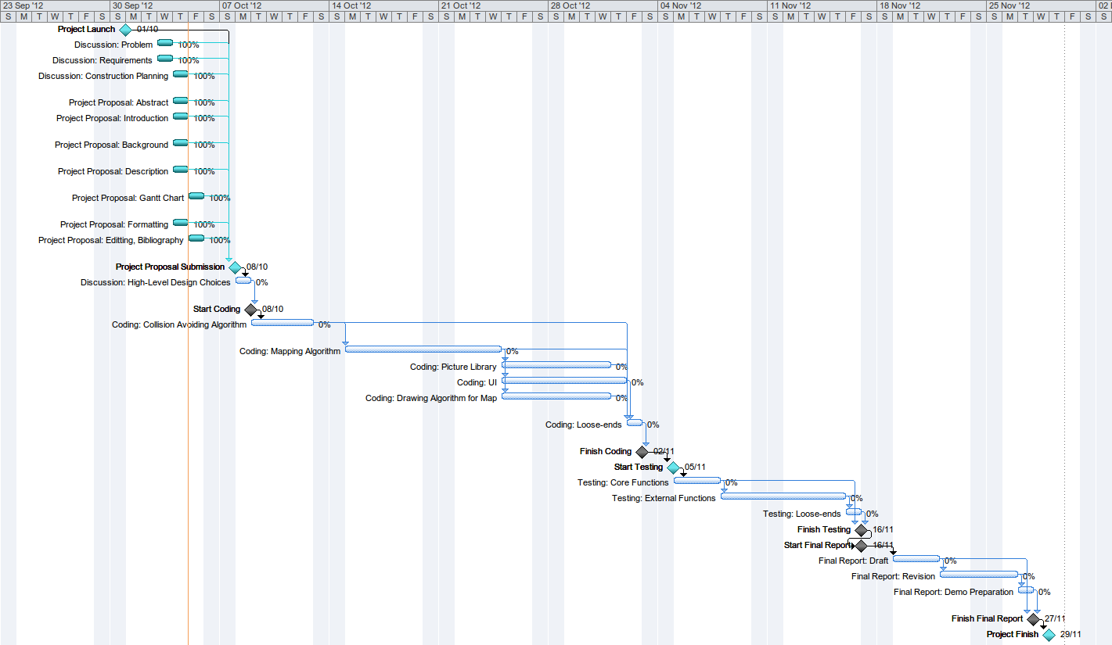

**Note:** This is a thumbnail. See included PNG file for full-sized Gantt Chart.

**Bibliography**

Andrews, Gordon C., et al. *Introduction to Professional Engineering in Canada*, 3rd edition. Toronto: Pearson, 2009. Print.

Northey, Margot, and Judi Jewinski. *Making Sense in Engineering and the Technical Sciences: A Student's Guide to Research and Writing*, 4th edition. London: Oxford University Press, 2012. Print.