AI^2 readme

- All the data on the external drive in the corresponding folder
- The tools for data preprocessing, model training, model evaluation and annotation in the Scripts subfolder, current scripts subsubfolder of AI2 folder.
- Description of the model and calculations

Model architecture (UNet-based, with intermediate outputs as modifications)
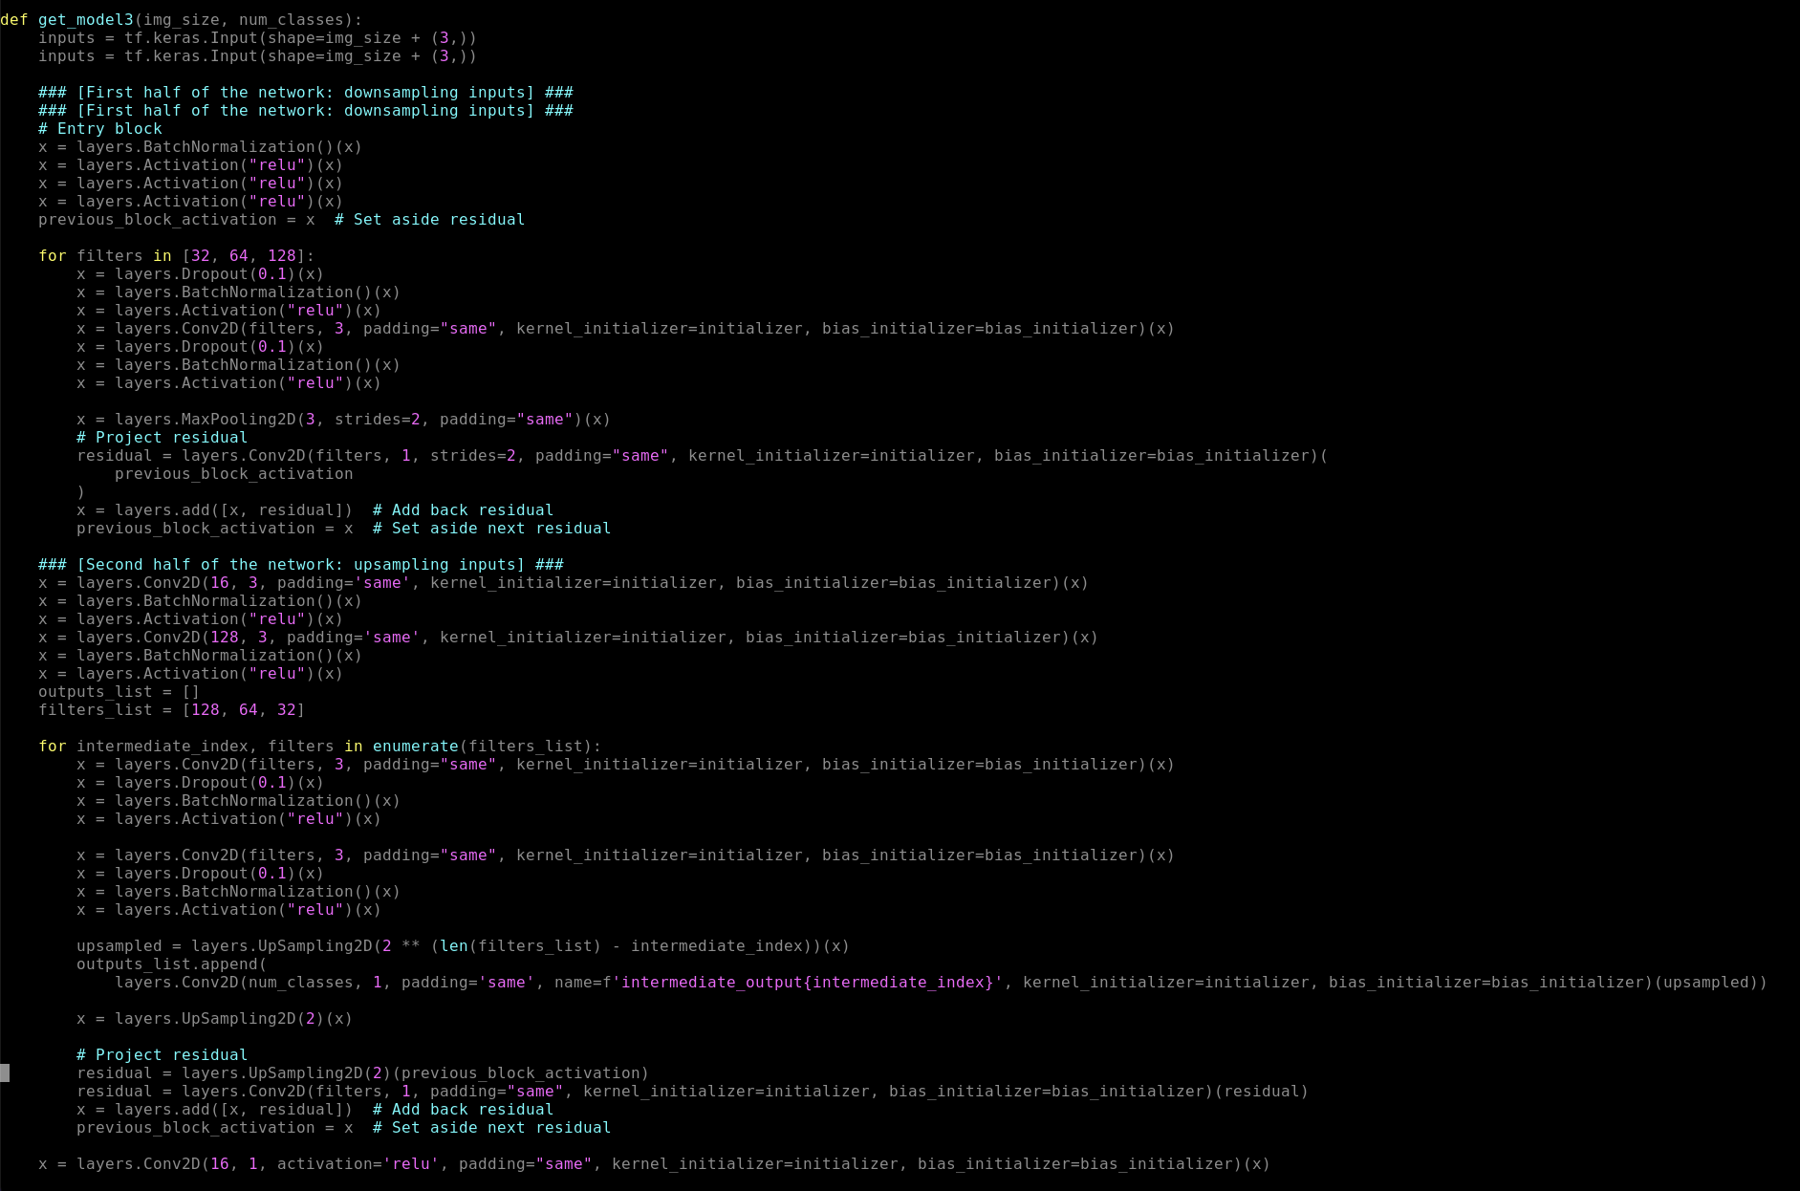
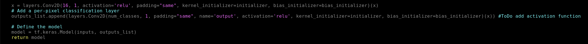
Building and compiling the model
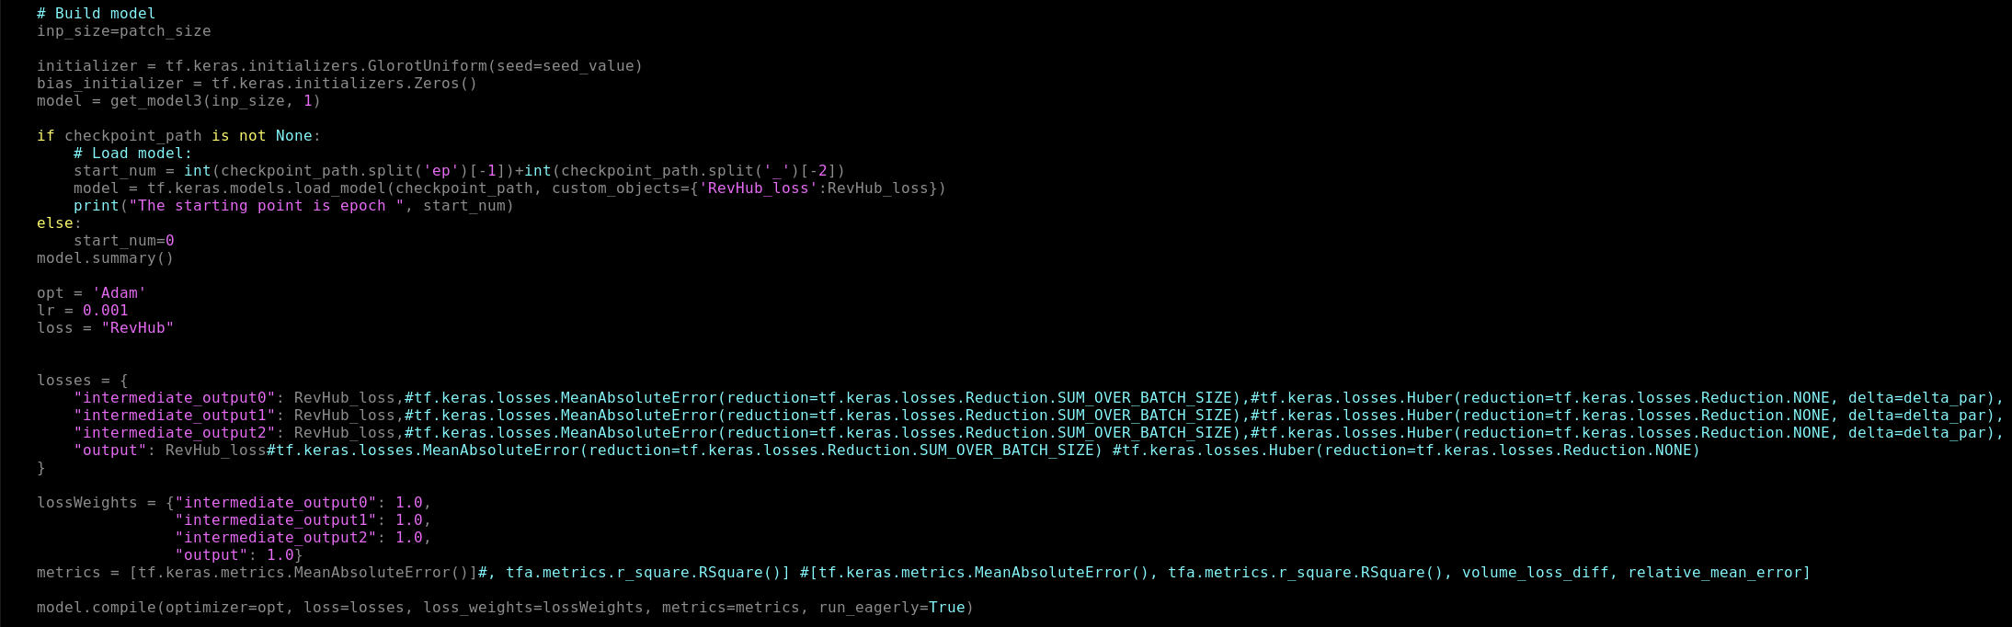

Loss function
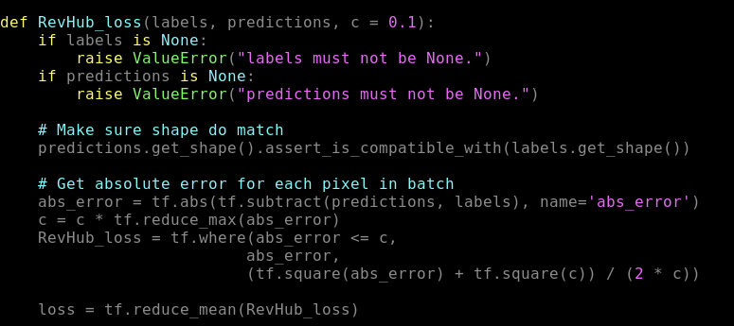
Preprocessing of data
- Create circular mask around well (region of interest)
- 0-1 normalization of input values
- The ground truth output clipped to min of -0.05
Additional training
A set of outliers has been selected from the train set of the original training, and the model trained for 21 more epoch on that data.
Calculating volume loss
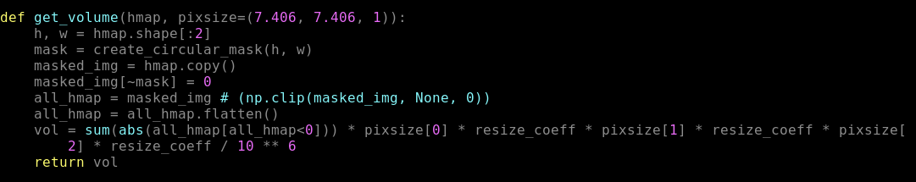

Calculating symmetrical Inhibition Efficiency
The desired output of the pipeline, aside from heatmap, is the symmetrical inhibition efficiency.
It is calculated using the formula:

(Weight_loss_NaCl-weight_loss_material)/weight_loss_NaCl, if weight loss of NaCl is greater than material weight loss
(Weight_loss_NaCl-weight_loss_material)/weight_loss_material, if weight loss of material is greater than weight loss of NaCl

In the first case, the material is an inhibitor.

Pipeline

Input – profilometer optical image before cleaning
Output – heatmap (based on heatmap after cleaning), based on which we calculate volume loss, weight loss and symmetrical inhibition efficiency.

The train, test and validation are 60%, 20% and 20%, with 232 compounds and around 1000 images evaluated.

The model is trained on 256*256 patches of the given images.

The resulting heatmap is clipped (same as input) to -0.05
Results

Inhibition efficiency correlation

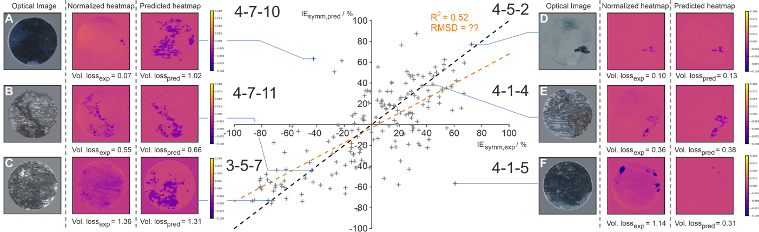
Predictions on new dataset (with no provided ground truth)

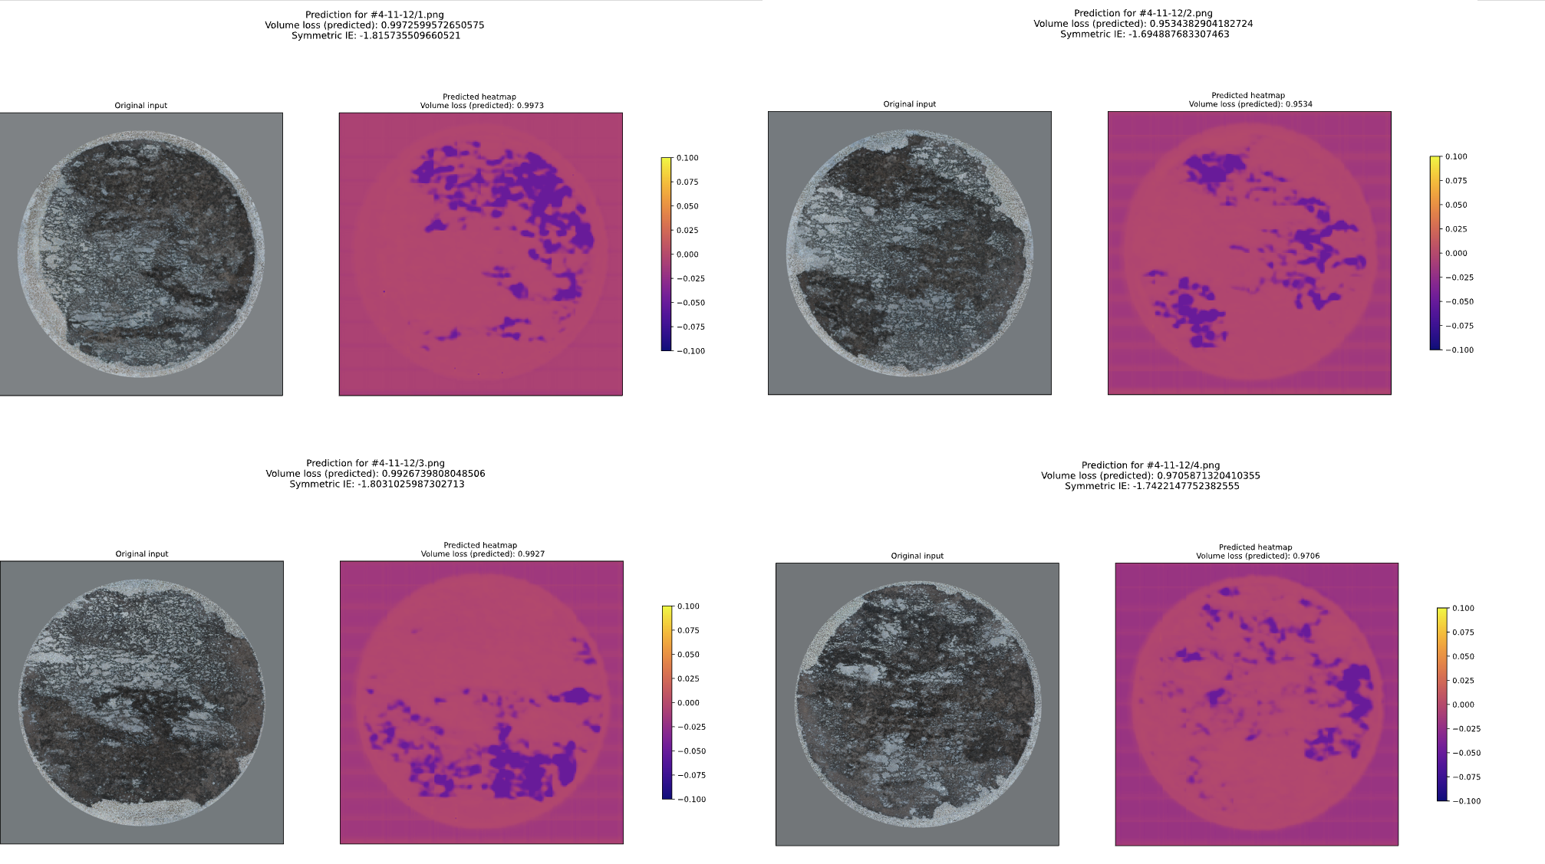

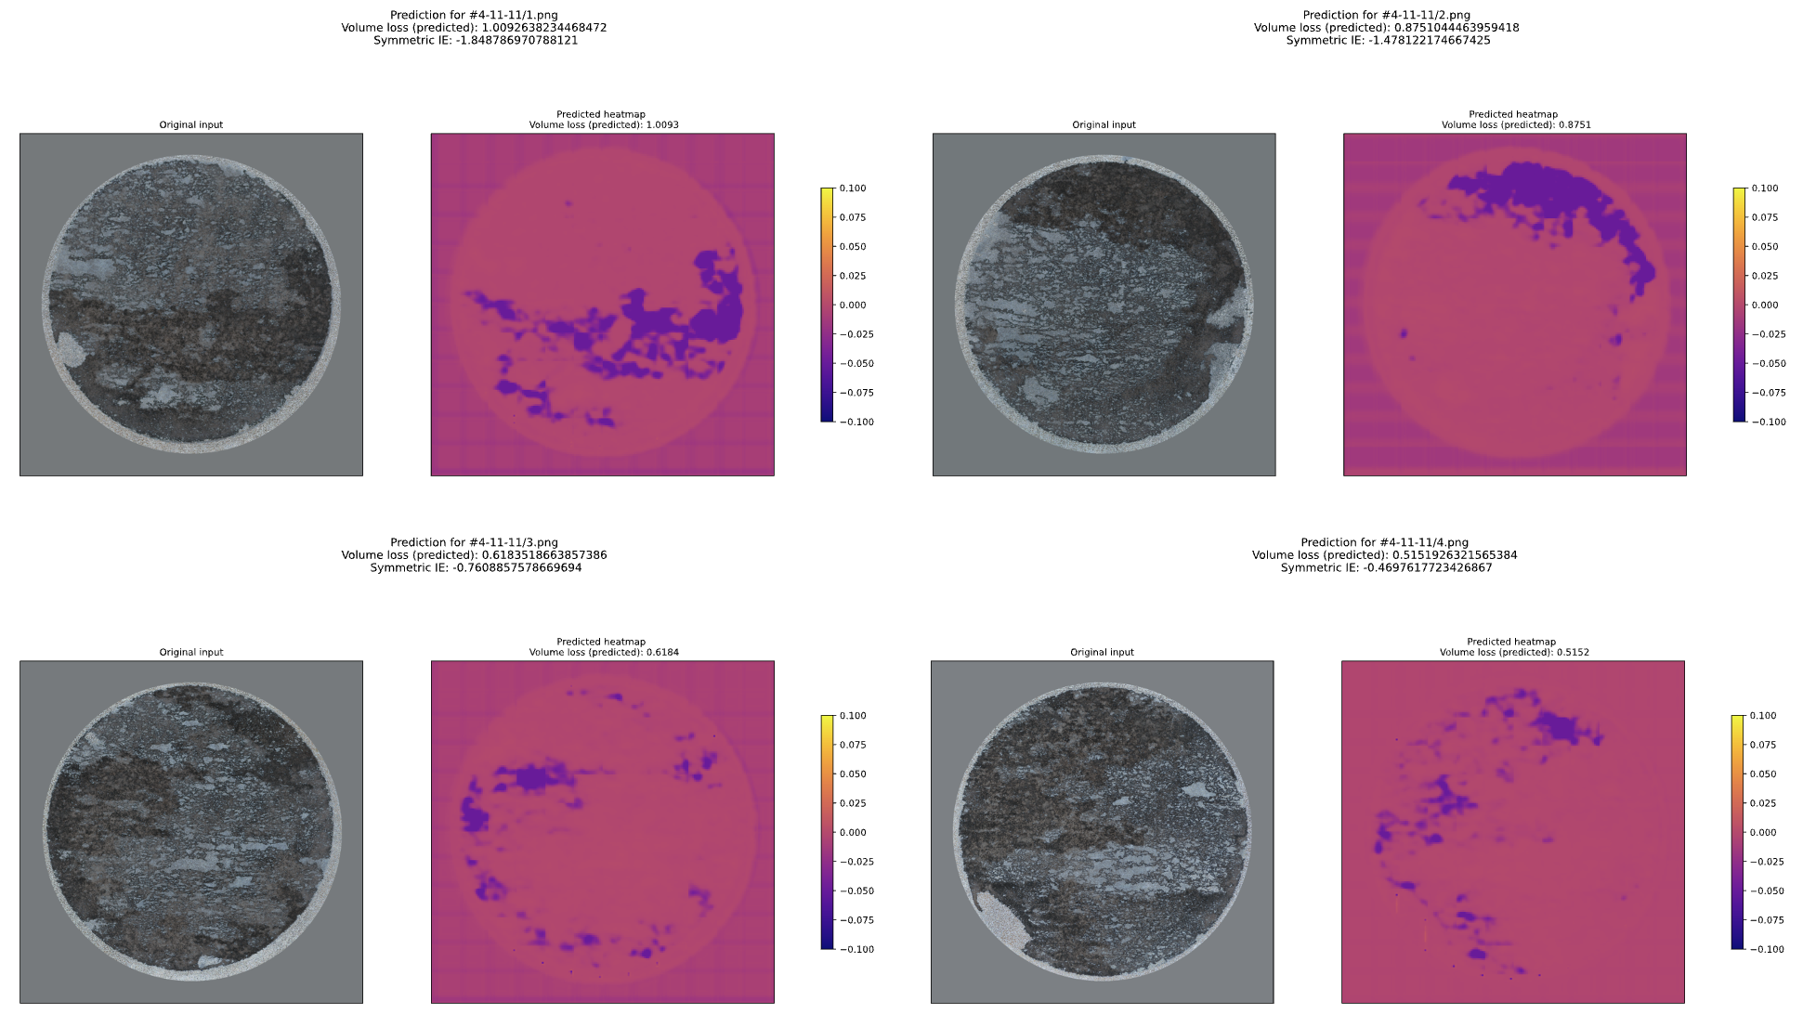
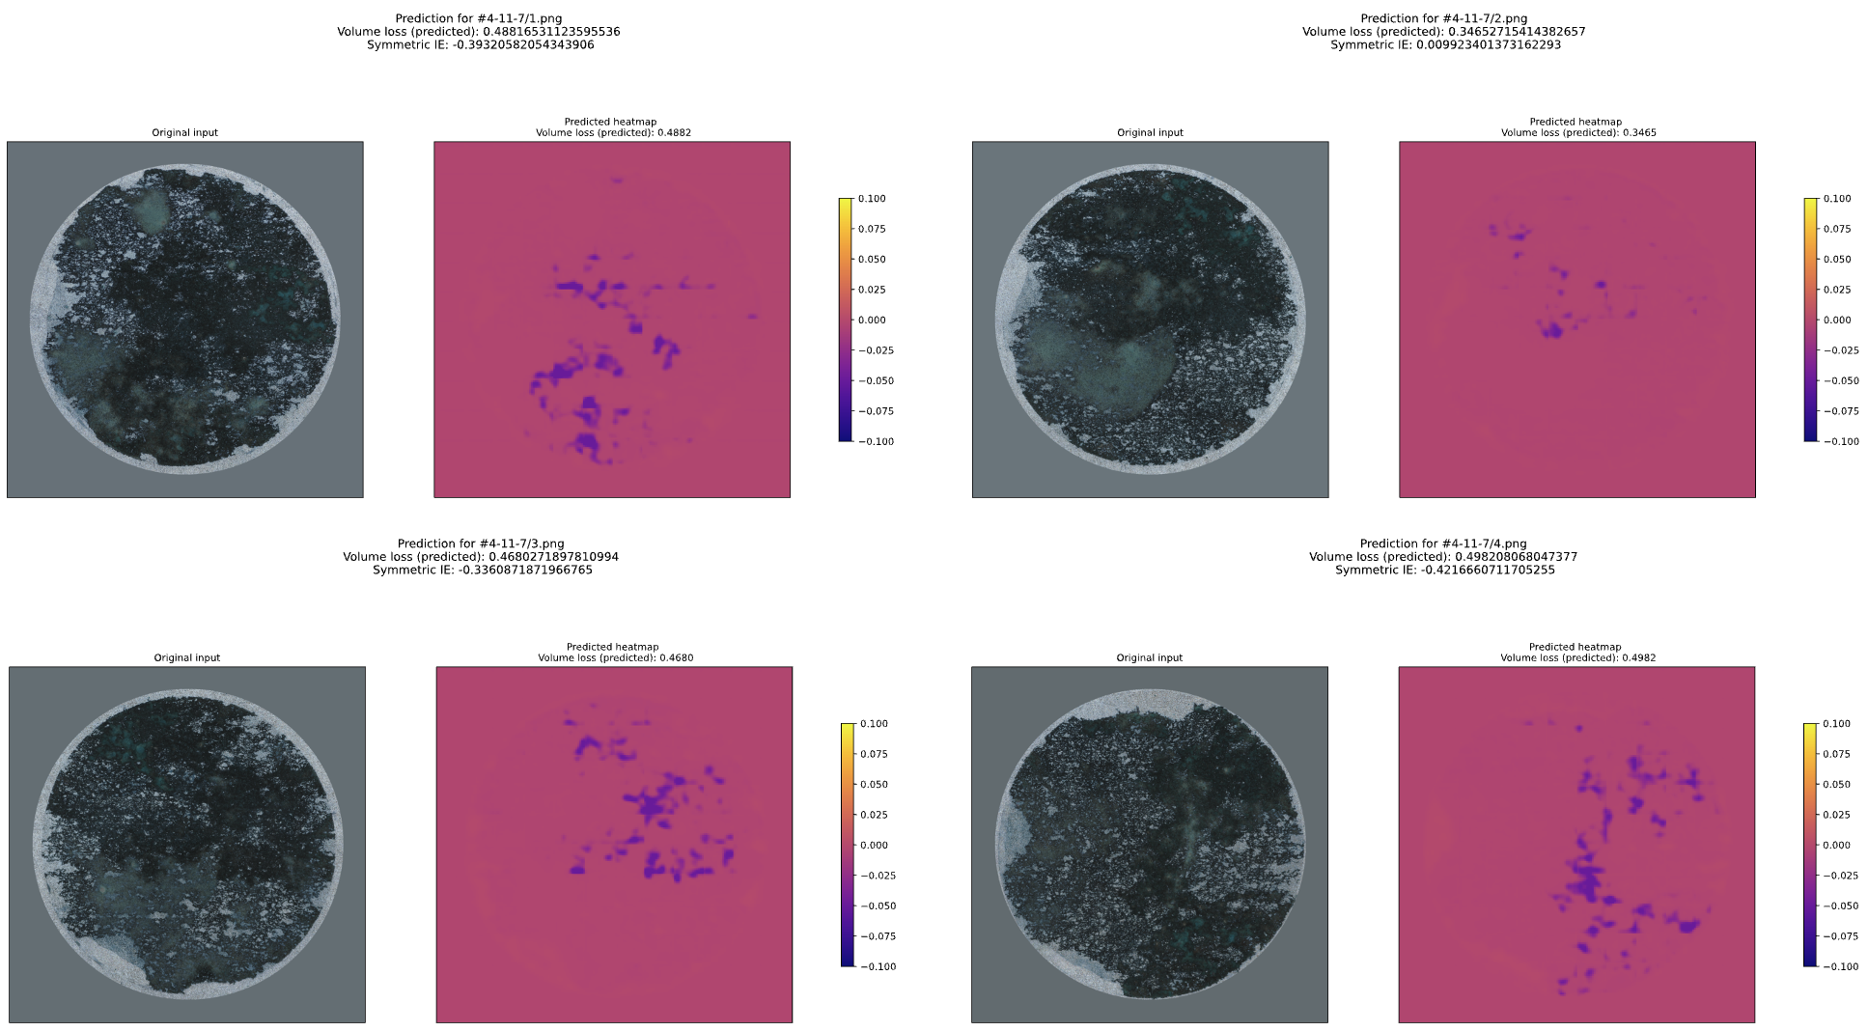

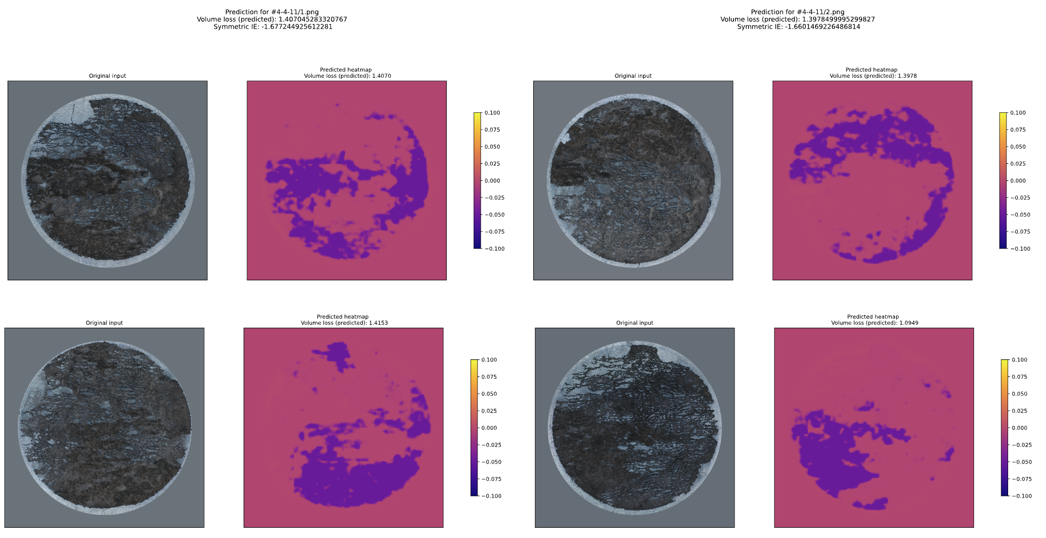

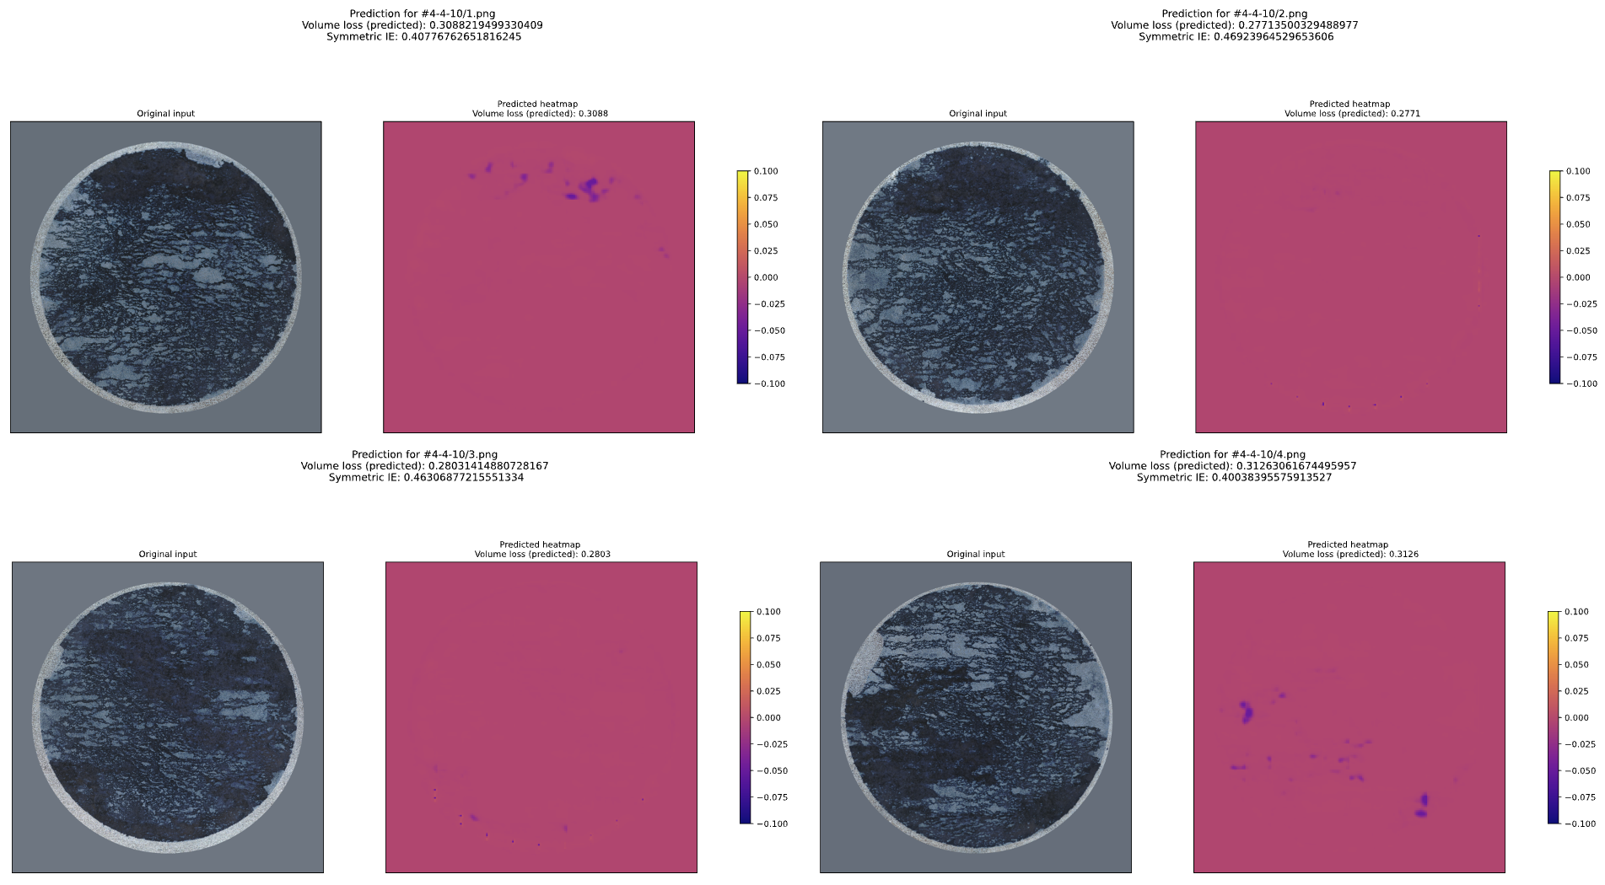

The results seem promising, although some (with the very dark input images) seem to lead to very low corrosion predictions.

