Data Communication

Lars Rikard Rådstoga | 223786

2022-01-18

# Introduction

This report…

Screenshot in Figure 1‑1 shows a seemingly deterministic program which assigned the task “Describe communication directions”. The program scanned my computer for information and took my student information as input to generate the task. Repeated tests of the program with the same inputs resulted in the same task. Thus, the program is inductively postulated to be deterministic.

Figure 1‑1: Student and computer information

# System information

# Network information

asdf

## Describe communication directions

Asdf

## Number of network devices

asdf

## Physical address

asdf

## Logical address

Asdf

## Why TCP/IP

asdf

## Other network protocols?

Asdf

## IPv6

# Network testing

# Conclusion

# Material and Methods

The main purpose of the 'Materials and Methods' section is to provide enough detail for a competent worker to repeat your study and reproduce the results. The scientific method requires that your results be reproducible, and you must provide a basis for repetition of the study by others. You may call the chapter 'Implementation' in a typical software project.

For larger reports, you typically start a new chapter on a new page (use Layout->Breaks->Section Breaks->Next Page). For smaller reports this chapter may be omitted and probably combined with the “Results” chapter.

Equipment and materials available off the shelf should be described.

In Figure 2‑1 we see the control system developed in this project.

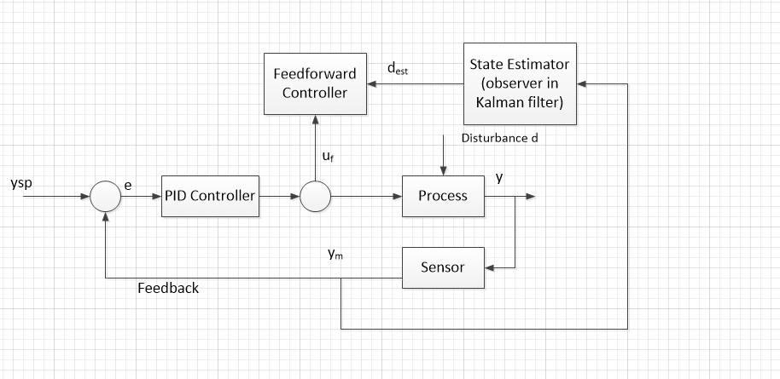

Figure 2‑1: Control System

From eq. (2.1) we see that there is a linear relationship between the input and the output.

|  |  |
| --- | --- |
| $$y=ax+b$$ | (2.1) |

Make sure to enter equations properly. See how it is done in different textbooks, etc.

## Technical Details

Typically, the equations are centered like shown in eq. (2.1). In addition, you need an equation number as shown in eq. (2.1). This number is typically aligned to the right as shown in eq. (2.1). In order to achieve that you can use a table with 3 columns and hidden borders as shown.

Typically, you don’t use multiplication sign “*” in equations. You don’t use that when typing equations with pen and paper, so you don’t need to use it in a report either.

### Code Structure

Hundreds of code lines in the report makes no sense. You may include small code snippets in your main report or screen-shots of the most important parts of your program. The rest of the code could be in an appendix if it’s not too much. 50-100 pages with code listing makes no sense in the report or in appendix.

Typically, you should not use more than 3 levels in your report structure. In this example we have level 1 “2 Material and Methods”, level 2 “2.1 Technical Details” and level 3 “2.1.1 Code Structure”. If you feel you need a 4. level, your report structure is wrong, then you need to restructure your report and probably create more chapters.

A better way is to attach it in electronic form in some way, e.g. a link to a web site where you can download it.

You should also plan and document your code using flow charts (see example in Figure 2‑2), etc.

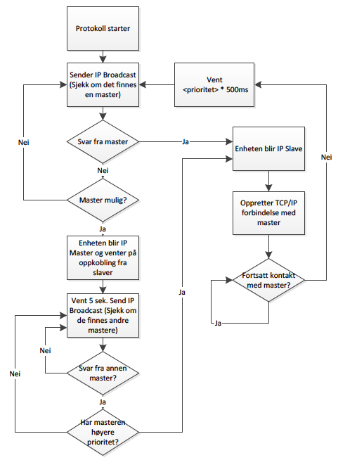

Figure 2‑2: Flow Chart

You may also include other kind of sketches if you think that is relevant in order to explain your work. Use a proper tool like e.g., MS Visio or similar.

In Figure 2‑3 we see an example of a Use Case diagram. The Use Case diagram shows the main features of the system.

4.15 UseCases.eps

Figure 2‑3: Use Case Diagram

Below we see the C# code for the PID controller:

bool myTest;

myTest=false;

if (myTest == false)

{

MessageBox.Show("Hello1");

MessageBox.Show("Hello2");

}

From the code, we see that the PID controller is implemented in C# using an if structure.

# Results

In the results section, you present your findings: display items (figures and tables) are central in this section.

For larger reports, you typically start a new chapter on a new page (use Layout->Breaks->Section Breaks->Next Page).

In Table 3.1 the results are summarized. We see that the data match the real system based on the logged data.

Table 3.1: Weekly Data

|  |  |  |  |  |  |  |
| --- | --- | --- | --- | --- | --- | --- |
| **M** | **T** | **W** | **T** | **F** | **S** | **S** |
| 1 | 2 | 3 | 4 | 5 | 6 | 7 |
| 8 | 9 | 10 | 11 | 12 | 13 | 14 |
| 15 | 16 | 17 | 18 | 19 | 20 | 21 |
| 66 | 56 | 12 | 34 | 12 | 23 | 18 |
| 12 | 21 | 34 | 54 | 12 | 33 | 43 |

**Note that table numbering should be above the table!**

# Discussions

One of the most important things in your report is to analyze and discuss your results in detail. For larger reports, each chapter should be on a separate page.

For larger reports, you typically start a new chapter on a new page (use Layout->Breaks->Section Breaks->Next Page).

For small reports, you may put this chapter inside either Results or Conclusions/Summary.

# Conclusion

A Conclusion is always needed in a technical report or article. Here you shall summarize your results and draw conclusions, not write how much you have learned, etc.

For larger reports, you typically start a new chapter on a new page (use Layout->Breaks->Section Breaks->Next Page).

Bad “Conclusion” examples:

* “I have learned much doing this assignment”
* “This was very useful, and I will need this when I get a job”
* “From this Lab, we understand the Kalman Filter much more and how to implement it in LabVIEW which also make us much better to use LabVIEW. We also learned how to design a feedforward controller to combine with a traditional PID controller and by comparison, we have better understanding that the usage of Kalman Filter and feedforward controller.”

You should focus on your results, not just list up what you have done or how much you have learned by doing this, etc. It is nice that you have learned a lot, but this is not relevant!!

Does the program work as expected? Why/Why Not? Any improvements that needs to be made with your program, etc.

# References

For larger reports, you typically start a new chapter on a new page (use Layout->Breaks->Section Breaks->Next Page).

The **IEEE** referencing style is typically used in engineering and in ICT studies.

**IEEE** referencing style:

The references are numbered in the order they appear in the text and are enclosed in square brackets, e.g. [1] and [2].  If you need to cite one particular page or more pages, it should be done like this: [1, p. 34] or [2, pp. 5-6]. A reference list is placed at the end of the text containing full details of the sources.  The references appear in numerical order using the same numbers as in the text.

Example of Book with one author (note that this yellow text should not be in the report):

[1] J. Keats, Virtual words: language on the edge of science and technology. Oxford: Oxford University Press, 2011.

Example of Book with three or more authors:

[2] M. Fasting, et al., Den norske velferden. Oslo: Civita, 2011.

Web Site Example:

[3] D. Robert, (2017, 12. 07). How do I write a scientific paper? [Website]. Available: <http://www.scidev.net/global/publishing/practical-guide/how-do-i-write-a-scientific-paper-.html>

Master or PhD thesis Example:

[4] L. H. Daland, "Livskraften ebber ut: en undersøkelse av befolkningsendringen i utvalgte uthavnssamfunn mellom Lindesnes og Lista 1900-1970." Master Thesis, Kristiansand: University of Agder, 2010

E-book Example:

[5] C. Stansell. (2010). The feminist promise: 1792 to the present [E-book]. Available: http://site.ebrary.com/lib/agder/docDetail.action?docID=10386235

Remember to refer to all your references in the reference list in your text, and in the same order as they appear in the list.

A good source is for learning more about referencing and IEEE is: <http://kildekompasset.no/references/ieee.aspx>

# Appendices

Appendices contain information in greater detail than can be presented in the main body of the paper.

If you have multiple Appendices, you use Numbering, “Appendix 1 Project Plan”, “Appendix 2 Data Sheet”, etc.

Typically, you start a new appendix on a new page (use Layout->Breaks->Section Breaks->Next Page).

For smaller reports “Appendices” may be omitted.