**Intro to Java Assignment 6**

**Nested Loop and Nested If/Else – Data Entered from a file and print to console and to an output file [50 points]**

**Carbon Footprint**

Assume it is year 2050. The gas price has risen to $25.00 per gallon. Federal government wishes to reduce consumption of gas to keep gas prices low as well as to reduce the carbon footprint to head off global warming. Carbon footprint is measured as metric tons of carbon dioxide released in air per person per year. Federal government has issued following guidelines for fines on US cities if they exceed various levels of carbon footprint in their metropolitan area. The table below gives the average carbon footprint per month for a city and fines that will be imposed if footprint lies in corresponding range.

|  |  |
| --- | --- |
| Average Carbon footprint (Whole number thresholds) | Fine in $ per year |
| <= 1 | 0.0 |
| >1 but <= 3 | 1000000.0 |
| >3 but <= 5 | 2000000.0 |
| >5 but <= 7 | 3000000.0 |
| > 7 | 4500000.0 |

The file CarbonFP.txt provides carbon footprint data for selected US cities. Your task is to read the file in a Java program and get the average carbon footprint for each city and compute the fine they have to pay. As per above table the fine can be zero or maximum 45 million dollars. Data file has carbon footprint record for various cities. One record from file is described below.

One word city name

Sentinel value. (Impossible value for carbon foot print).

Amarrilo 3 2 1 3 5 -7

Carbon foot print value for various months.

Each record in the file contains one word city name. (If city name contains more than one word then they are joined by an underscore. For example, San Francisco is written as San_Francisco). The purpose of program is to read the data file and print to console, each city’s name, and their average carbon foot print and fine they may have incurred. (If the fine is zero then fine printed is 0.0). If there is no data for a city then program prints, that there are no data available for this city, thus fine cannot be computed. Program also prints the number of cities in the file and total fine collected.

**Problem Analysis and Approach**

This programming assignment is similar to the student scores stored in the file averaging example we covered in the class. It would require nested loops. Outer loop is an EOF (end of file controlled) loop which uses hasNext method of Scanner class. This loop terminates when EOF character at the end of file has been read. The task of inner loop is to sum up all carbon foot print values and also count how many values are there. Sum and number of values are later used to find average carbon foot print. This inner loop is a sentinel controlled loop that terminates when the last negative value for each record is read.

**Sample Run #1(Both Input file and output file are successfully opened)**

**Below shows the console output.**

Welcome to Rose state Software Engineering Lab.

We will calculate average carbon footprints for cities and corresponding fines.

Please be ready to provide the data file name for carbon FP for US cities.

Program will crash if wrong filename is given.

In that case please run program again ascertaining correct file name.

Please enter the full path of input data file name. [Relative path needed on UNIX]:

C:\_CoursesTaught\Java\CIT1613IntrotoJavaSpring2011\Assignments\IntroJavaAssignmentWorkSpace\Assignment5Spring2011\CarbonFP.txt

Please provide full path to output file. [Relative path needed on UNIX]:

CAUTION: If output file exists all data in it will be deleted!

Program will crash if wrong filename is given.

In that case please run program again ascertaining correct file name.

C:\_CoursesTaught\Java\CIT1613IntrotoJavaSpring2011\Assignments\IntroJavaAssignmentWorkSpace\Assignment5Spring2011\out.txt

*****************************************************************************

*****************************************************************************

Data for city of: Amarillo

Carbon footprint values are: 3 2 1 3 5

Total carbon foot print values are: 5

Sum of all carbon footprint values = 14.0

The real average of carbon footprint values is = 2.80

Rounded Carbon footprint = 3

Fine for Amarillo is $1000000.0

*****************************************************************************

Data for city of: Rochester

Carbon footprint values are: 5 6 7 4 6

Total carbon foot print values are: 5

Sum of all carbon footprint values = 28.0

The real average of carbon footprint values is = 5.60

Rounded Carbon footprint = 6

Fine for Rochester is $3000000.0

*****************************************************************************

Data for city of: Albuquerque

Carbon footprint values are: 3 4 5 2 3

Total carbon foot print values are: 5

Sum of all carbon footprint values = 17.0

The real average of carbon footprint values is = 3.40

Rounded Carbon footprint = 3

Fine for Albuquerque is $1000000.0

Data for city of: Durham

Carbon footprint values are: 9 8 7 9 9 8

Total carbon foot print values are: 6

Sum of all carbon footprint values = 50.0

The real average of carbon footprint values is = 8.33

Rounded Carbon footprint = 8

Fine for Durham is $4500000.0

Data for city of: Boise

Carbon footprint values are: 3 4 6 2 8 9

Total carbon foot print values are: 6

Sum of all carbon footprint values = 32.0

The real average of carbon footprint values is = 5.33

Rounded Carbon footprint = 5

Fine for Boise is $2000000.0

Data for city of: Jacksonville

Carbon footprint values are: 2 5 2 1 5 7 2 1 1

Total carbon foot print values are: 9

Sum of all carbon footprint values = 26.0

The real average of carbon footprint values is = 2.89

Rounded Carbon footprint = 3

Fine for Jacksonville is $1000000.0

*****************************************************************************

Data for city of: Lexington

Carbon footprint values are: 8 9 12 3 4 10 11

Total carbon foot print values are: 7

Sum of all carbon footprint values = 57.0

The real average of carbon footprint values is = 8.14

Rounded Carbon footprint = 8

Fine for Lexington is $4500000.0

*****************************************************************************

Data for city of: Tulsa

Carbon footprint values are: 8 2 9 5 6 11 8 4 2 9

Total carbon foot print values are: 10

Sum of all carbon footprint values = 64.0

The real average of carbon footprint values is = 6.40

Rounded Carbon footprint = 6

Fine for Tulsa is $3000000.0

*****************************************************************************

Data for city of: San_Francisco

Carbon footprint values are: 1 1 2 1 1 0 0 1

Total carbon foot print values are: 8

Sum of all carbon footprint values = 7.0

The real average of carbon footprint values is = 0.88

Rounded Carbon footprint = 1

Fine for San_Francisco is $0.0

*****************************************************************************

Data for city of: Washington

Carbon footprint values are:

No value available for carbon FP. Fine not calculated.

*****************************************************************************

Total number of cities in the file = 10

Total fine collected: $20000000.00

Thank you for using Rose state Software Engineering Lab.

**Below shows the partial screen shot of output file.**

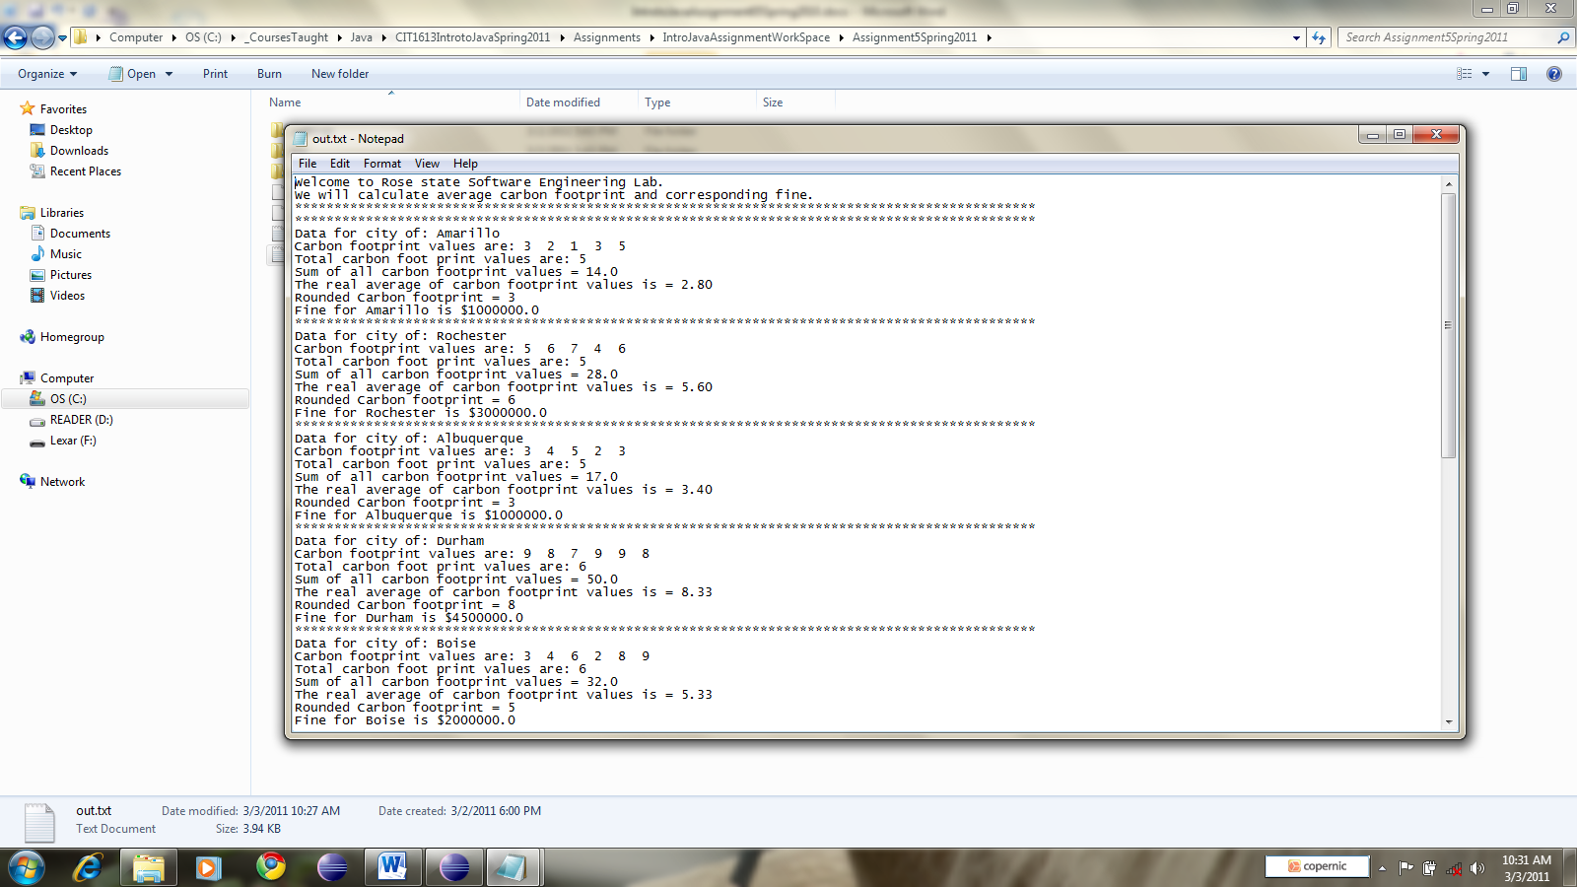

**Sample Run #2 (How your program can crash #1)**

Notice that when input file does not exist, the program will crash. It does not ask for output file.

Welcome to Rose state Software Engineering Lab.

We will calculate average carbon footprints for cities and corresponding fines.

Please be ready to provide the data file name for carbon FP for US cities.

**Program will crash if wrong filename is given.**

**In that case please run program again ascertaining correct file name.**

Please enter the full path of input data file name. [Relative path needed on UNIX]:

xyz

Exception in thread "main" java.io.FileNotFoundException: xyz (The system cannot find the file specified)

at java.io.FileInputStream.open(Native Method)

at java.io.FileInputStream.<init>(Unknown Source)

at java.util.Scanner.<init>(Unknown Source)

at MainClassAssignment5.main(MainClassAssignment5.java:23)

**Sample Run #3 (How your program can crash #2): Program crash output if input file is correct but wrong drive letter is provided for the output file.**

Welcome to Rose state Software Engineering Lab.

We will calculate average carbon footprints for cities and corresponding fines.

Please be ready to provide the data file name for carbon FP for US cities.

Program will crash if wrong filename is given.

In that case please run program again ascertaining correct file name.

Please enter the full path of input data file name. [Relative path needed on UNIX]:

C:\_CoursesTaught\Java\CIT1613IntrotoJavaSpring2011\Assignments\IntroJavaAssignmentWorkSpace\Assignment5Spring2011\CarbonFP.txt

Please provide full path to output file. [Relative path needed on UNIX]:

CAUTION: If output file exists all data in it will be deleted!

Program will crash if wrong filename is given.

In that case please run program again ascertaining correct file name.

Y:\xyz

Exception in thread "main" java.io.FileNotFoundException: Y:\xyz (The system cannot find the path specified)

at java.io.FileOutputStream.open(Native Method)

at java.io.FileOutputStream.<init>(Unknown Source)

at java.io.FileOutputStream.<init>(Unknown Source)

at java.io.PrintStream.<init>(Unknown Source)

at MainClassAssignment5.main(MainClassAssignment5.java:39)

The input file screen shot is below. The file is uploaded to D2L.

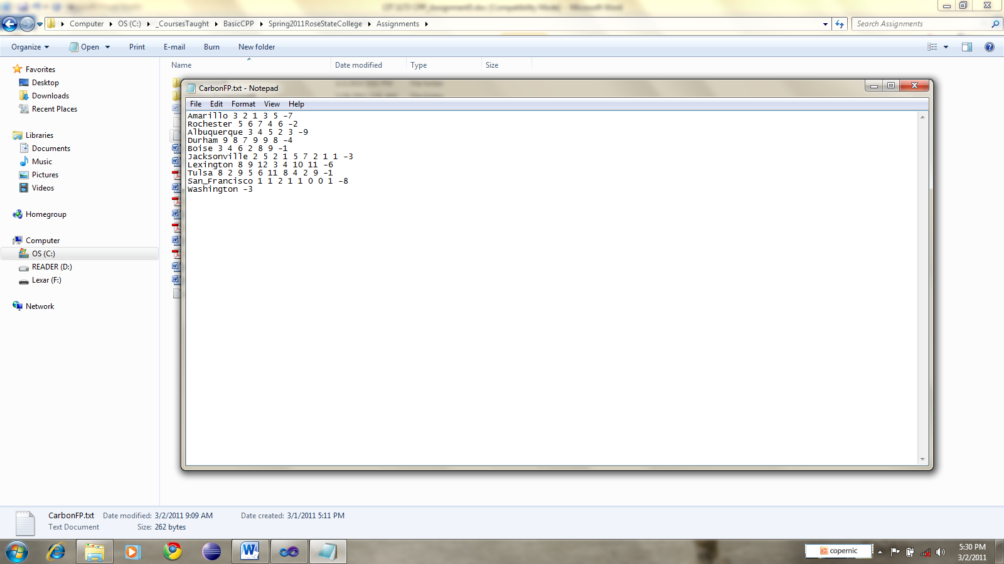

Grading Components

Your grade will be affected by followings:

1. Efficiency of your program. If/else if it has unneccessary comparisons would lead to grade reduction.
2. Are all components of program done? Points will be deducted in proportion to missing functionality, formatting etc.
3. All spellings are correct.
4. Program is user friendly.

**Advanced Programming [Optional]**

If user provides same name for input file and output file, their input file data would be deleted. That is a serious loss of data. Can we program to avoid such possibility? If you do that, you would be exhibiting advanced programming skill. The console output in that case will look as below.

Welcome to Rose state Software Engineering Lab.

We will calculate average carbon footprints for cities and corresponding fines.

Please be ready to provide the data file name for carbon FP for US cities.

Program will crash if wrong filename is given.

In that case please run program again ascertaining correct file name.

Please enter the full path of input data file name. [Relative path needed on UNIX]:

C:\_CoursesTaught\Java\CIT1613IntrotoJavaSpring2011\Assignments\IntroJavaAssignmentWorkSpace\Assignment5Spring2011\CarbonFP.txt

Please provide full path to output file. [Relative path needed on UNIX]:

CAUTION: If output file exists all data in it will be deleted!

Program will crash if wrong filename is given.

In that case please run program again ascertaining correct file name.

C:\_CoursesTaught\Java\CIT1613IntrotoJavaSpring2011\Assignments\IntroJavaAssignmentWorkSpace\Assignment5Spring2011\CarbonFP.txt

You have specified name for output file that is actually input file. Dangerous operation. Exiting the program to avoid data loss. Run program again by specifying different names for input and output files.