Legal Services Corporation
Post Program Quality Visit (Post-PQV)
2012 Grant Renewal Application

This Request for Proposals is for Renewal Applicants that have:

- had an LSC program quality visit since January 1, 2009

- been notified that they will receive the final PQV report by July 1, 2011

Contact the LSC competitive grants service desk at competition@lsc.gov if you have questions regarding this matter.

LEGAL SERVICES CORPORATION
2012 POST-PQV GRANT RENEWAL - INSTRUCTIONS

Applicants should read this instruction, the most recent final PQV report, and the LSC Performance Criteria in their entirety before preparing the Post-PQV grant renewal application.

All recipients of LSC funds who received a three-year grant in calendar year 2010, or a two-year or three-year grant beginning in calendar year 2011 are required to submit a grant renewal application in order to receive a 2012 renewal grant.

For calendar year 2012 grants, LSC is piloting a new grant renewal application for Applicants that received a program quality visit (PQV) since January 1, 2009. Post-PQV Renewal Applicants: 1) have had an LSC program quality visit since January 1, 2009 and 2) have been notified that they will receive the final PQV report by July 1, 2011.

This document contains instructions and formats for preparing the 2012 Post-PQV grant renewal Application.

Post-PQV grant renewal Applicants will not prepare the standard grant renewal narrative. Instead, these Applicants will address: 1) actions taken or planned in response to “Tier 1” recommendations in the final PQV report, and 2) significant changes or major developments in the delivery system since the PQV ended, and those that are anticipated during the grant year. The responses to these inquiries combined with the final PQV report take the place of the standard grant renewal narrative. Post-PQV grant renewal Applicant responses to these inquiries are entered into an online web form, which is accessed at www.grants.lsc.gov. Attachment 1 illustrates the web form Applicants use to respond to these inquiries. See page 5 for guidance on preparing the Post-PQV grant renewal application.

TABLE OF CONTENTS
Click on each section title to jump to that page in this document.

1. OVERVIEW OF THE POST-PQV GRANT RENEWAL 2
Key Dates 2
Listing of Applicants Eligible to File Post-PQV Grant Renewals 2
Applicant Informational Session 3
2. PREPARING THE POST-PQV GRANT RENEWAL APPLICATION 4
General Guidance 4
Guidance for Responding to “Tier 1” Recommendations Based on the Applicant's Actions to Date 4
Guidance for Addressing Significant Changes or Major Developments in the Delivery System Since the PQV Ended, and Those that Are Anticipated During the Grant Year 5
Applications For Multiple Service Areas 6
3. ACCESSING AND SUBMITTING GRANT RENEWAL FORMS 7
Important Reminder 7
Grant Renewal Forms Checklist 7
Preparing The Overview Of The Applicant’s Organization And Delivery System 8
4. UPLOAD INSTRUCTIONS 9
Uploads Checklist 9
Preparing Staff Contact Information 10
Preparing and Submitting Applicant’s Current Year (2011) PAI Plan 11
Preparing and Submitting Applicant’s 2012 Technology Plan 12
5. OBTAINING FURTHER GUIDANCE OR TECHNICAL ASSISTANCE 12
ATTACHMENT 1 13

1. OVERVIEW OF THE POST-PQV GRANT RENEWAL

The primary difference between the Post-PQV grant renewal application and the standard grant renewal application is that the narrative component of the Post-PQV grant renewal application will comprise written responses to “Tier 1” recommendations from the final PQV report. Additionally, while the standard renewal narrative describes significant changes or major developments in the delivery system since the last competitive grant application, in the Post-PQV grant renewal, Applicants describe significant changes or developments since the PQV ended, as well as those anticipated during the grant year. The Post-PQV grant renewal application together with the final PQV report supplants the standard grant renewal application.

The Post-PQV grant renewal application requires Applicants to: 1) respond to certain recommendations from the final LSC PQV reports (i.e., “Tier 1” recommendations); and 2) inform LSC of significant changes or major developments in the delivery system (for each of the Performance Areas) since the PQV ended, and those anticipated during the grant year.

Post-PQV Applicants will also submit grant application attachments, which include but are not limited to the PAI Plan, Technology Plan, statistical charts (e.g., budget), and program evaluation and monitoring reports.

KEY DATES

Registration for Applicants Informational Session | By May 16, 2011 (5:00 p.m. E.D.T.)
Applicant Informational Session Conducted | May 26, 2011 (2:00 p.m. E.D.T.)
Post-PQV Grant Renewal Due Dates | June 20, 2011 (5:00 p.m. E.D.T.) for Applicants who have received a final PQV report by April 30, 2011  Aug. 15, 2011 (5:00 p.m. E.D.T.) for Applicants who have received a final PQV report after April 30 and by July 1, 2011
Grant Renewal Funding Decisions Published | December 2011

LISTING OF APPLICANTS ELIGIBLE TO FILE POST-PQV GRANT RENEWALS
 | State | Applicant  Number | Applicant Name | Service  Area Code
1 | AZ | 703050 | Southern Arizona Legal Aid | AZ-5, NAZ-6
2 | CA | 705158 | California Indian Legal Services | NCA-1, CA-1
3 | CA | 805080 | Legal Aid Foundation of Los Angeles | CA-29
4 | CA | 805240 | Legal Services of Northern California | CA-27
5 | CA | 805270 | Bay Area Legal Aid | CA-28
6 | DC | 309080 | Neighborhood Legal Services Program of DC | DC-1
7 | FL | 610010 | Community Legal Services of Mid-Florida | FL-15
8 | FL | 610020 | Florida Rural Legal Services | FL-17, MFL
9 | FL | 610040 | Legal Services of Greater Miami | FL-5
10 | FL | 610050 | Bay Area Legal Services | FL-16

Listing of Applicants Eligible to File Post-PQV Grant Renewals (continued)
 | State | Applicant  Number | Applicant Name | Service  Area Code
11 | HI | 912000 | Legal Aid Society of Hawaii | HI-1, NHI-1
12 | IN | 515030 | Indiana Legal Services, Inc. | IN-5, MIN
13 | KY | 618030 | Appalachian Research and Defense Fund of Kentucky | KY-5
14 | LA | 619081 | Southeast Louisiana Legal Services Corporation | LA-12
14 | MA | 122090 | Merrimack Valley Legal Services, Inc. | MA-4
15 | MI | 423060 | Legal Services of Eastern Michigan | MI-14
17 | MO | 526041 | Mid-Missouri Legal Services Corporation | MO-5
16 | MO | 526051 | Legal Services of Southern Missouri | MO-7
18 | MT | 927000 | Montana Legal Services Assoc. | MT-1, NMT-1, MMT
19 | NM | 732010 | New Mexico Legal Aid | NM-5, NNM-4
20 | NY | 233150 | Legal Aid Society of Mid-New York | NY-22, MNY
21 | OH | 436050 | The Legal Aid Society of Cleveland | OH-21
22 | PA | 339000 | Philadelphia Legal Asst. Center | PA-1, MPA
23 | PR | 253030 | Community Law Office | PR-2
24 | SC | 641030 | South Carolina Legal Services | SC-8
25 | TN | 643929 | Legal Aid of East Tennessee | TN-9
26 | TX | 744050 | Legal Aid of NorthWest Texas | TX-14
27 | VA | 447081 | Blue Ridge Legal Services | VA-19

Renewal Applicants that have not had a PQV since January 1, 2009 are required to file a standard grant renewal using the FY 2012 Grant Renewal Instruction (Standard). These instructions are at www.grants.lsc.gov.

APPLICANT INFORMATIONAL SESSION
LSC will conduct an Applicant Informational Session Wednesday, May 26, 2011 (2:00 p.m. E.D.T.) to respond to Applicants’ questions concerning Post-PQV grant renewals. This is a free Webinar conference. It is designed to provide an understanding of the information needed to prepare the 2012 Post-PQV grant renewal application. To register for the conference, go to www.grants.lsc.gov then go to LSC Grants Announcements and Updates. Select the link titled “Register for the Post-PQV Applicant Informational Session.” Applicants will have an opportunity prior to and during the session to email questions to LSC for response. Additionally, LSC publishes frequently asked questions and responses at www.grants.lsc.gov.

2. PREPARING THE POST-PQV GRANT RENEWAL APPLICATION

General Guidance

As described above, Post-PQV renewal Applicants will not prepare the standard grant renewal narrative. Instead, the Post-PQV grant renewal application requires Applicants to: 1) respond to certain recommendations from the final LSC PQV reports (i.e., “Tier 1” recommendations); and 2) inform LSC of significant changes or major developments in the delivery system (for each of the Performance Areas) since the PQV ended, and those anticipated during the grant year.

The responses to these inquiries combined with the final PQV report take the place of the standard renewal narrative. Post-PQV Applicant responses to these inquiries are entered into an online web form, which is accessed at www.grants.lsc.gov. Attachment 1 illustrates the web form Post-PQV Renewal Applicants use to respond to these inquiries.

The information from the Post-PQV grant renewal application along with the findings from the final PQV report will be used in determining funding decisions. An Applicant’s response to a single recommendation in most instances should not exceed one full type-written page; however, there may be responses that require less than a full page. Applicants are urged to prepare responses using their word processing application and paste that information into the web form. This approach makes available all the advantages of your word processing application in editing Applicant responses.

Responses to recommendations are to be direct and to the point. Provide the detail necessary to notify LSC of the course of action(s) taken and the reason(s) for it. Where the recommendation is not being implemented, in whole or in part, it is in the Applicant's interest to fully explain Applicant's consideration of the recommendation and to demonstrate that efficient and effective high quality services will be provided during the grant term.

Some recommendations ask grantees to “consider” a certain course of action rather than to take it. As a practical matter, recommendations should be answered the same way whether they are worded as instructions to implement a course of action or to consider it. A response to a recommendation to “consider” an action that was rejected upon consideration is only sufficient where it demonstrates that the course of action was considered and persuasively explains why it was not pursued.

Guidance for responding to “Tier 1” recommendations based on the Applicant's actions to date

Applicant’s action to date: The LSC recommendation has been implemented.

In the event the recommendation has been fully implemented, Applicant should specifically state that in one sentence. Also describe what was done to make it clear that the recommendation was fully implemented. Information describing the impact of having implemented the recommendation and the anticipated outcomes is of interest to LSC and should be included except where the impact and outcomes are evident.

Guidance for Responding to “Tier 1” Recommendations Based on the Applicant's Actions to Date (continued)

Applicant’s action to date: The LSC recommendation is being implemented.

Where the recommendation is being implemented as suggested, describe the aspect of the recommendation that is completed, what aspect(s) remain to be completed, and why. To the extent necessary, include such details as: a timeline including the tasks to be completed, staff involved, the expected benefits and outcomes, etc.

Applicant’s action to date: The LSC recommendation is being implemented in part or with certain modifications.

Where a recommendation is being implemented in part or with modifications, describe the course of action the Applicant has taken and the reasons for it. Explain why the recommendation wasn't implemented fully. Give the reasons why the partial implementation or modification better suits the needs of the Applicant, supports more efficient or effective service delivery, or why full implementation is not possible or practical.

Applicant’s action to date: The LSC recommendation is being considered.

Where the Applicant is still considering how, or whether, or to what extent, to implement the recommendation, include the following in the response:
  - what is under consideration and why?
  - what factors are influencing the decision? If resources are at issue, discuss the costs and any less resource-intensive ways to accomplish the goals of the recommendation
  - when the decision is expected to be made
  - the key persons in the decision making process

Applicant’s action to date: The LSC recommendation is not being implemented

Where a recommendation is not being implemented, it is important to explain, in detail, why that course of action is being taken. If the Applicant agrees with the goals of the recommendation but does not have the resources to pursue it at this time, this conclusion should be supported with an explanation of the financial implication and the reason that following the recommendation isn't possible or feasible at the present time. If the Applicant does not agree with the recommendation, that conclusion should be supported with a thorough explanation as to why the recommendation is not, in the light of all the circumstances, in the best interests of the client community, and/or the program and would not lead to more efficient and/or effective service delivery.

Guidance for addressing significant changes or major developments in the delivery system since the PQV ended, and those that are anticipated during the grant year

Below, by performance area, are examples of types of significant changes or major developments to report in the Post-PQV grant renewal application that have occurred since the PQV ended, and which are anticipated during the grant year. As noted above, this information along with the findings from the final PQV report and responses to the “Tier 1” recommendations supplants the standard grant renewal application narrative and will be used in making funding decisions.

Guidance for addressing significant changes or major developments in the delivery system (continued)

Applicants are required to address significant changes or major developments since the PQV ended, and those that are anticipated during the grant year for each of the four performance areas. If there have
been no significant changes or major developments since the PQV ended, and none are anticipated during the grant year, state that in one sentence under the appropriate performance area. If there have been significant changes or major developments since the PQV ended, or changes or developments are anticipated during the grant year, provide a thorough discussion of that under the appropriate performance area. Where applicable, the Applicant should discuss actions it has taken or plans to take in response to the significant change(s) or major development(s) in the delivery system. Use the examples of significant changes and major developments listed below as a guide. This listing is not intended to be exhaustive. Applicants should address all significant changes to the delivery system and those anticipated during the grant year, even those not included in the listing below.

Performance Area One:
  - a decision to conduct or postpone a client needs assessment
  - change in program priorities
  - new emerging needs identified

Performance Area Two
  - opening of offices
  - closing of offices
  - change in intake process such as implementing centralized or coordinated intake, launching online intake or decrease/increase of intake hours of 10% or more

Performance Area Three
  - increases or decreases in staff of 10% or more
  - changes in legal work management (implementation of practice groups, adoption of new case management protocols/standards, changes in supervisory structure)
  - implementation of new projects (e.g., foreclosure clinics, medical/legal projects, pro bono initiatives)

Performance Area Four
  - changes in corporate structure
  - changes in senior management structure
  - shifts of 10% or more in resource allocations for cases, other services, or support activities
  - disasters and responses to disasters
  - increase or decrease in non-LSC funding of 10% or more
  - significant changes in technology (e.g., acquisition of phone system or case management system)
  - major new partnerships/collaborations (e.g., with other LSC grantees, agencies, state bar, law schools)
  - strategic planning
  - resource development strategies

As noted earlier, the final PQV report along with the Applicant’s Post-PQV grant renewal application are considered together for the purposes of the Post-PQV grant renewal process.

Applications for Multiple Service Areas
Applicants that currently receive LSC funding for multiple service areas will complete a separate Post-PQV renewal application for each service area. Each service area’s application will contain only those “Tier 1” recommendations that are relevant to that service area.

3. ACCESSING AND SUBMITTING GRANT RENEWAL FORMS

Important Reminder
A complete Post-PQV grant renewal application consists of the forms and document uploads listed in the charts below. The charts identify the required document format where applicable. Applicants must transmit all grant documents and forms to LSC from www.grants.lsc.gov. Limit the Post-PQV grant renewal application to items specifically requested in this Post-PQV grant renewal instruction. No other materials will be accepted unless requested by LSC. Applicants may, however, be required to submit additional materials prior to the final award of grant funds.

All forms and instructions for preparing forms are available from the online grant Application at www.grants.lsc.gov. To access and submit application forms log into www.grants.lsc.gov, click on the “Submit Post-PQV Renewal Grant Application” link for the desired service area, select the appropriate form, enter the required data, and click the save button after data entry is complete. All forms are required for all Post-PQV grant renewal Applicants. Applicants can preview the Application Forms at www.grants.lsc.gov. Email any questions to the competition service desk at competition@lsc.gov.

GRANT REnewal FORMS CHECKLIST
Application Form |  | Description
 | PQV | Applicants use this form to respond to each of the LSC “Tier 1” recommendations, and to describe significant changes or major developments in the delivery system that have occurred since the PQV ended, and those that are anticipated during the grant year. See page 4 for instructions.  Applicants will also describe the three most significant accomplishments for clients achieved within the last twenty-four months, and describe the systems and procedures that ensure compliance and enforcement of LSC’s requirements and regulations. See Attachment 1 for a preview of this form.  LSC will assess Applicant responses to: a) determine whether Applicant demonstrates its ability to meet the LSC Selection Criteria (see LSC Regulation § 1634.9) and b) remain informed about significant changes and major developments in the delivery system.
 | Budget Forms  D-12, D-14 | Budget forms collect projected 2012 revenue and expense information.
 | Forms F-1 and F-2 | These forms capture the name, contact information, and demographic information of each board member; the name of the appointing organization; and the relevant experience of each board member.
 | Form G-12 | Form G-12 captures projected expenditures for cases, other services, and supporting activities.
 | Form D-13 | Form D-13 captures information regarding PAI (Private Attorney Involvement) expenses.
 | Form K | Form K captures information about current office technology (hardware and software). Form K is different from the Technology Plan. See page 12 for instructions for the Technology Plan.
Grant Forms Checklist (continued)

Application Form |  | Description
 | Form D-15 | Form D-15 captures projected LSC and non-LSC expenses for carrying out Applicant’s 2012 Technology Plan.  At a minimum this budget should contain entries for: 1) software and hardware acquisition costs; 2) software and hardware maintenance costs; 3) IT staffing costs (internal and/or out-sourced); and 4) staff training costs (for IT staff and to insure all program staff can effectively use the program’s technologies).
 | Organizational Overview | The overview captures a description of the geographical and cultural characteristics of the Applicant’s service area(s), the scope of legal services provided by the Applicant, and the delivery methods and distinctive characteristics of the Applicant’s organization. See more information about the Organizational Overview below this chart.
 | Conflicts, Complaints and Performance Evaluations | Applicant must disclose any potential significant conflicts and should describe its capacity to protect against any such conflicts that may arise during the term of the grant or contract.  Applicants must list all professional disciplinary complaints, criminal convictions, civil contempt, and malpractice lawsuits and/or claims made against the Applicant or any of its attorneys during the past thirty-six months, as well as all pending lawsuits and/or claims, regardless of the date of the lawsuit or the date the claim was initiated.  Applicants must list the name of the report, the date of the report, and the name of the agency that prepared the report for all non-LSC evaluation and monitoring reports received within the past thirty-six months.

Preparing the Overview of the Applicant’s Organization and Delivery System
LSC requires each Applicant to provide an overview of its organization and delivery system and a current copy of the program’s organization chart. The overview is to contain a concise description of the geographical and cultural characteristics of the Applicant’s service area(s), the scope of legal services provided by the Applicant, and the delivery methods and distinctive characteristics of the Applicant’s organization. LSC may use excerpts from the overviews in publications and presentations.

The Applicant Overview will be submitted by completing the Applicant Overview “web form.” This form and instructions for preparing the form are available from the online grant Application at www.grants.lsc.gov. The Applicant Overview will no longer be uploaded; it must be completed and submitted through the online application system.
Preparing the Overview of the Applicant’s Organization and Delivery System (continued)

Consider the suggestions below in preparing the overview:

Description of the geographical and cultural characteristics of the service area. This description should address whether the Applicant’s service area is either urban or rural or a mix, and explain which counties or cities (or the number of counties or cities) classify it as such. If there have been significant changes, the response might explain what those changes are and how those changes affect the eligible client population of the service area. If there have been no significant changes, the response would indicate this and go on to explain the characteristics that have consistently affected the eligible client population. In describing the distinctive characteristics of the service area it would be helpful to make note of the things such as the service area’s poverty, changes in population, area-specific legal issues, or other such characteristics.

Describe the scope of legal services to be provided by the Applicant. This description should address whether the Applicant provides a full range of services, and examples of what those services include and whether the full range of service is extended throughout the service area. Programs that do not provide a full range of service should indicate this and explain methods employed to ensure that a full range of services is provided to the client population.

Describe the delivery methods and distinctive characteristics of the Applicant’s Organization. This description should address the methods of delivery used by the Applicant organization. This response should also detail the distinctive characteristics that the Applicant considers to be unique to its organization.

4. Upload Instructions

To upload files, go to www.grants.lsc.gov, click on the “Submit Post-PQV Renewal Grant Application” link for the desired service area, and then click “Uploads.”

Uploads Checklist
Upload Document |  | Page Reference/Instruction |  | Required Format
 | Organizational Chart | The organizational chart should depict the components of Applicant’s organization, the titles of the management and executive positions responsible for those components and the number of staff positions in each component. |  | PDF
 | Applicant Staff Contact Information | See page 10 of this document for instructions regarding Applicant staff contact information. |  | MS Word file
 | 2011 PAI Plan | See page 11 of this document for instructions regarding the PAI plan. |  | PDF
 | 2012 Technology Plan | See page 11 of this document for instructions regarding the technology plan. |  | PDF
 | Performance evaluations and monitoring reports  (PEM) | Submit one copy of all performance evaluation and monitoring reports, provided to Applicant within the past thirty-six months, by non-LSC funders and other agencies. |  | PDF
 | LSC Certification Form (Form I)  LSC Grant Assurances Form (Form C) | LSC Certification Form (Form I) and LSC Grant Assurances Form (Form C) will be available during the month of August 2011. When these forms are published, LSC will send an e-mail to all Applicants informing them of their availability and instructions on how to proceed. Applicants will be given adequate time to review Form C and submit Form I. Applicants will not return Form C to LSC. |  | PDF

Preparing staff contact information
LSC requests that all Applicants provide staff contact information to receive bulletins, announcements, and other information pertaining to legal services delivery.

Use the format below to provide Applicant staff contact information for each permanent, full-time employee. Enter the employee’s name, job classification code, email address, and the Applicant number. Use the job classification codes below to ensure consistency in this data. The chart will be uploaded as a MS Word or WordPerfect file.

Applicant  Staff Name | Applicant Staff Job Classification Code | Applicant Staff Email Address | Applicant  Number | Job Title (only for job class. 99)
Jane Doe | 01 | john@doe.org | 000000
John Doe | 99 | jane@doe.org | 000000 | Social Worker

Job Classification Codes and Definitions
01 Director - chief executive officer.
03 Deputy Director - deputy executive officer.
05 Director of Litigation - executive responsible for oversight of litigation.
07 Managing Attorney - attorneys who supervise legal work and have substantial administrative and financial responsibilities, e.g., administer a cost center, branch office, or the like.
09 Supervising Attorney - attorneys who supervise legal work but do not have substantial administrative and financial responsibilities.
11 Staff Attorney - all other attorneys, as well as law school graduates, who have passed a bar examination.
13 Paralegal - professionals whose duties consist primarily of such activities as intake interviewing, case investigations, checking court records, legal research, client representation at administrative hearings, and outreach and community work.
14 Technology Staff –individuals who devote a major portion of time to maintaining the program’s computers, web site(s), and technology infrastructure.
15 PAI Coordinator – individuals who devote a major portion of time to coordination of the PAI plan.
17 Training Responsible Person - individuals who devote a major portion of time coordinating or providing training for the Recipient’s or sub-recipient’s staff.
18 Financial Professional - persons who assist the director with financial management (e.g. controller, accountant or bookkeeper). .
19 Management Professional - persons who assist the director with personnel or administrative management. It does not include managing attorney positions covered in job code 07 or financial professionals covered in job code 18.

Preparing Staff Contact Information (continued)

21 Law Clerk - law students who have not graduated from law school.
23 Senior Aide - persons employed under a specially designed job program for older workers.
25 Administrative Assistant - executive assistants and administrative aides who do not have substantial administrative and financial responsibilities, but whose duties exceed those delegated to legal secretaries and clerical workers.
27 Secretarial/Clerical - legal secretaries, as well as clerical workers, file clerks, receptionists, etc.
99 Other (provide job title)

Preparing and Submitting Applicant’s Current Year (2011) PAI Plan
LSC requires each grant renewal Applicant to submit a copy of its current 2011 PAI plan and PAI budget along with its 2012 grant renewal application. Include the following information in the title page of the PAI plan: Applicant Name, Applicant Number, and “2011 PAI Plan.” The PAI plan should be uploaded as a PDF file using the LSC Grants site at www.grants.lsc.gov.

Applicants are encouraged to review 45 C.F.R. Part 1614 before developing their Private Attorney Involvement (PAI) plan. Pursuant to 45 C.F.R. § 1614.4(b) Applicants are required to present their PAI plans to all local bar associations and to summarize responses received.

At a minimum, Applicant’s PAI plan must address each of the requirements of 45 C.F.R. § 1614.4. These are threshold requirements and are referenced below. If the PAI plan does not address these threshold requirements, include a supplemental response with the PAI plan that does.

Upload Applicant’s 2011 PAI Plan (and supplement if necessary) as a single PDF file. Include the following information in the title of the PAI plan: Applicant name, Applicant number, and “2011 PAI Plan.” Use RFP Budget Form D-13 to prepare and submit Applicant’s PAI budget (see page 7).

Pursuant to 45 C.F.R. § 1614.4, Applicant’s PAI plan shall:

- Address the legal needs of eligible clients in the geographical area (service area) served by the Applicant consistent with the Applicant’s priorities (see 45 C.F.R. § 1614.4(a)(1)).

- Describe the mechanisms available for private attorneys to participate in Applicant’s delivery of legal services (see 45 C.F.R. § 1614.4(a)(2)). The plan should discuss how Applicant will involve private attorneys in its work, such as case handling, special projects involving law firms, local government legal departments, the legal departments of local corporations and other legal organizations, hotlines, full service and pro se clinics, the use of bilingual attorneys with LEP clients, community education, writing pamphlets, major litigation, transactional work, contributing to websites, technical assistance, mentoring of staff, co-counseling with staff, and staff training (see LSC Program Letter 07-2 and examples contained therein).

- Discuss the results of Applicant consultations with the client community, private attorneys, and bar associations in the service area in the development of the PAI plan (see 45 C.F.R. § 1614.4(a)(3)).

Preparing and Submitting Applicant’s 2012 Technology Plan
LSC requires each grant renewal Applicant to submit a 2012 Technology Plan. Include the following information in the title of the Technology Plan: Applicant Name, Applicant Number, and “2012 Technology Plan.” At a minimum, Applicant’s Technology Plan must identify any capacities from the document “Technologies That Should Be in Place in a Legal Aid Office Today” (www.lsc.gov/pdfs/technologybaselinereport.pdf) that it lacks and, for every missing capacity, explain: 1) Why it is not needed, either for the program’s role in the state justice community or because it is provided by another entity; or 2) Describe the Applicant’s strategy for acquiring the capacity.

LSC encourages Applicants to develop and submit a more comprehensive technology plan that addresses Applicant’s current and planned uses of technology in all facets of its operations. For resources on technology planning, see http://tig.lsc.gov/resources.php.

Also, a Technology Budget is required for 2012. See page 8 for more information.

5. Obtaining Further Guidance or Technical Assistance
Assistance available to Applicants preparing the Post-PQV grant renewal application:
- LSC Competitive Grants Service Desk - competition@lsc.gov
- LSC Resource Information at www.lri.lsc.gov
- LSC Performance Criteria (RFP Appendix C at www.grants.lsc.gov)
- Responses to Frequently Asked Questions at www.grants.lsc.gov
- LSC Applicant Informational Session (see page 3)

Submit inquiries pertaining to technical issues, Applicant passwords and primary email addresses, using the website application, and uploading files to techsupport@lsc.gov.

Contact Reginald Haley at haleyr@lsc.gov if you do not receive a response within 48 hours.

ATTACHMENT 1

Legal Services Corporation
PQV 2012 Grant Application - Preview of the PQV Forms

PQV – Main Form

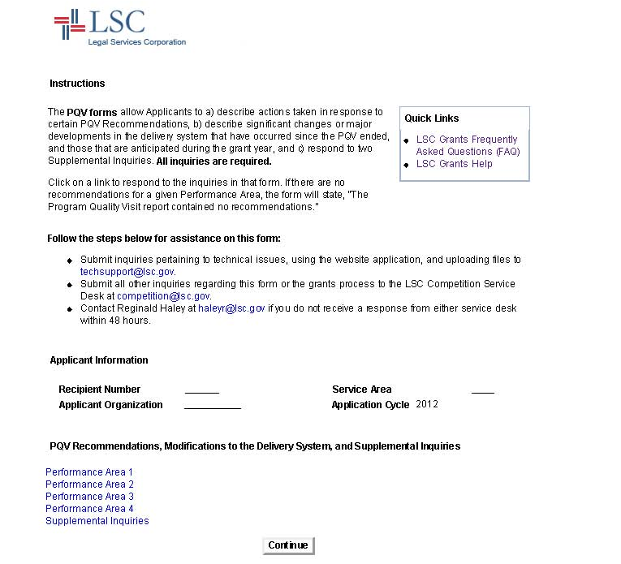
PQV – Performance Area Form
(Performance Area Two is shown; each Performance Area will have a comparable
form with the Tier 1 Recommendations for that Performance Area.)
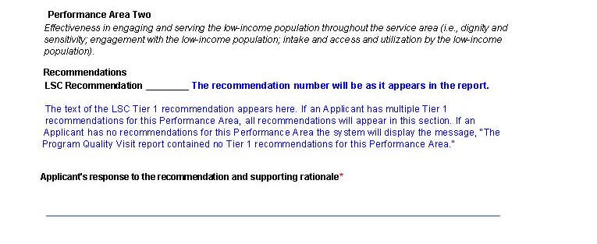

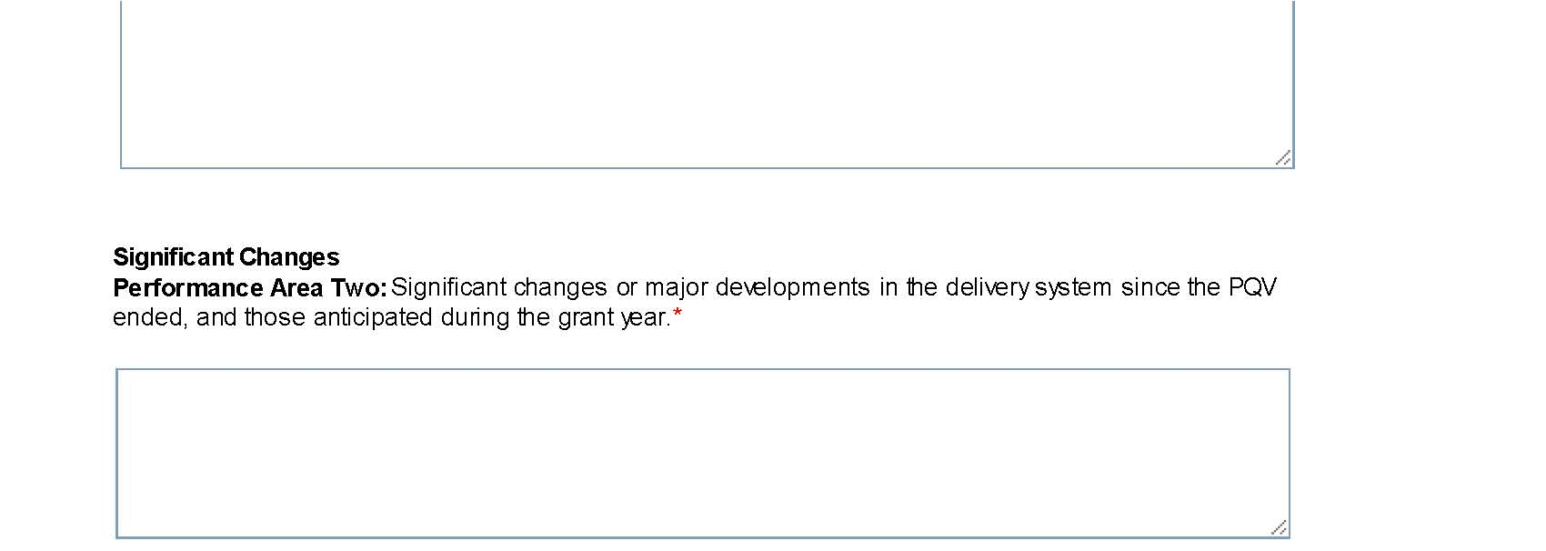

PQV – Supplemental Inquiries Form
