Sample Book for Testing

Table of Contents
1.0 Introduction ................................... 1
1.1 Purpose ....................................... 1
1.2 Scope ......................................... 2
1.2.1 Technical Scope ............................. 2
1.2.2 Audience .................................... 3
2.0 Getting Started ............................... 4
2.1 Installation .................................. 4
2.2 Configuration ................................. 5
2.2.1 Basic Settings .............................. 5

1.0 Introduction
This is the introduction chapter. It provides an overview of the document and its purpose.

1.1 Purpose
The purpose of this document is to demonstrate the conversion system. It shows how content is extracted and formatted.
Key features include:
- • Text with formatting
- • Tables and images
- • Multiple sections
The following diagram shows the document processing flow:
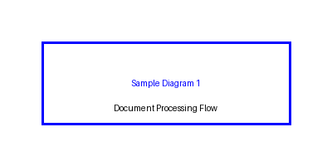
1.2 Scope
This section describes the scope of the document.
1.2.1 Technical Scope
The technical scope includes:
Python programming language for backend processing.
Feature | Description
JSON Output | Structured data format
Markdown Output | Human-readable format
1.2.2 Audience
The intended audience includes developers and technical writers.

2.0 Getting Started
This chapter guides you through the initial setup and configuration.
2.1 Installation
To install the system, run the following command:
make install-deps
This will install all required dependencies.
The chart below shows the comparison of output formats:
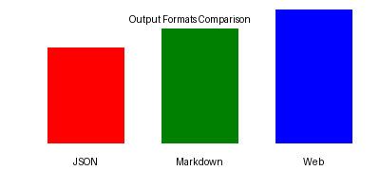
2.2 Configuration
Configuration involves setting up your environment.
2.2.1 Basic Settings
Basic settings include:
- 1. Input document path
- 2. Output directory
- 3. Processing options
For more information, see the README.md file.

