TTK4147 miniproject

As long as no priorities are enforced, more threads tend to cause more context-swithces, increasing the response-time of time-critical tasks. As a result, we went from a 4-threaded design, which favored periodicity to a 2-threaded one, trying to minimize the response-time, while also keeping a robust controller. The sendto()-funtion may block (this is OS-scpecific), but none of this was observed on the board, so we opted for responding on signal-packets directly from the receiver-thread.

Since the board has a 32-bit processor, it is able to read an entire float in one operation, which we can abuse as a synchronization-mechanism. This will, however keep us from being able to use globaly shared doubles, since that requires a 64-bit processor.

The controller was made to be called periodically, and was implemented as a PID-controller with limited derivative action. We did this in order to keep the controller from overreacting to noise or other quick changes. We chose this because it works as a low-passed derivative. Since the regulator is only concerned with input and output, and does not estimate states. As a result, there will allways be some overshoot when controlling an unstable system. The controller was tuned manually, until we got a satisfactory response. We chose to prioritise a quick response, rather than ominimisng overshoot.

The regulator is dependent of both time and system-output. Since the packets and scheduling can cause variations in when the regulator is run. There are two possible remedies for this

1) Mesure the time between itterations of the controller
+ More exact
- Requires reading the time
- The reads can be noisy
- Reading the clock is often done through a sys-call when high precission is needed, but they are not nececarily as easily interrupted.
- Greater delay between receiving a packet and giving a system input
2) Use a periodic sleep, and use the sleep-time as the time-difference in the controller
+ Less sys-calls required
- Less precise
- Will not react to random changes in the scheduling-time
- Will not be able to converge towards the actual period between controller-iterations

The first approach was chosen, and implemented through the use of clock_gettime(). For the implementation that was chosen, there is not a clear sense of priority between reading controller thread and receiver/answering thread. If we would have implemented this, we would have needed to give the threads priorities, or use xenomai, and its thread-priorities. Alternatively, since the linux-version is >=2.6, the kernel is preemptive, and the problem could have been solved with a kernel module.

The time-delay in the system makes it a bit more difficult to implement more advanced controllers, since analysing e^{tau*s} is kind of hard, beyond saying if it is stable, by using nyquist-plots, additionally there is then no way to say if you still are able to achieve the desired poles set from an ideal linear system. As the PID was considered to provide a satisfactory system behavior based on the criteria given in the project, this controller was chosen.

The variance from the response time when awnsering signals, most likely comes from the time the regulator is called to when it has completed. The visible spread that seemingly follows a normal distribution most likely comes from the varaible time it takes when waking up the receive-thread. When running the program multiple times, we were able to provoke the (un)desired response:

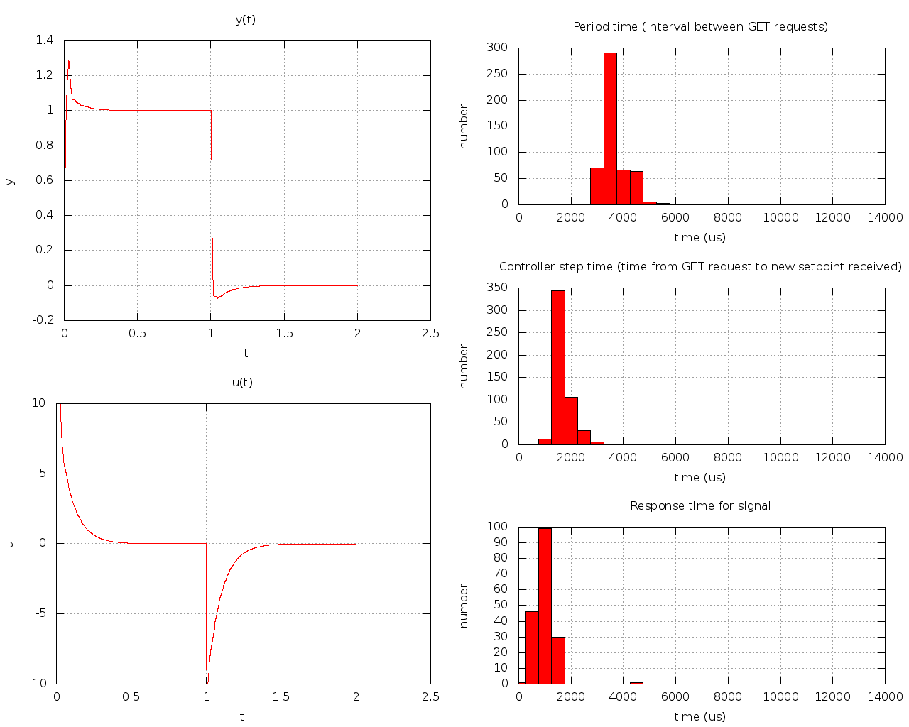

http://www.informit.com/articles/article.aspx?p=101760&seqNum=3 [Read: 10.11.18 ]

