Using the Enhanced SQL Trace Tool

January 2006

© 2006 Microsoft Corporation. All rights reserved.

This document provides information about installing and using the Enhanced SQL Trace tool. It also includes some additional tracing methodology that can be used with Microsoft Business Solutions–Axapta, now part of Microsoft Dynamics. This methodology is designed to help administrators and developers identify performance and blocking issues within the Axapta environment.
Contents
Installation Steps 1
Selective SQL Tracing 3
Table selection for active SQL trace 3
Using templates with selective tracing 4
Blocking Tracking 6
Setup functionality 6
Blocking Tracking window functionality 7
Call stack information from Blocking Tracking 10
Blocking Activity Report 12
Clearing the blocking information 12
SQL Operation Counters 14
Collecting statistics 14
Evaluating statistics 14
Export statistics 15
Appendix 16
Clicked event script for All Users – DB Settings button 16

Installation Steps
Installation of the Enhanced SQL Trace tool is a multi-step process that involves importing two Axapta code files (eeSQLTraceEnhancements.xpo and eeSQLTraceEnhancementsTwo.xpo) and copying in a set of English-US label files (axEETen-us.ald). To use the Blocking Tracking functionality, see the additional required setup steps that are described in the Blocking Tracking section of this document.

NOTE – Prior to installing this tool, back up your AXUSR.AOD file.

After making your code backup, the first step to installing the tool is to import the two export (.xpo) files that contain the enhanced trace code and resources.
To import the .xpo files:
- Log in to Axapta and open the Application Object Tree (AOT).
- Select the Import button from the AOT window and browse to the location where the eeSQLTraceEnhancements.xpo file exists on your system.
- Leave all the options unmarked and make sure that the Import option is set to “Only application objects.”
- Click OK to begin the import. A dialog box will ask if you want to replace a resource (refer to step 6 for instructions on answering this question). The following core Axapta resources were modified as part of the creation of this tool:
  - The SysUserSetup form
  - The sysTrace method in the Application class
  - The outputTable method in the sysTrace class
- The changes to the SysUserSetup form for this tool can be easily remade by a customer or partner if the customer or partner previously modified the SysUserSetup form. The changes made to this form were to change the design of the SQL TabPage to add four buttons next to the SQL trace check box. If customers or partners need to recreate this functionality, they can do so by adding three MenuItemButtons and pointing them to the Display Menu Items eeTableSelect, eeBlockingTracker, and eeSQLCounter.
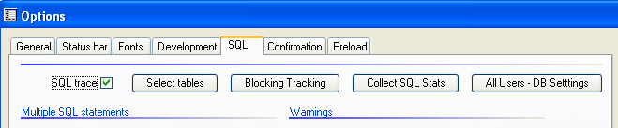
The fourth button (All Users – DB Settings) requires a Button control with a clicked event script that can be found in the Appendix of this document. This button allows an administrator to copy, to all users, the settings on the window for the following fields:
- SQL Trace
- All four Table (database) fields
- Threshold under Long queries.
No other settings for users are changed by clicking All Users- DB Settings.
- If the current environment does not have modifications to the SysUserSetup form, select Yes to replace the resource.
- The second .xpo file to import contains the changes to the sysTrace method and the outputTable method. It is critical that you import the file named eeSQLTraceEnhancementsTwo.xpo after the first .xpo file (eeSQLTraceEnhancements.xpo). The bulk of the functionality for this trace tool is within the sysTrace method, and if customers or partners have previously modified this method, they will not be able to use the Enhanced SQL Trace Tool without attempting to merge their changes into the sysTrace method that is provided with the tool. The changes made to the outputTable method involve securing the active Transaction ID for each SysTraceTableSql record.
- To properly use the tool, you must also copy the English-US label file into the correct directory within Axapta directory structure. The label file provided (axEETen-us.ald) should be placed within the Appl\Standard folder (or whichever folder the current configuration is set to) along with all the other label files. If this file is not copied, users will see @EET## labels on fields, buttons, captions, and warning statements.
- If the application is running against a SQL 2005 Server, then some additional setup steps are required to run the Blocking Tracking portion of this Enhanced SQL Tracing tool. Those steps are outlined in the Blocking Tracking section of this document.

Selective SQL Tracing
Axapta has its own built-in mechanism for providing SQL Tracing information; it can be enabled through the Options window within Axapta. However, because of the metadata-driven nature of the Axapta system, it becomes very hard to use the information in either the built-in SQL trace or a standard SQL profile without having to sift through a lot of irrelevant information. The Selective SQL Tracing window allows users to choose exactly which tables to log through the Axapta SQL tracing mechanism. This allows for more concise, easier-to-process results that should lead to faster troubleshooting. The selective tracing also makes the application perform better while SQL trace is activated by choosing to write the trace entries only when needed.

Table selection for active SQL trace
To access this window, navigate to the Options window by choosing Tools-Options or by clicking the Options button from the Administration-Users window. Settings can be made for any user in the system if the Options form is opened from the Administration-Users window. Settings can also be applied to all users if desired. To open this form, choose the SQL tab from the Options form and click the new Select tables button to open the window. The following screen shot is an example of the window that appears.

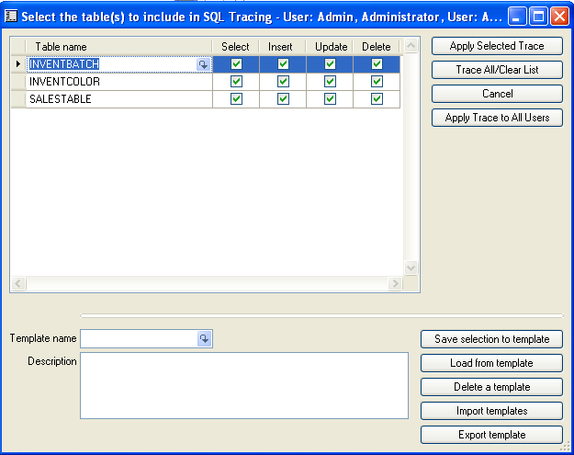
This window uses standard Axapta grid functionality – use Ctrl-N to add new lines, highlight and delete lines by using the buttons on the toolbar, and so on. Users can select as many tables as they want to trace, and can also choose which operations to trace. The list being built in this window is built using a temporary file, so changes can be aborted by clicking Cancel. If you want to clear the list and return to the standard behavior, click Trace All/Clear List. To make the changes active for the user, you must click Apply Selected Trace. When you close the window by using the Close button, you will be asked if you want to apply or cancel any changes. All selections made in this window are made using a per user per company format. So logging in as a different user or to a different company could give different settings – this is identical to how the other tracing settings in Axapta are stored.
The Apply Trace to All Users button will allow an administrator to quickly deploy, to all users in the company, the same list of selective tables to be traced. The admin user will be prompted to confirm this choice before continuing and will have the option to add to the existing tables being selectively traced or to just overwrite all existing trace information. If no tables are displayed in the list of selected tables, then the selective tracing will be removed for all users, and their systems will then trace every table again. Users will need to log off and log back on again before the changes take effect.

Using templates with selective tracing
One of the features that should be quite useful for helping deploy selective tracing within a single environment and across multiple customer sites is the ability to save and load templates by using the bottom half of this window. Once users or support engineers have identified the tables that they want to trace and have defined them in the window, the user can enter a Template name and Description, and then click Save the selection to a template. This will save the information to a system-wide table in the Axapta database, which will allow users to open up a different company or choose a different user and click Load from template to get exactly the same settings. If you are looking for a specific issue related to a set of tables, but you do not know how it is recreated consistently, then you should establish the same trace across all users who might touch those tables to get the most accurate picture.
You must choose a template name from the lookup by using the drop-down control before you can use the Load from Template or the Delete a Template options.
Import templates and Export template functionality will be used by support engineers and partners to allow them to define a set of settings into a template and then send a simple text file by e-mail to the customer who will make the actual trace. Support engineers should make their settings, save it as a template, select the template name from the lookup and then click Export a template. The support engineers will be prompted for a location to which to save the file, and to choose an existing file or to create a new file. If they choose an existing file, a warning will appear about over-writing the existing file. This warning should be ignored because the data will actually be appended to the existing file, making it possible to store multiple template settings in the same file. After all the templates have been exported, the support engineer or partner can send, by e-mail, the text file that was created and advise the customer to import the templates by clicking Import templates. If any templates exist that have the same name as the original, the imported information will be merged into those templates. After the templates have been imported, the user can load them by following the standard "Load from template" instructions in the preceding paragraph.

Blocking Tracking
If users periodically report that their Axapta client has an hour glass and that they are stalled and unable to continue working, the Blocking Tracking tool can be used to determine which process is causing the delay. An example of this would be users in a data entry window who are able to enter transactions without difficulty for most of the day, but, occasionally, the hour glass appears and they have to wait.
Multiple possibilities exist that can cause one process to block another:
- Reporting external to Axapta (Microsoft Excel or other reporting tools)
- Customizations created within a transaction initiated by core Axapta code
  - A large amount of processing may have been added within a transaction
  - A report may have been included within a transaction
  - A prompt for user input may have been included within a transaction
  - Inefficient data access may be extending the duration of the transaction
- A large amount of processing occurring within the transaction
- Queries and other processing occurring within Query Analyzer
The Blocking Tracking functionality built into the Enhanced SQL Trace tool uses a combination of SQL logic and Axapta SQL Trace functionality to try to pinpoint areas of performance concern when records are being held for a long period of time. The Blocking Tracking tool identifies the process that is holding a record open while another process is waiting for that record for a user-definable length of time. Identifying these areas can lead to required code changes that will greatly optimize performance and prevent future blocking conditions.

Setup functionality
To use Blocking Tracking functionality, three SQL objects need to be created within the user’s Axapta database. The core functionality of identifying “lead blockers” will be created in a SQL stored procedure called eeLeadBlockerSearch, which will populate two new SQL tables, eeLeadBlocker and eeLeadBlockerStatus. To help automate the creation of these three SQL objects, code has been written into the Blocking Tracking window. That code is executed by opening the form, automatically creating the three objects in the current Axapta database. The Blocking Tracking window will also create a job on the server when Blocking Tracking is active, and will stop and delete that job when Blocking Tracking is stopped within Axapta. The job will continue to search for blocking occurrences even if the Axapta client has been shut down.
IMPORTANT: To use the Blocking Tracking, you must first start the SQL Server Agent service. This can be done through the SQL Service Manager or Administrator Tools – Services.
IMPORTANT: If using SQL Server 2005, an additional step is required to use Blocking Tracking because of tighter default security restrictions within a SQL Server 2005 environment. If your Axapta server is a SQL Server 2005 server, follow these additional steps to set up Blocking Tracking. These steps only need to be run once, not for every client. Do not run these steps for SQL Server 2000; it will fail if the script is executed.
- Launch SQL Server Management Studio and connect to your server as a user who has rights to grant permissions and assign users to the MSDB database.
- Click Open File or go to the File menu and select Open – File (or Ctrl-O) and browse to the location of the eeTrace2005Grant.sql file.
- If prompted for user authentication, again choose a user who has rights to grant permissions and assign users to the MSDB database.
- IMPORTANT – Change the database drop-down list to your Axapta database to ensure that the changes properly take place within your Axapta database.
- If the core SQL user that the Axapta Object Server (AOS) or client uses to communicate with SQL Server is not the default 'bmssa' user, modify the script and change the line that is
select @userid = 'bmssa'
to match the user that you have specified in the AOS Configuration Settings on the SQL Server tab for Database User ID, or the Axapta Client Configuration Settings if your environment does not connect to an AOS.
- Run the script within Management Studio. If any errors occur (generally errors would be permission issues), then log in as a different user with more permissions, and go back to step 4 and resume the setup process.
Successful completion of the script should return the message in the results section of “1 row(s) affected.” At this point the Blocking Tracking window should be able to create and schedule the job used to watch for blocking activity.

Blocking Tracking window functionality
The grid on the Blocking Tracking window, illustrated in the following screen shot, shows rows that have been identified as lead blockers in the system. This means that another user has been waiting for a record in the table for a period of time greater than the Minimum Time for Blocker threshold set at the top of the window. The Search Frequency in seconds field is used to tell the SQL job how often to run the search for any blockers. These values can be adjusted prior to starting Blocking Tracing, and are then locked until the Blocking Tracing is stopped.
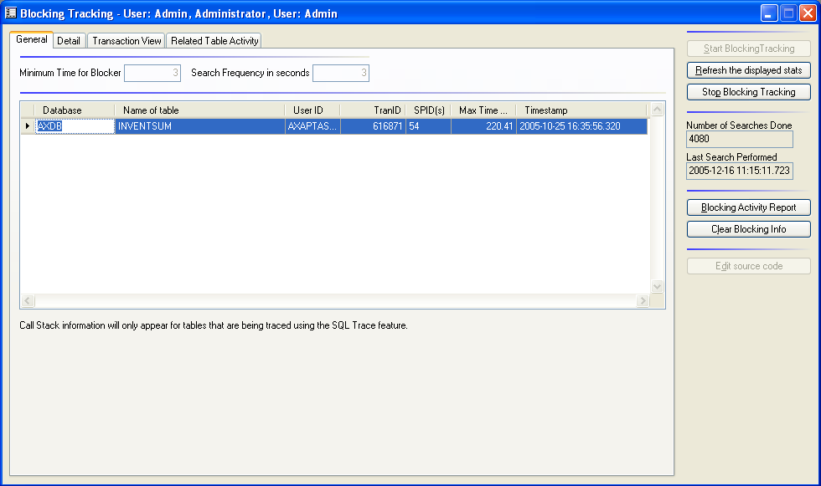

A typical scenario for using this tool might involve one of the two primary ways of using this window to identify the cause of blocking issues. These two methods vary slightly, depending on whether or not the database administrator/support engineer has already identified the tables that are causing the blocking problem. The following scenarios illustrate the differences.

Scenario 1 – Core tables already identified — looking for root cause
- For best results to trace the code, use the Selective SQL Tracing tool to narrow the results of SQL Tracing down to the table(s) that have been identified as part of the problem. Apply these trace settings across all users who would be accessing this portion of Axapta. Activate SQL Trace for all these users as well.
- Open the Blocking Tracking window, and select criteria for the Minimum Time for Blocker and Search Frequency. Typically you would not look for values under three seconds for the Minimum time for blockers.
- Click Start Blocking Tracking. This step only needs to be done once; it applies to the entire server.
- Have the users continue to do their normal processing for a period of time long enough to experience the blocking issues. You can periodically open the Blocking Tracking window to see if new information appears in the grid, or click Refresh the displayed stats if the window remains open.
- After new information appears in the grid, the user can get more information about the table that is causing the issue, along with other pertinent information. The user ID will likely be the bmssa (or other SQL user defined during Axapta setup) unless the blocking is being caused by an external program.
- You can highlight a row of the grid and then go to the Transaction View tab or the Related Table Activity tab if you are using SQL tracing with the table being blocked. The details of what these windows will show and how to use them are described in the Call stack information from Blocking Tracking section of this document.

Scenario 2 – Core tables not identified – early stages of blocking detection
For situations in which users cannot identify the tables that are involved in blocking scenarios, but they suspect a blocking scenario might exist, the Blocking Tracking window should be turned on without using SQL Trace functionality. To do this effectively, follow these steps:
- In this scenario, unless you are using the information for some other purpose, SQL Tracing should be turned off for all users.
**Note: An alternative technique would be to turn on SQL Tracing for all users who have a Long Query Threshold of 1000 (1 second) logged to Table (database). One cause of blocking is a process that has a long running query within a transaction, and this technique can be used to identify the call stack of the lead blocker. Scenario 1 can then be used as a follow up if needed.
- Open the Blocking Tracking window, and select criteria for the Minimum Time for Blocker and Search Frequency in seconds. Typically you would look for values of at least three seconds for the Minimum time for blockers.
- Click Start Blocking Tracing. This step only needs to be done once, and it applies to the entire server.
- Have the users continue to do their normal processing for a period of time long enough to experience the blocking issues. You can periodically open the Blocking Tracking window to see if new information appears in the grid, or click Refresh the displayed stats if the window remains open.
- After new information appears in the grid, the user can get more information about the table that is causing the issue, along with other pertinent information. The user ID will likely be the bmsssa user (or other SQL user defined during Axapta setup) unless the blocking is being caused by an external program.
- After the table(s) are narrowed down using this method, then the debugging process should switch to using the SQL Trace tool in conjunction with the Blocking Tracking tool as described in Scenario 1.

Call stack information from Blocking Tracking
The call stack is the starting point for a developer to resolve blocking problems. When reviewing the code, it is important to be aware that the problem is not necessarily in the lowest level of code identified in the call stack. The entire chain of execution needs to be reviewed from the highest level to the lowest. The section of code to focus on will be the area between the start of a transaction, and the point at which it is either committed or aborted. In this section look for:
- Large number rows being updated (including inserts and deletes)
Updating a large number of rows will create the potential for blocking other users, and may require a query review (along with index considerations) or a redesign to reduce the amount of work being completed within the transaction. Long running select statements should also be reviewed to determine if they can be generated with a nolock statement to prevent them from becoming blocked.
- Inefficient data access
All table access (insert, update and delete, as well as selects) should be reviewed to be sure they are being accessed as efficiently as possible. This includes inserts, updates and deletes, and select statements. An inefficient select statement, or many iterations of a select statement increases the duration of the transaction even though no data is being changed. Indexes should be reviewed to be sure the optimal index is being used, or, if a new index should be created to better support the query.
- Reports
Reporting within a transaction adds additional table reads and extends the duration of the transaction. Displaying a report to users and waiting for them to close the report before continuing would also unnecessarily hold open the transaction.
- End user prompts
Displaying a prompt to end users that requires them to click an OK button before continuing will hold the transaction open and give widely varying blocking times, depending on how quickly the button is clicked.

Both the Transaction View and Related Table Activity tabs on the Blocking Tracking form can help you to identify what might be going on related to the blocking situation that has been uncovered. Both tabs will show the same type of field values related to the data stored in the SysTraceTableSQL table such as the Call Stack, the SQL statement that was executed and the length of time to execute the statements, but the criteria for filling the grid with records is very different between the two.

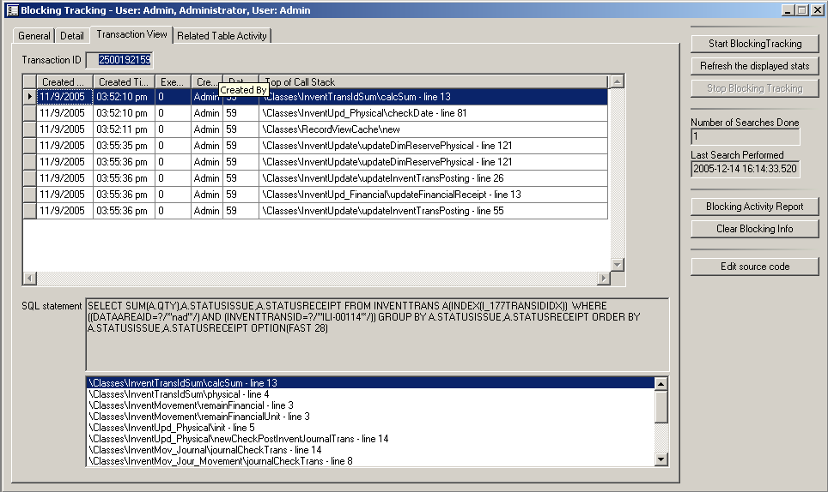

The Transaction View tab shows the SQL transaction ID that has been selected, and will display, ordered by date and time, all the rows logged in the SysTraceTableSQL table that used that same transaction ID. Highlighting individual rows of the upper grid will display the SQL statement and full Call Stack information for each operation that was part of the core transaction. It is important to note that records must be logged into the SysTraceTableSQL using the criteria established on the SQL tab of the Options form before they will show up in this view. So, if you are trying to troubleshoot transactions at this level, you may need to temporarily turn on SQL tracing with a Long Query Timeout of some low value such as 20 (which is 20 milliseconds), or, use the Selective Table option to be able to properly see all the data activity related to these transactions.
Investigating the order of the SQL statements may lead to a clue of what is being blocked or potentially causing deadlocks by comparing the order of update activity within this transaction to other code locations that might be updating the same tables in a different order. The person using this window can also highlight a line of the CallStack list at the bottom of the window and click Edit source code to zoom right to the line of code specified in the call stack.

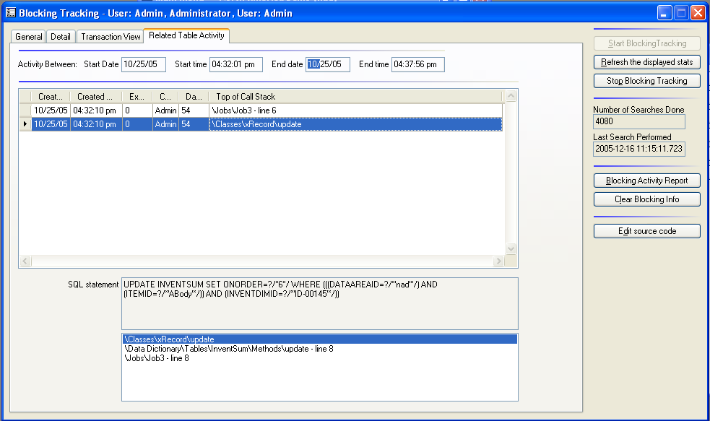

The Related Table Activity tab will show all the details of all the SQL statements logged against just the specific table that is currently being a lead blocker. The range of time for the records being shown is based on the blocking record. The start time is equal to 15 seconds prior to when the blocking statement was executed, and the end time is equal to 2 minutes after the blocking statement completed. These start and end values are displayed above the grid. The activity in this view will potentially show records from multiple users and multiple SPIDs and can be used to see what other activity is present in the system and might be contributing to the blocking situation or might be an activity that was put on hold because of the blocking situation. The ability to edit the source code exists on this tab as well.

Blocking Activity Report
The Blocking Tracking window also allows a user to print a Blocking Activity report that will show the blocking information, the SQL Statement and the Call Stack Information for all rows within the same transaction that the blocking statement is using. The information should match that which shows in the Transaction View tab. Users can choose to restrict the report to a specific date matching the timestamp date of the blocking records or to a specific transaction ID when they choose to print the report.

Clearing the blocking information
Periodically it will be useful to clear the blocking information from the tables used by the Blocking Tracker window. To do this, click Clear Blocking Info to remove information that may be outdated. When the users click Clear Blocking Info, they will be prompted to supply the number of days old. If a value greater than 0 is entered, then the system will remove all information that is greater than that many days old, keeping the most recent info. If a value of 0 is entered, all blocking information will be removed. The routine that creates the blocking log records will also clean up rows in the table after the table reaches a size of 10,000 rows. At that point the oldest 1000 rows will be removed. This process will also clear the contents of the eeSqlTraceExtension table, which is used to store the Transaction ID for each SQL Trace record.

SQL Operation Counters
The main purpose for using SQL Operation Counters functionality is to help determine where potential performance problems exist. The basic functionality of this window is to capture information about how many table operations (select, insert, update and delete) happen within a user-defined time frame. If the information shows that a specific table is being hit an inordinate or unexplainable number of times, then further debugging can determine the cause of the extra table operations.
Functionality also exists within this tool to capture the total time spent on the operations if the time spent is greater than 1 millisecond. Operations that are under 1 millisecond will not add to the total time on this window. To use this window to report all operations, set Long Query Timeout for the Axapta Tracing information to 1 if you want to track all operations. If you only want to see the impact of longer running queries over a period of time, set Long Query Timeout to a higher value before you click Collect stats for all tables.

Collecting statistics
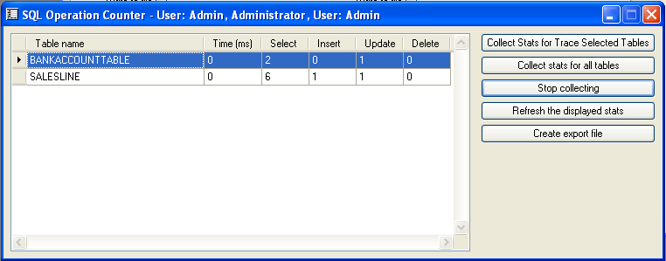
This window will also work in conjunction with the Selective SQL Tracing options outlined earlier in this document. If a user is tracing specific tables, then the Collect Stats for Trace Selected Tables button will only capture information for the tables chosen in the Selective SQL Tracing window. The Collect stats for all tables button will capture table statistics for any table in the Axapta system, including those that are used for Axapta system functionality related to metadata storage.
After starting the collection by clicking one of the two Collect buttons, users should perform the activity they want to investigate. Users can then come back to the window and either hit the Refresh the displayed stats button or Stop collecting and begin to investigate the results.

Evaluating statistics
The biggest challenge in using this window is to properly interpret the results. To interpret the results most accurately, the user doing the interpretation should be aware of what table operations should have taken place. For example, if a sales order has 3 line items on it, when you post that order you would expect to see numbers for the SALESLINE table that are fairly low if that is the only operation you performed. If you see a very high number for a table, then there may be room for performance tuning in that area. If there are any operations that take over 1 ms to run, their total time will show in the Time column. This time information can help to identify blocking areas and possible cases where adding nolock hints or performing index tuning might help improve overall performance.

Export statistics
The Create export file button can be used to create a comma-delimited file that can be sent to a partner or support engineer for further evaluation. The information is only useful if the export file is also accompanied by a description of the activity that was done to generate the statistics.

Appendix

Clicked event script for All Users – DB Settings button
void clicked()
{
UserInfo updateUserInfo;
;
if (box::yesNo("@EET73",DialogButton::Yes) == DialogButton::Yes)
{
if (UserInfo.debugInfo & #FLAG_SQLTrace)
{
ttsbegin;
while select forUpdate updateUserInfo
{
if (updateUserInfo.Id == userinfo.Id)
continue;
updateUserInfo.QueryTimeLimit = UserInfo.querytimeLimit;
updateUserInfo.DebugInfo = updateUserInfo.debugInfo | #FLAG_SQLTrace;

if (UserInfo.traceInfo & #FLAG_TraceInfoWarningTable)
updateUserInfo.traceInfo = updateUserInfo.traceInfo | #FLAG_TraceInfoWarningTable;
else
updateUserInfo.traceInfo = updateUserInfo.traceInfo & ~(#FLAG_TraceInfoWarningTable);

if (UserInfo.traceInfo & #FLAG_TraceInfoDeadlockTable)
updateUserInfo.traceInfo = updateUserInfo.traceInfo | #FLAG_TraceInfoDeadlockTable;
else
updateUserInfo.traceInfo = updateUserInfo.traceInfo & ~(#FLAG_TraceInfoDeadlockTable);

if (UserInfo.traceInfo & #FLAG_TraceInfoQueryTable)
updateUserInfo.traceInfo = updateUserInfo.traceInfo | #FLAG_TraceInfoQueryTable;
else
updateUserInfo.traceInfo = updateUserInfo.traceInfo & ~(#FLAG_TraceInfoQueryTable);

if (UserInfo.traceInfo & #FLAG_TraceInfoStateTable)
updateUserInfo.traceInfo = updateUserInfo.traceInfo | #FLAG_TraceInfoStateTable;
else
updateUserInfo.traceInfo = updateUserInfo.traceInfo & ~(#FLAG_TraceInfoStateTable);

updateUserInfo.update();
}
ttscommit;
}
else
while select forUpdate updateUserInfo
updateUserInfo.DebugInfo = updateUserInfo.debugInfo & ~(#FLAG_SQLTrace);

warning ("@EET78"); // warning ("In order to see these changes take effect, users will need to log out and log back in again");
}
}

Information in this document including URL and other Internet Web site references, is subject to change without notice. Unless otherwise noted, the example companies, organizations, products, domain names, e-mail addresses, logos, people, places, and events depicted herein are fictitious, and no association with any real company, organization, product domain name, e-mail address, logo, person, place or event is intended or should be inferred. Complying with all applicable copyright laws is the responsibility of the user. Without limiting the rights under copyright, no part of this document may be reproduced, stored in or introduced into a retrieval system, or transmitted in any form or by any means (electronic, mechanical, photocopying, recording, or otherwise), or for any purpose, without the express written permission of Microsoft Corporation.
Microsoft may have patents, patent applications, trademarks, copyrights, or other intellectual property rights covering subject matter in this document. Except as expressly provided in any written license agreement from Microsoft, the furnishing of this document does not give you any license to these patents, trademarks, copyrights, or other intellectual property.
Microsoft, Windows, Axapta, and Microsoft Dynamics are either registered trademarks or trademarks of Microsoft Corporation in the United States and/or other countries.
The names of actual companies and products mentioned herein may be the trademarks of their respective owners.

