1. Sampling Rate Verification

An oscilloscope was attached to pin P10 and its activity was monitored through the Diligent waveform software. Below is a snapshot of what was observed

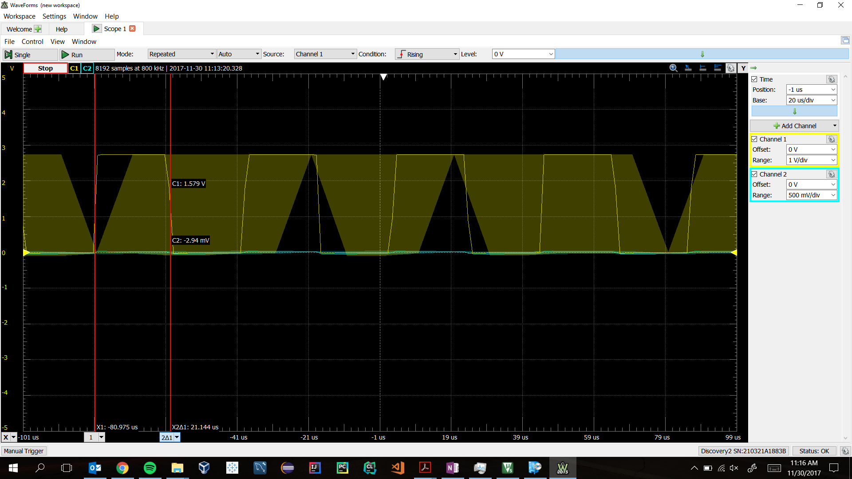

Figure - Oscilloscope capture of the interrupt frequency

Using the time measured between the rise and fall of the signal on the pin, the frequency could be derived. It was expected to be similar to 48 kHz.



Which is very close to 48,000 Hz. It is to be expected that there is small inaccuracy in the measurement. The closeness of the observed value verifies the sampling rate is 48 kHz.

1. When the delay program is run, the right side of the audio performs as it had in the previous program where audio was simply fed through the system. The left side of the audio was very different however. While audio was still fed immediately from input to output, there was also a very noticeable delay that would occur in the left headphone, but not the right headphone. This was due to a ring buffer that stored audio samples and replayed them later.

After initial experimentation, the size of the buffer was decreased by half so that it would store 12,000 audio samples. This caused the delay to shorten as well; the delay was now 0.25 seconds. At this point it became difficult to differentiate between the actual sound being picked up, and the sound which was being played back from a previously saved sample. The smaller the buffer size, the quicker it would roll over and play the previously stored audio sample.

When the delay was increased substantially to twice the size, the delay was noticeably longer. The time between the initial sound and when it was played back was roughly 1 second. Weird behavior was introduced when this was done however. It seemed that the audio that was supposed to be delayed was sometimes lost, and there was a noticeable dead sound that happened periodically in the left headphone. When saved audio should have been played back during the “dead zone”, the audio was lost. It’s could be possible that some sort of memory limit was set which prevented the larger buffer from storing all of the necessary data.

1. Part 9 – block diagram

The block diagram for the echo would be similar to the delay, except for one important feature. The echo block diagram would include a loopback so that audio samples would be multiplied by their gain, and restored to be played again at a lower amplitude.

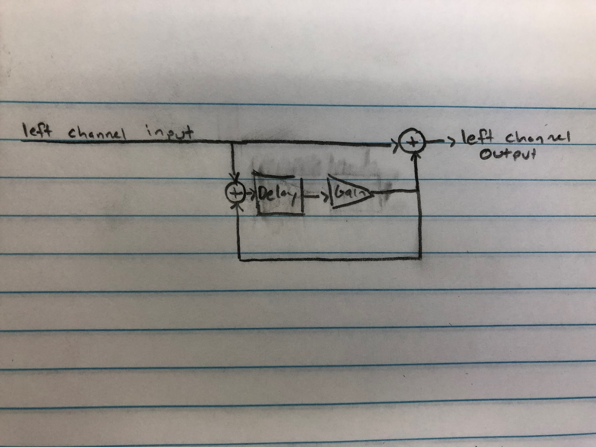

Figure - Block diagram of the echo functionality.

1. Part 9 – Gain

If the gain was made greater than or equal to 1, the saved samples would not go to 0. If the gain were 1, the sound recorded would be infinitely repeated periodically with the same amplitude. A gain greater than 1 would be much worse. Rather than repeating or slowly dying, the amplitude would continue to increate over time at a non-linear rate. This would not only take up increasing amounts of data for storage, but could also be harmful and damage the playback device or a person’s hearing. An echoed sample with a gain greater than or equal to 1 should be avoided if it is to remain stable.

1. Part 9 – Time Domain Impulse Response

In the time domain, an impulse response would result in a discrete periodic response that decreases/increases in amplitude according to the gain. Such a response would look similar to the sketch shown below.

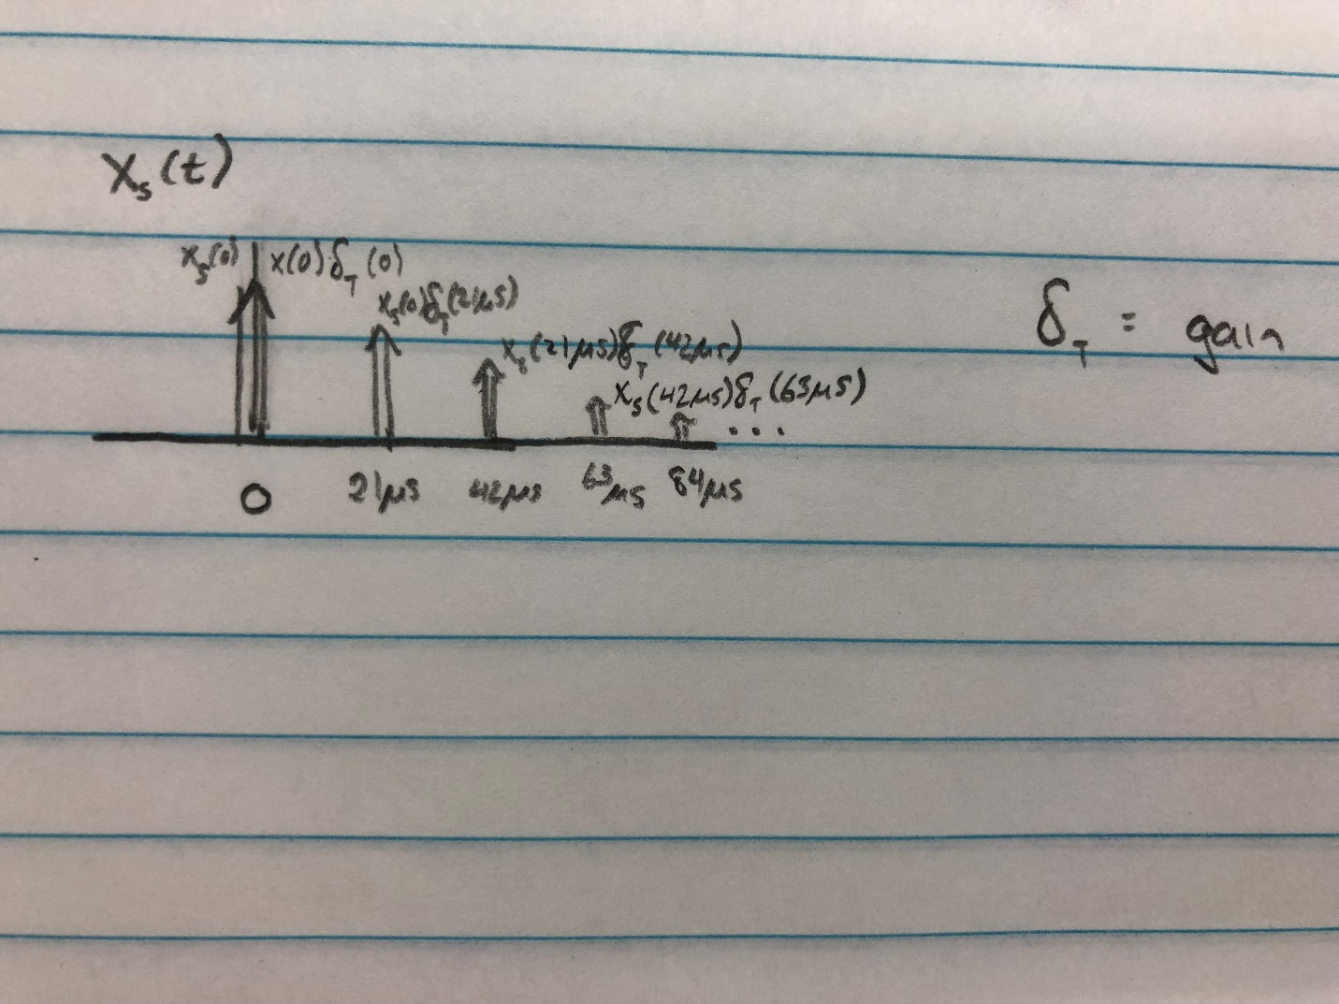

Figure - The impulse response using the echo file in the time domain.