Group Name: Blogbox
Group Number: 19
Group members:
Gustav Simonsson 911017
Andreas Trakossas 920515
Henrik Merlander 921114
Patrik Larsson 890608

Our Web Application is a platform for blogs. It is supposed to be used by people who want to have a place to blog on or who want to read other peoples blogs.

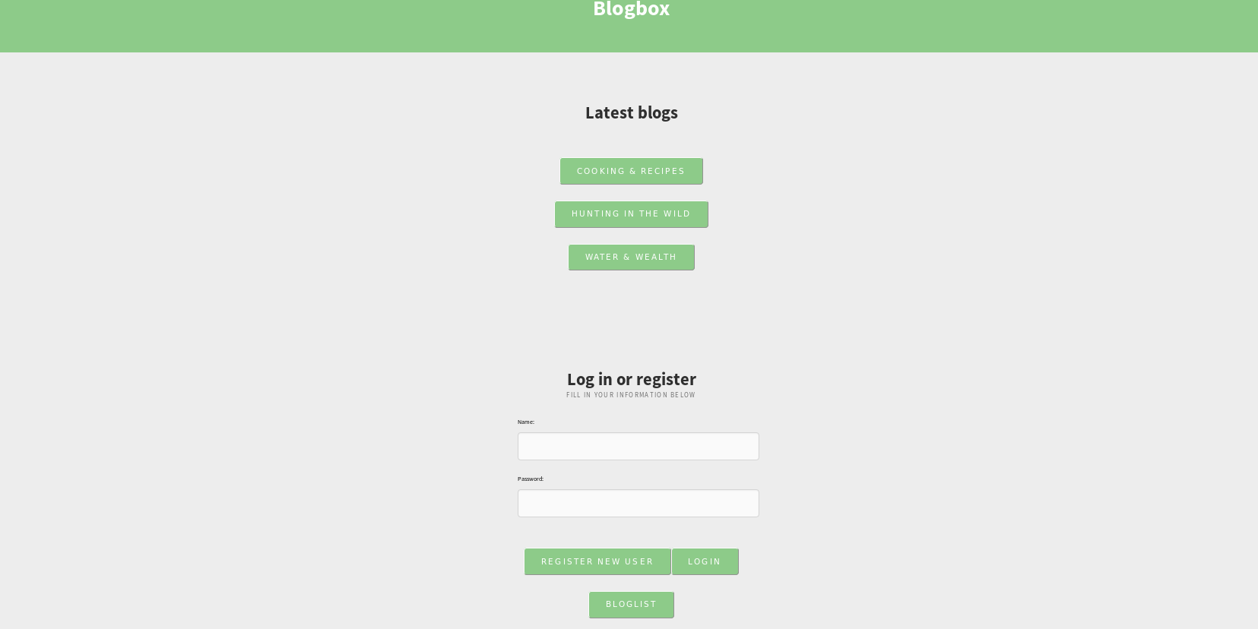

We have two roles, user and non-user. A non-registered user can only read blogs but not create own blogs or blog posts. If you create a user you can post your own blogs and posts in them.

User Cases:
-Create a personal user name with password security.
-Add as many blogs to my user as I want.
-Add as many blog posts as I want to each blog.
-Quick access to the index page by clicking the index button, and still be able to access my blog list with a button.
-Log out and create a new user not related to my old account.
-Latest blogs from the start page without being logged in.
-Button that lists all existing blogs without need for an account.
-Blog not vulnerable for hackers by modifying the URL.

Client – Web Browser
Server – Web Application, GlassFish, Java 1.7
Database server – Derby

Server – Java, JSF. Jquery, JavaScript,

Presentation – Here is all the beans responsible for creating sessions and forward get and set operations.

Entities – Everything that should be saved in the database, Blog, user and blog post.

Boundary – The connection between the presentation package and the database.

