## Wood Game: User Manual

Wood Game is an Android game where the player takes control of a small hero lost in the forest. He needs to find his way through different levels, avoiding hazards along the way.

The game is easy to get into but can be challenging, since your score while doing a level is steadily decreasing. Speed is of the essence if you wish to have a nice score by the end.

The game has a number of interesting features

* Animated graphics
* Interactive terrain: movable blocks, dangerous water, teleportation blocks
* Items: Locks & keys
* Music and sound
* A highscore list: Make your name known as you try to beat the score of others.

On the following pages you will find a guide on how to play Wood Game.

## Starting the game

After the splash screen you will be welcomed with a menu screen with two buttons. The green one starts the game and the red one closes the application.

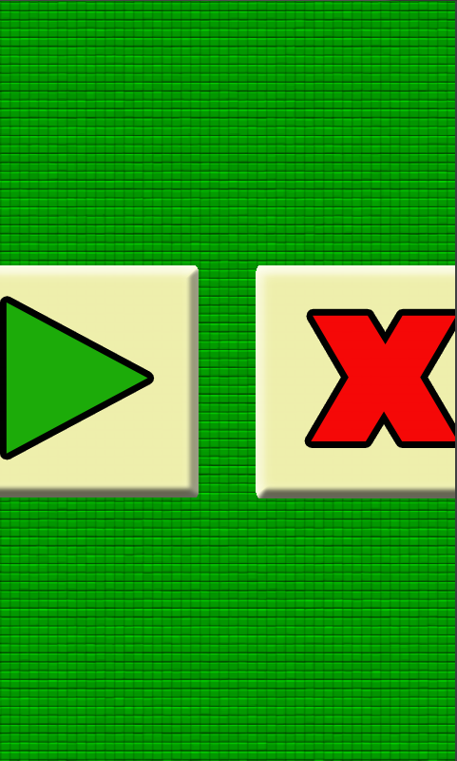

Afterwards you are asked to enter a username so you can put your name on the highscore list. If you wish to be anonymous you can always ignore entering a name and just leave it blank.

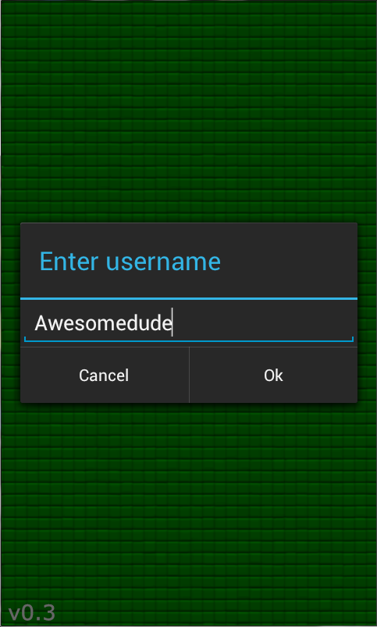

## Playing the game

In the game you control the character by touching the dpad on the lower right of the screen. The character can move in four different directions. Holding the dpad in one direction lets the character move in that direction repeatedly. On the lower left of the screen you will see your score. As time goes on it will go down so its important that you complete the level quickly, or else your score fort he level will be too low. There is also a text telling you how many keys the character is currently carrying, more on that later.

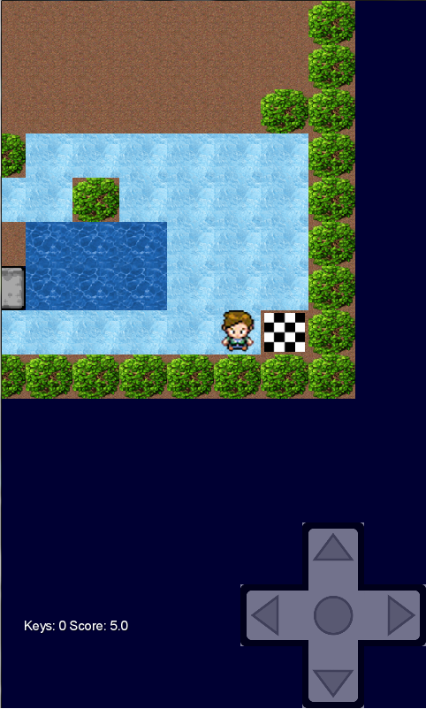

To complete a level, the character must reach the ending tile. (shown on the picture above, to the right oft he character.)

## Interacting with the level

During a level you might stumble upon gray blocks. These can actually be moved by the character by moving right beside it, thus pushing it forward. A block can also be used to create safe ground for the character to walk on, by pushing it into water!

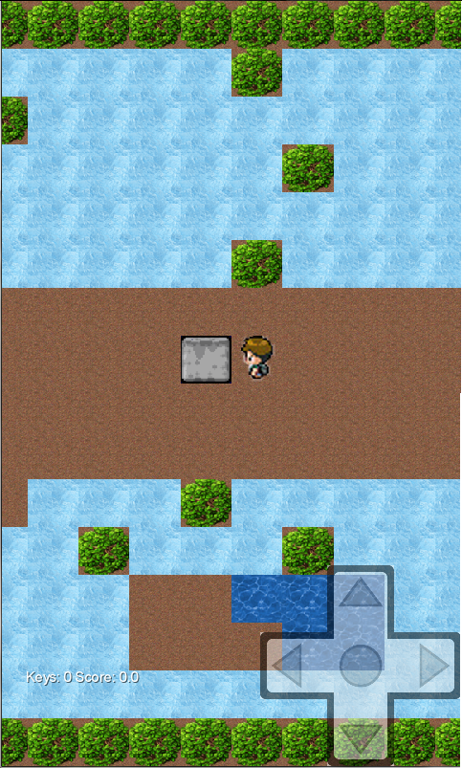

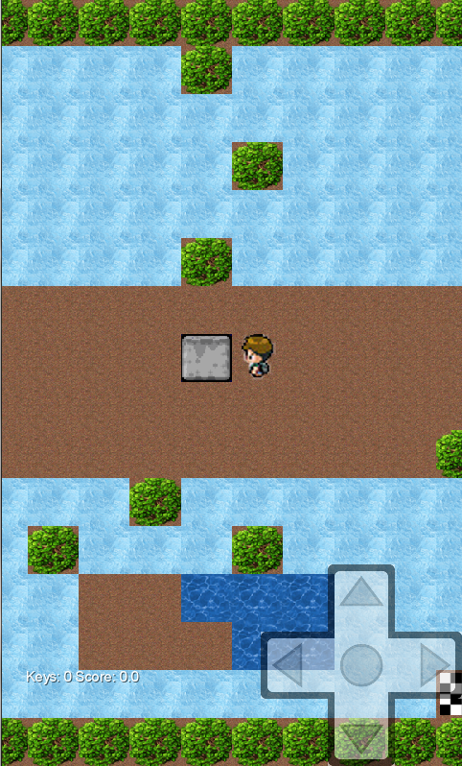

The character might also stumble upon locks that cannot be passed unless the character is carrying a key. To pick up a key, simply walk into it and the number of keys on the lower left of the screen will be updated with your new number of keys. To unlock a lock, walk into it when carrying a key and it will remove the lock so the character can get through. (See below)

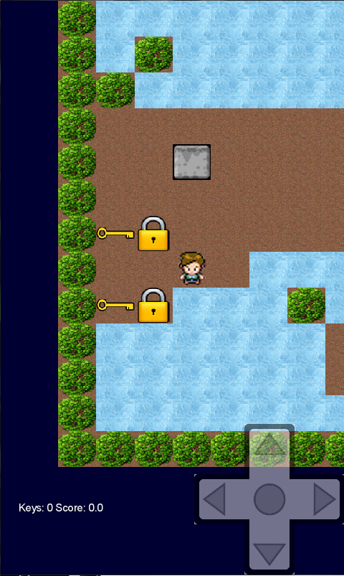

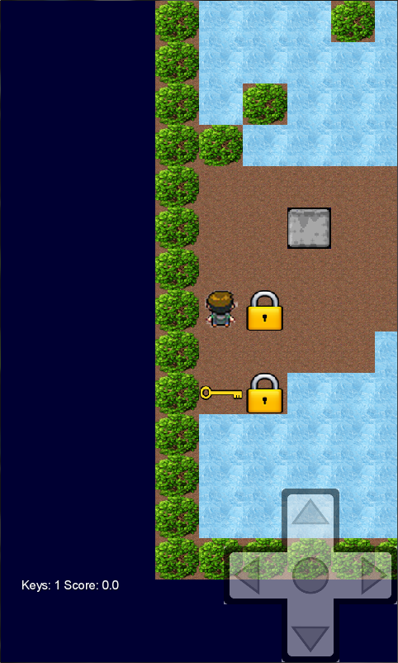

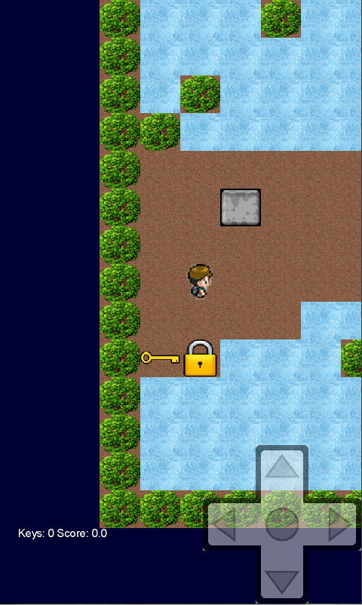

This covers the basics of Wood Game. We hope you have a fun time playing!