Running Stata in a Jupyter notebook on Google Colab or repo2docker
Open In Colab
This notebook installs Stata into the notebook runtime, asks for your Stata license (as a base64-encoded string), and then runs Stata code through the %%stata cell magic provided by StataCorp’s PyStata.
Before you start, create the base64-encoded version of your stata.lic on your own computer:
base64 -w0 /usr/local/stata/stata.lic # Linux
base64 -i /Applications/Stata/stata.lic # macOS
[Convert]::ToBase64String([IO.File]::ReadAllBytes("C:\Program Files\Stata19\stata.lic")) # Windows
Copy the resulting single line; you will paste it into a hidden prompt below. It is only written to the runtime’s Stata directory, never to the notebook.

1. Settings
Stata is copied out of one of the AEA Data Editor’s Stata Docker images (which contain no license). Set the version using the image-name spelling (e.g. 19_5 for Stata 19.5) and pick a tag, or use latest to look up the most recently updated tag on Docker Hub. Pick the edition that matches your license: an MP license can also run SE, so se works for both SE and MP licenses.
import os
VERSION = "19_5" # image-name spelling, e.g. "19_5" for Stata 19.5
TAG = "2026-08-12" # a specific tag, or "latest"
EDITION = "se" # "be", "se" or "mp"
IMAGE = f"dataeditors/stata{VERSION}-{EDITION}:{TAG}"
STATA_ROOT = "/" if os.geteuid() == 0 else os.path.expanduser("~")
STATA_DIR = os.path.join(STATA_ROOT, "usr/local/stata")

2. Install Stata
This uses the helper script from this repository (downloading it only if needed) and copies Stata to /usr/local/stata on Colab, or ~/usr/local/stata for non-root users such as repo2docker (about 700 MB, usually well under a minute on Colab).
if not os.path.exists("setup_stata.py"):
!wget -q https://raw.githubusercontent.com/larsvilhuber/jupyter-stata-colab/main/setup_stata.py
import setup_stata
setup_stata.install_stata(image=IMAGE, root=STATA_ROOT)
Fetching Stata from docker.io/dataeditors/stata19_5-se:2026-08-12 ...
layer 1/9 sha256:b71466b94f26
layer 2/9 sha256:50bbe9355d9a
layer 3/9 sha256:36b113ab1d27
layer 4/9 sha256:21f5f60104a3
layer 5/9 sha256:c2114ca3083a
layer 6/9 sha256:2f76430387b3
layer 7/9 sha256:bae8c00e3552
layer 8/9 sha256:f5762a497a42
layer 9/9 sha256:5df1c422ab3d
Stata installed in /usr/local/stata
'/usr/local/stata'

3. Enter your license
Paste the base64-encoded content of your stata.lic when prompted (the input is hidden). If the environment variable STATA_LIC_BASE64 is set, it is used instead of prompting.
from getpass import getpass
license_b64 = os.environ.get("STATA_LIC_BASE64") or getpass("Base64-encoded stata.lic: ")
setup_stata.write_license(license_b64, stata_dir=STATA_DIR)
del license_b64
License written to /usr/local/stata/stata.lic

4. Start Stata
This first checks that Stata accepts the license, then initializes PyStata, which registers the %stata and %%stata magics.
setup_stata.configure_pystata(stata_dir=STATA_DIR, edition=EDITION)
Stata license OK.
___ ____ ____ ____ ____ ®
/__ / ____/ / ____/ StataNow 19.5
___/ / /___/ / /___/ SE—Standard Edition
Statistics and Data Science Copyright 1985-2025 StataCorp LLC
StataCorp
4905 Lakeway Drive
College Station, Texas 77845 USA
800-782-8272 https://www.stata.com
979-696-4600 service@stata.com
Stata license: 2-user network, expiring 27 Apr 2027
Serial number: 501909230155
Licensed to: Lars Vilhuber / AEA Data Editor
Cornell University
Notes:
1. Unicode is supported; see help unicode_advice.
2. Maximum number of variables is set to 5,000 but can be increased;
see help set_maxvar.
<module 'pystata.config' from '/usr/local/stata/utilities/pystata/config.py'>

5. Use Stata
Any cell starting with %%stata is run by Stata.
%%stata
sysuse auto, clear
summarize price mpg weight
. sysuse auto, clear
(1978 automobile data)
. summarize price mpg weight
Variable | Obs Mean Std. dev. Min Max
-------------+---------------------------------------------------------
price | 74 6165.257 2949.496 3291 15906
mpg | 74 21.2973 5.785503 12 41
weight | 74 3019.459 777.1936 1760 4840
.
%%stata
regress price mpg weight foreign
Source | SS df MS Number of obs = 74
-------------+---------------------------------- F(3, 70) = 23.29
Model | 317252881 3 105750960 Prob > F = 0.0000
Residual | 317812515 70 4540178.78 R-squared = 0.4996
-------------+---------------------------------- Adj R-squared = 0.4781
Total | 635065396 73 8699525.97 Root MSE = 2130.8
------------------------------------------------------------------------------
price | Coefficient Std. err. t P>|t| [95% conf. interval]
-------------+----------------------------------------------------------------
mpg | 21.8536 74.22114 0.29 0.769 -126.1758 169.883
weight | 3.464706 .630749 5.49 0.000 2.206717 4.722695
foreign | 3673.06 683.9783 5.37 0.000 2308.909 5037.212
_cons | -5853.696 3376.987 -1.73 0.087 -12588.88 881.4934
------------------------------------------------------------------------------
Graphs are displayed inline:
%%stata
twoway (scatter price mpg) (lfit price mpg), title("Price vs. mileage")
Data can be moved between Stata and Python (pandas):
from pystata import stata
df = stata.pdataframe_from_data()
df.groupby("foreign")[["price", "mpg"]].mean()
 | price | mpg
foreign
0 | 6072.423077 | 19.826923
1 | 6384.681818 | 24.772727
%%stata -d df -force
describe, short
Contains data
Observations: 74
Variables: 12
Sorted by:
Note: Dataset has changed since last saved.

6. Your turn: a printable table and a figure
The cells below are the solutions to part 4 of the Reproducible Documents tutorial: a clean regression table and a figure, a number from Stata in a sentence, and a figure made with Python. Run the cells above first.
A clean, printable regression table (etable), and a figure that is shown below the cell and saved to disk.
%%stata
* Estimate three models and store them
sysuse auto, clear
quietly regress price mpg
estimates store m1
quietly regress price mpg weight
estimates store m2
quietly regress price mpg weight i.foreign
estimates store m3
* A clean, printable regression table
etable, estimates(m1 m2 m3) column(index) varlabel ///
showstars showstarsnote mstat(N) mstat(r2) ///
title("Table 1: Car prices and fuel efficiency")
* A figure: shown below the cell, and saved to disk
twoway (scatter price mpg) (lfit price mpg), by(foreign, note("")) ///
ytitle("Price (USD)") xtitle("Mileage (mpg)")
graph export price_mpg.png, replace width(1600)
. * Estimate three models and store them
. sysuse auto, clear
(1978 automobile data)
. quietly regress price mpg
. estimates store m1
. quietly regress price mpg weight
. estimates store m2
. quietly regress price mpg weight i.foreign
. estimates store m3
.
. * A clean, printable regression table
. etable, estimates(m1 m2 m3) column(index) varlabel ///
> showstars showstarsnote mstat(N) mstat(r2) ///
> title("Table 1: Car prices and fuel efficiency")
Table 1: Car prices and fuel efficiency
----------------------------------------------------------------
1 2 3
----------------------------------------------------------------
Mileage (mpg) -238.894 ** -49.512 21.854
(53.077) (86.156) (74.221)
Weight (lbs.) 1.747 ** 3.465 **
(0.641) (0.631)
Car origin
Foreign 3673.060 **
(683.978)
Intercept 11253.061 ** 1946.069 -5853.696
(1170.813) (3597.050) (3376.987)
Number of observations 74 74 74
R-squared 0.22 0.29 0.50
----------------------------------------------------------------
** p<.01, * p<.05
.
. * A figure: shown below the cell, and saved to disk
. twoway (scatter price mpg) (lfit price mpg), by(foreign, note("")) ///
> ytitle("Price (USD)") xtitle("Mileage (mpg)")
. graph export price_mpg.png, replace width(1600)
(file price_mpg.png not found)
file price_mpg.png written in PNG format
.
A number from Stata, in a sentence: Python asks Stata for the coefficient, and writes the sentence (as Markdown) below the cell. No %%stata here: this is Python.
# A number from Stata, in a sentence (Python, no %%stata)
from pystata import stata
from sfi import Scalar
from IPython.display import Markdown
stata.run("sysuse auto, clear", quietly=True)
stata.run("regress price mpg weight", quietly=True)
stata.run("scalar b_mpg = _b[mpg]")
b_mpg = Scalar.getValue("b_mpg")
Markdown(f"Holding weight constant, one more mile per gallon "
f"changes the price by **{b_mpg:.1f}** dollars.")
Holding weight constant, one more mile per gallon changes the price by -49.5 dollars.
A figure that is hard to make in Stata, made with Python (matplotlib) from the Stata data: the scatter plot, with a histogram of each variable along its axis.
# A figure that is hard to make in Stata (Python, matplotlib):
# the scatter plot, with a histogram of each variable along its axis
import matplotlib.pyplot as plt
from pystata import stata
stata.run("sysuse auto, clear", quietly=True)
auto = stata.pdataframe_from_data() # Stata data -> pandas
fig, ax = plt.subplots(figsize=(7, 6))
ax.scatter(auto["mpg"], auto["price"])
ax.set_xlabel("Mileage (mpg)")
ax.set_ylabel("Price (USD)")
top = ax.inset_axes([0, 1.02, 1, 0.2], sharex=ax) # above
right = ax.inset_axes([1.02, 0, 0.2, 1], sharey=ax) # on the right
top.hist(auto["mpg"], bins=15)
right.hist(auto["price"], bins=15, orientation="horizontal")
top.axis("off")
right.axis("off")
fig.savefig("price_mpg_hist.png", dpi=200, bbox_inches="tight")
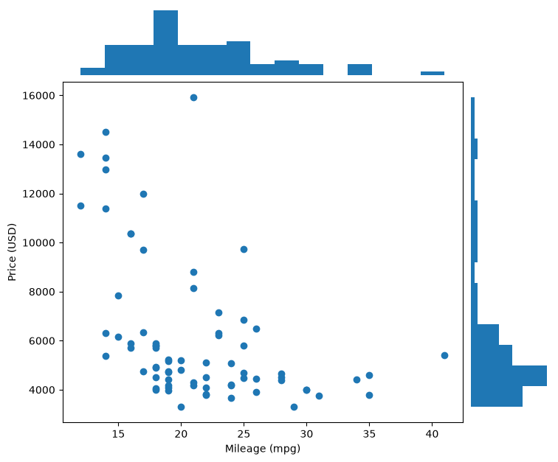

7. Print this notebook
- PDF: File ▸ Print ▸ Save as PDF.
- Word (or PDF) on Binder: save the notebook, then File ▸ New ▸ Terminal, and type pip install quarto-cli, then quarto render stata_colab_solutions.ipynb --to docx (or --to typst for PDF). Add -M echo:false to hide the code.
- Word on Colab: File ▸ Download ▸ Download .ipynb, then run the same quarto render command wherever Quarto is (posit.cloud, or your laptop).

