Summer School on Research Reproducibility

TITLE: Summer School in Research Reproducibility: Ensuring the Transparency and Credibility of Your Work
- May 28, 9 AM to 3 PM
- In person at SFU Downtown, 515 W Hastings St, Vancouver BC (exact room TBD)
- In English
- Free

This intensive training explores the fundamental principles of reproducibility, a pillar of open science that ensures the transparency and credibility of scientific research. You will discover best practices to make your work reproducible, from data management to code documentation, version control, and results publication.

OBJECTIVES
- Master the challenges and principles of research reproducibility
- Acquire technical skills to create reproducible projects
- Learn to effectively document your analyses and code
- Develop concrete strategies for data management and sharing

WHO SHOULD ATTEND
This training is intended for researchers of all levels (graduate students, faculty, research staff) with experience in empirical data analysis. Knowledge of at least one statistical software package (Stata, R, Python, MATLAB) is required.
Participants must bring their own laptop with their preferred statistical software.

Sponsored by:

Research Chair in Intergenerational Economics, ESG UQAM

Alfred P. Sloan Foundation grant to Cornell University (Lars Vilhuber)

INSTRUCTORS

 | Lars Vilhuber holds a Ph.D. in Economics from Université de Montréal, and is currently on the faculty of the Cornell University Economics Department. He has interests in labor economics, statistical disclosure limitation and data dissemination, and reproducibility and replicability in the social sciences. He is the current Data Editor of the American Economic Association.
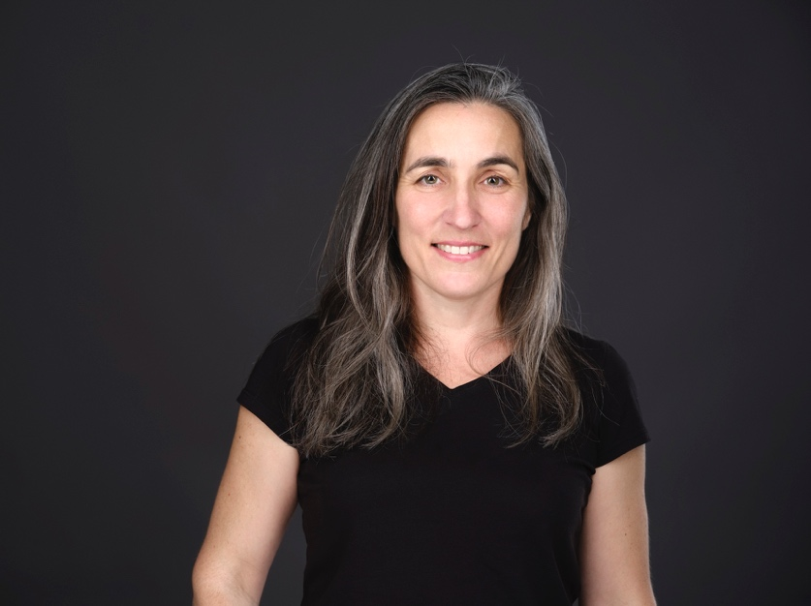 | Marie Connolly (Ph.D. 2007, Princeton University) is a professor at the Department of Economics of UQAM’s School of Management (ESG UQAM), where she teaches statistics and econometrics to undergraduates. Since 2020, she is the Data Editor at the Canadian Journal of Economics. Her research is primarily empirical and touches upon various topics in labor economics, such as the intergenerational transmission of income, social mobility, and the formation of human capital. Her work has been published in the Journal of Labor Economics, the Journal of Economic Behavior and Organization and the Canadian Journal of Economics, among others.

