* In tortoise Hg pull incoming changes from Bitbucket
  + Right Click “update”
  + Discard local changes
  + “Update”

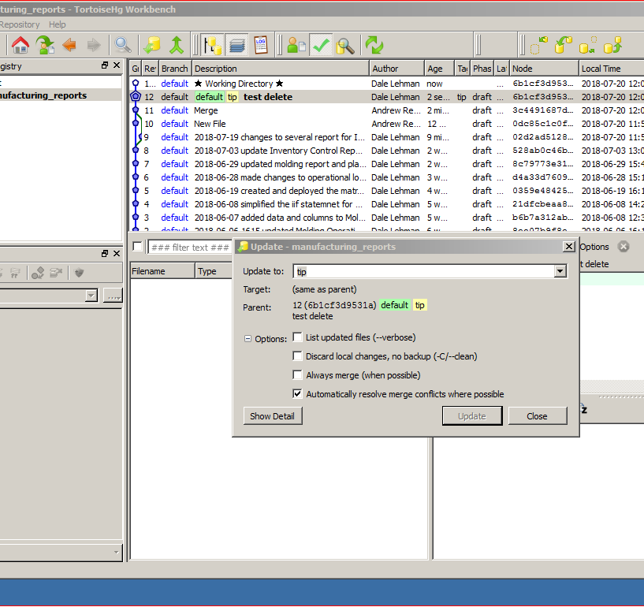

* Visual Studio 2008 and Local Repository
* In Solutions add a new project
  + Base the project name on the Report
  + Move Trello Card to “In Process”
  + Right Click “Add”
  + Report Server Project
  + Name Accordingly
* Edit Project Properties
  + Right click project name
  + Properties
    - Configure Release and Debug compared to reference document Project_property_config.txt
    - Destination Folders are to be set up such that they resemble the current organization
* Create or Choose a Shared Data source
  + HELP
* Add Report number
  + New Text Box
* When deploying reports change configuration to release

