Growing up surrounded by cultural diversity galore in the heart of downtown Toronto, interracial relationships have always seemed like a commonplace feature of society. Several of my friends are mixed-race and hence have parents who are in a mixed union. All of my own romantic relationships have been with people of different races, and I ultimately married someone of a different race.

While my parents never suggested or even hinted that I should marry someone of Chinese origin, I have friends who, like Kumail Nanjiani tells in his autobiographical movie *The Big Sick*, are pressured by their families to marry someone of the same racial and/or religious background. Watching *The Big Sick* recently got me thinking about interracial marriages, wondering how common they are in Canada today and how quickly the number of people in interracial marriages is growing.

To answer these questions, I found **open data** on mixed unions, i.e., a conjugal relationship* of two people of which one partner belongs to a visible minority** group or both partners belong to different visible minority groups, collected in the 2011 National Household Survey (NHS) of 4.5 million - roughly a third of all - households across Canada.

**How many mixed unions are there in Canada?**

In 2011, approximately 360,000 or 4.6% of all married or common-law couples were mixed unions. Though still a small proportion of Canada’s nearly eight million couples, this number has grown from just 2.6% in 1991. It has likely increased since the 2011 NHS and will probably continue growing as the country continues to welcome immigrants from around the world and our society becomes increasingly diverse and integrated.

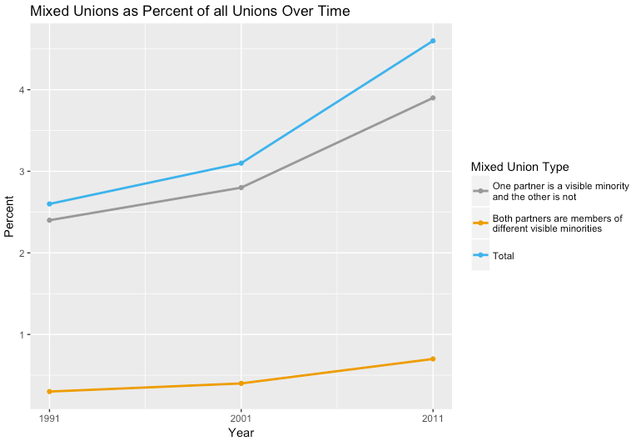

**Where are there the most mixed unions?**

As the map below illustrates, in metropolitan areas, the porportion of couples in mixed unions is already much higher than the national average. This makes sense, as the porportion of visible minorities in big cities is much higher than in smaller towns, meaning a much more diverse dating pool. In Vancouver, approximately 9.6% of couples were in mixed unions in 2011, and Toronto followed closely behind at 8.2%.

[Leaflet map of cities]

**Who is most likely to be in a mixed union?**

Individuals of certain visible minority groups are much more likely to be in mixed unions than others. In 2011, nearly 80% of all Japanese-Canadians in a conjugal relationship were in a mixed union, whereas only 19.4% of Chinese and 13% of South Asians were in mixed unions.

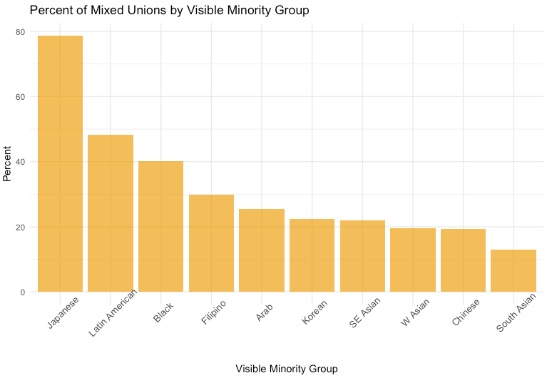

Why are people of certain visible minority groups so much more likely to “marry out” than others? While the marital traditions of certain cultures probably play a large role, data also suggests that visible minorities are more likely to enter a mixed relationship if they are second- or third-generation immigrants. Plotting the percent of people (aged 15+) of a visible minority group that are at least second generation immigrants against the percentage of people of that visible minority group in a mixed union, we can see that, generally speaking, the higher the percentage of people of a visible minority group that are second+ generation immigrants+, the higher the percentage of people of that visible minority group in mixed unions.

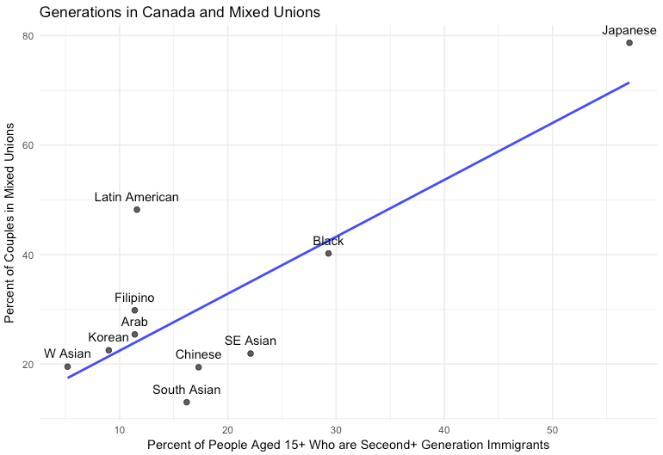

The 2011 NHS data also shows that younger people are more likely to be in mixed unions than older folks. Nearly 60% of couples in mixed unions are under the age of 45, whereas the bulk of couples in non-mixed unions are over 45. This further suggests gradual progression of mixed unions in society as time passes.

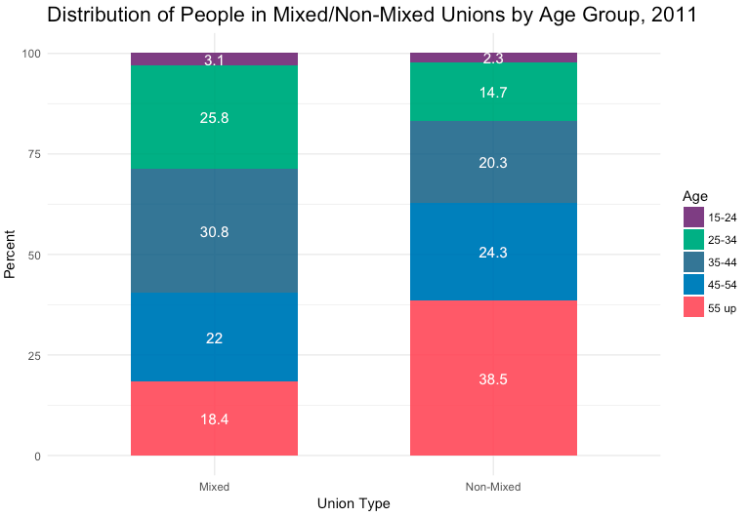

**More Mixed Up for the Better**

With steady immigration and a growing visible minority population in Canada (predicted to reach one third of the population by 2030), it is likely that the proportion of mixed unions will continue to grow. This is good news, as there are many benefits of interracial relationships for the couple and for society on the whole. For the couple, being in a mixed union means the chance to share new perspectives, traditions, food, and celebrations. Mixed-race children often grow up more accepting of people of different races. On the societal level, mixed unions imply more opportunities for families of different cultures and backgrounds to come together, which will ultimately foster greater understanding and acceptance.

**\***two people of opposite or same-sex in a marital or common-law relationship who are living in the same dwelling.

**\*\*** persons, other than Aboriginal peoples, who are non-Caucasian in race or non-white in colour *(The Employment Equity Act).*

+Second generation immigrant: Someone born in Canada but whose parents were immigrants, Third generation immigrant: Someone who was born and whose parents were born in Canada, but whose grandparents were immigrants