**Hands-on No.: 6**

**Topic : CRUD Operations**

**Date : 23-09-2025**

**Create (C):**

**1. Create hospitals, doctors, patients, appointments and admins collection schemas for Hospital Management System**

**2. Insert new documents into collections following the defined schemas**

**using insertOne and insertMany**

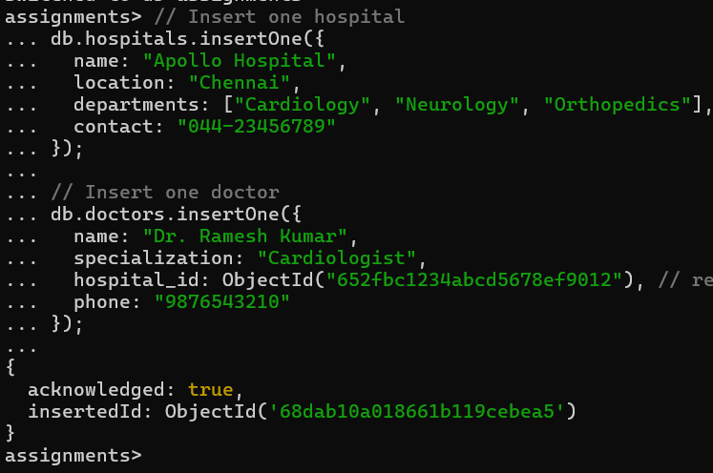

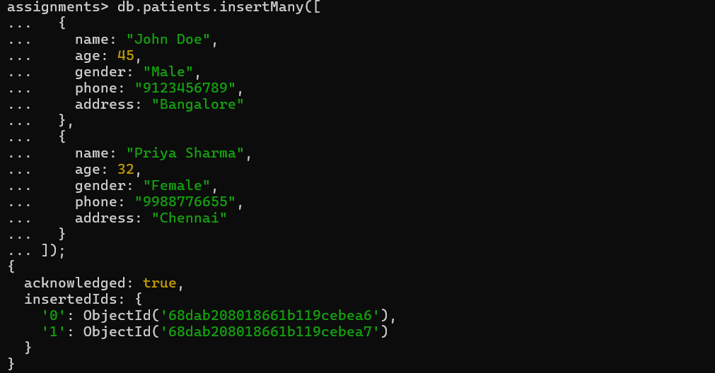

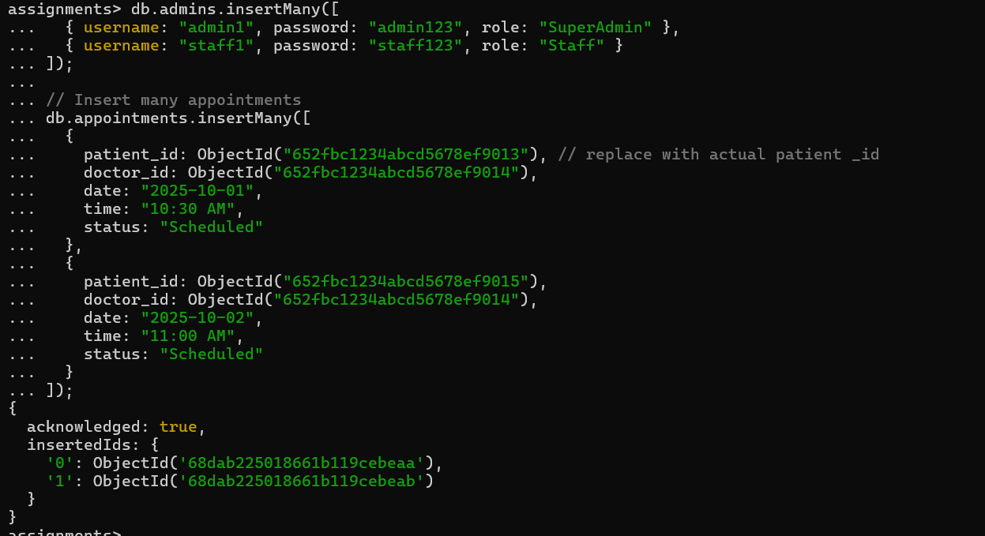

**Read (R):**

1. **Find all hospitals**

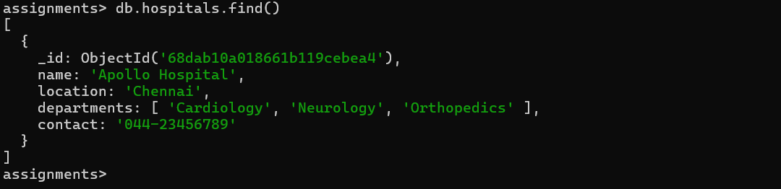

1. **Find hospitals with specific departments**

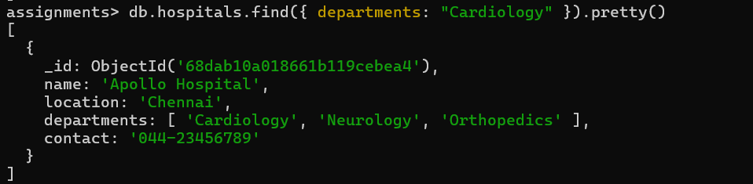

1. **Find doctors by name**

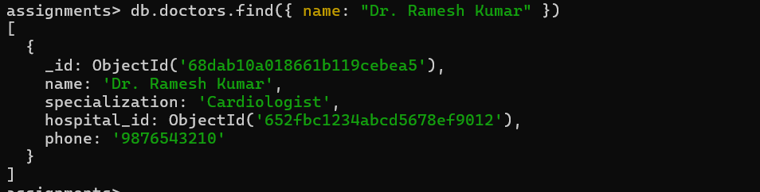

1. **Find doctors by hospital**

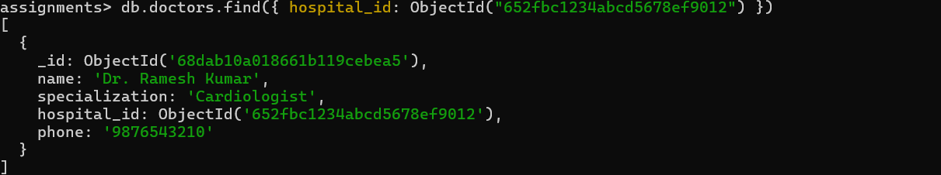

1. **Find patients age 40 and above**

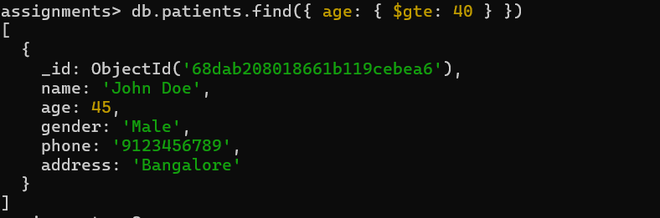

1. **Find appointments by doctor**

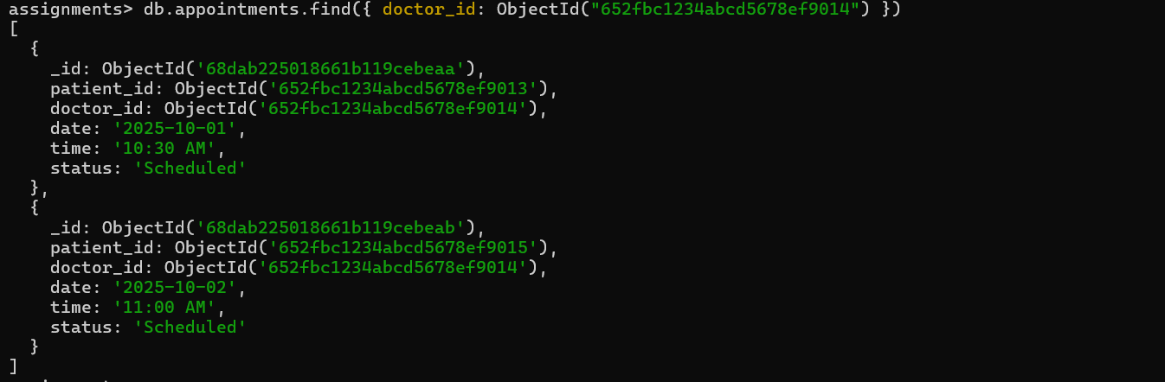

1. **Find appointments by patient**

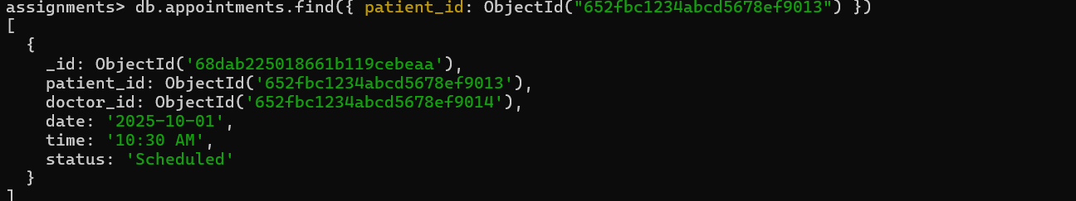

1. **Find all admins**

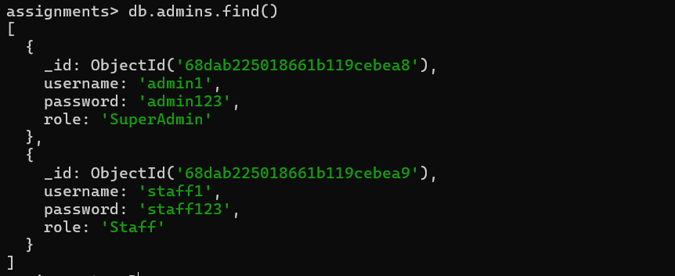

1. **Find admins by name**

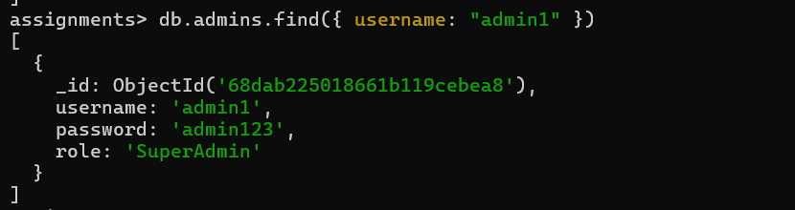

**10.Find admins by role**

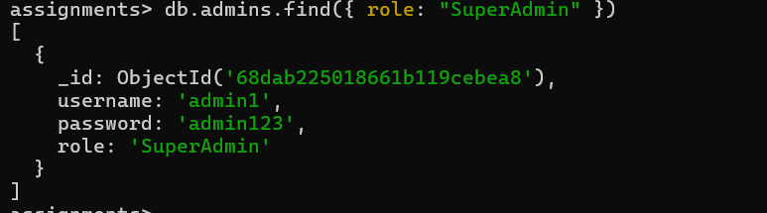

**Update (U):**

1. **Add a new department to a hospital**

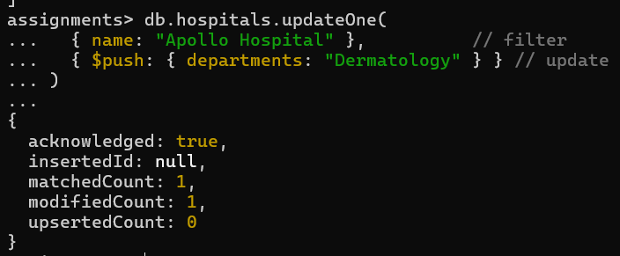

1. **Update contact details for a hospital**

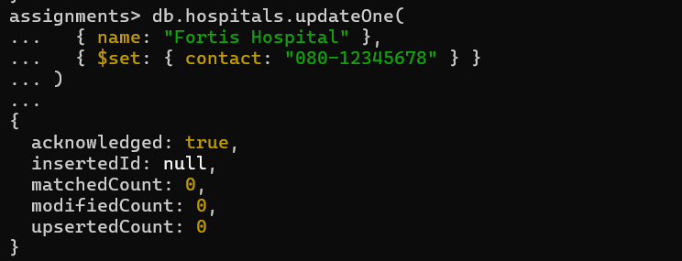

1. **Add a new doctor to a hospital**

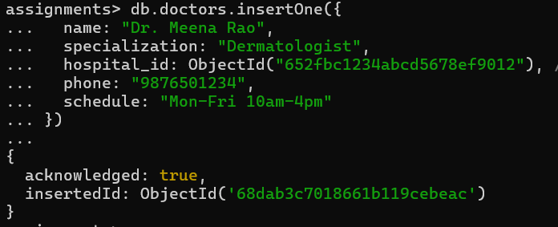

1. **Update schedule for a doctor**

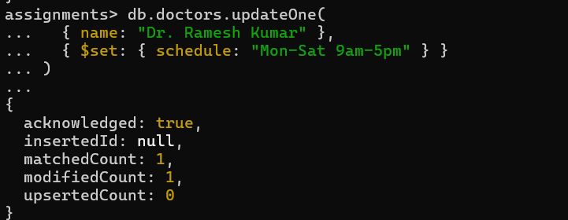

1. **Update health records for a patient**

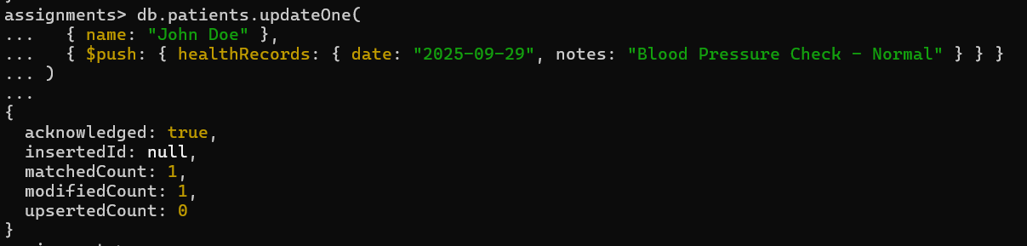

1. **Add a new appointment for a patient**

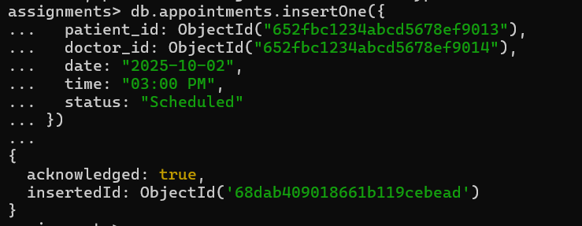

1. **Update appointment status**

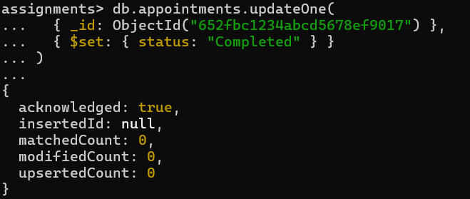

1. **Update contact details for an admin**

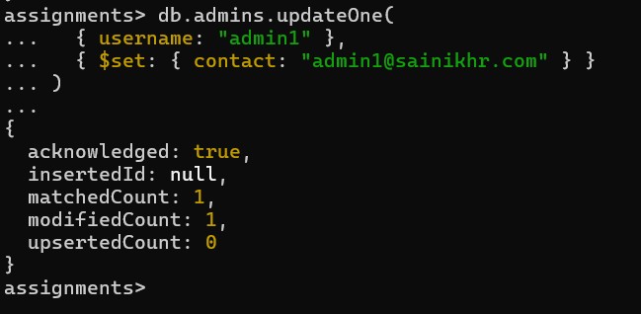

1. **Update the availability of all doctors who have a specific specialization, such as "Pediatrics", to mark them as unavailable on weekends**

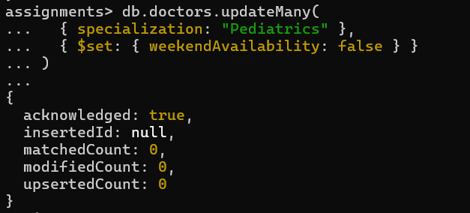

**10.Update the status of all appointments that are scheduled for tomorrow to**

**"Cancelled"**

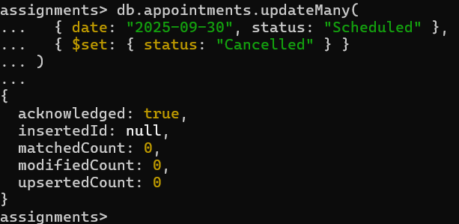

**Delete (D):**

1. **Delete a Hospital and Associated Doctors**

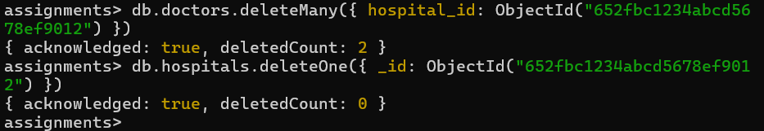

1. **Delete a Doctor and Their Appointments**

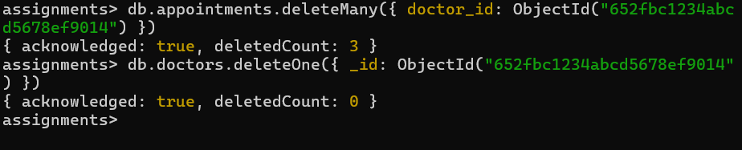

1. **Delete a Patient and Their Appointments**

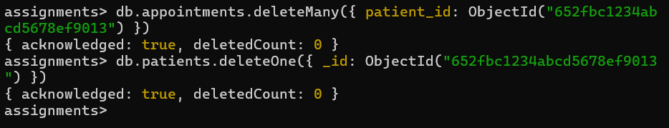

1. **Delete an Appointment**

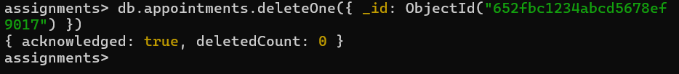

1. **Delete an Admin**

