**Hands-on No. : 2**

**Topic : SQL Basics**

**Date : 16.09.2025**

1. Schema Creation o Q1: Write a SQL query to create a new schema named hr.

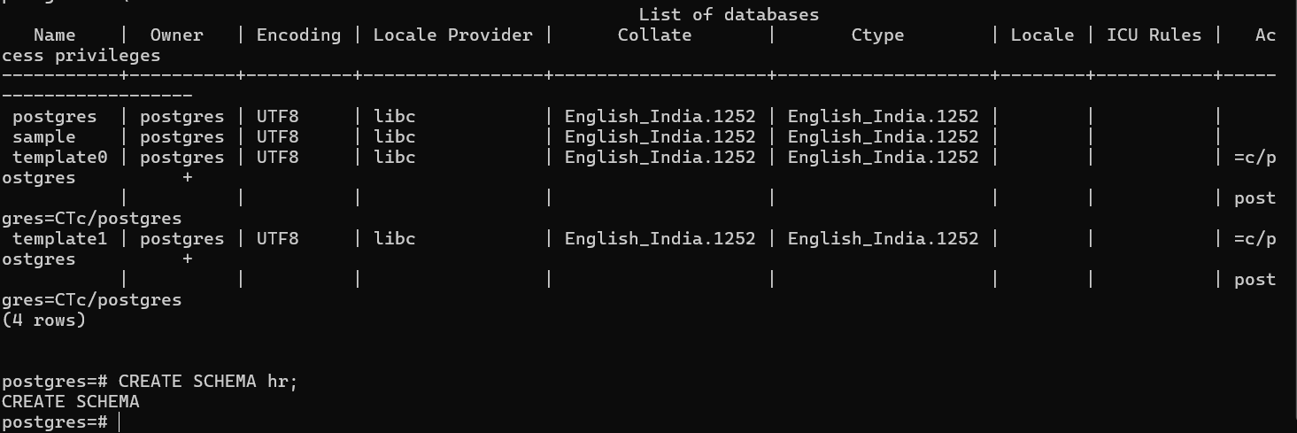

1. Regions Table o Q2: Create a table named regions with the following:
   * + - * region_id as primary key (INT, not null).
         * region_name with a maximum of 25 characters.



1. Countries Table o Q3: Create a table named countries with:
   * + - * country_id (2-character code, primary key).
         * country_name (up to 40 characters).
         * region_id (foreign key to regions).

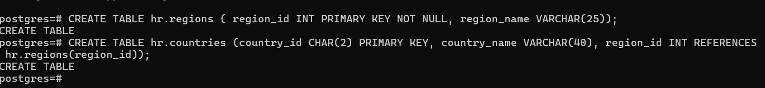

1. Locations Table

o Q4: Create a table named locations with:

* + - * + location_id (INT, auto-increment, primary key).
        + street_address, postal_code, city (not null), state_province.
        + country_id referencing the countries table.



1. Departments Table o Q5: Create a table named departments with:
   * + - * department_id (primary key).
         * department_name (not null).
         * manager_id (employee reference, nullable).
         * location_id referencing locations.



1. Jobs Table o Q6: Create a table named jobs with:
   * + - job_id (primary key).
       - job_title (not null).
       - min_salary and max_salary (unsigned decimals).



1. Employees Table
   * Q7: Create a table named employees with the following attributes:
     + - employee_id (primary key).
       - first_name, last_name (last name not null).
       - email (not null).
       - phone_number, hire_date (not null).
       - job_id, salary, commission_pct, manager_id, department_id.



* + Q8: Ensure that employee_id can be used as a manager for another employee (self-referencing foreign key).



1. Job History Table o Q9: Create a table named job_history with:
   * + - employee_id (not null).
       - start_date, end_date (not null).
       - job_id, department_id.



* + Q10: Add a unique constraint on (employee_id, start_date).



1. Regions Data

Q11: Insert records for 4 regions: *Europe, Americas, Asia, Middle East & Africa*. 

1. Countries Data

Q12: Insert records for at least 20 countries with their region mappings (e.g., Italy–Europe, India–Asia, USA–Americas).

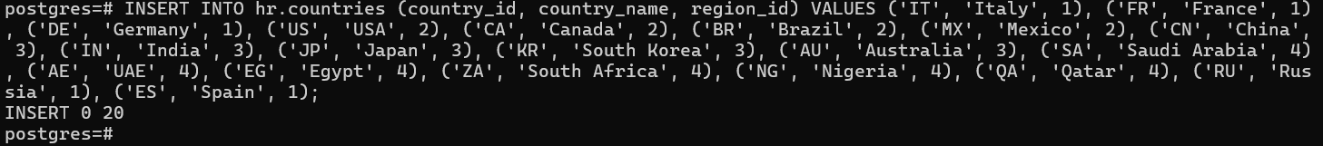

1. Locations Data

Q13: Insert records for office locations with proper address, postal code, city, state, and country_id.

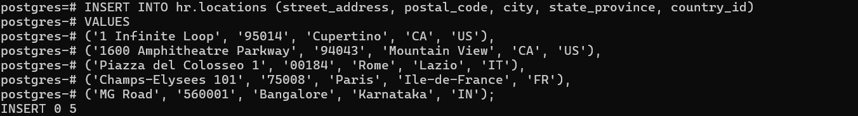

1. Departments Data

Q14: Insert multiple departments such as *Administration, Marketing, IT, Human Resources, Sales, Finance,* etc., with their manager_id and location_id.



1. Jobs Data

Q15: Insert different job roles with job titles and salary ranges (e.g., President, Manager, Programmer, Accountant, Clerk, etc.).



1. Employees Data

Q16: Insert employee details including employee_id, name, email, hire_date, job_id, salary, manager_id, department_id.

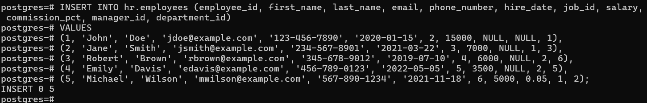

Q17: Ensure hierarchy is maintained (e.g., VP reports to President, Managers report to VP, etc.).

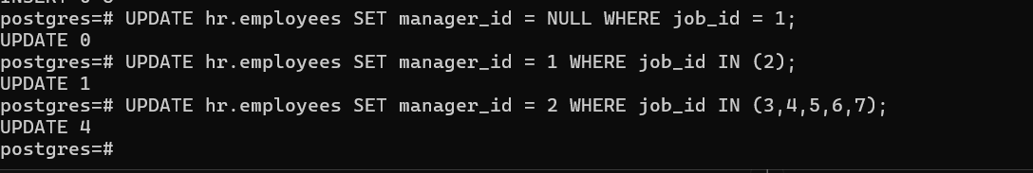

1. Job History Data

Q18: Insert employee job history with details of previous jobs, departments, and start & end dates.

