|  |  |
| --- | --- |
| **Hands-on No.** | **: 3** |
| **Topic** | **: Operators, SQL Functions, Aggregate functions** |
| **Date** | **: 17-09-2025** |

# Operators

1. Write a SQL query to retrieve and display each employee's first_name, last_name, and salary from the EMPLOYEES table. Additionally, calculate and display the Provident Fund (PF) (15%), Professional Tax (2%), and Income Tax (10%), and compute the Net Salary by subtracting the total deductions from the salary.

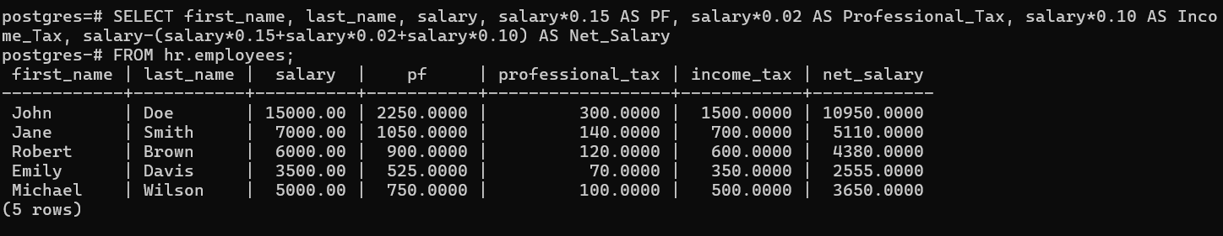

1. Write a SQL Query to retrieve employees with a salary greater than 50,000.

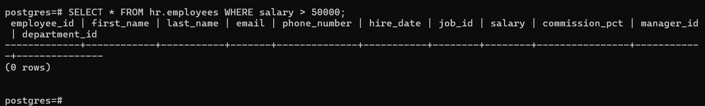

1. Write a SQL query to display the full name and salary of employees from the EMPLOYEES table who earn more than 50,000. The full name should be a combination of first name and last name, and the salary should be formatted with comma separators (e.g., 75000 → 75,000). The results must be sorted in ascending order based on the actual salary amount.

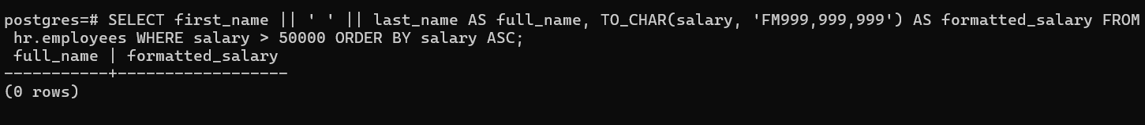

1. Write a SQL query to display all the details from employees whose department_id is not 30.

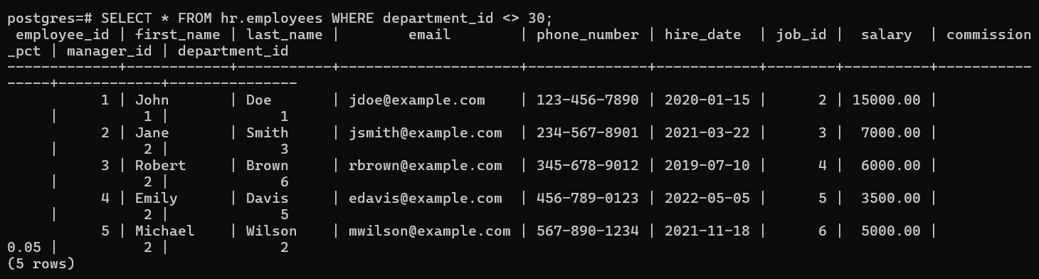

1. Write an SQL query to retrieve the firstname, lastname, salary for employees whose salary is between 30,000 and 60,000 (inclusive).



1. Write an SQL query to retrieve the first name and last name of employees who do not have a commission percentage.

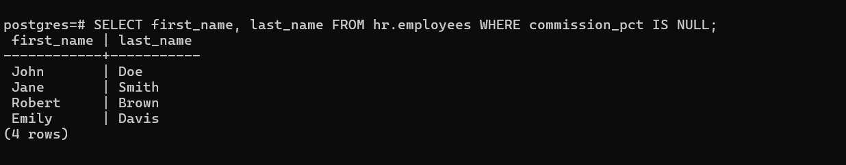

1. Retrieve employees whose salary is greater than 40,000 and who work in the 'IT' department with job_ID ‘IT_PROG’.

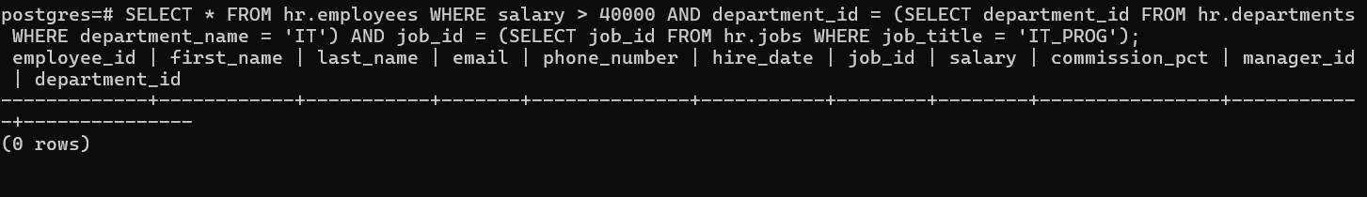

1. Find employees whose last name is "Susan" or whose salary is less than 30,000.

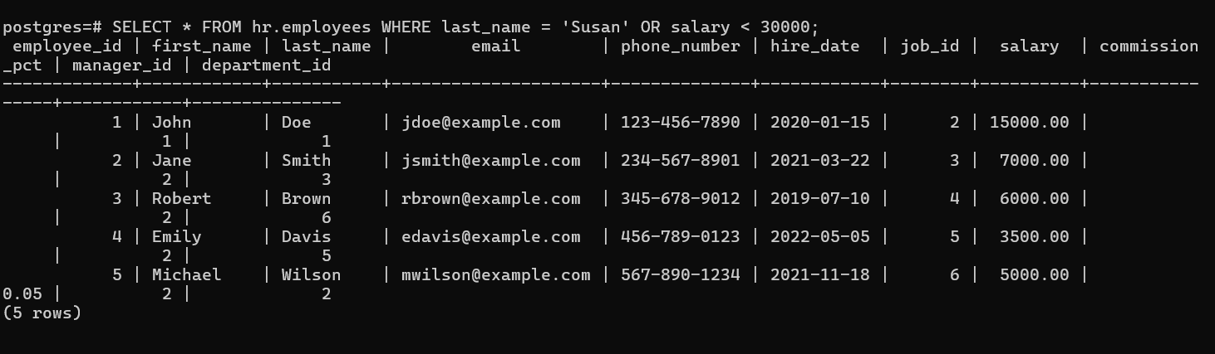

1. Retrieve employees who work in departments 'HR', 'Finance', or 'IT'.

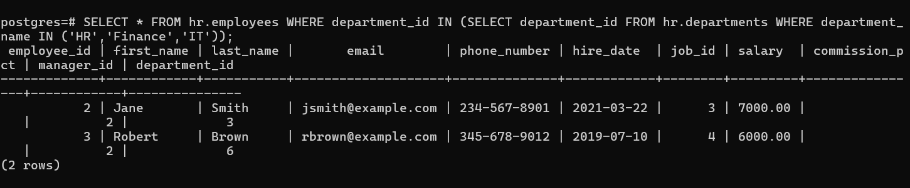

1. Find employees whose first name contains "John".

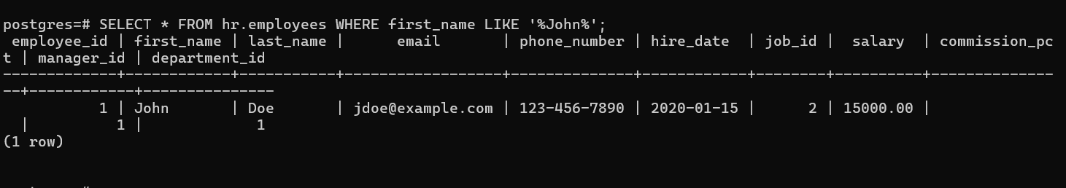

# SQL Functions

1. Write an SQL query to find the length of each employee's first_name in the EMPLOYEES table.

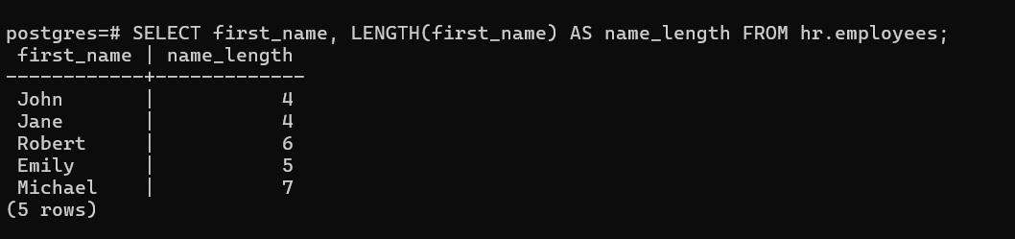

1. Write an SQL query to display each employee's salary formatted as currency (e.g., with a dollar sign, comma-separated thousands).

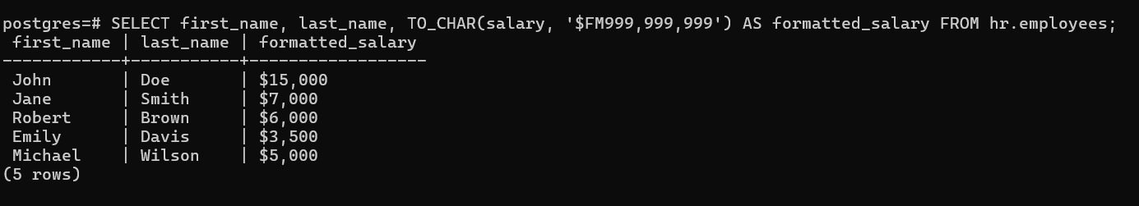

1. Write an SQL query to find the employee with the longest last_name in the EMPLOYEES table.

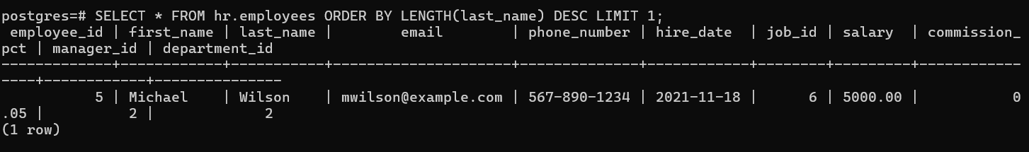

1. Write an SQL query to find the first_name and last_name of employees whose last_name starts with a vowel (A, E, I, O, U).



1. Write an SQL query to display the first_name, last_name, and salary of employees, but round the salary to two decimal places.

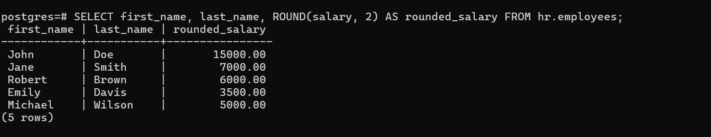

1. Write an SQL query to calculate each employee's salary as a percentage of the total salary of all employees.

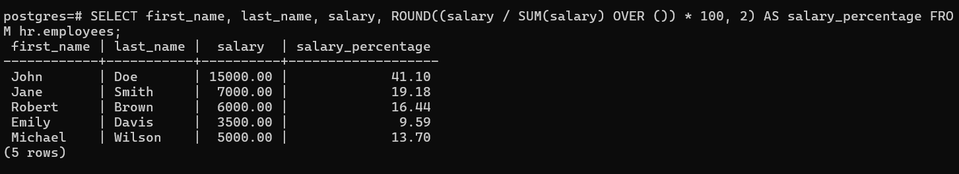

1. Write an SQL query to find the first_name, last_name, and salary of employees whose salary is greater than the average salary of all employees.

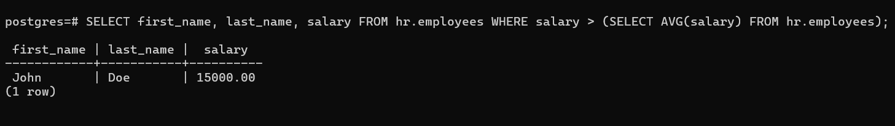

1. Write an SQL query to extract and display the year from the hire_date of each employee in the EMPLOYEES table.

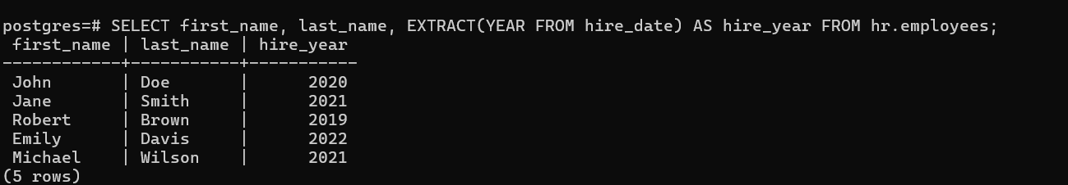

1. Write an SQL query to find the first_name, last_name, and hire_date of employees who were hired in the last 30 days.

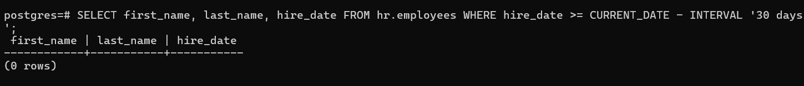

1. Write an SQL query to find the day of the week on which each employee was hired.

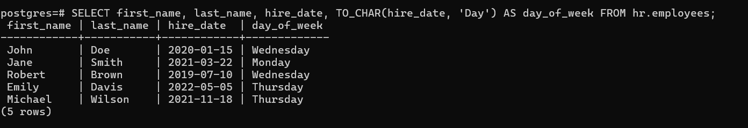 11. Write an SQL query to retrieve the first_name, last_name, and hire_date of employees who were hired in the current year.

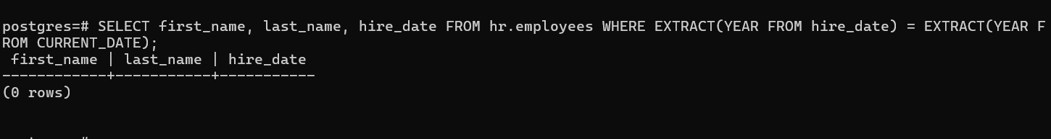

1. Write an SQL query to calculate and display the number of days since each employee was hired.

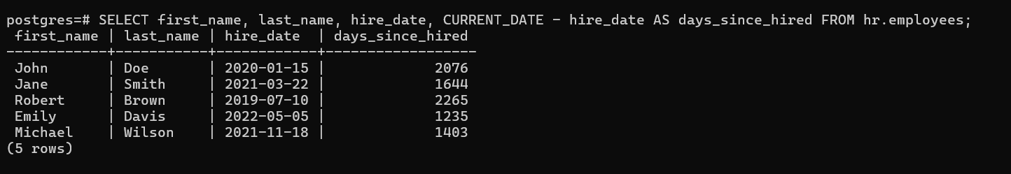

1. Write an SQL query to find employees who were hired in the last quarter (i.e., the last 3 months).

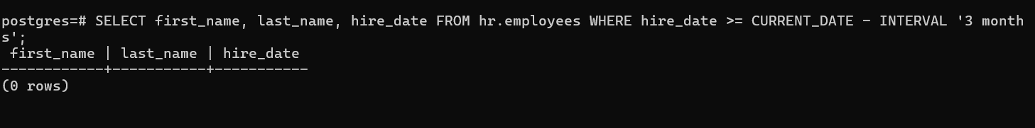

1. Write an SQL query to retrieve the first_name, last_name, and hire date of employees, but display the hire date in the format DD-MM-YYYY.

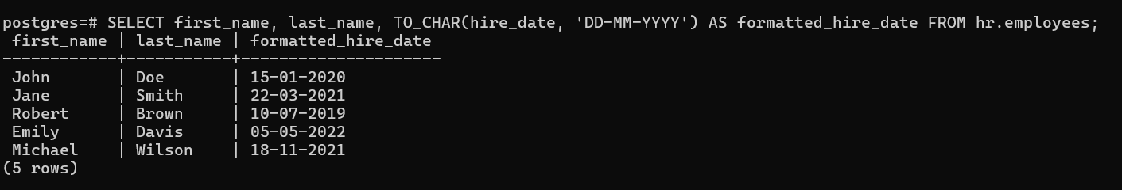

1. Write an SQL query to find the first_name, last_name, and hire_date of employees whose hire date falls on a weekend (Saturday or Sunday).

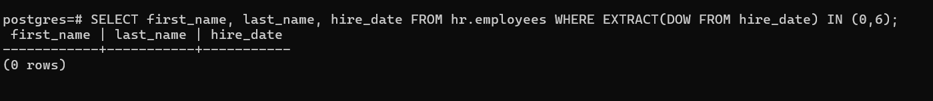

# Aggregate Functions

1. Write an SQL query to count the total number of employees in the EMPLOYEES table.

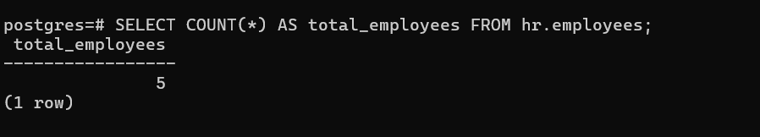

1. Write an SQL query to find the average salary of all employees in the EMPLOYEES table.



1. Write an SQL query to find the highest (MAX) and lowest (MIN) salary of employees in the EMPLOYEES table.

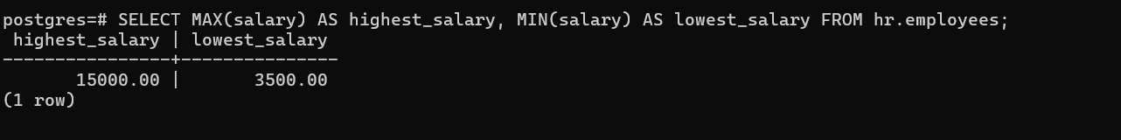

1. Write an SQL query to calculate the total sum of salaries of all employees in the EMPLOYEES table.

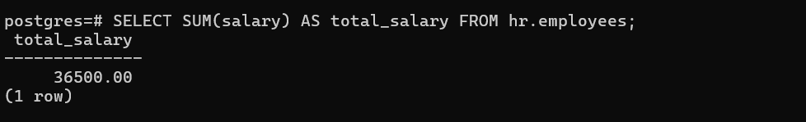

1. Write an SQL query to find the number of employees in each department, and return the department and count of employees.

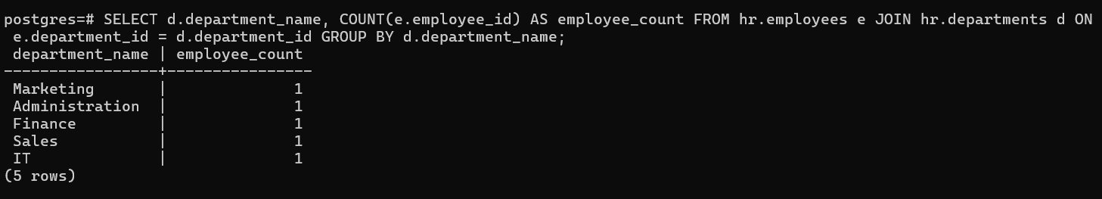

1. Write an SQL query to find the number of employees who have the jobid 'PU_CLERK'.

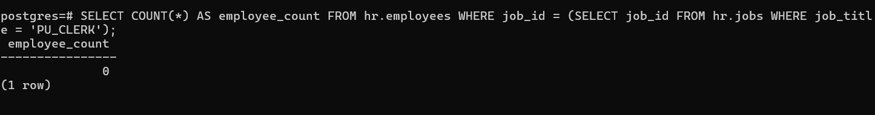

1. Write an SQL query to display departments that have more than 6 employees.

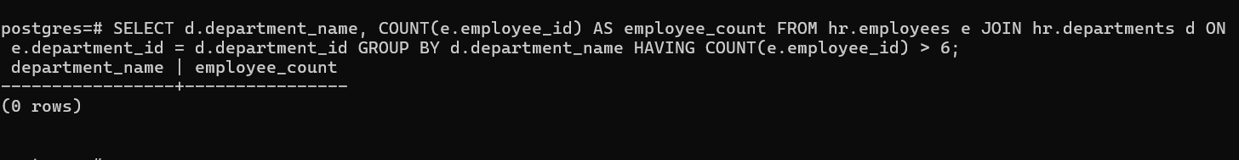

1. Write an SQL query to calculate the average salary of employees in each department.

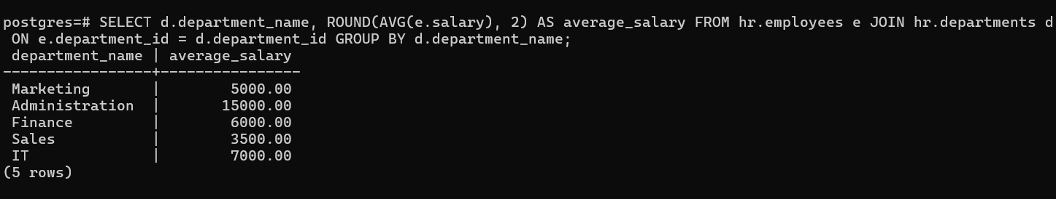

1. Write an SQL query to find departments where the average salary is greater than 50,000.

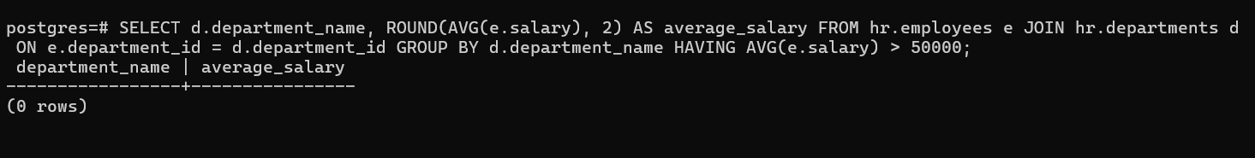

1. Write an SQL query to find the total salary paid to employees for each job role.

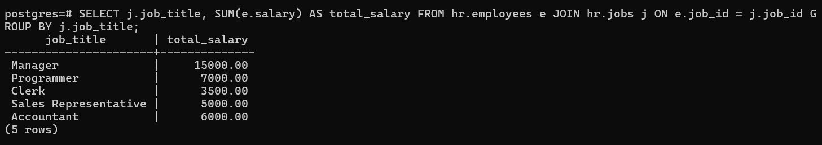

1. Write an SQL query to display job roles where the average commission is greater than 0.1 and not null.

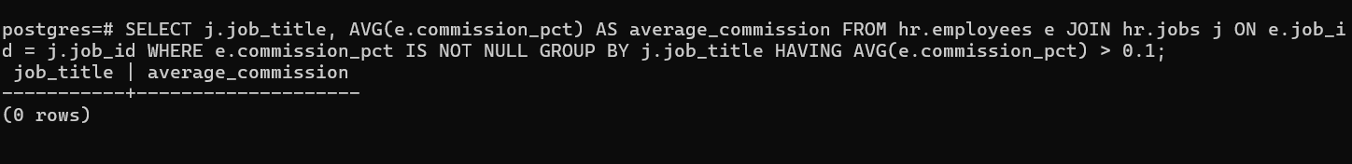

1. Write an SQL query to count employees hired each year, but display only those years where more than 2 employees were hired.

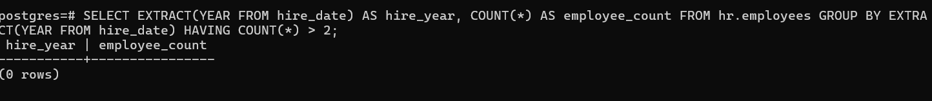

1. Write a query to display the total salary, maximum salary, and minimum salary for each department.

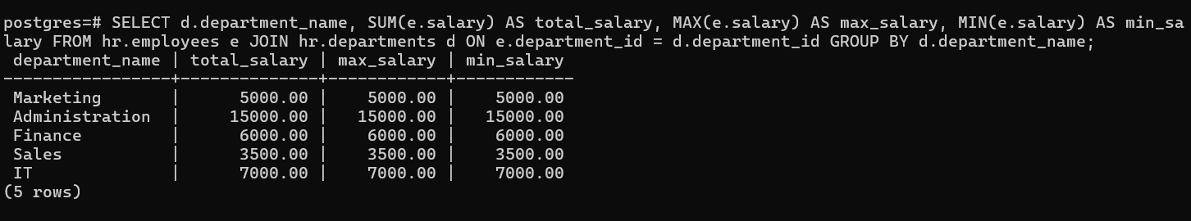

1. Find departments where the difference between the highest and lowest salary is greater than 30000.

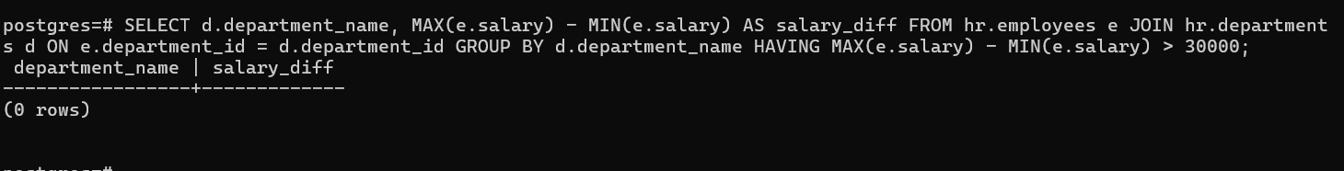

1. Display the number of employees and average salary for each job where the job title starts with the letter 'S'.

