**Hands-on No. : 4**

**Topic : Joins and Subqueries**

**Date : 18-09-2025**

**Joins**

1. Display the full names of all employees along with their job titles.

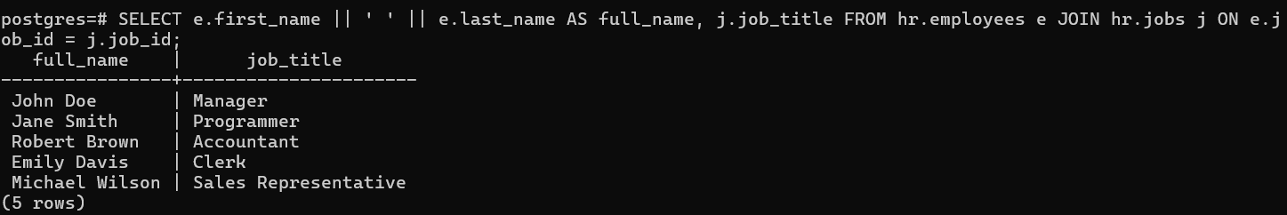

1. Retrieve the names of employees along with the names of the departments they belong to.

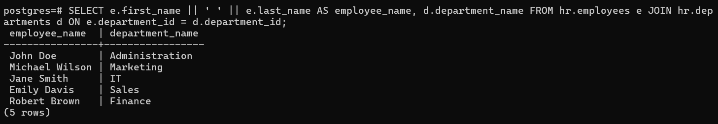

1. List every employee along with the name of their respective manager, if they have one.

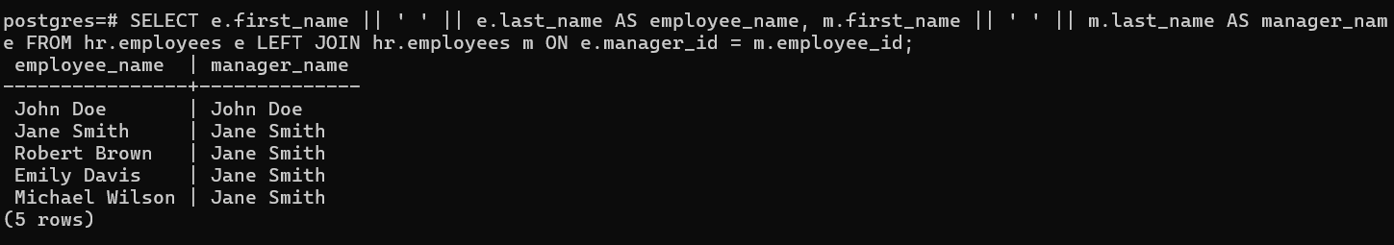

1. Show each employee's full name, their department name, and the title of their job.

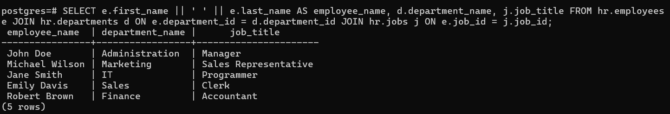

1. Identify employees who are not currently assigned to any department.

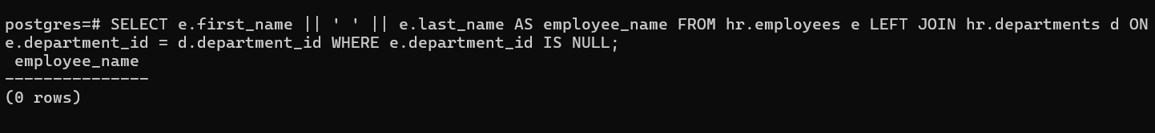

1. Display all departments along with the count of employees in each one.

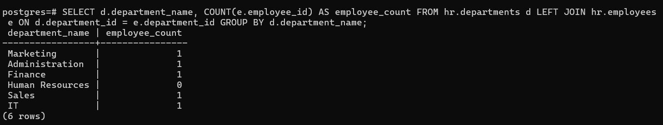

1. List employees along with the city and country of their office location.

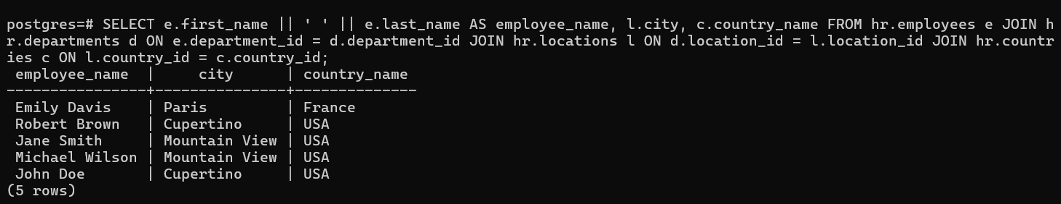

1. Retrieve the names of departments that are based outside the United States.

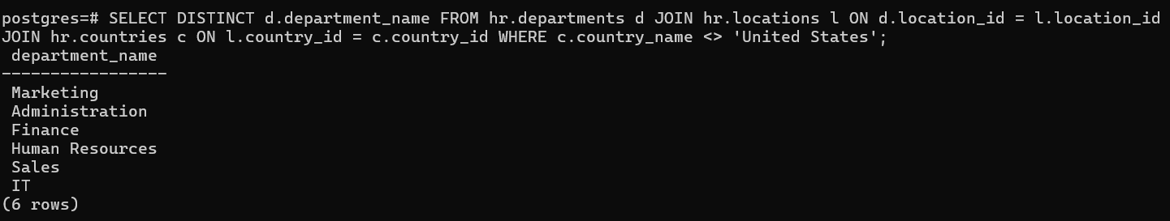

1. Find the names of employees whose salary is below the average salary within their department.

**HANDS**

**-**

**ON**



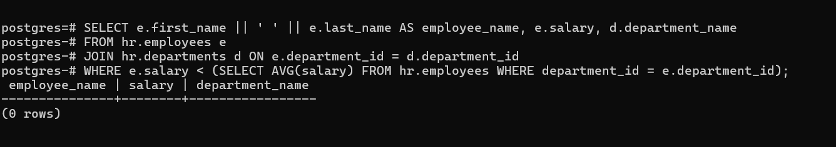

1. List all job titles and include the names of employees assigned to each title, even if some job titles are unassigned.

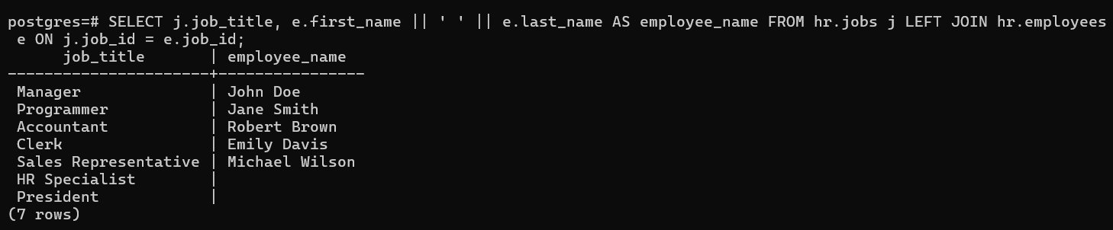

1. Display all departments and the names of employees in them, including departments that have no employees.

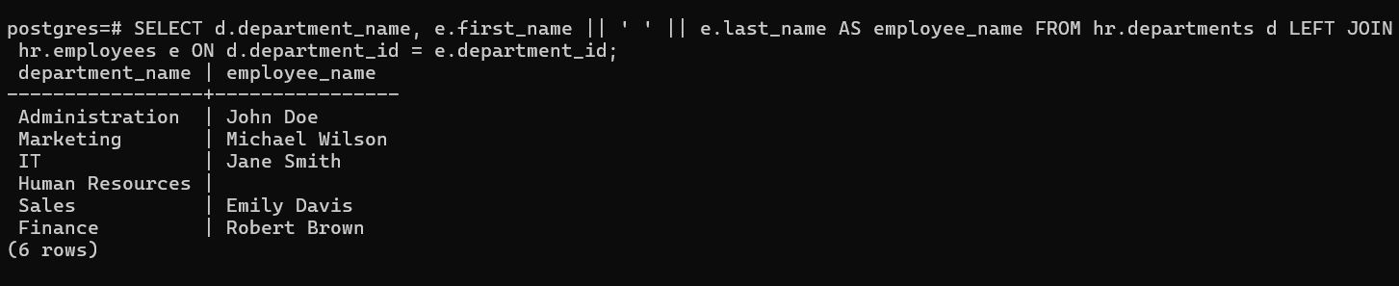

1. Show employee–manager name pairs where both individuals work in the same department.

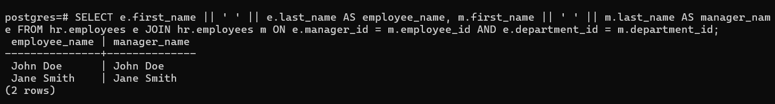

**Subqueries**

1. Retrieve the details of employees whose salaries exceed the average salary across the organization.

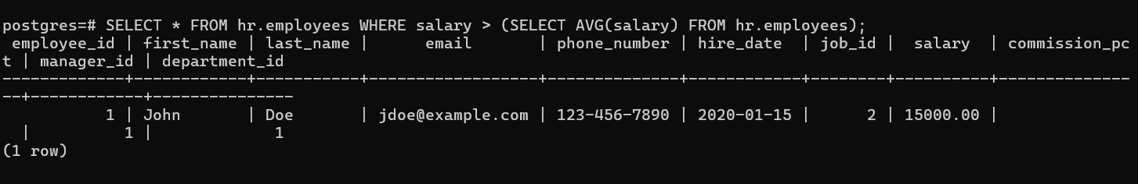

1. List all employees who are part of the same department as an employee named 'John'.

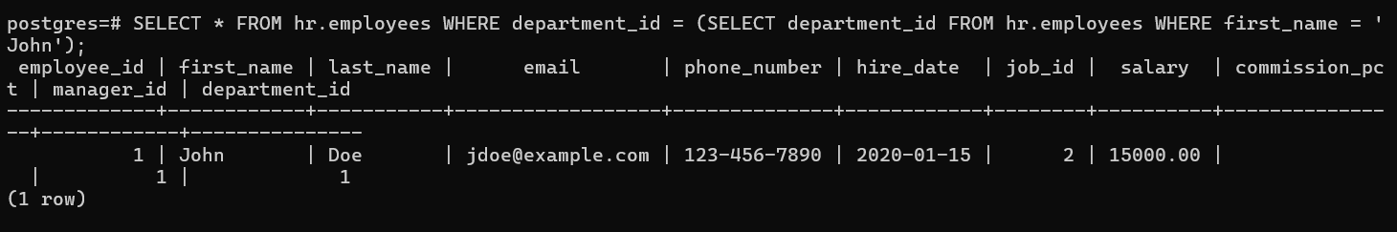

1. Identify employees who receive the highest salary within their respective departments.

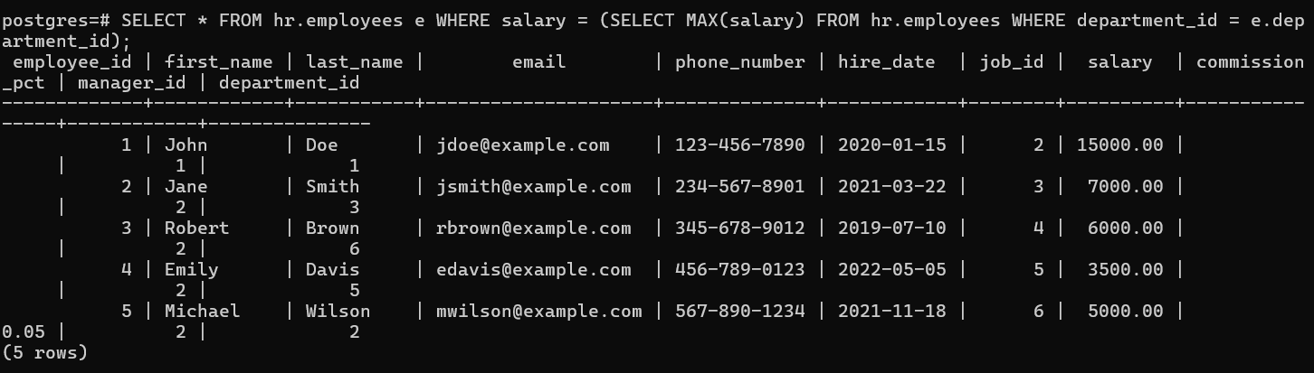

***It is going to be hard but, hard does not mean impossible.***

1. Determine the job title associated with the employee earning the highest salary in the company.

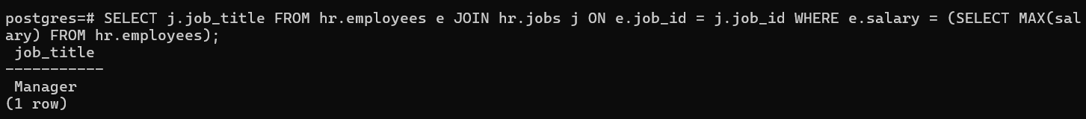

# 

1. Fetch the details of employees who hold managerial positions (i.e., their employee ID is referenced as a manager).

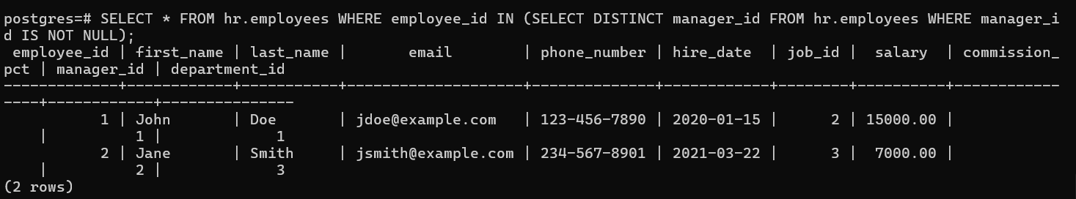

1. List employees whose salaries are greater than at least one employee in department 60.

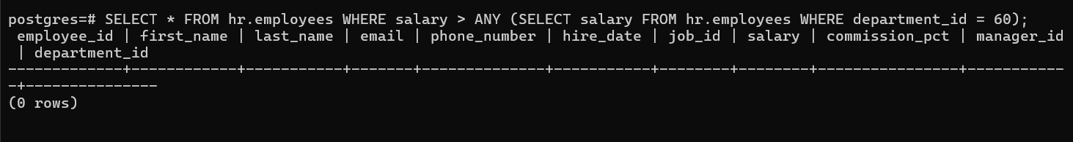

1. Identify employees whose salaries exceed the salaries of all employees in department 90.

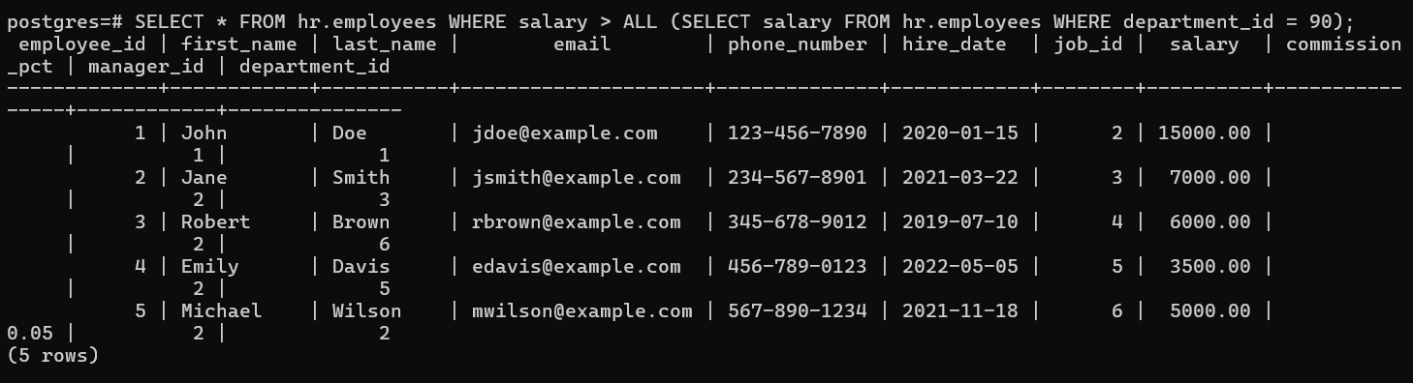

1. Retrieve the details of employees who do not manage any other employees.

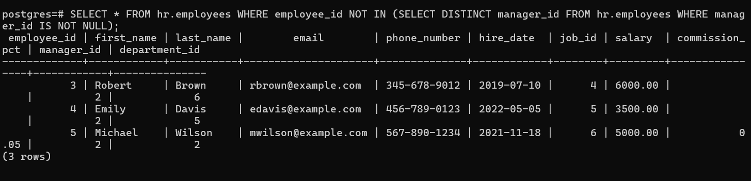

9.Find employees who are working in departments located in the city of ‘Toronto’.

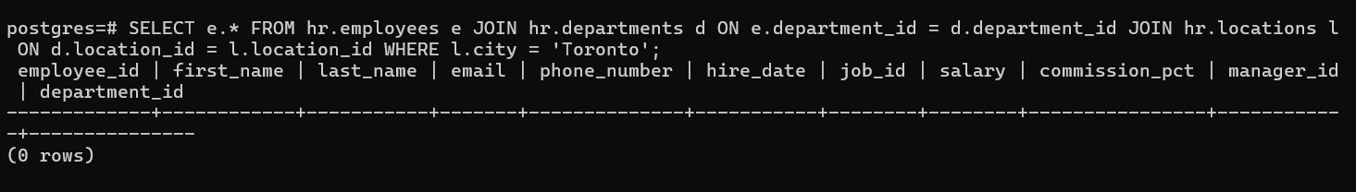

10. List employees whose job roles match that of the highest-paid employee in the

organization.

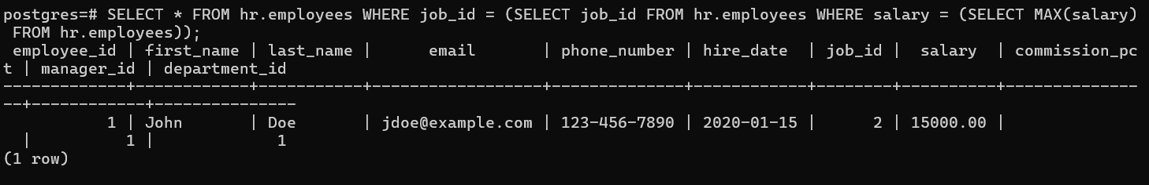

11. Display departments that have more than five employees currently assigned

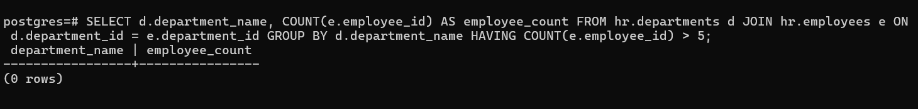

12.Retrieve departments where the average salary of employees exceeds 4000.

