<!-- #region forheader-->  <div class="pr">  <form class="form-header">  <p class="form-ttl">  Leave your contacts and we will call you back  </p>  <div class="header-input">  <label class="header-lab" for="lab-name">Name</label>  <input class="form-header-inp" type="text" id="lab-name">  <label class="header-lab" for="lab-phone">Phone</label>  <input class="form-header-inp" type="text" id="lab-phone">  <label class="header-lab" for="lab-mail">Email</label>  <input class="form-header-inp" type="text" id="lab-mail">  <label class="header-lab" for="lab-comm">Comment</label>  <input class="form-header-inp" type="text" id="lab-comm" placeholder="Text input">  </div>  <button>  </button>  </form>  </div>  <!-- #endregion forheader-->  <!-- #region forfooter-->  <div>  </div>  <!-- #endregion forfooter--> | .pr {  background-color: #434455;  }  .form-header {  border-radius: 4px;  width: 408px;  height: 584px;  box-shadow: 0 1px 1px 0 rgba(0, 0, 0, 0.14), 0 1px 3px 0 rgba(0, 0, 0, 0.12), 0 2px 1px 0 rgba(0, 0, 0, 0.2);  background-color: #fcfcfc;  padding-top: 72px;  padding-left: 24px;  padding-right: 24px;  margin-right: auto;  margin-left: auto;  margin-top: 100px;  }  .form-ttl {  font-family: "Roboto", sans-serif;  font-weight: 500;  font-size: 16px;  line-height: 1.5;  letter-spacing: 0.02em;  text-align: center;  color: #2e2f42;  /*margin-right: 24px;  margin-left: 24px;*/  margin-bottom: 16px;  }  /*.header-input {  display: flex;  align-items: flex-start;  justify-content: flex-start;  flex-direction: column;  gap: 8px;  border-radius: 4px;  width: 360px;  height: 336px;  margin-right: 24px;  margin-left: 24px;  margin-bottom: 32px;  }*/  .header-lab {  display: block;  font-family: "Roboto", sans-serif;  font-weight: 400;  font-size: 12px;  line-height: 1.17;  letter-spacing: 0.04em;  color: #8e8f99;  margin-bottom: 4px;  }  .form-header-inp {  width: 360px;  height: 40px;  border: 1px solid #4d5ae5;  border-radius: 4px;  padding-left: 16px;  margin-bottom: 8px;  }

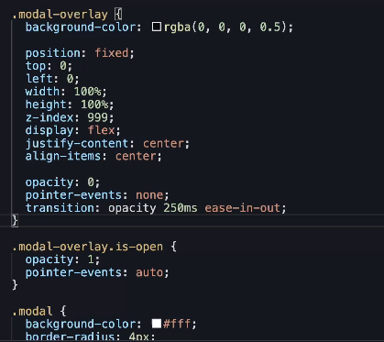
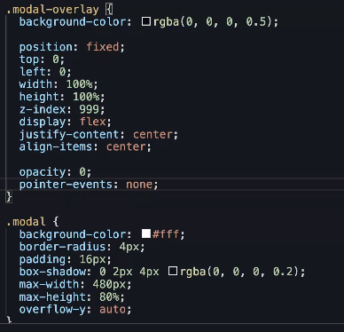
 | <div class="modal-cont-checkbox">  <input type="checkbox" id="user-checkbox" class="checkbox visually-hidden"/>  <label for="user-checkbox" class="custom-label-user-checkbox">  <span class="custom-checkbox">  <svg class="" width="10" height="8">  <use href="./images/icons.svg#icon-tak"></use>  </svg>  </span>  I accept the terms and conditions of the  <a href="#">Privacy Policy</a>  </label>  </div>

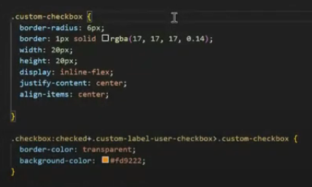

<label class="check option">  <input class="check__input" type="checkbox">  <span class="check__box"></span>  Первый  </label>  <label class="check option">  <input class="check__input" type="checkbox" checked>  <span class="check__box"></span>  Второй  </label>  <label class="check option">  <input class="check__input" type="checkbox" disabled>  <span class="check__box"></span>  Третий  </label>  <label class="check option ">  <input class="check__input" type="checkbox" checked disabled>  <span class="check__box"></span>  Четвёртый  </label> | body {  margin: 0;  padding: 25px;  font-family: sans-serif;  }  /* Option */  .option {  display: block;  margin-bottom: 0.5em;  }  /* Check */  .check {  padding-left: 1.2em;  }  .check__input {  position: absolute;  clip: rect(0 0 0 0);  width: 1px;  height: 1px;  margin: -1px;  }  .check__box {  position: absolute;  margin-top: 0.2em;  margin-left: -1em;  width: 0.6em;  height: 0.6em;  overflow: hidden;  border-radius: 0.05em;  background-color: white;  background-repeat: no-repeat;  background-position: 50% 50%;  box-shadow: 0 0 0 0.1em #4A90E2;  }  /* Checked */  .check__input:checked + .check__box {  background-color: #4A90E2;  background-image: url(images/check.svg);  }  /* Focused */  .check__input:focus + .check__box {  box-shadow:  0 0 0 0.1em #4A90E2,  0 0 0 0.2em #7ED321;  }  /* Disabled */  .check__input:disabled + .check__box {  box-shadow: 0 0 0 0.1em #9B9B9B;  }  .check__input:checked:disabled + .check__box {  background-color: #9B9B9B;  }

